AP Computer Science | GraphicsLab07 JavaAssignment
The "Disappearing Squares" Program | 80 & 100 Point Versions
Assignment Purpose:

The purpose of this program is to use recursion to draw a set of squares,
which become smaller as they reach the other side of the screen.

Write a program which start by drawing a 200 X 200 square at the top-left corner of the monitor. Continue drawing squares that become steadily smaller as they are displayed to right side of each preceding square. The bottom of the square stays at the same level. Each square is 25 percent smaller than the previously drawn square. Start with the student version, shown below.

Provided Student Program for GraphicsLab07

// GraphicsLab07st.java
// This is the Student Version of the GraphicsLab07 assignment.

import java.awt.*;
import java.applet.*;

public class GraphicsLab07st extends Applet
{

public void paint(Graphics g)
{

}

}

Inside the paint method you need to call another method, like drawSquare . Do not call method paint recursively. That is the job of the drawSquare method.

The recursive process exits when it is true that either the square size becomes smaller than four pixels or the border of the monitor is reached. You must be aware that only full-sized squares must be displayed. Keep this in mind as you determine if you are reaching the border of the monitor.

80 Point Version

The 80 point version draws one set of squares from left to right, starting with a 200X200 square
that is drawn with a top-left corner at coordinate (0,100). Each square is drawn with a 10 pixel space between the squares.

100 Point Version

The 100 point version draws a second set of squares in the same manner as the 80 point version, but this time the large square start on the right side and successive squares are drawn moving to the left side of the screen. You will need two different drawSquare methods.

80 Point Execution

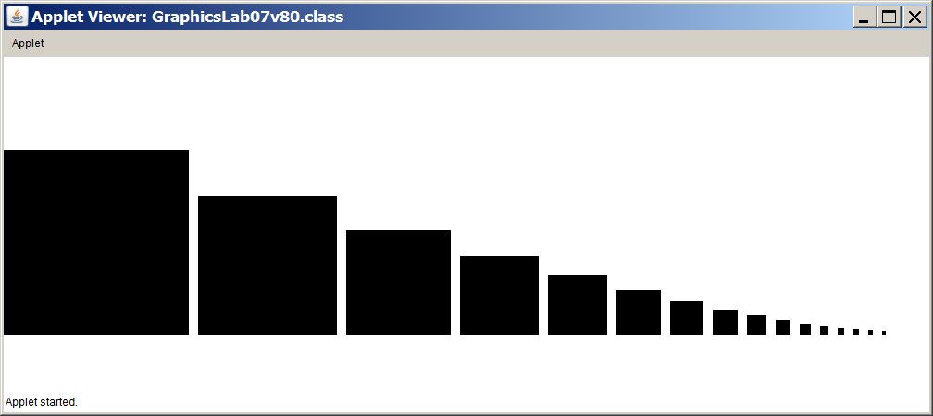

100 Point Execution

