AP Computer Science | MathLab01 Java Assignment
The Geometry Class Program | 60 through 100 Point Versions
Assignment Purpose:

The purpose of this lab assignment is to demonstrate knowledge of modular programming, program design and writing short return class methods.

For this lab assignment you are provided with a program that enters data from the keyboard to allow computing the areas, perimeters, surface areas, and volumes of various 2D and 3D shapes. All of the computations need to be done in short return class methods in the Geometry class. There will be a total of 24 different methods in the Geometry class when finished. 4 of them, squarePerimeter, squareArea, cubeSurfaceArea and cubeVolume are provided for you as examples. You will need to write the other 20 yourself.

You will notice that the main method is using proper programming design in that is calls other methods. These are methods to enter the information and display the results. These methods are also provided for you.

MathLab01 Student Version | Do not copy this file, which is provided.
// MathLab01st.java
// The Geometry Class Program
// This is the student, starting version of the Lab07MATH01 assignment.
// 4 Geometry class methods are provided as an example.
// You need to write the other 20 on your own.

import java.util.Scanner;

public class MathLab01st
{
public static double side, length, width, height, base1, base2, radius;

public static void main (String args[])
{
System.out.println("\nLAB07C - The Geometry Class Program\n\n");
enterData();
display2DPerimeters();
display2DAreas();
display3DSurfaceAreas();
display3DVolumes();
}

public static void enterData()
{
Scanner input = new Scanner(System.in);
System.out.print("Enter Side ===>> ");
side = input.nextDouble();
System.out.print("Enter Length ===>> ");
length = input.nextDouble();
System.out.print("Enter Width ===>> ");
width = input.nextDouble();
System.out.print("Enter Height ===>> ");
height = input.nextDouble();
System.out.print("Enter Base1 ===>> ");
base1 = input.nextDouble();
System.out.print("Enter Base2 ===>> ");
base2 = input.nextDouble();
System.out.print("Enter Radius ===>> ");
radius = input.nextDouble();
}

// Remove comments from the println statements below as you complete each of the methods of the Geometry class.
// Leave comments in place for any methods that you have not finished.

public static void display2DPerimeters()
{
System.out.println("\n\nPerimeters of 2D Shapes");
System.out.println("=====================================================");
System.out.println("Square Perimeter: " + Geometry.squarePerimeter(side));
// System.out.println("Pentagon Perimeter: " + Geometry.pentagonPerimeter(side));
// System.out.println("Hexagon Perimeter: " + Geometry.hexagonPerimeter(side));
// System.out.println("Octagon Perimeter: " + Geometry.octagonPerimeter(side));
// System.out.println("Rectangle Perimeter: " + Geometry.rectanglePerimeter(length,width));
// System.out.println("Circle Perimeter (circumference): " + Geometry.circumference(radius));
System.out.println("\n");
}

public static void display2DAreas()
{
System.out.println("Areas of 2D Shapes");
System.out.println("====================================================");
System.out.println("Square Area: " + Geometry.squareArea(side));
// System.out.println("Rectangle Area: " + Geometry.rectangleArea(length,width));
// System.out.println("Parallelogram Area: " + Geometry.parallelogramArea(base1,height));
// System.out.println("Triangle Area: " + Geometry.triangleArea(base1,height));
// System.out.println("Trapezoid Area: " + Geometry.trapezoidArea(base1,base2,height));
// System.out.println("Hexagon Area: " + Geometry.hexagonArea(base1,base2,height));
// System.out.println("Circle Area: " + Geometry.circleArea(radius));
System.out.println("\n");
}

public static void display3DSurfaceAreas()
{
System.out.println("Surface Areas of 3D Shapes");
System.out.println("=====================================================");
System.out.println("Cube Surface Area: " + Geometry.cubeSurfaceArea(side));
// System.out.println("Square Prism Surface Area: " + Geometry.squarePrismSurfaceArea(side,height));
// System.out.println("Rectangular Prism Surface Area: " + Geometry.rectangularPrismSurfaceArea(length,width,height));
// System.out.println("Sphere Surface Area: " + Geometry.sphereSurfaceArea(radius));
System.out.println("\n");
}

public static void display3DVolumes()
{
System.out.println("Volumes of 3D Shapes");
System.out.println("=====================================================");
System.out.println("Cube Volume: " + Geometry.cubeVolume(side));
// System.out.println("Square Prism Volume: " + Geometry.squarePrismVolume(side,height));
// System.out.println("Rectangular Prism Volume: " + Geometry.rectangularPrismVolume(length,width,height));
// System.out.println("Pyramid Volume: " + Geometry.pyramidVolume(side,height));
// System.out.println("Cylinder Volume: " + Geometry.cylinderVolume(radius,height));
// System.out.println("Cone Volume: " + Geometry.coneVolume(radius,height));
// System.out.println("Sphere Volume: " + Geometry.sphereVolume(radius));
System.out.println("\n");
}
}

class Geometry
{
// 2D Perimeters
public static double squarePerimeter (double s)
{
return 4 * s;
}

// 2D Areas
public static double squareArea (double s)
{
return s * s;
}

// 3D Surface Areas
public static double cubeSurfaceArea (double s)
{
return 6 * s * s;
}

// 3D Volumes
public static double cubeVolume (double s)
{
return s * s * s;
}

}

NOTE: There is a formulas chart provided for you on the last page.

Explanation of Inputs
In this program, the user will enter 7 values for the side, length, width, height, base1, base2, and radius. Most of these values are used in multiple formulas. For example length and width are used to compute the area of a rectangle, the perimeter or a rectangle, and are 2 of the 3 variables needed to computer the volume of a rectangular prism. The side of a square is the same side for a cube. The same height is used for triangles, rectangular prisms, cones, and pyramids. Computing the area of a trapezoid requires two base values (base1 and base2). Since a hexagon is essentially one trapezoid on top of another, it has the same parameters. For formulas requiring only one base value, base1 will be used. The value of PI does not need to be entered, nor does it need to be passed as a parameter. For any formula that requires the value of PI, use Math.PI.

Explanation of Grading
As is frequently the case, students earn a grade of 60 just for trying the assignment. That will be are starting point. There are 24 short return methods to write in the Geometry class. I have given you 4 so there are 20 left for you to write. Each method is worth 2 points. If you write all 20, then 20 * 2 = 40 and 40 + 60 = 100. Since the grading is done in this way, there is not really an “80” or “90” point version, but an 80 can be earned by having 10 Geometry class methods completed, and a 90 can be earned by having 15.

Sample Output for the Student Provided File

(This is essentially the 60 Point Version.)

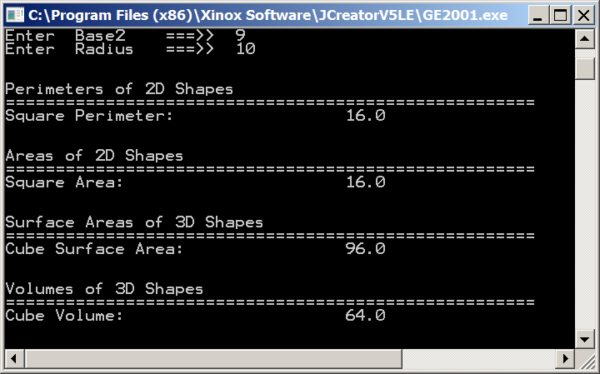

Sample Output for the “70” Point Version

(A 70 is what you earn if you only do the 2D Perimeter methods.)

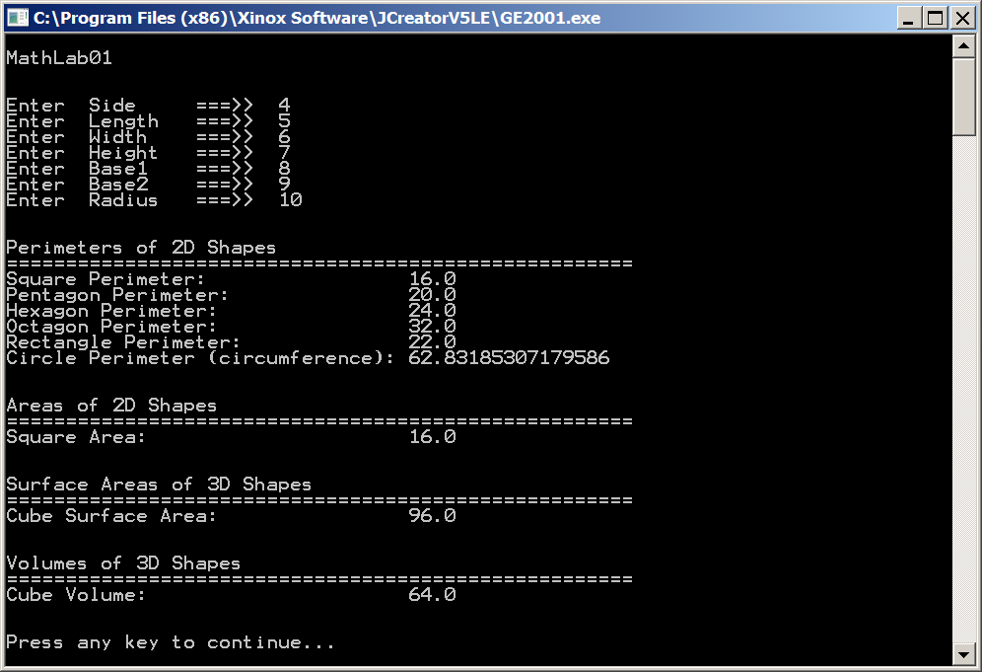

Remember… Do not hard code your program output !!!!

Also, you can write any of these methods in any order.
Sample Output for the 100 Point Version

(To earn a 100, ALL methods must be written.)

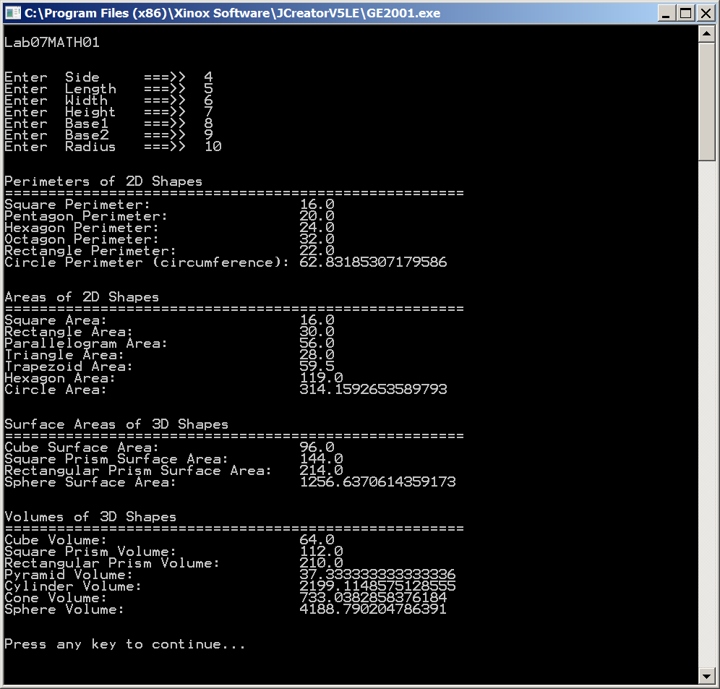
Formulas Chart

The bolded formulas are the ones given to you in the MathLab01.java starter file.
Use Math.PI for all formulas involving π.

Perimeter of a Square | 4 * side
Perimeter of a Pentagon | 5 * side
Perimeter of a Hexagon | 6 * side
Perimeter of an Octagon | 8 * side
Perimeter of a Rectangle | (length + width) * 2
Perimeter of a Circle (Circumference) | 2 * π * radius
Area of a Square | side²
Area of a Rectangle | length * width
Area of a Parallelogram | base * height
Area of a Triangle | base * height / 2
Area of a Trapezoid | (base1 + base2) / 2 * height
Area of a Hexagon | (base1 + base2) * height
Area of a Circle | π * radius²
Surface Area of a Cube | 6 * side²
Surface Area of a Square Prism | 2 * side² + 4 * side * height
Surface Area of a Rectangle Prism | 2 * length * width + 2 * length * height + 2 * width * height
Surface Area of a Sphere | 4 * π * radius²
Volume of a Cube | side³
Volume of a Square Prism | side² * height
Volume of a Rectangular Prism | length * width * height
Volume of a Pyramid | side² * height / 3
Volume of a Cylinder | π * radius² * height
Volume of a Cone | π * radius² * height / 3
Volume of a Sphere | 4 * π * radius³ / 3

Some of you may simply use the formulas shown in this lab and never think twice about them. Other people may notice that the formulas for the Volume of a Cone, and the Volume of a Pyramid may not look exactly like what you have seen in your math class.  The formula for both is actually: ⅓ * base * height  In the case of our Pyramid, the base is a square with dimensions: side * side.  In the case of our Cone, the base is a circle which has an area of: π * radius² | 

