AP Computer Science | MathLab03 Java Assignment
The Rational Class Program II | 80, 90 & 100 Point Versions
Assignment Purpose:

The purpose of this lab is to demonstrate knowledge of creating a class with object methods, instantiate multiple objects of the created class, and then call the object methods from the main program method. Additionally, this lab requires knowledge of the GUI input output and string to number conversion.

This lab assignment continues the Rational class that was started with the Lab08MATH02 assignment. Now comes the times to add, subtract, multiply and divide fractions with your nifty Rational class. This assignment will also be the first unit lab assignment. A unit assignment implies a more challenging assignment that carries greater weight for your average computation. A unit assignment involves bringing together a greater number of computer skills in one assignment. For instance, the last keyword assignment provided complete main methods, which handled all the GUI input and output. For this assignment you will need to write the Rational class and also handle most of the code in the main method.

MathLab03 Student Version | Do not copy this file, which is provided.
// MathLab03st.java
// The Rational Class Program II
// This is the student, starting version of the Lab08MATH03 assignment.
// There are 5 return methods in the Ration class that have temporary return statements
// which allow the program to compile. Students will need to change these statements.

import javax.swing.JOptionPane;

public class MathLab03st
{
public static void main (String args[])
{
String strNum1 = JOptionPane.showInputDialog("Enter Numerator 1");
String strDen1 = JOptionPane.showInputDialog("Enter Denominator 1");
String strNum2 = JOptionPane.showInputDialog("Enter Numerator 2");
String strDen2 = JOptionPane.showInputDialog("Enter Denominator 2");

int num1 = Integer.parseInt(strNum1);
int den1 = Integer.parseInt(strDen1);
int num2 = Integer.parseInt(strNum2);
int den2 = Integer.parseInt(strDen2);

Rational r1 = new Rational(num1,den1);
Rational r2 = new Rational(num2,den2);
Rational r3 = new Rational();

r3.multiply(r1,r2);
String mul = r1.getOriginal() + " * " + r2.getOriginal() + " = " + r3.getRational();
r3.divide(r1,r2);
String div = r1.getOriginal() + " / " + r2.getOriginal() + " = " + r3.getRational();
r3.add(r1,r2);
String add = r1.getOriginal() + " + " + r2.getOriginal() + " = " + r3.getRational();
r3.subtract(r1,r2);
String sub = r1.getOriginal() + " - " + r2.getOriginal() + " = " + r3.getRational();

String output = mul + "\n" + div + "\n" + add + "\n" + sub;

JOptionPane.showMessageDialog(null,output);

System.exit(0);
}
}

class Rational
{

private int firstNum; // entered numerator
private int firstDen; // entered denominator
private int num; // reduced numerator
private int den; // reduceddenominator

public Rational() { }

public Rational(int n, int d) { }

private int getGCF(int n1,int n2)
{
int rem = 0;
int gcf = 0;
do
{
rem = n1 % n2;
if (rem == 0)
gcf = n2;
else
{
n1 = n2;
n2 = rem;
}
}
while (rem != 0);
return gcf;
}

private void reduce() { }

public double getDecimal()
{
return 0.0;
}

public String getRational()
{
return "";
}

public String getOriginal()
{
return "";
}

public int getNum()
{
return 0;
}

public int getDen()
{
return 0;
}

public void multiply(Rational r1, Rational r2) { }

public void divide(Rational r1, Rational r2) { }

public void add(Rational r1, Rational r2) { }

public void subtract(Rational r1, Rational r2) { }

}

80 Point Version Specifics

This lab assignment starts by doing everything that was required for the MathLab02 assignment. You need to write methods Rational, getNum, getDen, getDecimal, getRational, and getOriginal. You will also need to write methods multiply and divide. Your fractions do not need to be reduced.

80 Point Version Output 1

The execution output will not show the input dialog windows. They are identical to the windows that were used for the MathLab02 assignment. Four separate input dialog windows are used, as is shown by the provided main method.

Enter these 4 numbers: 2, 5, 5, 7

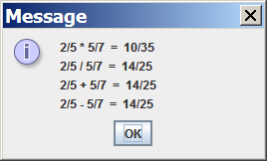

Note that in the GUI output window above, 4 lines of output are shown. In the 80 and 90 point versions, only the first 2 lines are significant. The sum and difference will appear to be the same as the quotient.

80 Point Version Output 2

Enter these 4 numbers: 6, 10, 20, 35

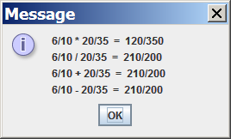

90 Point Version Specifics

The 90 point version adds the reduce method. As with MathLab03, you are provided with the getGCF method. Not only do you need to write the reduce method, but you also need to call it in the appropriate places so that the product and quotient will be displayed in lowest terms.

90 Point Version Output 1

Enter these 4 numbers: 2, 5, 5, 7

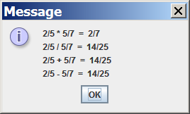

NOTE: As with the 80 point version, only the first 2 lines of output are significant.

90 Point Version Output 2

Enter these 4 numbers: 6, 10, 20, 35

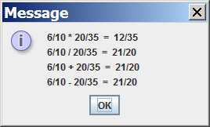

100 Point Version Specifics

The 100-point version completes the Rational class with methods add and subtract. The sum and difference also need to be displayed in lowest terms.

100 Point Version Output 1

Enter these 4 numbers: 2, 5, 5, 7

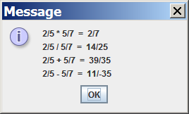

NOTE: Now all 4 lines of output are significant.
ALSO: In the subtraction answer, the negative sign might show up in the numerator.
It also might show up in the denominator. Either way is fine.

100 Point Version Output 2

Enter these 4 numbers: 6, 10, 20, 35

