AP Computer Science | MathLab04 Java Assignment
The "Sieve of Eratosthenes" Program |  | 80 & 100 Point Versions
Assignment Purpose:

The purpose of this assignment is to practice declaring one-dimensional array objects and manipulating the elements of the array.

Write a program that computes prime numbers using the “Sieve of Eratosthenes” method.
The Sieve prime number generator uses an ingenious method, which does not involve any type of division, by using the following steps:

[1] Initialize all numbers in the array, starting with 2, as prime numbers. Ignore number 1.

[2] Check the first number, 2, to see if it is prime.
Since it is designated prime, change all the multiples of 2 to Not Prime.

[3] Check the next number, 3, to see if it is prime.
Since it is designated prime, change all the multiple of 3 to Not Prime.

[4] Continue this process, until the upper limit is reached.

Imagine that a small upper limit of 21 is requested.
The “Sieve” will work with Pr (Prime) and NP (Not Prime) as follows:

STEP 01 Initialize all elements to Prime

xx | Pr | Pr | Pr | Pr | Pr | Pr | Pr | Pr | Pr | Pr | Pr | Pr | Pr | Pr | Pr | Pr | Pr | Pr | Pr | Pr
1 | 2 | 3 | 4 | 5 | 6 | 7 | 8 | 9 | 10 | 11 | 12 | 13 | 14 | 15 | 16 | 17 | 18 | 19 | 20 | 21

STEP 02 Change all multiples of 2 to Not Prime

xx | Pr | Pr | NP | Pr | NP | Pr | NP | Pr | NP | Pr | NP | Pr | NP | Pr | NP | Pr | NP | Pr | NP | Pr
1 | 2 | 3 | 4 | 5 | 6 | 7 | 8 | 9 | 10 | 11 | 12 | 13 | 14 | 15 | 16 | 17 | 18 | 19 | 20 | 21

STEP 03 Change all multiples of 3 to Not Prime

xx | Pr | Pr | NP | Pr | NP | Pr | NP | NP | NP | Pr | NP | Pr | NP | NP | NP | Pr | NP | Pr | NP | NP
1 | 2 | 3 | 4 | 5 | 6 | 7 | 8 | 9 | 10 | 11 | 12 | 13 | 14 | 15 | 16 | 17 | 18 | 19 | 20 | 21

STEP 04 Repeat this process until the upper limit is reached

xx | Pr | Pr | NP | Pr | NP | Pr | NP | NP | NP | Pr | NP | Pr | NP | NP | NP | Pr | NP | Pr | NP | NP
1 | 2 | 3 | 4 | 5 | 6 | 7 | 8 | 9 | 10 | 11 | 12 | 13 | 14 | 15 | 16 | 17 | 18 | 19 | 20 | 21

Prime Numbers left are: 2, 3, 5 ,7 , 11, 13, 17, 19

80 Point Version Specifics

The 80-point version displays all the prime numbers between 1 and 100. Complete methods ComputePrimes and DisplayPrimes inside the Lab12st class. There is only a single execution and there is no program user input at all.

MathLab04 Student Version | Do not copy this file, which is provided.
public static void main(String args[])
{
// This main method needs additions for the 100 point version.
Scanner input = new Scanner(System.in);
System.out.println("\nMathLab04\n");
final int MAX = 100;
boolean primes[];
primes = new boolean[MAX];
computePrimes(primes);
displayPrimes(primes);
}

80 Point Version Output (1 required)

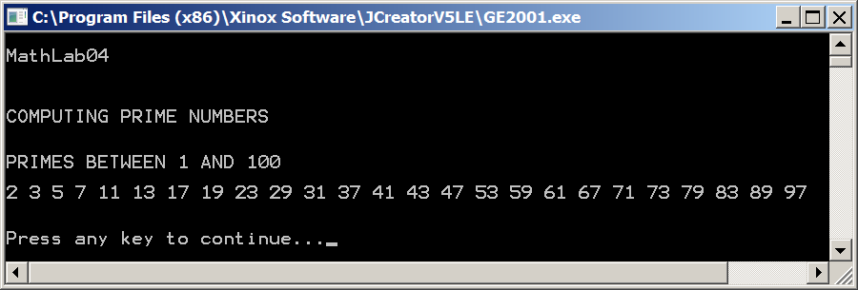

100 Point Version Specifics

The 100-point version requires interactive input in a text window. Additionally, the 100-point version needs to format program output so that all prime numbers display four digit numbers with leading zeroes where necessary using a DecimalFormat of "0000". To make the output look proper 1 blank space needs to be printed after each number. Execute the program twice.

MathLab04 100 Point Version | Required main Method
public static void main(String args[])
{
System.out.println("\nMathLab04\n");
Scanner input = new Scanner(System.in);
System.out.print("Enter the primes upper bound ===>> ");
final int MAX = input.nextInt();
boolean primes[] = new boolean[MAX];
computePrimes(primes);
displayPrimes(primes);
}

100 Point Version Outputs (2 required)

First Output

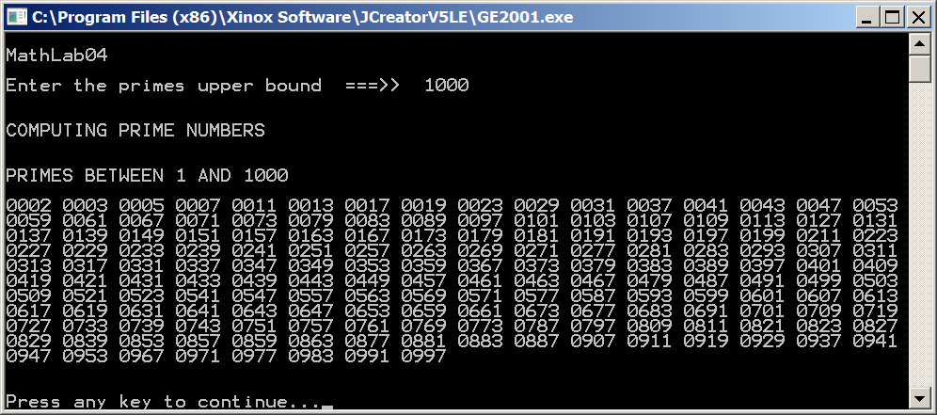

Second Output

