AP Computer Science | TextLab02 Java Assignment
The Time Display Program | 80 & 100 Point Versions
Assignment Purpose:

The purpose of this lab assignment is to demonstrate knowledge of using simple data type variables in a program and use arithmetic binary operations.

Write a program that starts with seconds, and then displays the hours, minutes and seconds. It will be your job to give the computer a set of computational instructions that will provide the desired results. Right now, early in your computer science course you need to realize that it is not possible to write a program, which means a set of computer instructions, to accomplish anything unless you can personally solve the problem.

It is possible to write a computer program that will play chess. Now can you imagine writing such a program if you cannot personally play chess? In other words, right now you need to first understand the logical steps that are necessary to compute the time from seconds. Yes, you saw these exact same words for the practice version. Repetition is a good habit with learning. Just ask your band director, football coach or cheerleading sponsor.

Step description | Arithmetic Operation
Start with 10,000 seconds. | 10000
First, you need to compute the number of whole hours using integer division. Use the fact that there are 3600 seconds in one hour. | 10000 seconds / 3600 = 2 hours
Now you need to determine how many seconds are left over from the integer division. This is accomplished with the remainder division. | 10000 seconds % 3600 = 2800 seconds
The 2800 seconds now need to be used to compute the whole minutes by using integer division with 60. | 2800 seconds / 60 = 46 minutes
Once again you need to determine the left over seconds. Use the remainder division with 60. | 2800 seconds % 60 = 40 seconds
The result of these computations shows the following  results: | 10000 seconds equals:  2 hours, 46 minutes and 40 seconds

TextLab02 Student Version | Do not copy this file, which is provided.
// TextLab02st.java
// Student starting version of the TextLab02 assignment.
// Resave this program as TextLab02v80 for the 80 point version.
// Resave this program as TextLab02v100 for the 100 point version.

public classTextLab02st
{
public static void main(String args[])
{
System.out.println("TextLab02, 80 Point Version\n");

}

}

80 Point Version

The 80-point version requires a program that simulates the computational steps demonstrated on the previous page. Starting with this assignment you will do your lab assignments by starting with a special student version. All student versions include the letters st in the file name, like TextLab02st.java. Student versions are intended to save time and provide code that is not the focus of the graded assignment. There was a TextLab01st.java for the last assignment, but that file was totally empty since it was your job to copy a program correctly.

TextLab02 80 Point Version | One Required Output
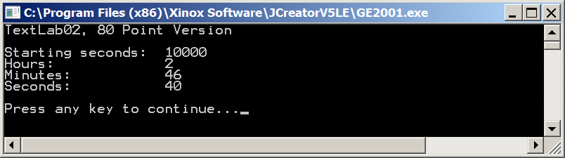

100 Point Version

The 100-point version is slightly more complex. For this program the computer is provided with milli-seconds, not seconds. The program logical is identical to the 80-point version. The only change is that additional steps are required to handle the milli-seconds. There are 1000 milli-seconds in one second and there are 3600000 milliseconds in one hour.

TextLab02 100 Point Version | One Required Output
