AP Computer Science | TextLab03 Java Assignment
The "Dynamic Matrix" Program |  | 80 & 100 Point Versions
Assignment Purpose:

The purpose of this assignment is to demonstrate knowledge of the ArrayList class by creating a
dynamic two-dimensional Matrix class implemented with the ArrayList class.

Write a Matrix class that handles two-dimensional array-needs "dynamically". Dynamically means that the size of the array can be altered during program execution. You are required to use the Java one-dimensional ArrayList class to implement the Matrix class. You will be provided with a student file, which includes the main methods for the 80-point and 100-point version.

Chapter 13 introduces the "generics" concept with the ArrayList class. You have not yet learned how to create your own generic class, which is shown in a later chapter. For that reason this assignment and the Matrix class will be implemented without the use of generics. Now Java is very touchy when new and improved features are not used. You will get the warning message shown below. Ignore the message. Later in the course the warning will disappear when you use generics.

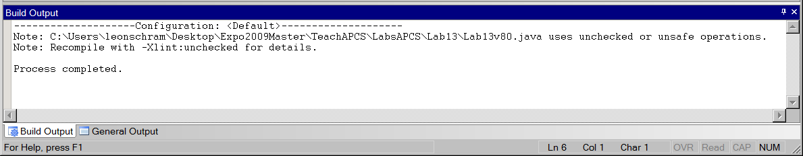

TextLab03 80 and 100 Point Versions | Student Provided File
// TextLab03st.java
// This is the student starting version of the TextLab03 assignment.
// Testing <main> methods are provided for the 80-point and 100-point versions.
// This means that this version will not compile as provided.

import java.util.ArrayList;

public class TextLab0303st
{
public static void main(String args[])
{
System.out.println("\nTexdtLab03 80-POINT VERSION\n");

Matrix m1 = new Matrix();
m1.displayMatrix("Matrix m1 Default Display");
System.out.println();

Matrix m2 = new Matrix(3,5);
m2.displayMatrix("Matrix m2 3 X 5 Display");
System.out.println();
int count = 100;
for (int r = 0; r < m2.getRows(); r++)
{
for (int c = 0; c < m2.getCols(); c++)
{
m2.setValue(r,c,count);
count++;
}
}
m2.displayMatrix("Matrix m2 3 X 5 Consecutive Integers Display");
System.out.println();

Matrix m3 = new Matrix(3,3,100);
m3.displayMatrix("Matrix m3 3 X 3 Initialized to 100 Display");
System.out.println();
}

}

class Matrix
{

private ArrayList list; // one-dimensional array stores matrix values
private int listSize; // total number of elements in the matrix
private int numRows; // number of rows in the matrix
private int numCols; // number of cols in the matrix

}

80 & 100 Point Versions

The 80-point version of the Matrix class requires implementing three constructors plus methods getRows, getCols, getSize, getValue, setValue and displayMatrix. There are four private date fields, which are list, listSize, numRows and numCols. Dynamic resizing is not required for the 80-point version, but method resize is required and this is the only difference with the 100-point version.

TextLab03 80 & 100 Point Version | Matrix Class Interface
private ArrayList list; // one-dimensional array stores matrix values
private int listSize; // total number of elements in the matrix
private int numRows; // number of rows in the matrix
private int numCols; // number of cols in the matrix

/** Constructs empty ArrayList object and sets all values to 0 **/
public Matrix()

/** Constructs r X c matrix with all elements initialized to 0 **/
public Matrix(int r, int c)

/** Constructs r X c matrix will all elements initialized to value **/
public Matrix(int r, int c, int value)

/** Returns numRows value **/
public int getRows()

/** Returns numCols value **/
public int getCols()

/** Returns listSize value **/
public int getSize()

/** Returns Matrix object value at (r,c) location **/
public int getValue(int r, int c)

/** Alters Matrix object value at (r,c) to value **/
public void setValue(int r, int c, int value)

/** Displays Matrix object in two-dimensional matrix format **/
public void displayMatrix(String str)

/** Resizes Matrix object to new rows X cols size, copies all possible
previous values and initializes new elements to zero **/
public void resize(int rows, int cols)

TextLab03 80 Point Version | One Required Output
TextLab03 80-POINT VERSION

Matrix m1 Default Display
Matrix has no elements

Matrix m2 3 X 5 Display
0 0 0 0 0
0 0 0 0 0
0 0 0 0 0

Matrix m2 3 X 5 Consecutive Integers Display
100 101 102 103 104
105 106 107 108 109
110 111 112 113 114

Matrix m3 3 X 3 Initialized to 100 Display
100 100 100
100 100 100
100 100 100

TextLab03 100 Point Version | One Required Output
LAB13TEXT03 100-POINT VERSION

Matrix m1 Default Display
Matrix has no elements

Matrix m2 3 X 5 Consecutive Integers Display
100 101 102 103 104
105 106 107 108 109
110 111 112 113 114

Matrix m2 After 4 X 4 Resizing Display
100 101 102 103
105 106 107 108
110 111 112 113
0 0 0 0

Matrix m3 3 X 3 Initialized to 100 Display
100 100 100
100 100 100
100 100 100

