AP Computer Science | TextLab04 Java Assignment
The Student Records File Program | 80, 90, 100 & 110 Point Versions
Assignment Purpose:

This program requires knowledge and manipulation of Java text file creation and retrieval.

Write a program that reads in a text file called "students.dat". The file is organized with a separate character string on each line. This is a sequential file of characters, but the file is organized to store student records with three fields in each record. There is a name field, age field and a gpa field. Keep in mind that Java does not realize these are records. You, as programmer, need to convert the age string to an integer and the gpa string to a double. The first five records of the "students.dat" text file are shown below.

Bart Reagor
27
2.075
Kristyn Reckner
19
3.225
Paul Reiman
41
4.000
Andy Reitinger
20
3.525
William Reynolds
50
3.375

Using the File class, FileReader class and the BufferedReader class of the java.io.* package, you need to read in each line and display the results. You have no knowledge of the actual size of the file. You will need to use a conditional loop to keep entering file data until the end or null is reached.

The provided student file (shown on the next page) has a few things done for you. Three File objects are created (f1, f2, & f3). The first is for the students.dat file. The other 2 are for files you create in the 100 and 110 point versions of this assignment – which are explained later. The program checks to see if the students.dat file exists and then sets up the BufferedReader and InputStreamReader objects for you.

NOTE: Unlike most programs, this program will be done entirely in the main method. While this might not be considered the best program design, the focus of the assignment is File Handling. Putting everything in the main method just made everything simpler.

TextLab04 Student Version | Do not copy this file, which is provided.
// TextLab04st.java
// The Student Records File Program
// This is the student, starting version of the Lab17TEXT04 assignment.

import java.io.*;
import java.text.DecimalFormat;

public class TextLab04st
{
public static void main (String args[]) throws IOException
{
System.out.println("\nTextLab04 -- The Student Records File Program\n");
DecimalFormat df = new DecimalFormat("00.000");
File f1 = new File("students.dat");
File f2 = new File("passing.dat");
File f3 = new File("honors.dat");
f2.delete();
f3.delete();

if (f1.exists())
{
FileReader inFile = new FileReader(f1);
BufferedReader inStream = new BufferedReader(inFile);

}
else
{
System.out.println(f1.getName() + " does not exist");
}
System.out.println();
}
}

NOTE: While placing the entire program in the main method is not normally considered proper programming design, for this program we are simply focusing on handling and manipulating text files. Breaking this up into different methods would add extra complexity which I am trying to avoid at this time. In chapter 18, there will be another program that uses text files with methods.

80-Point Version Specifics

The 80-point version only requires that the file is retrieved and displayed. It is not necessary to process any record information for this version.

80-Point Version Output
.

On the left is the beginning of the output. On the right is the end of the output.

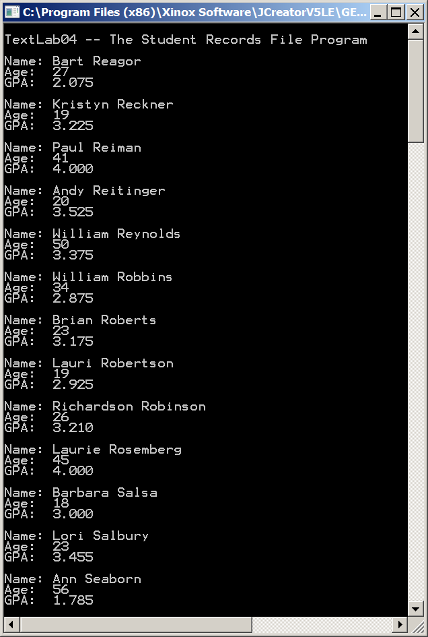 | 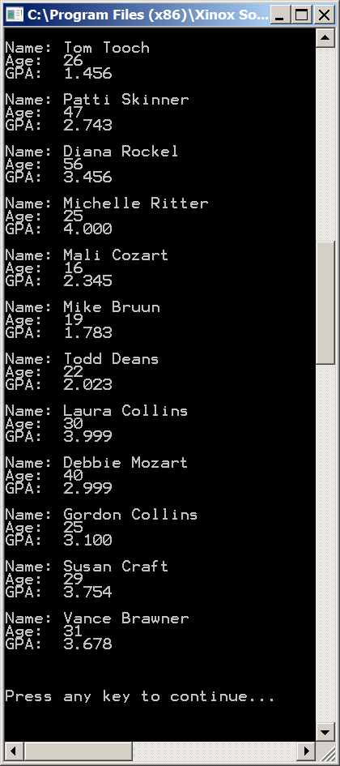
90-Point Version Specifics

The 90-point version requires everything from the 80-point version but adds processing. Your program needs to count the number of records, compute the meanAge and the meanGPA for students. Keep in mind that both age and gpa are retrieved as strings from the text file, and require conversions. Both meanAge and meanGPA need to be displayed rounded off to three digits beyond the decimal point. This can be achieved with the DecimalFormat class and the format method.

90-Point Version Output

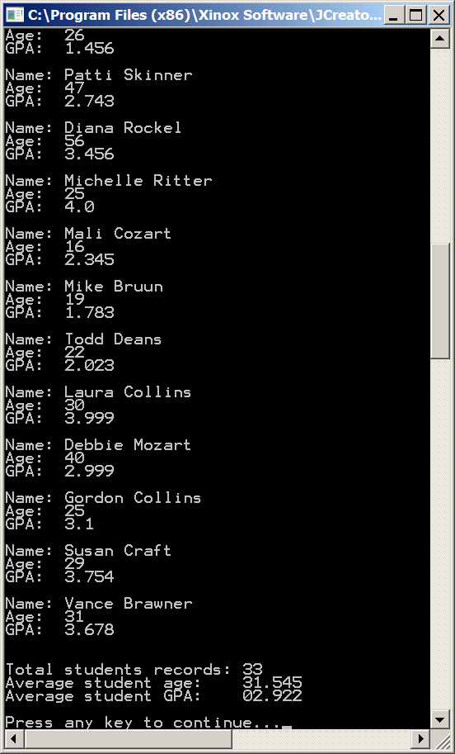

100-Point Version Specifics

The 100-point version requires everything from the 90-point version but adds file writing. Your program needs to create a file called passing.dat and as it reads in each student record, it needs to check if the student is passing (gpa >= 2.0). The name, age, and gpa of each passing student needs to be written to this file on a separate line.

100-Point Version Output
The monitor output of this file is the same as the 90-point version as will not be shown here; however, this program also has file output. When having this version of the program graded, you will need to show the monitor output first, and then show the file output in Notepad.

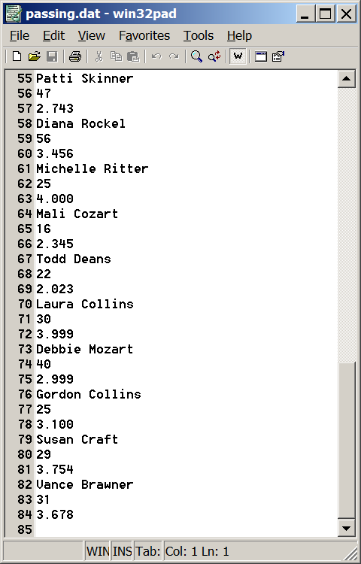

110-Point Version Specifics

The 110-point version requires everything from the 90-point version but also writes to an additional file. In addition to creating a file called passing.dat, you also need to create a file called honors.dat.

Just like passing.dat, as your program reads in each student record, and checks to see if the student is passing (gpa >= 2.0), it also needs to check to see if the student is on the honor roll
(gpa >= 3.75). The name, age, and gpa of each passing student needs to be written to this file on a separate line.

NOTE: All of the students who are written to the honors.dat file will also be written to the passing.dat file.

110-Point Version Output
The monitor output of this file is the same as the 90 and 100-point version as will not be shown here; however, this program also has file output. The file output for passing.dat is the same as the 100-point version and will also not be shown here.

What will be shown is the file output for honors.dat, which is considerable smaller than passing.dat.

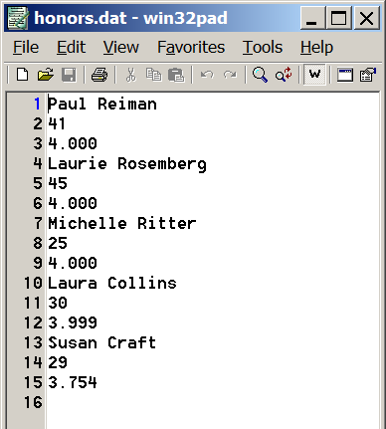

When having this version of the program graded, you will need to show the monitor output first, and then show the file output for both passing.dat and honors.dat in Notepad.

