AP Computer Science II | Java Unit Lab Assignment # 32a
The "Disappearing Squares" Program |  | 80 & 100 Point Versions
Assignment Purpose:

The purpose of this program is to use recursion to draw a set of squares,
which become smaller as they reach the other side of the screen.

Write a program which start by drawing a 200 X 200 square at the top-left corner of the monitor. Continue drawing squares that become steadily smaller as they are displayed to right side of each preceding square. The bottom of the square stays at the same level. Each square is 25 percent smaller than the previously drawn square. Start with the student version, shown below.

Provided Student Program for Lab32a

// Lab32ast.java
// The student version of the Lab32a assignment.

import java.awt.*;
import java.awt.event.*;

public class Lab32ast
{
public static void main(String args[])
{
Windows win = new Windows();
win.setSize(1000,750);
win.addWindowListener(new WindowAdapter() {public void
windowClosing(WindowEvent e) {System.exit(0);}});
win.show();
}
}

class Windows extends Frame
{

}

In the student version you are provided with a completed main method. This method is designed to execute graphics application, which done by completing the Windows class. Make no changes to the main method.

Inside the Windows class, you will need to use a paint method that controls the graphics output with an object of the Graphics class. You will also need to create a method, called drawSquare, which actually draws the squares and calls itself recursively until the base case is reached.

The recursive process exits when it is true that either the square size becomes smaller than four pixels or the border of the monitor is reached. You must be aware that only full-sized squares must be displayed. Keep this in mind as you determine if you are reaching the border of the monitor.

This program may seem very familiar. It is a repeat of Lab Assignment 19b, which you may have done during the first-year course. This assignment is a good practice in preparation for the next assignment, which is quite a bit more challenging.

80 Point Version

The 80 point version draws one set of squares from left to right, starting with a 200X200 square
that is drawn with a top-left corner at coordinate (0,100). Each square is drawn with a 10 pixel space between the squares.

100 Point Version

The 100 point version draws a second set of squares in the same manner as the 80 point version, but this time the large square start on the right side and successive squares are drawn moving to the left side of the screen.

80 Point Execution

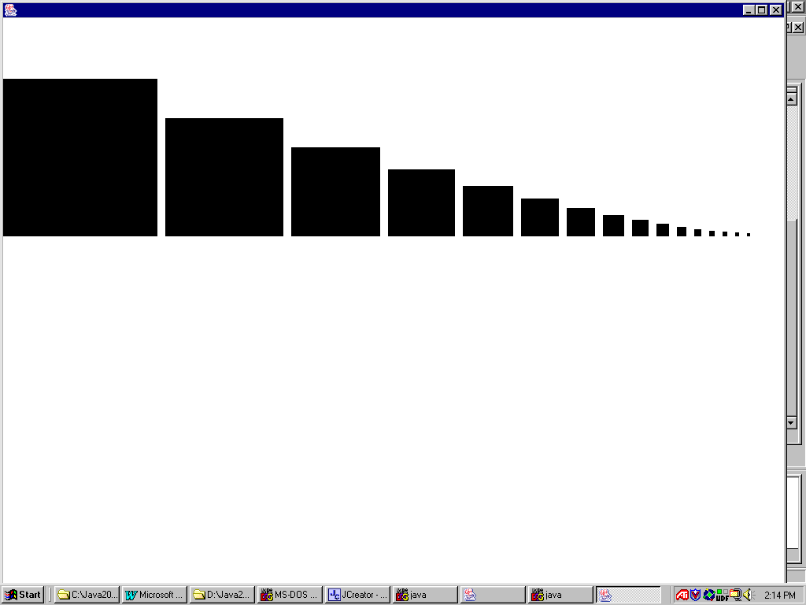

100 Point Execution

