AP Computer Science II | Java Unit Lab Assignment # 33a
The "Graphical Linked List" Program |  | 80 & 100 Point Versions
Assignment Purpose:

The purpose of this program is to demonstrate logical understanding of linked lists,
without yet knowing how to implement any type of linked list class.

Write a program that draws a graphical linked list. You will be drawing a linked list of six nodes. The linked list must be drawn in the sequence that a linked list is formed. For this assignment you will first draw a linked list as a stack for 80 points. For the 100-point version you will make a second drawing that display a linked list drawn as a queue. The graphics display needs to have a time delay so that the sequence of the linked list creation can be viewed.

You will be provided with a special GfxNode class, which is designed to draw linked lists. It is not important that you understand the implementation of the methods in the GfxNode class. Your mission is to know how to use the methods properly. The GfxNode class is shown below, but only the public method headers and comments are provided. Understanding the implementation of the GfxNode class is not necessary for completing this assignment.

GfxNode Public Methods Headers and Comments

// GfxNode constructor instantiates an object and
// stores its Top-Left coordinate (tlx,tly) information, as
// well as the length and width of the node object. A node object
// with two fields is drawn at the specified coordinate.
public GfxNode(Graphics g, int tlx, int tly, char ltr, int clr, int dt)

// Method getColor a private helper method to make it easier to use colors
// in a graphics program.
private Color getColor(int clr)
{
Color temp = Color.white;
switch (clr)
{
case 0: temp = Color.black; break;
case 1: temp = Color.red; break;
case 2: temp = Color.green; break;
case 3: temp = Color.blue; break;
case 4: temp = Color.orange; break;
case 5: temp = Color.cyan; break;
case 6: temp = Color.magenta; break;
case 7: temp = Color.yellow; break;
case 8: temp = Color.pink; break;
case 9: temp = Color.white; break;
}
return temp;
}

// Method getX returns the top-left X-coordinate of a linked list node.
public int getx()

// Method getY returns the top-left Y-coordinate of a linked list node.
public int gety()

// Method drawPointer draws a vertical pointer down to an existing node.
// The first pointer to a node uses OffSet value 1 and the second
// pointer to the same node uses OffSet value 2. The result is that
// the second pointer is moved farther to the right.
public void drawPointer(Graphics g, char ltr, int offSet, int clr)

// Method enterData draws a letter in the Data field of the GfxNode.
public void enterData(Graphics g, char ltr, int clr)

// Method drawLink draws a link from the current sourceNode to the
// endNode in the specified color (clr).
public void drawLink(Graphics g, GfxNode endNode, int clr)

// Method drawNull draws a diagonal g.drawLine in the Next
// field of a list node, to indicate a NULL value.
public void drawNull(Graphics g, int clr)

// Method drawLetter upper-case Letter characters. The characters
// are drawn in a 9x9 pixel box.
// The (x,y) parameters indicate the coordinate of the top-left corner
// of the box. Only capital letters and numbers are drawn.
public void drawLetter(Graphics g, char ltr, int x, int y)

// Method delay allows viewing the sequence in which the linked lists are drawn/
private void delay(double n)

The use of the GfxNode methods is explained in Chapter 33 with a variety of program examples. Make sure that you understand how to use this class before you start the assignment. This program needs to be written as a graphics application program. The student file already has the main method completed. The paint method is also completed. The goal of this assignment revolves around completing the drawStack and drawQueue methods.

80 Point Version

The 80 point version draws only one linked list which is drawn in a stack LIFO manner.

100 Point Version

The 100 point version starts by drawing the stack and then also draws a second linked list that will behave like a queue FIFO.

Provided Student Program for Lab33a

// Lab33ast.java
// This is the student Version of the Lab33a assignment.

import java.awt.*;
import java.awt.event.*;

public class Lab33ast
{
public static void main(String args[])
{
GfxApp gfx = new GfxApp();
gfx.setSize(1000,750);
gfx.addWindowListener(new WindowAdapter() {public void
windowClosing(WindowEvent e) {System.exit(0);}});
gfx.show();
}
}

class GfxApp extends Frame
{

private int td = 200; // time delay to slow down graphics display

public void paint (Graphics g)
{
g.setFont(new Font("ARIAL",Font.BOLD,28));
g.drawString("LAB 33A 80/100 POINT VERSION",300,50);
g.setFont(new Font("ARIAL",Font.BOLD,20));
g.drawString("DRAWING A LINKED LIST AS A STACK",50,215);
// g.drawString("DRAWING A LINKED LIST AS A QUEUE",50,415); // for 100 point version only
drawStack(g);
// drawQueue(g); // for 100 point version only
}

public void drawStack(Graphics g)
{
g.setFont(new Font("ARIAL",Font.BOLD,20));

}

/* for 100 point version only
public void drawQueue(Graphics g)
{

}
*/

}

80 Point Execution

In the 80-point, as well as the 100-point execution you will only see the finished display on hardcopy. Make sure that you select a sufficient delay-time to demonstrate the sequence of the linked list creation. It is not sufficient that your final picture matches the pictures that follow. The essence of this assignment is that you demonstrate knowledge of the proper step sequence of creating linked lists as a stack and for 100 points as a queue as well.

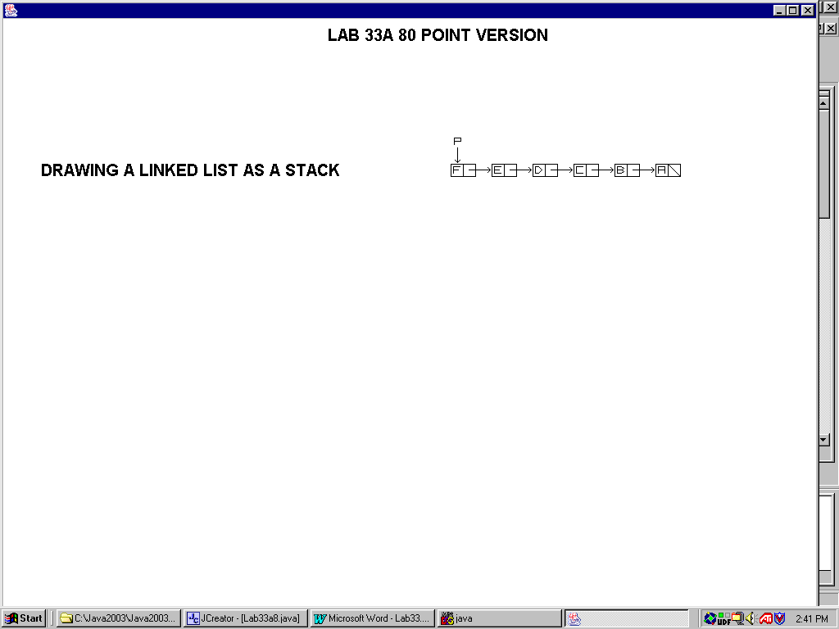

100 Point Execution

