AP Computer Science II | Java Lab Assignment # 35b
The Binary Expression Tree Evaluation Program | 80, 90 & 100 Point Versions
Assignment Purpose:

The purpose of this program is to demonstrate logical understanding of Binary Trees and Tree Traversal.

Write a program that will traverse and evaluate the following binary expression tree:

*
+
7
/
^
5
-
Root
12
3
2
4

You are not concerned with the creation of the binary expression tree. That part is done for you.

Provided Student Program for Lab35B

// Lab35bst.java
// The Binary Expression Tree Evaluation Program
// Student Version

import java.io.*;
import java.util.*;
import java.text.DecimalFormat;

public class Lab35bst
{
public static void main(String args[]) throws IOException
{
ExpressionNode root = ExpressionTree.createTree();

System.out.println("Original Tree");
System.out.println("=============");
System.out.print("\nIn-Fix Notation: ");
ExpressionTree.inOrderTraverse(root);
System.out.print("\n\nPre-Fix Notation: ");
ExpressionTree.preOrderTraverse(root);
System.out.print("\n\nPost-Fix Notation: ");
ExpressionTree.postOrderTraverse(root);
System.out.println("\n");

System.out.println("This tree has "+
ExpressionTree.operatorCount(root)+" operators and "+
ExpressionTree.numberCount(root)+" numbers, and evaluates to "+
ExpressionTree.evaluate(root)+"\n\n");

// ExpressionNode mirrorRoot = ExpressionTree.mirror(root);
//
// System.out.println("\nMirror Tree");
// System.out.println("===========");
// System.out.print("\nIn-Fix Notation: ");
// ExpressionTree.inOrderTraverse(mirrorRoot);
// System.out.print("\n\nPre-Fix Notation: ");
// ExpressionTree.preOrderTraverse(mirrorRoot);
// System.out.print("\n\nPost-Fix Notation: ");
// ExpressionTree.postOrderTraverse(mirrorRoot);
// System.out.println("\n");

// System.out.println("This tree has "+
// ExpressionTree.operatorCount(mirrorRoot)+" operators and "+
// ExpressionTree.numberCount(mirrorRoot)+" numbers, and evaluates to "+
// ExpressionTree.evaluate(mirrorRoot)+"\n");
}
}

class ExpressionNode
{
public ExpressionNode(double initNum, char initOpr, ExpressionNode initLeft, ExpressionNode initRight)
{
num = initNum;
opr = initOpr;
left = initLeft;
right = initRight;
}

public double getNum() { return num; }
public char getOpr() { return opr; }
public ExpressionNode getLeft() { return left; }
public ExpressionNode getRight() { return right; }
public void setNum(int theNewNum) { num = theNewNum; }
public void setOpr(char theNewOpr) { opr = theNewOpr; }
public void setLeft(ExpressionNode theNewLeft) { left = theNewLeft; }
public void setRight(ExpressionNode theNewRight) { right = theNewRight; }

private double num;
private char opr;
private ExpressionNode left;
private ExpressionNode right;
}

class ExpressionTree
{
public static ExpressionNode createTree()
{
ExpressionNode n12 = new ExpressionNode(12,' ',null,null);
ExpressionNode n6 = new ExpressionNode( 6,' ',null,null);
ExpressionNode ndiv = new ExpressionNode( 0,'/',n12,n6);
ExpressionNode n7 = new ExpressionNode( 7,' ',null,null);
ExpressionNode nadd = new ExpressionNode( 0,'+',n7,ndiv);
ExpressionNode n2 = new ExpressionNode( 2,' ',null,null);
ExpressionNode n4 = new ExpressionNode( 4,' ',null,null);
ExpressionNode ncar = new ExpressionNode( 0,'^',n2,n4);
ExpressionNode n5 = new ExpressionNode( 5,' ',null,null);
ExpressionNode nsub = new ExpressionNode( 0,'-',ncar,n5);
ExpressionNode root = new ExpressionNode( 0,'*',nadd,nsub);
return root;
}

public static void inOrderTraverse (ExpressionNode p)
{

}

public static void preOrderTraverse (ExpressionNode p)
{

}

public static void postOrderTraverse (ExpressionNode p)
{

}

public static int numberCount (ExpressionNode p)
{

}

public static int operatorCount (ExpressionNode p)
{

}

public static double evaluate (ExpressionNode p)
{

}

// public static ExpressionNode mirror(ExpressionNode p)
// {

// }
}

80 Point Version Specifics

The 80-point version requires the completion of the 3 traversal methods, 2 counting methods, and the evaluate method. NOTE: The in-order traversal is does not show any parentheses.

80 Point Version Output

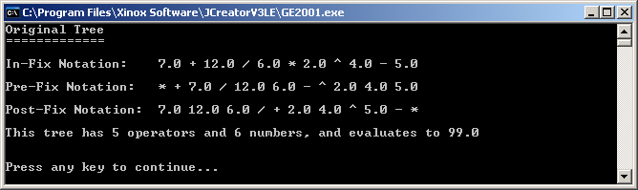

90 Point Version Specifics

The 90-point version is almost identical to the 80-point version. If you look at the In-Fix Notation output in the 80 point version, and used order of operations (PEMDAS) to solve it, you would get an answer of 34 and not 99. The problem is that the parentheses are missing. The 90-point version requires that the inOrderTraverse method is improved to show properly placed parentheses.

90 Point Version Output

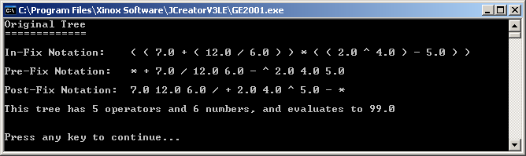

100 Point Version Specifics

The 100-point version adds the mirror method which will create a mirror image of the original binary expression tree. Then this tree is traversed, counted, and evaluated just like the original.

100 Point Version Output

