AP Computer Science II | Java Lab Assignment # 30a
The "Screen Saver" Program | 80 & 100 Point Versions
Assignment Purpose:

Demonstrate knowledge of the queue ADT. For this assignment you will write a program with using Java's Queue class. Without knowledge or even concern for the implementation of this queue class, write the specified program.

You will be provided a Circle class. The program needs to be extended to behave like a screen saver. You need to write a program that draws circles that will erase themselves after a certain number of circles are displayed. This is an ideal problem for a queue data structure. Every set of circle's top-left coordinates needs to be stored in a Queue object. After 50 circles are drawn the coordinates must be dequeued and the previous circles need to be erased. This assignment requires the graphics display to be implemented as a GUI application, not an applet.

Three methods eraseCircle, getTLX and getTLY need to be added to the provided Circle class. Each method is shown below with a brief description.

public void eraseCircle(int x, int y)
// erases the circle, which is drawn with top-left coordinate at (x,y)

public int getTLX()
// returns the value of the top-left corner X-value of the current circle drawn

public int getTLY()
// returns the value of the top-left corner Y-value of the current circle drawn

The provided Queue class uses queue elements that are objects. You need to create a small Coord class which stores x and y coordinate values. Objects of this Coord class need to be enQueued on the queue as each circle is drawn.

The provided student file, Lab30st.java, is functional. You need to do more than add three methods to the Circle class. You also need to add program statements to the paint method, inside the GfxApp class to use the Queue class in such a way that it becomes a screensaver and erases circles in a FIFO manner.

Lab30st.java Provided Student File
// Lab30st.java
// The Screen Saver Program
// Student Version

import java.awt.*;
import java.awt.event.*;
import java.applet.*;
import javax.swing.JOptionPane;

public class Lab30st
{
public static void main(String args[])
{
GfxApp gfx = new GfxApp();
gfx.setSize(800,600);
gfx.addWindowListener(new WindowAdapter() {public void
windowClosing(WindowEvent e) {System.exit(0);}});
gfx.show();
}
}

class GfxApp extends Frame
{

private int circleCount, circleSize;

public GfxApp()
{
circleCount = 50;
circleSize = 30;
}

class Coord
{
private int xPos;
private int yPos;

public Coord(int x, int y)
{
xPos = x;
yPos = y;
}
}

public void paint(Graphics g)
{
int incX = 5;
int incY = 5;
int diameter = 30;
int timeDelay = 10;
Circle c = new Circle(g,diameter,incX,incY,timeDelay);
for (int k = 1; k <= 2000; k++)
{
c.drawCircle(g);
c.hitEdge();
}

}
}

class Circle
{
private int tlX; // top-left X coordinate
private int tlY; // top-left Y coordinate
private int incX; // increment movement of X coordinate
private int incY; // increment movement of Y coordinate
private boolean addX; // flag to determine add/subtract of increment for X
private boolean addY; // flag to determine add/subtract of increment for Y
private int size; // diameter of the circle
private int timeDelay; // time delay until next circle is drawn

public Circle(Graphics g, int s, int x, int y, int td)
{
incX = x;
incY = y;
size = s;
addX = true;
addY = false;
tlX = 400;
tlY = 300;
timeDelay = td;
}

public void delay(int n)
{
long startDelay = System.currentTimeMillis();
long endDelay = 0;
while (endDelay - startDelay < n)
endDelay = System.currentTimeMillis();
}

public void drawCircle(Graphics g)
{
g.setColor(Color.blue);
g.drawOval(tlX,tlY,size,size);
delay(timeDelay);
if (addX)
tlX+=incX;
else
tlX-=incX;
if (addY)
tlY+=incY;
else
tlY-=incY;
}

public void newData()
{
incX = (int) Math.round(Math.random() * 7 + 5);
incY = (int) Math.round(Math.random() * 7 + 5);
}

public void hitEdge()
{
boolean flag = false;
if (tlX < incX)
{
addX = true;
flag = true;
}
if (tlX > 800 - (30 + incX))
{
addX = false;
flag = true;
}
if (tlY < incY + 30) // The +30 is due to the fact that the title bar covers the top 30 pixels of the window
{
addY = true;
flag = true;
}
if (tlY > 600 - (30 + incY))
{
addY = false;
flag = true;
}
if (flag)
newData();
}

}

The student provided file draws 2000 circles in a unique pattern. No circles are erased. All circles have a diameter of 30 pixels.

Student Version Output when execution finishes...)

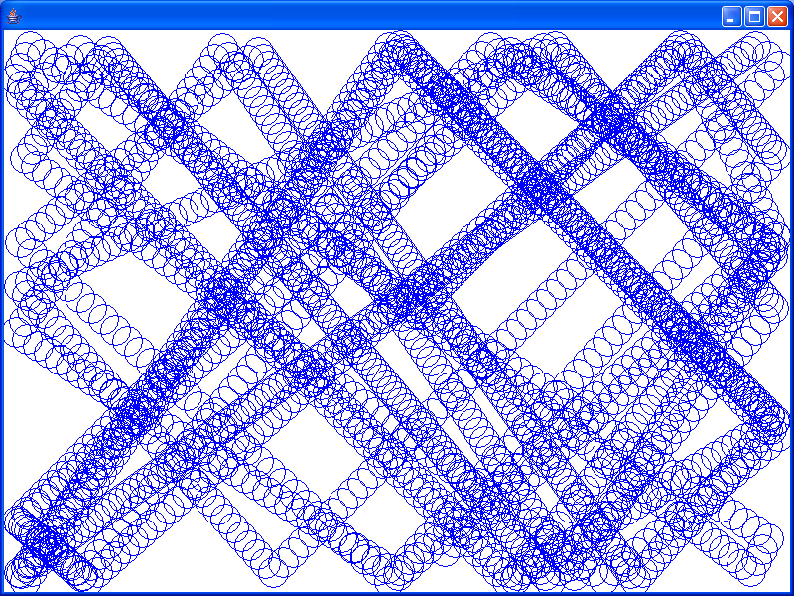

80-Point Version Specifics

The 80-point version displays a screen saver with 2000 circles, which start to erase themselves after 50 circles are displayed. There are never more than 50 circles on the screen. When the program stops, the last 50 circles are still displayed.

80-Point Version Output

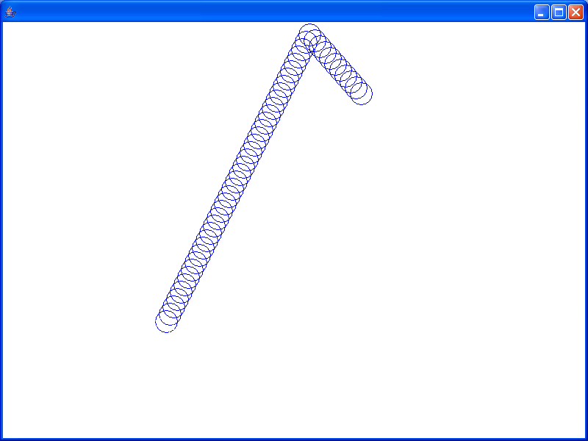

100-Point Version Specifics

The 100-point version requires the user to use 2 JOptionPane windows to enter the number of circles to be displayed at a time (circleCount) and the diameter of the circle (circleSize). These values are sent to an altered constructor of the GfxApp class. Since the diameter of the circles will not always be the same, one or more methods will need to be altered to adjust for this.

100-Point Version Output #1

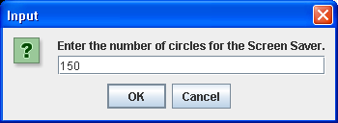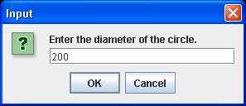

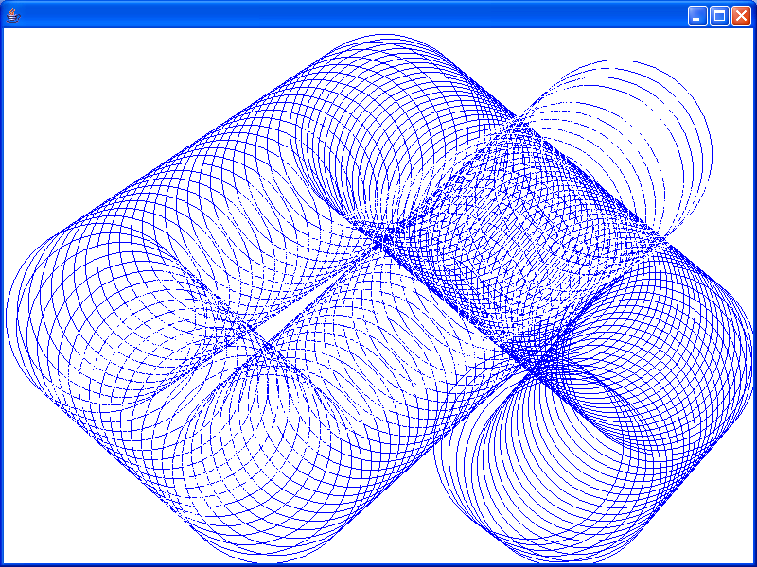
100-Point Version Output #2

