AP Computer Science II | Java Keyword Lab Assignment # 24a
The Polygon Program |  | 80 & 100 Point Versions
Assignment Purpose:

Create a polygon class, which encapsulates all the necessary attributes and
actions to draw regular polygons of a requested number of sides. The essence of this assignment is to demonstrate the ability to create a practical class.

Write a program, which uses a RegPoly (RegularPolygon) class to draw regular polygons. The class requires the following data and methods:

RegPoly class attributes:

radius of the circle
center X-coordinate
center Y-coordinate
Number of points or sides of the polygon
Array of x-coordinates
Array of y-coordinates

RegPoly class methods:

RegPoly constructor with parameters for centerX, centerY, radius and points
drawPoly method to draw the appropriate regular polygon with a Graphics class parameter

The provided student file for Lab24a is a classic example of a starting file. Your program is meant to focus on the creating of a regular polygon class. The graphics output is a graphics application, which requires an uncomfortable looking main method. The details of the main method are not the issue for this assignment. For that reason the entire main method is provided and you need to use it exactly as provided without making any changes whatsoever.

The only possible exception is that you may want to alter the size of the graphics output window. Right now the main methods sets that size to 900x700. Those window size values, and only those values, you can alter. Leave everything else completely intact.

// Lab24ast.java
// This is the student version of the lab 24a assignment.

import java.awt.*;
import java.awt.event.*;

public class Lab24ast
{
public static void main(String args[])
{
GfxApp gfx = new GfxApp();
gfx.setSize(900,700);
gfx.addWindowListener(new WindowAdapter() {public void
windowClosing(WindowEvent e) {System.exit(0);}});
gfx.show();
}
}

class GfxApp extends Frame
{
public void paint(Graphics g)
{

}
}

class RegPoly
{

}

80 Point Version

The 80-point version needs to draw one blue solid octagon with the following values:

centerX: 400
centerY: 300
radius: 150
points: 8

80 Point Version Execution

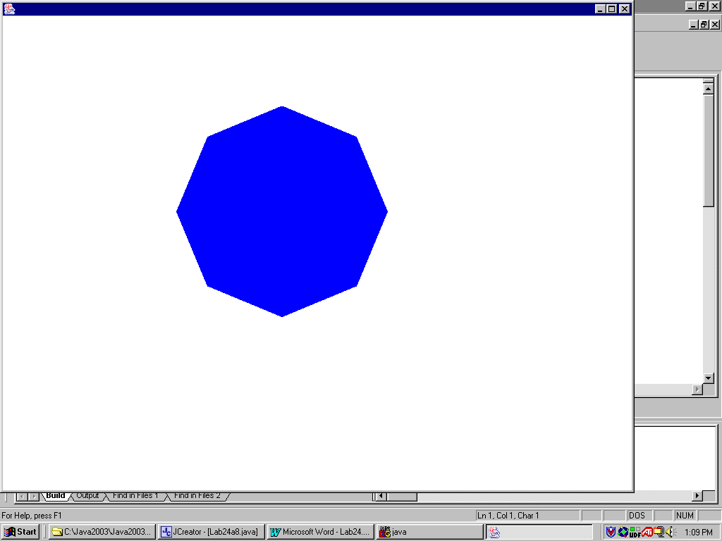

100 Point Version

The 100-point version needs to draw six regular polygons. Each polygon has a radius of 60 and every polygon is displayed on a diagonal from the top-left corner to the bottom-right corner. The first polygon is a triangle and the last polygon is an octagon.

100 Point Version Execution

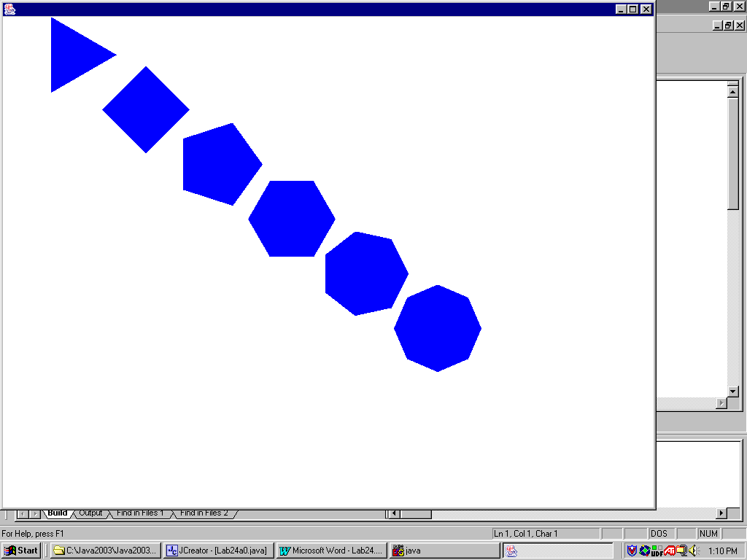

AP Computer Science II | Java Unit Lab Assignment # 24b
The Circle Class Program |  | 80 & 100 Point Versions
Assignment Purpose:

Continue to demonstrate an understanding of encapsulation by creating a Circle class with a large number of attributes and methods to manipulate circle movement.

Write a program, which uses a Circle class to create applets that displays circles in various patterns. There is a major difference between the 80-point and 100-point Circle class.

80 Point Version

The 80-point version displays a two-dimensional array of blue circles diameter size 30. The applet needs to display the circles being drawn in sequence by intentionally delaying the display of each circle. A special Delay method needs to be used, which is shown below. The Circle class of this version has a limited number of attributes and methods, which include:

Circle class attributes:

topleft X-coordinate of the circle box
topleft Y-coordinate of the circle box
diameter of the circle or the size of the circle box
time Delay used by the Delay method

Circle class methods:

Circle constructor using size and timeDelay parameters

private void delay(double n)
{
for (double k = 1; k < n; k+=0.001);
}

setTLX method to alter the topleft X-coordinate

setTLY method to alter the topleft Y-coordinate

drawCircle method using one Graphics parameter to draw a circle with attribute information

The student provided file for the Lab24b assignment is very to the one provided for Lab24a. Once again you have the "hands off" main method. You primary concern is to create the Circle class according to the specifications.

// Lab24bst.java
// This is the student version of the lab24b assignment.

import java.awt.*;
import java.awt.event.*;

public class Lab24bst
{

public static void main(String args[])
{
GfxApp gfx = new GfxApp();
gfx.setSize(900,700);
gfx.addWindowListener(new WindowAdapter() {public void
windowClosing(WindowEvent e) {System.exit(0);}});
gfx.show();
}

}

class GfxApp extends Frame
{
public void paint(Graphics g)
{

}
}

class Circle
{

}

80 Point Version Execution

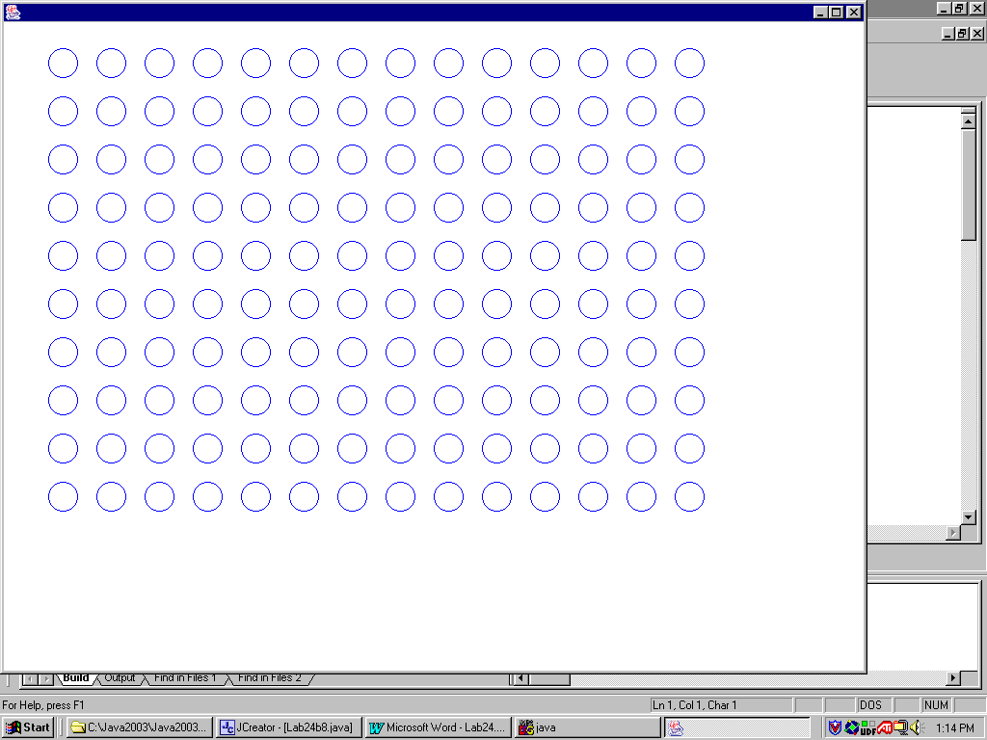

100 Point Version

The 100-point version is considerably more sophisticated than the 80-point version. 1000 Circles need to be drawn starting in the center of the window and then bounce through the window with straight lines. Each time that the border of the window is reached the circles change direction and travel in a new random direction. Every circle is blue and has the same diameter of 30. The Circle class uses the following attributes and methods:

Circle class attributes:

topleft X coordinate of the circle box
topleft Y coordinate of the circle box
incX increment movement of X coordinate
incY increment movement of Y coordinate
addX boolean flag to determine add/subtract of increment for X
addY boolean flag to determine add/subtract of increment for Y
size or diameter of the circle
timeDelay time delay until next circle is drawn

Circle class methods:

Circle constructor, which uses size, incX, incY and timeDelay parameters

private void delay(double n)
{
for (double k = 1; k < n; k+=0.001);
}

drawCircle uses one Graphics parameter and draw a circle based on attribute information and also
alter the tlX and tlY values to set the information for the next circle

setTLX method to alter the topleft X-coordinate

setTLY method to alter the topleft Y-coordinate

newData randomly alter the incX and incY attributes to a value in the [5..12] range

hitEdge determines if a circle has reached the window boundary, and then alters the
appropriate addX or addY value as well as call the newData method.

100 Point Version Execution

