AP Computer Science II | Java Unit Lab Assignment # 24b
The Circle Class Program |  | 80 & 100 Point Versions
Assignment Purpose:

Continue to demonstrate an understanding of encapsulation by creating a Circle class with a large number of attributes and methods to manipulate circle movement.

Write a program, which uses a Circle class to create applets that displays circles in various patterns. There is a major difference between the 80-point and 100-point Circle class.

80 Point Version

The 80-point version displays a two-dimensional array of blue circles diameter size 30. The applet needs to display the circles being drawn in sequence by intentionally delaying the display of each circle. A special Delay method needs to be used, which is shown below. The Circle class of this version has a limited number of attributes and methods, which include:

Circle class attributes:

topleft X-coordinate of the circle box
topleft Y-coordinate of the circle box
diameter of the circle or the size of the circle box
time Delay used by the Delay method

Circle class methods:

Circle constructor using size and timeDelay parameters

private void delay(double n)
{
for (double k = 1; k < n; k+=0.001);
}

setTLX method to alter the topleft X-coordinate

setTLY method to alter the topleft Y-coordinate

drawCircle method using one Graphics parameter to draw a circle with attribute information

The student provided file for the Lab24b assignment is very to the one provided for Lab24a. Once again you have the "hands off" main method. You primary concern is to create the Circle class according to the specifications.

// Lab24bst.java
// This is the student version of the lab24b assignment.

import java.awt.*;
import java.awt.event.*;

public class Lab24bst
{

public static void main(String args[])
{
GfxApp gfx = new GfxApp();
gfx.setSize(900,700);
gfx.addWindowListener(new WindowAdapter() {public void
windowClosing(WindowEvent e) {System.exit(0);}});
gfx.show();
}

}

class GfxApp extends Frame
{
public void paint(Graphics g)
{

}
}

class Circle
{

}

80 Point Version Execution

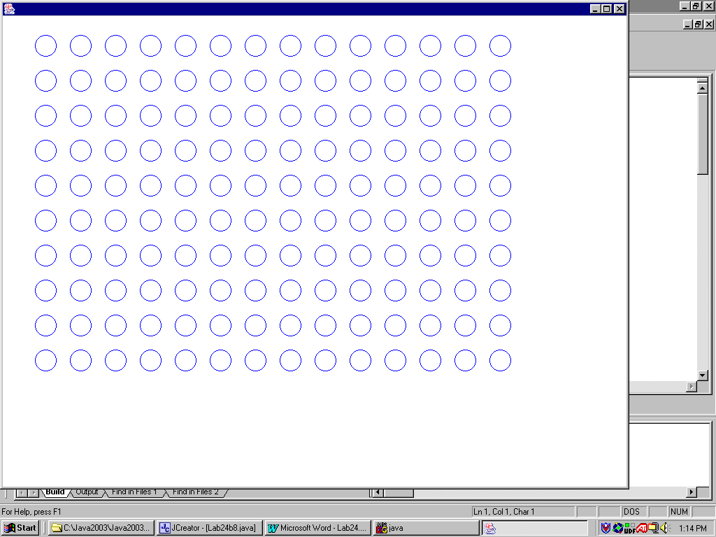

100 Point Version

The 100-point version is considerably more sophisticated than the 80-point version. 1000 Circles need to be drawn starting in the center of the window and then bounce through the window with straight lines. Each time that the border of the window is reached the circles change direction and travel in a new random direction. Every circle is blue and has the same diameter of 30. The Circle class uses the following attributes and methods:

Circle class attributes:

topleft X coordinate of the circle box
topleft Y coordinate of the circle box
incX increment movement of X coordinate
incY increment movement of Y coordinate
addX boolean flag to determine add/subtract of increment for X
addY boolean flag to determine add/subtract of increment for Y
size or diameter of the circle
timeDelay time delay until next circle is drawn

Circle class methods:

Circle constructor, which uses size, incX, incY and timeDelay parameters

private void delay(double n)
{
for (double k = 1; k < n; k+=0.001);
}

drawCircle uses one Graphics parameter and draw a circle based on attribute information and also
alter the tlX and tlY values to set the information for the next circle

setTLX method to alter the topleft X-coordinate

setTLY method to alter the topleft Y-coordinate

newData randomly alter the incX and incY attributes to a value in the [5..12] range

hitEdge determines if a circle has reached the window boundary, and then alters the
appropriate addX or addY value as well as call the newData method.

100 Point Version Execution

