Information: Record Deletions:
line 23 contained 5 spaces in the center of the "email" field, reading "vbe_____nchl@narod.ru"
line 4929 had no data, consisting only of 10 commas
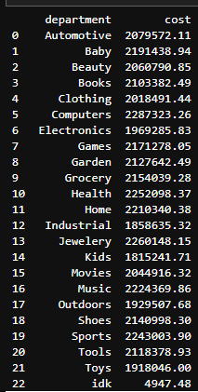
line 7320: additional column following "ip" field, with text "agan", shifting following columns to the right, and adding an additional column
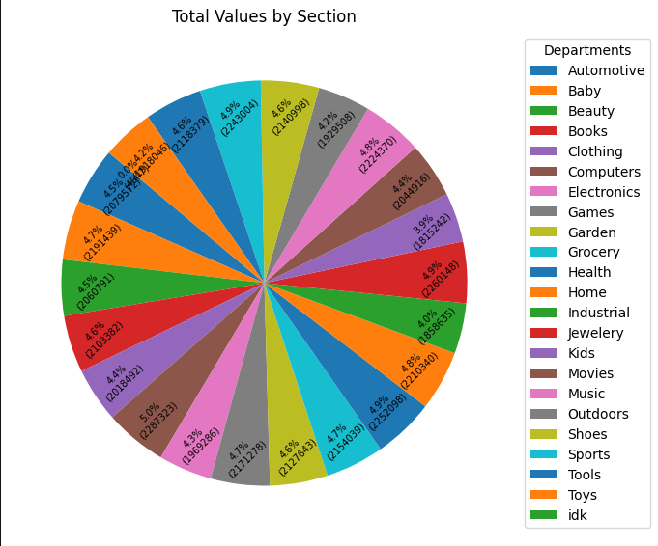
Department Spending:

Top/Bottom Departments
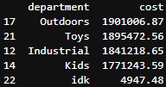
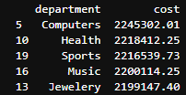

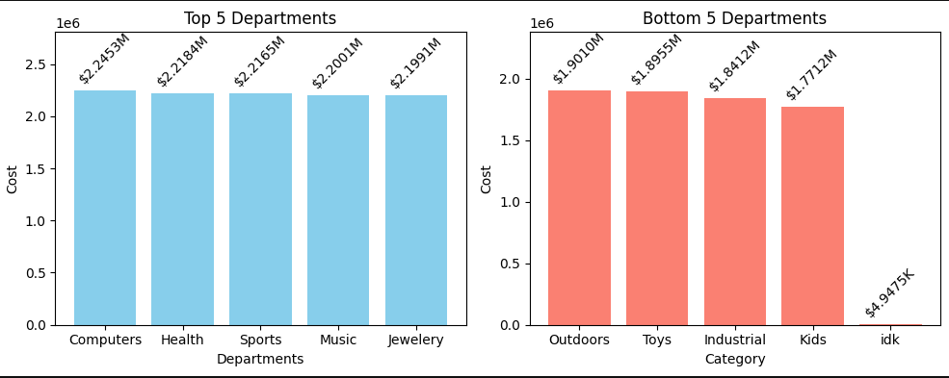

Cleaning Data:
Removes records in which the IP address begins with “0”,”192”,”127”, or “255”, as these represent
fake purchases.
Each record has too many variables to be shown well completely in a table, so it will not be shown
here, however it is shown in the notebook file.
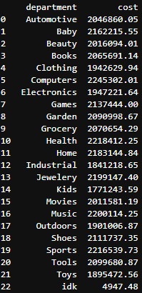
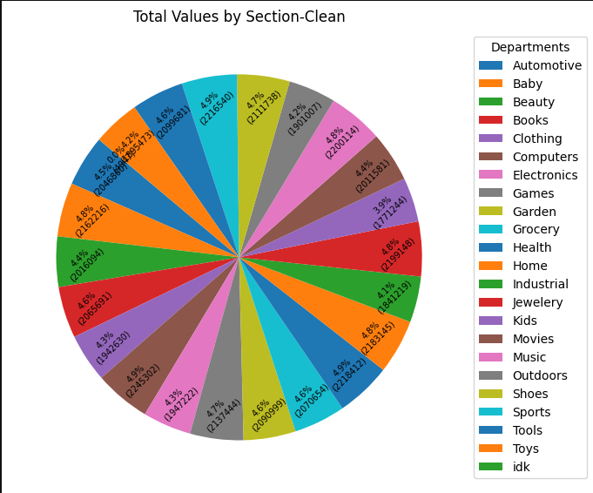
Rerun Department Spending and Top/Bottom Spending:
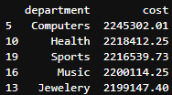
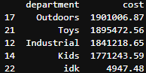

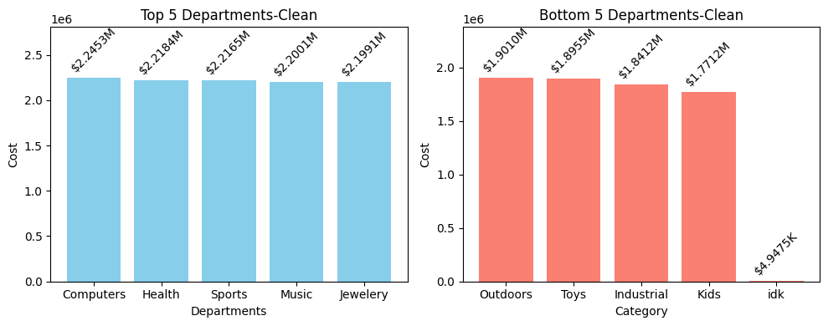
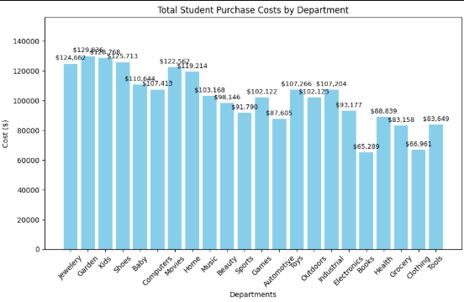
Student Purchases
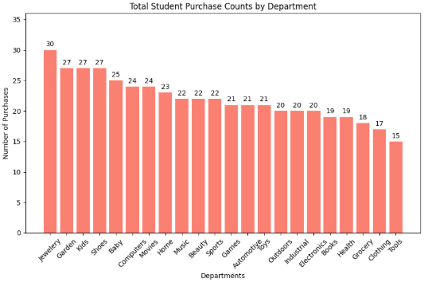
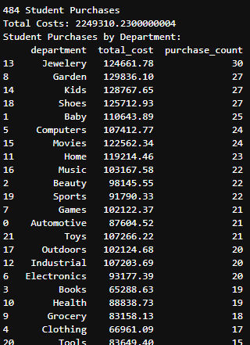

Credit Card Analysis
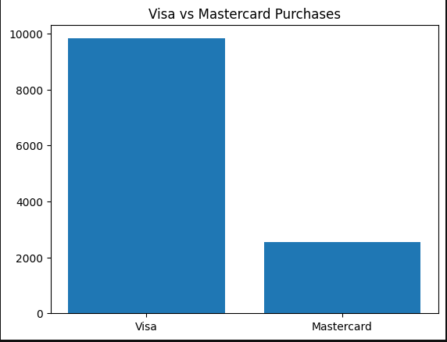

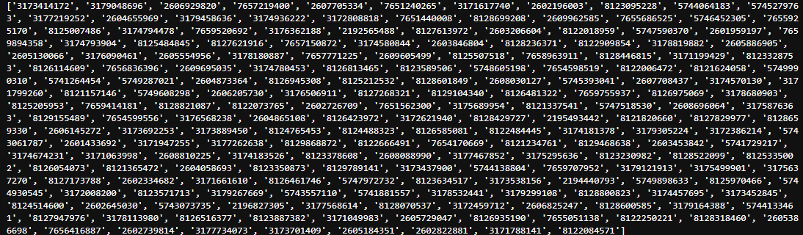
Targeted Survey
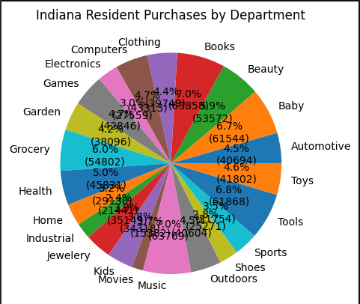
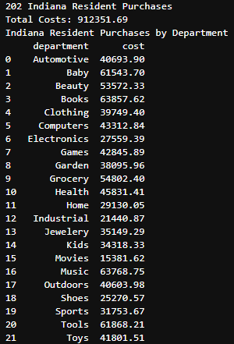

Top Purchasers
