Basic Nonlinear

Ethan Stuart

3/28/2018

## Theory HW Fx expansions I  
crops <- read.table(header=FALSE,text='  
4 3  
1 2  
8 5  
3 3  
3 1  
5 4  
6 5  
3 2  
2 1  
3 4  
')  
names(crops)<- c("Yield","Handlines")  
plot(crops$Handlines,crops$Yield) # Wow! Curvature!

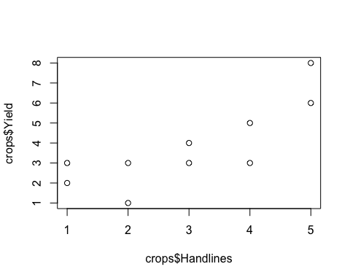

#2  
bigx <- matrix(c(  
 1,3,9,  
 1,2,4,  
 1,5,25,  
 1,3,9,  
 1,1,1,  
 1,4,16,  
 1,5,25,  
 1,2,4,  
 1,1,1,  
 1,4,16),ncol=3,byrow=TRUE)  
bigy <- matrix(crops$Yield,ncol=1,byrow=T)  
#3  
(BETAs <-solve(t(bigx)%*%bigx)%*%t(bigx)%*%bigy)

## [,1]  
## [1,] 3.5000000  
## [2,] -1.4714286  
## [3,] 0.4285714

#4  
n <- 10  
(ssquared <-(1/(n-3))*t(bigy-bigx%*%BETAs)%*%(bigy-bigx%*%BETAs))

## [,1]  
## [1,] 1.179592

#5  
out1 <- lm(Yield~Handlines+I(Handlines^2),data=crops,x=TRUE,se.fit=TRUE)

## Warning: In lm.fit(x, y, offset = offset, singular.ok = singular.ok, ...) :  
## extra argument 'se.fit' will be disregarded

out1$x

## (Intercept) Handlines I(Handlines^2)  
## 1 1 3 9  
## 2 1 2 4  
## 3 1 5 25  
## 4 1 3 9  
## 5 1 1 1  
## 6 1 4 16  
## 7 1 5 25  
## 8 1 2 4  
## 9 1 1 1  
## 10 1 4 16  
## attr(,"assign")  
## [1] 0 1 2

t(bigy-out1$x%*%out1$coefficients)%*%(bigy-out1$x%*%out1$coefficients)

## [,1]  
## [1,] 8.257143

out.reduced <- lm(Yield~Handlines, data=crops,x=TRUE)  
out.reduced$x

## (Intercept) Handlines  
## 1 1 3  
## 2 1 2  
## 3 1 5  
## 4 1 3  
## 5 1 1  
## 6 1 4  
## 7 1 5  
## 8 1 2  
## 9 1 1  
## 10 1 4  
## attr(,"assign")  
## [1] 0 1

t(bigy-out.reduced$x%*%out.reduced$coefficients)%*%(bigy-out.reduced$x%*%out.reduced$coefficients)

## [,1]  
## [1,] 13.4

anova(out1,out.reduced)

## Analysis of Variance Table  
##   
## Model 1: Yield ~ Handlines + I(Handlines^2)  
## Model 2: Yield ~ Handlines  
## Res.Df RSS Df Sum of Sq F Pr(>F)   
## 1 7 8.2571   
## 2 8 13.4000 -1 -5.1429 4.3599 0.07519 .  
## ---  
## Signif. codes: 0 '***' 0.001 '**' 0.01 '*' 0.05 '.' 0.1 ' ' 1

#Fstat=4.360. Pval=.07519.

Part 2

#6  
url <- "http://grimshawville.byu.edu/NFLinSLC.txt" #accessed 3/28/2018  
nfl <- read.csv(url)  
out.nfl <- lm(Audience~TotalPoints+I(TotalPoints^2)+I(TotalPoints^3)+I(TotalPoints^4)+I(TotalPoints^5)+I(TotalPoints^6),data=nfl,x=TRUE)  
median(abs(predict(out.nfl))) #61.808

## [1] 61.80776

library(car)

## Warning: package 'car' was built under R version 3.4.3

library(MASS)  
library(splines)  
#7  
out.nfl.ns <- lm(Audience~ns(TotalPoints,3),data=nfl)   
median(abs(predict(out.nfl.ns))) #63.123

## [1] 63.12295

x.star <- seq(25,65,length.out = 1001)  
yhat <- predict(out.nfl,newdata=data.frame(TotalPoints=x.star))  
yhat.ns <- predict(out.nfl.ns,newdata=data.frame(TotalPoints=x.star))  
  
plot(Audience~TotalPoints,data=nfl,xlim=c(25,65))  
lines(x.star,yhat.ns,col="sienna")  
lines(x.star,yhat,col="royalblue4",type="l")  
  
legend("topleft",legend=c("Data","Polynomial","Splines"),col=c("black","royalblue4","sienna"),pch=c(1,NA,NA),lty=c(NA,1,1))

