HW_8 - Binary Search Tree (BST)

(1). Given the following BST, apply preorder, inorder, and postorder traversal.
- Write the nodes visited below.

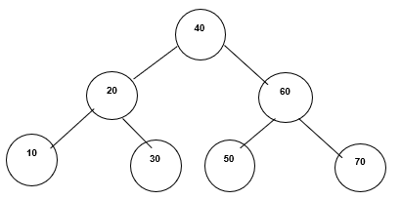

Preorder - ____________________________

Inorder - _____________________________

Postorder - ___________________________

______________________________________________________________________

(2). Create a Binary Search Tree by inserting these values:
Jan, Feb, Mar, Apr, May, June, July, Aug, Sept, Oct, Nov, Dec

- Insert in the order shown, i.e., insert Jan first, then Feb, etc.
- Before inserting, assign a value (1 – 12) to each month based on alphabetical order
of the first letter.
- Then insert according to the assigned value.

Ex. Apr = 1, because A is the lowest alphabetically, and Aug = 2, etc.

Draw the tree here

(3). Draw a Binary Search Tree (BST) whose preorder traversal produced:

40, 20, 10, 30, 70, 60, 50 and, inorder traversal produced: 10, 20, 30, 40, 50, 60, 70

Draw the tree here

4.) Traversing a binary tree using a recursive function

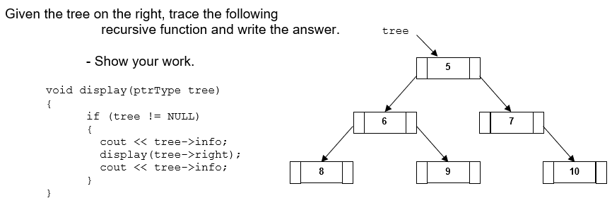

Trace – Show the output:

5.) Traversing a binary tree using a recursive function

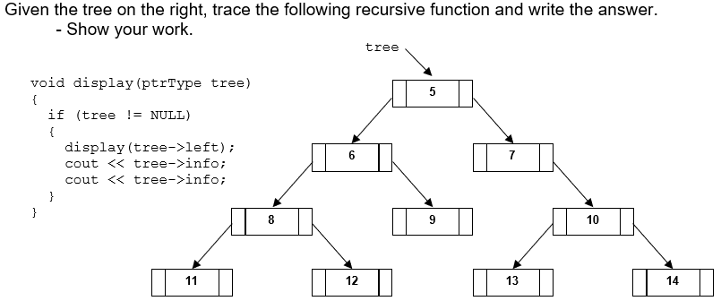

Trace – Show the output:

HW_8b - Binary Search Tree (BST)

- Enter and run the BST code in Lecture 8

- Lecture 8 has the code for a class BST. One of the functions is missing the body. Complete the countNodes() function to count the number of nodes in the BST.
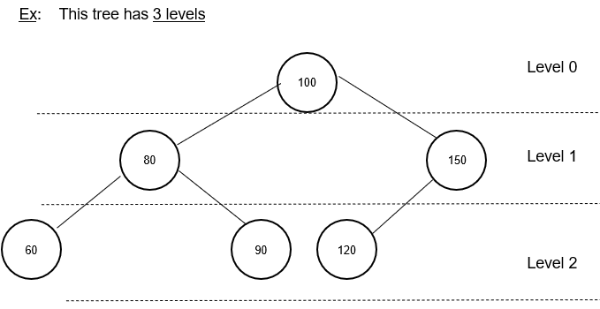

Write the code for the countNodes() function:
__________________________________________

__________________________________________

__________________________________________

__________________________________________

__________________________________________

__________________________________________

__________________________________________

__________________________________________

__________________________________________

__________________________________________

__________________________________________

__________________________________________

__________________________________________

__________________________________________

__________________________________________

__________________________________________

__________________________________________

__________________________________________

Classroom: Staple all parts together and submit at the beginning of the next class.

Online class SUBMIT all parts ON CANVAS - CHECK CANVAS FOR THE DEADLINE

