HW_9

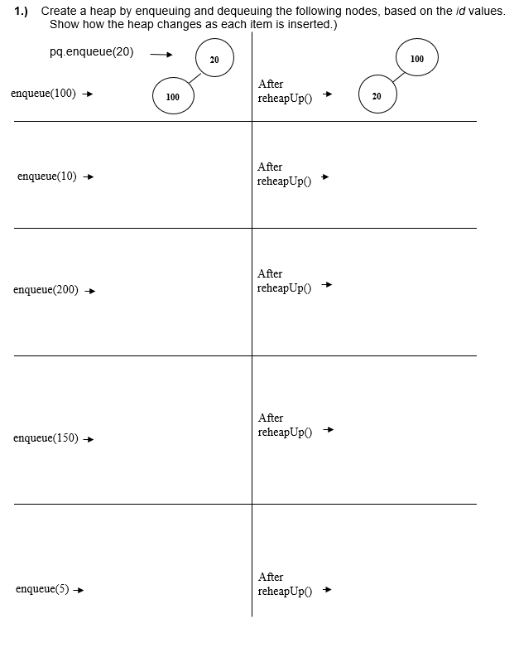

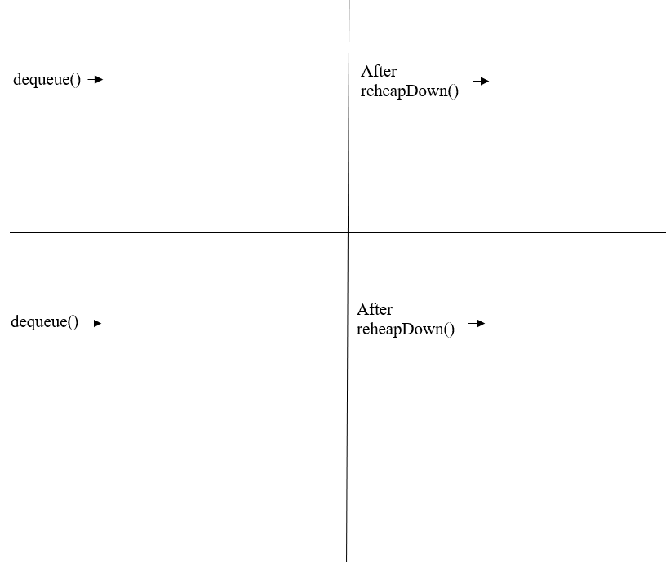

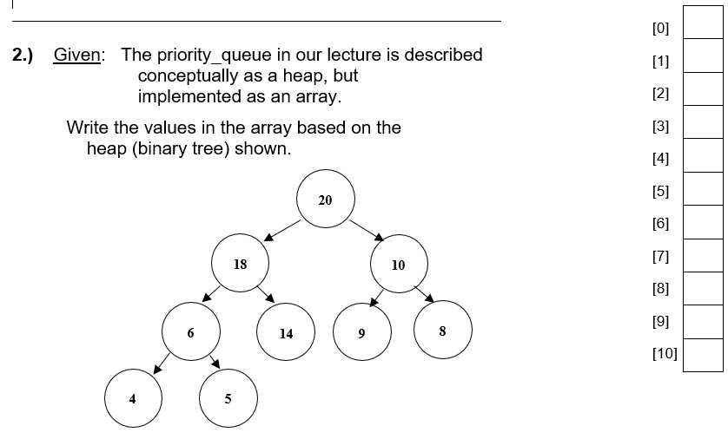

3.) In a few sentences, describe the heap Order Property.

4.) In a few sentences, describe the heap Shape Property.

5.) Referring to the priority queue discussed in our lecture ….
If the array index of a node is 10,

What is the index of its left child: Answer

What is the index of its right child: Answer

Classroom: Staple all parts together and submit at the beginning of the next class.

Online class SUBMIT all parts ON CANVAS - CHECK CANVAS FOR THE DEADLINE

