Lecture 10 - Graphs, Sets and STL set

Graphs

Graph Definitions:

- Graph - A data structure that consists of a set of nodes and a set of edges that relate the
nodes to each other.
  - Node - A node can point to more than two nodes, and can be pointed to by more
than one node (Unlike a binary tree).

  - Vertex - A node in a graph is called a vertex.

  - Edge - A connection between two vertices (nodes) in a graph, and specified by listing the pair of vertices.

- Undirected graph - A graph in which the edges have no direction.

- Directed graph (digraph) - A graph in which each edge is directed from one vertex to
another (or the same) vertex.

____________________________________________________________________________________________________________

Formally a graph is defined as: G = (V, E)
- The set of vertices is defined: V(G) = { a finite set of vertices – separated by commas }
- The set of edges is defined E(G) = { (pair of vertices), (pair of vertices), … }

____________________________________________________________________________________________________________

Undirected graph
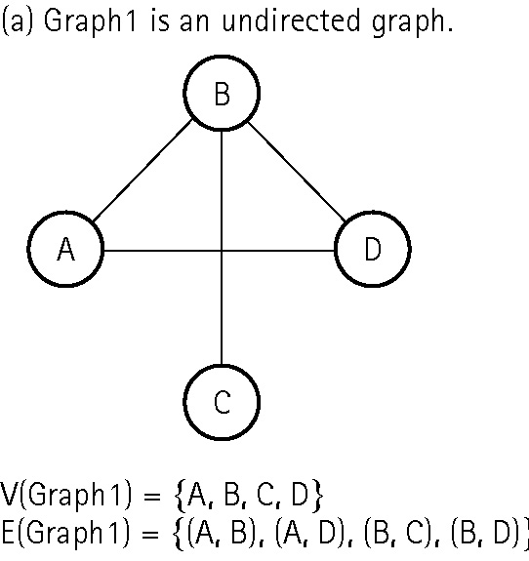
Specify the vertices:
V(Graph1) = { A, B, C, D}

Specify the edges:
E(Graph1) = { (A, B), (A, D), (B, C), (B, D) }

Directed graph Directed graph
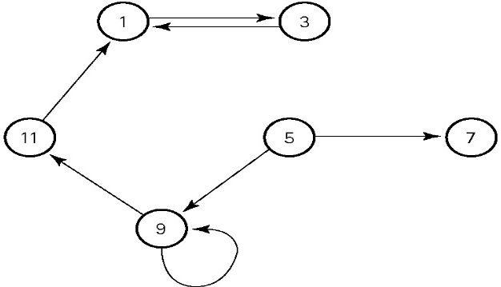
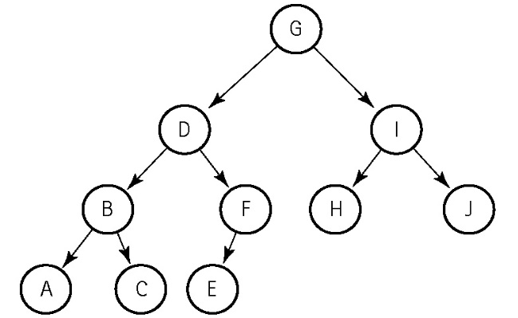

V(Graph2) = {A, B, C, D, E, F, G, H, I, J} V(Graph3) = { 1, 3, 5, 7, 9, 11 }

E(Graph2) = { (G,D), (G,I), (D,B), (D, F), (I, H), E(Graph3) = { (1,3), (3,1), (5, 7), (5, 9),
(I, J), (B, A), (B, C), (F, E) } (9, 9), (9, 11), (11, 1) }

Note: Specifying edges in a directed graph requires the vertices be specified in correct order

- Edge (G, D) cannot be specified (D, G) in Graph2 because of the arrow direction.
____________________________________________________________________________________________________________

More Graph Definitions:

- Adjacent vertices - Two vertices in a graph that are connected by an edge.

- Path - A sequence of vertices that connects two nodes in a graph.

- Complete graph - A graph in which every vertex is directly connected to every
other vertex.

- Weighted graph - A graph in which each edge carries a value.

____________________________________________________________________________________________________________

Complete Directed Graph Complete Undirected Graph
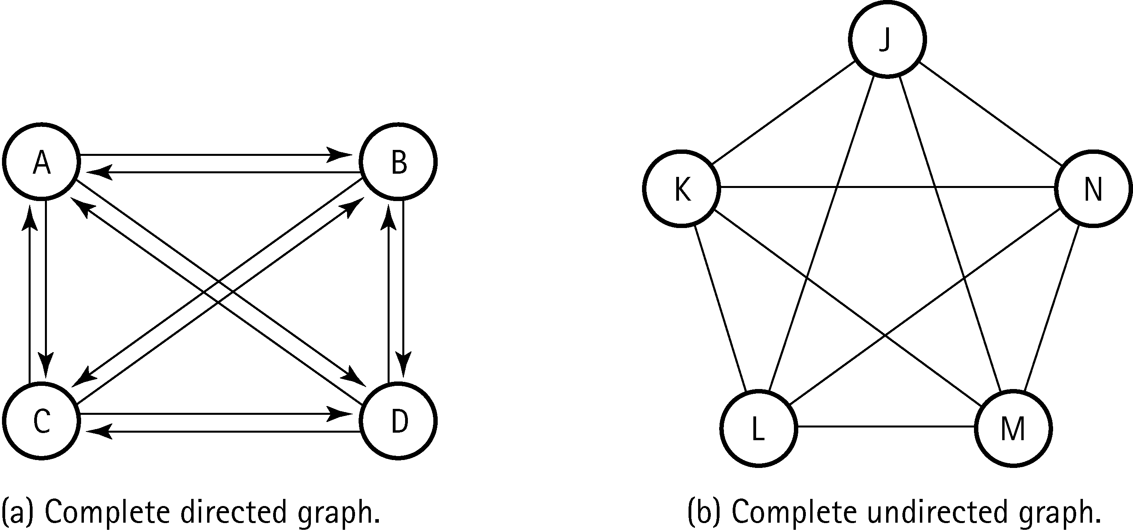

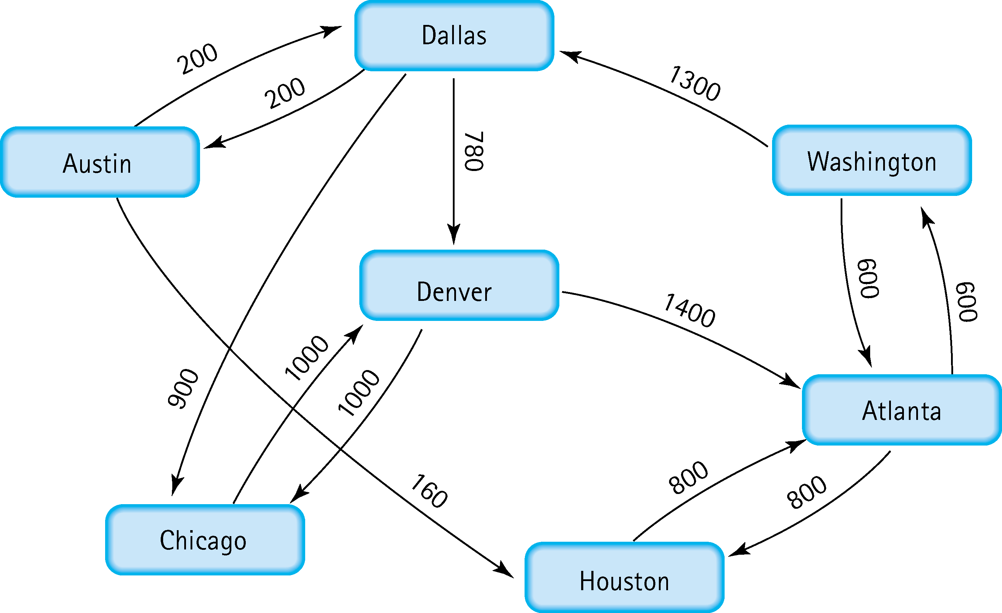

Weighted Directed Graph - The weights represent distances between cities
____________________________________________________________________________________________________________

Dijkstra’s Shortest Path algorithm - Given a graph and a source vertex in the graph, find the shortest paths from the source to all vertices in the given graph.

Dykstra’s shortest path algorithm is for finding the shortest path from one node to another node and was developed by Dr. Edsger W. Dijkstra. The algorithm is commonly used in GPS and for making suggestions within applications. The algorithm starts at the source node (the one from which to find the shortest distance) and then keeps track of the shortest path it finds to other nodes. After finding the shortest path to a node, the node is designated as visited. It then adds all these nodes to the path until all nodes in the graph are part of the path. A shortest path can then be found for any node in the graph from the source node.

https://en.wikipedia.org/wiki/Dijkstra%27s_algorithm#/media/File:Dijkstra_Animation.gif

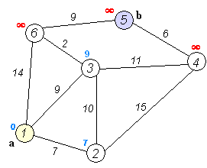

1 2 3 6 5

2 Algorithms for Searching a Graph

Depth-first Search Algorithm - Visit nodes in a branch to its deepest point before moving up.

- Postorder traversal is a form of Depth-first Search. (leaves visited first)
- Can be used to determine if a path exists from a starting point (startVertex) to
an ending point (endVertex) (weighted graph above)
  - Disadvantage – A dead end may result after several steps down a path.

Breadth-first Search Algorithm – Visit all nodes on one level before going to the next level.

- Begin at Level 0 (the root), then search all nodes in Level 1, then Level 2 …
- Can also be used to determine if a path exists.
  - Better for checking for direct flights first (weighted graph above).
  - A dead end requires only a little back up.
____________________________________________________________________________________________________________
Weighted Directed Graph - The weights represent distances between cities

Adjacency Matrix - A table of n by n size that shows the existence (and weights) of all edges
in a graph (for a graph with N nodes).

- A Two-Dimensional array implementation is used.
Advantage: Speed - Given two vertices, determining the existence or distance is 0(1)
Disadvantage: Wastes space.
Adjacency Matrix int matrix[0][6]; cout << matrix[4][0];
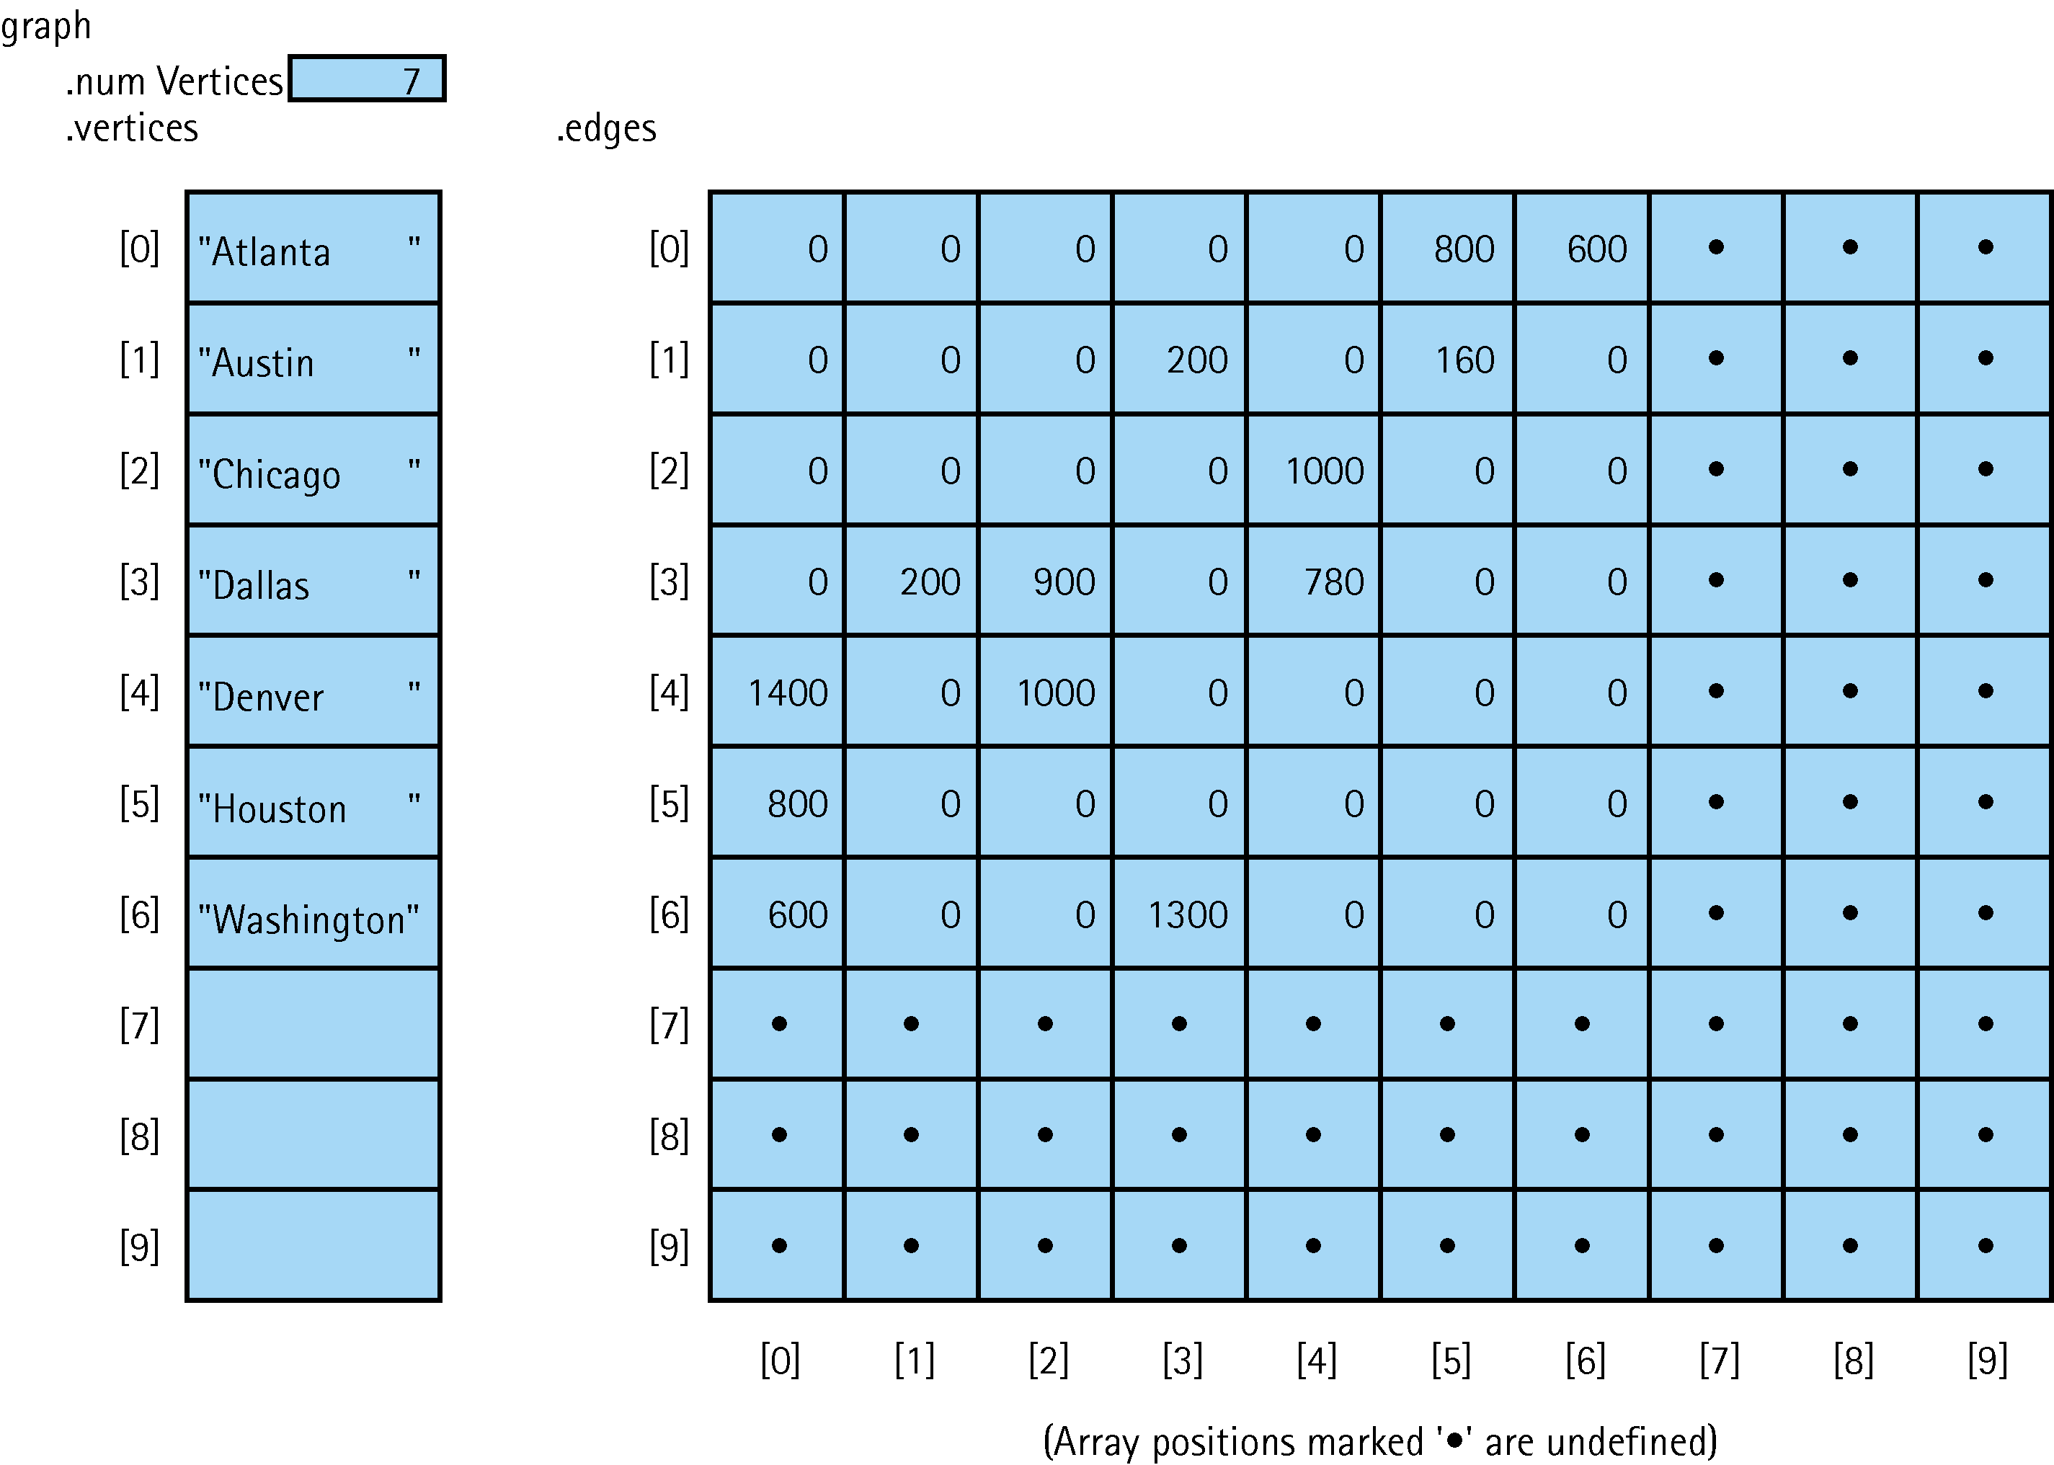

(Row are departing cities and columns are destinations)

Adjacency List - A linked list that identifies all vertices to which a particular vertex is connected.

- Vertices are stored in an array.

- Each vertex has its own adjacency list.

- An array of pointers

Advantage: – Efficient memory usage.
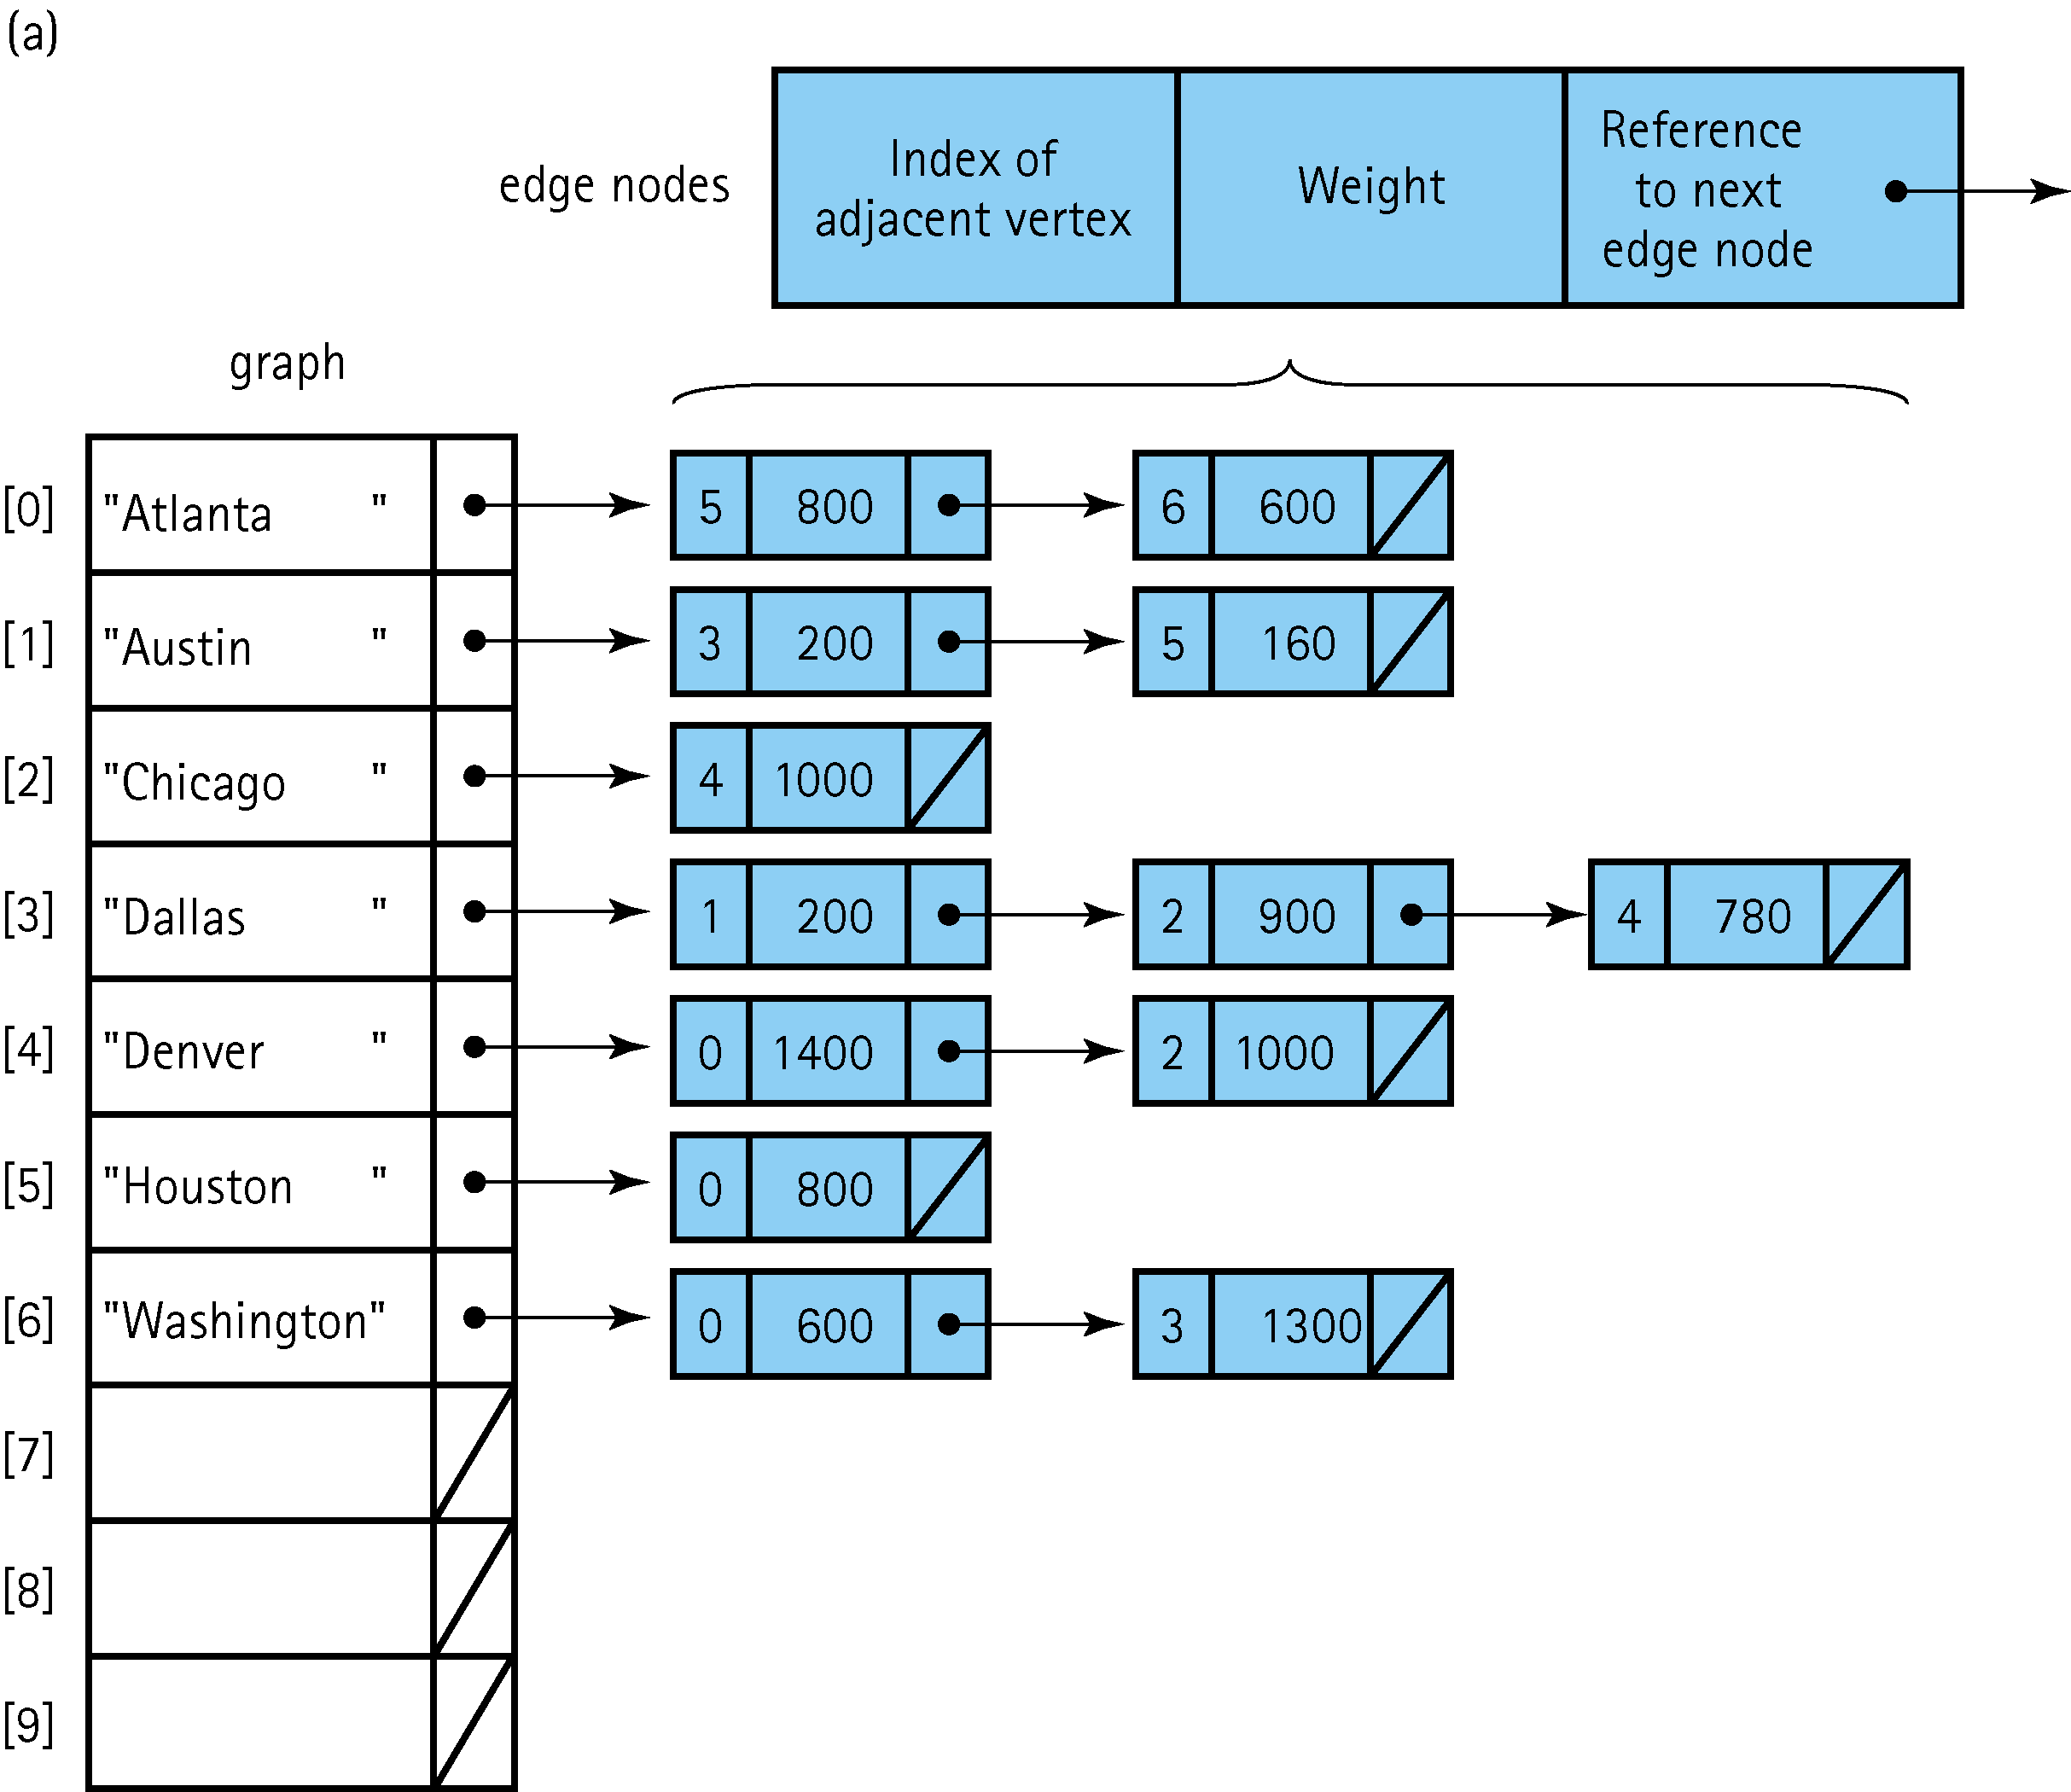

// =====================================================
// Adjacency List - Uses an array of <list> lists and <iterator>
// In other words, it is an array of linked lists, with each array
// element holding a pointer the front of the list.
// =====================================================

#include <iostream>
#include <list>
#include <iterator>
using namespace std;
void displayAdjList(list<int> adj_list[], int v);
void add_edge(list<int> adj_list[], int u, int v);
int main()
{
const int SIZE = 6;
list<int> adj_list[SIZE]; // An array of list<int> type (array of lists)

add_edge(adj_list, 0, 4); // 0--->4
add_edge(adj_list, 0, 3); // 0--->4 3
add_edge(adj_list, 1, 2); // 1--->2
add_edge(adj_list, 1, 4); // 1--->2 4
add_edge(adj_list, 1, 5); // 1--->2 4 5
add_edge(adj_list, 2, 3); // 2--->0 3
add_edge(adj_list, 2, 5); // 2--->0 2 5
add_edge(adj_list, 5, 3); // 5--->3
add_edge(adj_list, 5, 4); // 5--->3 4

displayAdjList(adj_list, SIZE);

return 0;
}
// ------------------------------------

// ------------------------------------
void displayAdjList(list<int> adj_list[], const int SIZE)
{
for (int i = 0; i < SIZE; i++)
{
cout << i << "--->";
list<int> ::iterator it;

for (it = adj_list[i].begin(); it != adj_list[i].end(); ++it)
{
cout << *it << " ";
}
cout << endl;
}
}
// ------------------------------------
u v

// ------------------------------------
// add_edge(adj_list, 0, 4); // 0--->4 (function call)

void add_edge(list<int> adj_list[], int u, int v)
{
u and v are index numbers in the array.
When the add_edge function executes, pointers
in two array elements are assigned addresses.
adj_list[u].push_back(v);
adj_list[v].push_back(u);
}
// =====================================================

/* OUTUT
0--->4 3
1--->2 4 5
2--->1 3 5
3--->0 2 5
4--->0 1 5
5--->1 2 3 4

Set ADT

Set Definitions:

- Base type: The type of the items in the set.
  - All items of a set are of the same data type.

- Cardinality: The number of items in a set.

- Union of two sets: A set made up of all the items of both sets.

- Intersection of two sets: A set made up of only items in both sets.

- Difference of two sets: A set made up of all the items in the first set that are not in
the second set.

- No Duplicates - Sets cannot contain duplicates.
  - Storing an item that is already in the set does not change the set.

- Delete - If an item is not in a set, deleting that item does not change the set.

- Sets are not ordered.

Three special types of sets:

- Subset – A set contained within another set.

- Universal set – A set that contains all values of the base set.

- Empty set – A set containing no values.

Set ADT - The following are typical methods included in a Set class:
- Constructor
- Destructor
- insertElement
- deleteElement
- unionOfSets - Returns a set containing the union of two sets.
- intersectionOfSets - Returns a set containing the intersection of two sets.
- isEqualTo - Compares 1 set to another set.
- printSet - Displays items in a set.
- isEmpty
- isFull
- cardinalityIs - Returns the number of items in a set.

Class IntegerSet - Each object can hold integers in the range 0 through 100.
Private data member: A set is represented internally as an array of ones and zeros.
  - Array element a[i] is 1 if integer i is in the set.
  - Array element a[j] is 0 if integer j is not in the set.

Public Functions:
- Default constructor - Initializes a set to an “empty set,” i.e., all zeros.

- Overloaded constructor - Initializes a set to an “empty set,” i.e., a set whose array
receives an array of integers and the size of that array and uses the array to initialize
a set object. IntegerSet(int *, int);

- unionOfSets - Creates a third set that is a union of two existing sets (i.e., an element
of the third set’s array is set to 1, if that element is 1 in either or both of the existing
sets, and an element of the third set’s array is set to 0 if that element is 0 in each of
the existing sets). IntegerSet unionOfSets(IntegerSet s2);

- intersectionOfSets - Creates a third set which is the intersection of two existing sets
(i.e., an element of the third set’s array is set to 0 if that element is 0 in either or both
of the existing sets, and an element of the third set’s array is set to 1 if that element
is 1 in each of the existing sets). IntegerSet intersectionOfSets(IntegerSet s2);

- insertElement - Inserts a new integer k into a set (by setting a[k] to 1).
void insertElement(int n);

- printSet - Prints a set as a list of numbers separated by spaces.
  - Prints only those elements that are present in the set (i.e., their position in the
array has a value of 1). void printSet();

- isEqualTo - Determines whether two sets are equal.
int isEqualTo(IntegerSet s2);

- deleteElement - Deletes integer m (by setting a[m] to 0).

// ========================================================
// File: IntegerSet.h -
// ========================================================

#include<iostream>
using namespace std;

const int SIZE = 101; // 0 to 100 set containing 101 elements
class IntegerSet
{
private:
int a[SIZE];
public:
IntegerSet();
IntegerSet(int*, int); // Pass a pointer to an array and array size
IntegerSet unionOfSets(IntegerSet s2); // returns an IntegerSet object
IntegerSet intersectionOfSets(IntegerSet s2); // “ “ “
bool isEqualTo(IntegerSet s2);
void insertElement(int n);
void printSet();
};

// ========================================================
// File: IntegerSet.cpp
// ========================================================

#include "IntegerSet.h"

// ---- default constructor -------------------------
IntegerSet::IntegerSet()
Assign 0 to all elements to
make the set empty.
{
for (int i = 0; i < SIZE; i++)
a[i] = 0;
}
// --------------------------------------------------

// ---- overloaded constructor ----------------------
// Initialize an object using another array of integers
IntegerSet::IntegerSet(int *ptr, int arraySize)
{
First, assign 0 to all elements
to make the set empty.
// Initialize the set first
for (int i = 0; i < SIZE; i++)
a[i] = 0;
Then assign 1 to the elements
that have values.
for (int i = 0; i < arraySize; i++)
a[(ptr[i])] = 1;
int arr[4] = { 3,76,34,56 }; declared in main()
for (int i = 0; i < arraySize; i++)
a[(ptr[i])] = 1;

a[3] = 1;

}
// --------------------------------------------------

// ---- unionOfSets ---------------------------------
IntegerSet& IntegerSet::unionOfSets(IntegerSet s2)
{
IntegerSet s3;
for (int i = 0; i < SIZE; i++)
Assign 1 to s3 elements when
elements in s1 or s2 have 1.
{
if (a[i] == 1 || s2.a[i] == 1)
s3.a[i] = 1;
}
return s3;
}
// NOTE: In this function, as well as the intersectionOfSets() function (below), s2 is passed
// by value and s3 is returned (not void).
// It is less efficient. (Best to pass objects by reference)
// --------------------------------------------------

// ---- printSet ------------------------------------
void IntegerSet::printSet()
{
for (int i = 0; i < SIZE; i++)
{
if (a[i] == 1)
cout << i << " ";
}
}
// --------------------------------------------------

// ---- intersectionOfSets -------------------------
IntegerSet IntegerSet::intersectionOfSets(IntegerSet s2)
{
IntegerSet s3;

for (int i = 0; i < SIZE; i++)
{
if (a[i] == 1 && s2.a[i] == 1)
s3.a[i] = 1;
}

return s3;
}
// --------------------------------------------------

// ---- insertElement -------------------------------
void IntegerSet::insertElement(int n)
{
// Check validity
if (n < SIZE && n >= 0)
a[n] = 1;
}
// --------------------------------------------------

// ---- isEqualTo -----------------------------------
bool IntegerSet::isEqualTo(IntegerSet s3)
{
for (int i = 0; i < SIZE; i++)
{
if (a[i] != s3.a[i])
return false;
}
return true;
}

// ========================================================
// File: Source.cpp
// ========================================================
#include "IntegerSet.h"

int main()
{
const int SIZE = 4;
int arr[SIZE] = { 3,76,34,56 };

// Declare 4 objects
IntegerSet s1;
IntegerSet s2(arr, SIZE); // Pass the array to the constructor
IntegerSet s3;
IntegerSet s4;

cout << "Default set (s1): { ";
s1.printSet();
cout << "}.";

cout << "\n\nInserting 50, 100, 1, 0, 34, 56 to s1";
s1.insertElement(50);
s1.insertElement(100);
s1.insertElement(1);
s1.insertElement(0);
s1.insertElement(34);
s1.insertElement(56);

cout << "\n\nNow, S1 = { ";
s1.printSet();
cout << "}.\n\n";

cout << "Using array as parameter, set s2 = { ";
s2.printSet();
cout << "}.\n\n";

cout << "Union of s1 and s2, set s3 = { ";
s3 = s1.unionOfSets(s2);
s3.printSet();
cout << "}.\n\n";

cout << "Intersection of s1 and s2, set s3 = { ";
s3 = s1.intersectionOfSets(s2);
s3.printSet();
cout << "}.\n\n";

cout << "Inserting 2 elements (34 and 56) into s4...\n";
s4.insertElement(34);
s4.insertElement(56);
cout << "set s4 = { ";
s4.printSet();
cout << "}.\n\n";

cout << "s2 == s3 = ";
if (s2.isEqualTo(s3) == 1)
cout << "True\n\n";
else
cout << "False\n\n";
cout << "s3 == s4 = ";
if (s3.isEqualTo(s4) == 1)
cout << "True\n\n";
else
cout << "False\n\n";
return 0;
}
// ======================================================

/* ==== OUTPUT =======================================
Default set (s1): { }
Inserting 50, 100, 1, 0, 34, 56 to s1
Now, S1 = { 0 1 34 50 56 100 }.
Using array as parameter, set s2 = { 3 34 56 76 }.
Union of s1 and s2, set s3 = { 0 1 3 34 50 56 76 100 }.
Intersection of s1 and s2, set s3 = { 34 56 }.
Inserting 2 elements (34 and 56) into s4...
set s4 = { 34 56 }.
s2 == s3 = False
s3 == s4 = True
Press any key to continue . . . */

STL set - Provides mathematical set operations union, intersection, difference,
symmetric difference and test of inclusion.

Ex: #include <set>
int main()
{
set<int>myset; // Declare an object of set type
mySet.insert(3);
set<int>::iterator it;

- begin() - Returns the address of the first set element
Ex: it = mySet.begin(); // it points to the first element

- end() - Returns the address of the last set element
Ex: it = mySet.end(); // it points to the last element

- insert(x) - Inserts a new set element

- erase(x) - Deletes an element
Ex: mySet.erase(it);
Ex: mySet.erase(2);

- erase(x,y) - Deletes all elements from x to y
Ex: mySet.erase(it, mySet.end());

- size() - Returns the number of elements in the set.
Ex: cout << mySet.size();

- find(x) - Searches the set and returns the address of an element.
Ex: it = mySet.find(14);

- clear() - Removes all set elements
Ex: mySet.clear();

- set_intersection( ) // #include <algorithm>
(first and second are the names of two sets)
Ex: it = set_intersection(first,first + 5, second,second + 5,
numbers.begin());

- set_union( ) // #include <algorithm>
Ex: it = set_union(first, first + 5, second, second + 5,
numbers.begin());

// ====================================================
// set(STL) Program
// ====================================================
// ====================================================
// File: Source.cpp
// ====================================================

#include<iostream>
#include<set>
using namespace std;

int main()
{
set<int> setA;
set<int>::iterator it; // Iterator to set positions.

cout << "Inserting values. . .\n"
<< "0, 2, 4, 6, 8, 10, 12, 14, 16, 18, 20\n";
for (int i = 0; i <= 20; i += 2)
{
setA.insert(i); // 0, 2, 4, 6, 8, 10, 12, 14, 16, 18, 20
}
cout << "\nAfter insertion, mySet now contains:\n";

for (it = setA.begin(); it != setA.end(); it++)
{
cout << *it << ", ";
}
cout << "\nSize is: " << setA.size();

cout << "\n\nSet iterator it to the beginning of mySet.\n";
it = setA.begin(); // Set it to beginning of mySet.

cout << "Use it++ to go to next value(2) in mySet.";
it++; // move it to next value(2) in mySet

cout << "\n\nDeleting it value(2) and value(6) in mySet.";
setA.erase(it); // delete 2
setA.erase(6); // delete 6

cout << "\n\nmySet now contains:\n";

for (it = setA.begin(); it != setA.end(); it++)
cout << *it << ", ";

cout << "\nSize is now: " << setA.size() << endl << endl;

cout << "Find and set value(14) in mySet, to iterator position.";
it = setA.find(14); // set it to number 14

cout << "\nDeleting values from value(14) to the end of mySet.";

// delete 14 AND all to the end of mySet.
setA.erase(it, setA.end());

cout << "\n\nmySet now contains:\n";
for (it = setA.begin(); it != setA.end(); it++)
{
cout << *it << ", ";
}
cout << "\nSize is now: " << setA.size();

cout << "\n\nNow, deleting all values. . . clearing mySet.";
setA.clear();

cout << "\nSize is now: " << setA.size() << "\n\n";

return 0;
}

set_intersection and set_union example - with vectors

#include <iostream>
#include <algorithm> // set_intersection, sort
#include <vector>
using namespace std;

int main()
{
int first[] = { 15, 10, 25, 5, 20 };
int second[] = { 50, 40, 30, 20, 10 };
vector<int> numbers(10); // 0 0 0 0 0 0 0 0 0 0

sort(first, first + 5); // 5 10 15 20 25
sort(second, second + 5); // 10 20 30 40 50

it = set_intersection(first, first + 5, second, second + 5,
numbers.begin());

// numbers: 10 20 0 0 0 0 0 0 0 0

numbers.resize(it - numbers.begin()); // 10 20

cout << "The intersection has " << (numbers.size())
<< " elements:\n";

for (vector<int>::iterator it = numbers.begin();
it != numbers.end(); ++it)
{
cout << ' ' << *it;
}

cout << endl;

numbers.resize(10);

it = set_union(first, first + 5, second, second + 5,
numbers.begin());

numbers.resize(it - numbers.begin());

cout << "The union has " << (numbers.size()) << " elements:\n";

for (vector<int>::iterator it = numbers.begin();
it != numbers.end(); ++it)
{
cout << ' ' << *it;
}

cout << endl;

return 0;
}

