Lecture #1 - Inline functions - this pointer - Review of classes

Classes

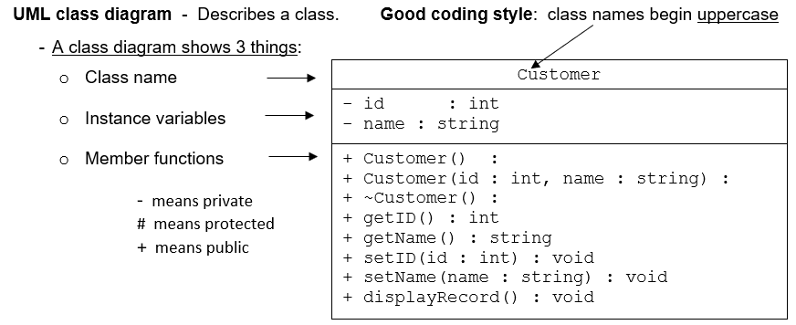

3 Files:
- Customer.h - class specification
- Customer.cpp - class function definitions
- Source.cpp - main()

Every Customer object has an ID and a Name. ID: 12345
Name: ABC Inc.

To declare a class object in main():

int main()
{
Customer first; // calls the default constructor
Customer second(12345, "ABC Inc"); // calls the overloaded constructor

To assign an ID, in main(), to first:

first.setID(33333); // Assigns 33333 to first’s id variable

Ex: File: Customer.cpp - setID function definition
Customer::setID(int idNum); // An int value (33333) is passed from main()
{ // The formal parameter, idNum, becomes a id = idNum; // variable and is initialized with 33333.
}

To retrieve a copy, in main(), of first’s ID:

cout << "ID: " << first.getID(); // Displays: ID: 33333

“this” Pointer

- By default, the compiler provides each class member function with an hidden this pointer
that points to the calling object.

- In each call to a member function, like setID(int id), the this pointer for the object is included
as a hidden parameter.

- Therefore, another way to write the setID function, above, is to use the this pointer:
Customer::setID(int id); // An int value (33333) is passed from main()
{ // The formal parameter, id, becomes a function
this->id = id; // variable and is initialized with 33333.
}
Advantage: The parameter, id, can be have the same name as the data member, id.

Inline Functions

- When a function is defined, the compiler creates one set of instructions in memory.
- When the function is called, execution of the program jumps to those instructions.
- When the function returns, execution jumps back to the next line in the calling function.
- If a function is called 10 times, the program jumps to the same set of instructions each time.
- There is a performance loss in jumping in and out of functions. (More processing time)
- If a function is small, one or two lines of code, some efficiency can be gained, if the
program can avoid making these jumps (just to execute one or two instructions).

inline (keyword) - If a function is declared with the keyword inline, the compiler does not create a
real function. Instead, it copies the inline function code directly into the calling function.
- When the function is called, no jump is made
  - Note: Using inline can increase the size of an executable program.
- Declaring a function inline almost never results in a big gain.
- Large functions usually result in loss of performance.
- If the function is small (one or two lines) it is a good candidate for inline.
Note: When you declare a function inline, the compiler may not do it. It’s just a suggestion.

#include<iostream>
using namespace std;

inline int calcDouble(int); // inline is declared in the function prototype
// before the return type.
int main()
{
int result;
int number;

cout << "Enter a number: ";
cin >> number;
result = calcDouble(number);
cout << "The number doubled is " << result << endl;

return 0;
}
// ============================================================

// ==== calcDouble() ==========================================
/* OUTPUT:
Enter a number: 4
The number doubled is 8
Press any key to continue */

int calcDouble(int value)
{ return 2 * value; }
// ============================================================

Inline class function

Note: The function definition can be included in the class specification, which
automatically makes that function inline. (Example below)
class Cat
{
private:
int weight;
public:
void setWeight(int weight); // Not inline
int getWeight() { return weight; } // Automatically inline
};
___________________________________________________________________________________________________________

Note: If the function definition is outside of the class specification, it must be explicitly
declared as inline.
inline void Cat::setWeight(int catWeight)
{
weight = catWeight;
}

Arrays - Review

Ex: Declare an array:
const int SIZE = 5;
int numbers[SIZE]
(or)
int numbers[SIZE] = {2,4,7,9,12}; // Initialize the array with values

Ex: Output array values:
cout << numbers[3]; // Output: 9

(or, use a for loop to output all array values)

for (int i = 0; i < SIZE; i++)
{
cout << numbers[i] << " "; // Output: 2 4 7 9 12
}

Ex: Pass an array to a function: (empty subscript)
void displayValues(int numbers[], int size); // Function prototype
int main()
{
const int SIZE = 5;
int numbers[SIZE] = {2,4,7,9,12};

displayValues(numbers, SIZE); // Function call
return 0;
}
// ----------------
void displayValues(int numbers[], int size) // Function call definition
{
for (int i = 0; i < SIZE; i++)
{
cout << numbers[i] << " ";
}
}

