Lecture 3 - Array-based Lists - Unsorted List and Sorted List - Big O Notation

Abstract Data Type (ADT) - A data type whose properties are specified independently of
any particular implementation.

- Logical level - An ADT provides an abstract view of data and the operations
on the data. (i.e., what it is (a list, a queue, a stack, etc.)

Data Structure – C++ code that holds data items, and provides operations on the data.

- Implementation level - A data structure provides a specific representation of the
structure to hold the data items, and the coding for operations. (i.e., how it works)

_____________________________________________________________________ _______________________

List ADT - Lists are used in everyday in life - Grocery lists, member lists, to-do lists, etc.
_____________________________________________________________________ _______________________________

List Definitions:
- Linear relationship
  - Each item in a list, except the first, has a unique predecessor.
  - Each element, except the last, has a unique successor.

- Length - The length of a list is the number of items in a list.
  - The length can vary over time.
_____________________________________________________________________ _______________________

Unsorted list (Array-based) - A list in which data items are placed in no particular order.
- Items are stored in an array.

- A list of items in random order. (like a grocery list)
- The only relationship between data elements is the list predecessor and
successor relationships.
_____________________________________________________________________ _______________________

Sorted list - A list of items, where the order in which the items are listed is important.
- In other words, items in a list must be sorted.
  - Items can be sorted alphabetically, or numerically, etc.
- A relationship exists among the items in the list.
Ex: In a list of names Adams is before Baker (when sorted in ascending order).
Ex: In a list of integers, 99 is before 85 (when sorted in descending order).

Key A data member whose values determine the order of the list items.
Ex: A book ISBN, a student ID, customer order number, or social security number
Unsorted List Data Structure - An unsorted list data structure is defined in a class
specification, and saved in a header file.

// ===============================================================
// File: UnsortedList.h - SPECIFICATION FILE - (Unsorted list of ID numbers)
// ===============================================================
#include <iostream>
#include <string>
using namespace std;

const int SIZE = 100;

class UnsortedList
{
private:
int length;
int idNumbers[SIZE];
public:
UnsortedList( );
~UnsortedList( );
void insertItem(int id);
void deleteItem(int id);
bool isFull( ) const;
bool isEmpty() const;
void displayList() const;
} ;
// ===============================================================

// ===============================================================
// File: UnsortedList.cpp
// ===============================================================
#include "UnsortedList.h"

// ---- default constructor --------------
UnsortedList::UnsortedList( )
{ length = 0; }
// ---------------------------------------

// ---- destructor -----------------------
UnsortedList::~UnsortedList( ){ }
// ---------------------------------------

insertItem algorithm for UnsortedList ADT
- An item is always inserted at the end of the list, so no search is required,
and no moving of other list values is required.
- Put the new element in the list.
- Increment length.

// ==== insertItem ===============================================
// Note: The item is inserted at the end of the list, so no search is necessary.
void UnsortedList::insertItem(int id)
{
idNumbers[length] = id;
length++ ;
}
// ===============================================================

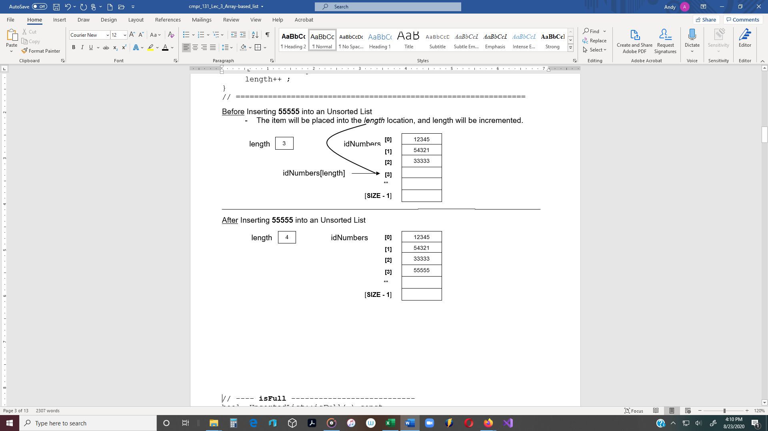

// ---- isFull ---------------------------
bool UnsortedList::isFull( ) const
{ return (length == SIZE); }
// ---------------------------------------

// ---- isEmpty --------------------------
bool UnsortedList::isEmpty( ) const
{ return (length == 0); }
// ---------------------------------------

deleteItem algorithm for UnsortedList ADT
- Find the location of the item in the list to be deleted.
(A linear search is required because the list is unsorted.)
- Assign a copy of the last item in the list to the element being deleted.
- decrement length.
// ---- deleteItem -----------------------
// The value to be deleted (id) is passed to the deleteItem function.
// Beginning with the first element in the list, location [0], the id is compared to each
// element. A while loop can be used to search the list.
// ---------------------------------------
void UnsortedList::deleteItem(int id)
{
int location = 0;

// Linear search for the item
while (id != idNumbers[location] && location < length)
location++;

if (location < length) // Item has been found
{
// The last item in list is assigned to names[location].
idNumbers[location] = idNumbers[length - 1];
length--;
}
else // Item is not in the list
{
cout << "The ID is not in the list\n";
}
}
// ---------------------------------------
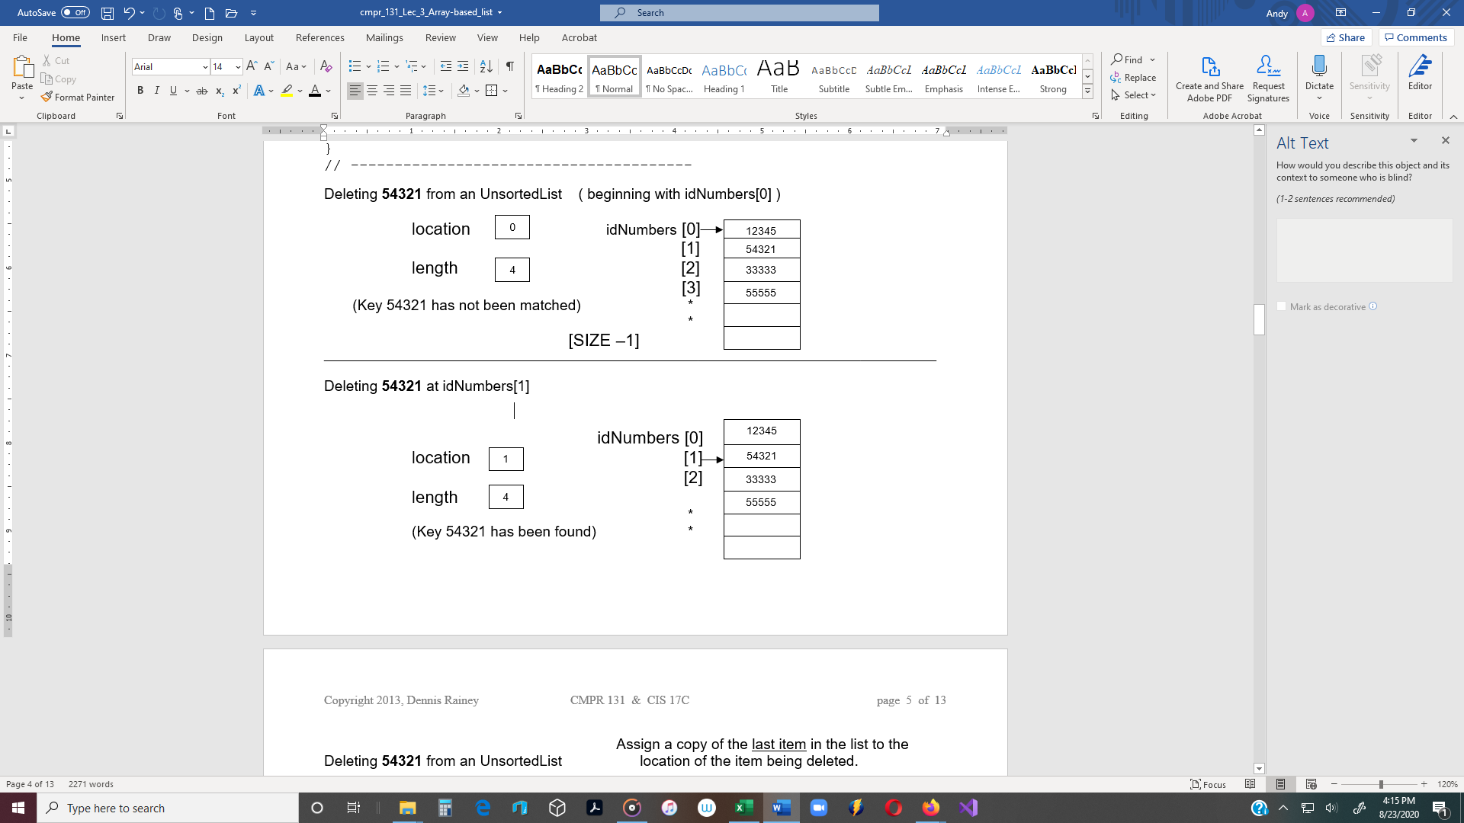

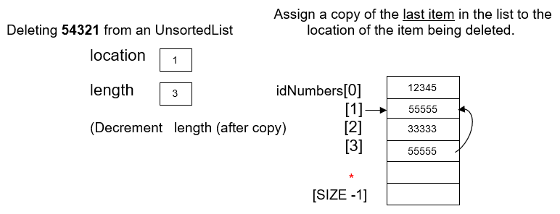

// ----- displayList ---------------------
void UnsortedList::displayList() const
{
int location = 0;

if (location < length)
{
while (location < length) // Linear search for the item
{
cout << idNumbers[location] << endl;
location++;
}
}
else
cout << "List is empty.\n";
}

// ==========================================================
// File: Source.cpp
// ==========================================================
#include <iostream>
#include "UnsortedList.h"
using namespace std;

int main()
{
UnsortedList list;

cout << "Inserting two ID numbers.\n";
if (!list.isFull())
list.insertItem(12345);
if (!list.isFull())
list.insertItem(54321);
cout << "\n\nDisplaying the list:\n";
list.displayList();
cout << "\n\nDeleting two ID numbers.\n";
// OUTPUT:
Inserting two ID numbers.

Displaying the list:
12345
54321

Deleting two ID numbers.
Displaying the list after delete.

Press any key to continue
if (!list.isEmpty())
list.deleteItem(12345);
// Delete the second one
if (!list.isEmpty())
list.deleteItem(54321);
cout << "Displaying the "
<< list after deleting:\n";
list.displayList();

return 0;
}

Sorted List Data Structure (Array-based) - Items are stored in an array
- List items are sorted in ascending or descending order

// ==========================================================
// File: SortedList.h - Demonstrates the SortedList class, as well as,
// linearSearch and binarySearch functions.
// ==========================================================
#ifndef SORTEDLIST_H_INCLUDED
#define SORTEDLIST_H_INCLUDED

#include <iostream>
#include <string>
using namespace std;

const int MAX_ITEMS = 100;

class SortedList
{
private:
int length;
string names[MAX_ITEMS];
public:
SortedList();
~SortedList();
void insertItem(string item);
void deleteItem(string item);
bool isFull() const;
bool isEmpty() const;
int binarySearch(string item);
int linearSearch(string item);
void displayList() const;
};
#endif
// ==========================================================
// File: SortedList.cpp
// ==========================================================
#include "SortedList.h"

// ---- default constructor --------------
SortedList::SortedList(){ length = 0; }
// ---------------------------------------

// ---- destructor -----------------------
SortedList::~SortedList(){}
// ---------------------------------------

Compared to an unsorted list, the following two methods must change to ensure that any
instance of the Sorted List ADT remains sorted at all times:
- insertItem
- deleteItem
_____________________________________________________________________ _______________________

insertItem algorithm for SortedList ADT
- Find proper location for the new element in the sorted list.
- Create space for the new element by moving down all the list elements that will follow it.
- Put the new element in the list.
- Increment length.

InsertItem function implementation

2 Search Algorithms - A sorted list must be searched to find the correct location to insert
a new item. (There are 2 ways to search the list).

1.) Linear Search - Search sequentially, beginning with the first element in the list.
- If it is not found, increment location and compare the next list value.
- A linear search function is used in the deleteItem function shown on page 9.

2.) Binary Search - Search the list using a binary search algorithm to find the location where
the item should be deleted.
- With each comparison, half of the list is eliminated.
- A binary search function is used in the insertItem function called below, and
shown on page 10.

// ---- insertItem ----------------------
void SortedList::insertItem(string item)
{
int location = 0;

location = binarySearch(item);
(insertItem continued on next page)

for (int i = length; i > location; i--)
{
names[i] = names[i-1];
}
names[location] = item;
length++;
}
// ---------------------------------------
Explanation of this code

for (int i = length; i > loction; i--)

means that the variable i is assigned the value in length (which is the number of values in the list). In other words, if there are 20 items in the list, then length holds a value of 20. Therefore, i is assigned names[20]. In other words, i starts at the end of the list, not i = 0. So i starts at the end or bottom of the list.

names[i] = names[i - 1]; If i is 20, then this what this means:

names[20] = names[19]; The value in index 19 is assign down one array element to index [20].

i-- So at end of the first iteration (loop), i is decremented and it goes to the next loop.

Now it’s this:

names[19] = names[18]; The value in index 18 is assign down one array element to index [19].

So basically, the loop is moving all values down one in the array, as long as i is > location.

When i == location, the loop stops. Now there is a space to insert a new item into the array.
names[location] = item;
-----------------------------------------------------------------------------------------------------------------------

DeleteItem algorithm for SortedList ADT

- Find the location of the element to be deleted from the sorted list.
- Eliminate space occupied by the item being deleted by moving up all the list
elements that follow it.
- Decrement length.
// ---- deleteItem ----------------------
void SortedList::deleteItem(string item)
Note: Just to show both functions,
a linear search is used here,
compared to the binary search
in the insertItem function above.

{
int location = 0;

location = linearSearch(item);

if (location < length)
{
for (int i = location + 1; i < length; i++)
{
names[i-1] = names[i];
}
length--;
}
else
cout << "The name is not in the list.\n\n";
}
// ---------------------------------------

// ---- linearSearch ---------------------
int SortedList::linearSearch(string item)
{
int location = 0;
while ((item > names[location]) && (location < length))
location++;
Note: On page 4, a linear search is included within the deleteItem() function. This linearSearch() function could be called from the deleteItem() function, (instead of including the search code within the deleteItem() function.

return location;
}

// ---- isFull ---------------------------
bool SortedList::isFull() const
{ return (length == MAX_ITEMS); }
// ---------------------------------------

// ---- isEmpty --------------------------
bool SortedList::isEmpty() const
{ return (length == 0); }
// ---------------------------------------

// ---- displayList ----------------------
void SortedList::displayList() const
{
for (int i = 0; i < length; i++)
cout << names[i] << endl;
}
// ---------------------------------------

// ---- binarySearch ---------------------
int SortedList::binarySearch(string item)
{
int first = 0;
int midpoint = 0;
int last = length - 1;

while (true)
{
if (first > last)
{
return first;
}

midpoint = (first + last) / 2;

if (item == names[midpoint])
{
return midpoint;
}
else if (item > names[midpoint])
{
first = (midpoint + 1);
}
else if (item < names[midpoint])
{
last = (midpoint - 1);
}
}
}
// ---------------------------------------

Note: The following is an alternative binarySearch() (recursive function).

// ==== binary search (recursive function) =================
bool SortedList::binarySearch(string names[ ],string item, int first,
int last, int & location)
{
int midPoint ;

if (first > last) // base case – item not found
return false ;
else
{
midPoint = (first + last)/2;
if (names[midPoint] == item ) // base case - found at midPoint
{
location = midpoint;
return true;
}
else if (item < names[midPoint]) // general - search lower half
return binarySearch (names, item, first, midPoint-1);
else // general - search upper half
return binarySearch(names, item, midPoint+1, last);
}
}
// ==========================================================

// OUTPUT:
Inserting the following names:
Cathy
Bill Displaying list after deleting David:
Tom Bill
Joe Cathy
David Joe
Tom
Displaying the sorted list:
Bill Deleting George.
Cathy The name is not in the list.
David
Joe Displaying list:
Tom Bill
Cathy
Deleting David. Joe
Tom
Press any key to continue . . .

.

Binary Search in a Sorted List

- Examines the element in the middle of the array.
  - If the item is found, stop searching.
  - If the item is less than the middle item, then search the top half of the array.
  - If the item is greater than the middle item, then search the bottom half of the array.
- Repeat the process in the half of the list that should be examined next.
- Stop when item is found, or when there is nowhere else to look and item is not found.

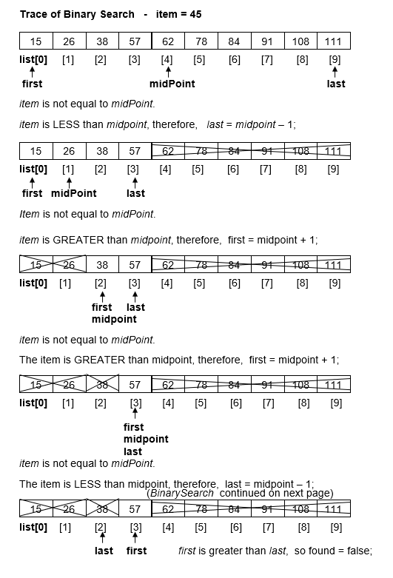

Big-O Notation - (Order of Magnitude)

O(N) notation is used to express the worst-case order of growth of an algorithm, i.e., how

the algorithm's worst-case performance changes as the size of the data increases.

Big O notation is used to compare alternative programming solutions.

Big-O is used for algorithm analysis of the operations on a List ADT.
_______________________________________________________________________________________________________________

Orders of Magnitude
O(1) bounded (by a constant) time - Work does not change with size of n
O(log n) logarithmic time O(log n)
O(n) linear time
O(n log n) n*logn time O(n * log n)
O(n²) quadratic time
O( 2^{n} ) exponential time

n log n n log n n² n^{n}

¹ ⁰ ⁰ ¹ ²
² ¹ ² ⁴ ⁴
⁴ ² ⁸ ¹⁶ ¹⁶
⁸ ³ ²⁴ ⁶⁴ ²⁵⁶
¹⁶ ⁴ ⁶⁴ ²⁵⁶ ^{65,536}
³² ⁵ ¹⁶⁰ ¹⁰²⁴ ^{4,294,967,296}
⁶⁴ ⁶ ³⁸⁴ ⁴⁰⁹⁶

Big-O Comparison of List Operations

Operation UnsortedList SortedList

insertItem
Search O (1) (no search) O(logn) - binary search
Assign O (1) O(n) - move items down to make room
Combined O (1) O(n)

deleteItem
Search O (n) – linear search O(logn) - binary search
Swap O (1) O(n) - move items up
Combined O (n) O(n)

