Lecture 4-1 - Linked List - doubly & circular linked lists - typedef - Big O Notation

3 Types of Program Data:
- STATIC DATA: Memory allocation exists throughout execution of program.
- Even if a variable is declared in a function other than main(), it will continue to exist and
will continue to hold data, until the program has ended.

Ex #: static int result; // Use the word static (reserved word)
- A static variable can be declared in a class.
  - A static class variable can be accessed by all objects of a class.

- AUTOMATIC DATA: Memory is automatically created at function entry, and is
destroyed when returning from function.
- These variables are stored on the runtime stack.
- Local variables we typically declare in functions (including main)
Ex #: int result;

- DYNAMIC DATA - Dynamic memory is memory allocated for variables and objects
allocated at runtime.
- Pointers - Pointers must be used to access dynamically allocated variables and objects
    - A dynamically allocated object or variable does not have a name, and
therefore, the only way to access it is by using a pointer.
    - To do this, the pointer must be assigned the address of the object.

- Memory must be explicitly allocated (dynamic memory allocation) and deallocated
during program execution using the new and delete operators.
struct Box
{
int id;
Box * next;
};
- new operator - Used to create a new object on the heap.
    - The new operator uses a special part of
memory called the free store or heap.
    - Objects created on the heap do not have names.
    - Therefore, pointers must be used to access dynamically-created objects and variables
Ex #: int * ptr = new int; // Creates a new int variable on the heap.

Ex #: Box * ptr = new (Box); // Creates a new Box object.
// Object’s address is assigned to ptr.

- delete operator - Used to de-allocate (delete) an object on the heap.
    - The delete operator deletes the object the pointer points to, not the pointer.
Ex #: delete ptr;

- Arrow Operator ( -> ) - Use a pointer with the arrow operator to access an
object’s data members
Ex #: Box * ptr = new (Box);
ptr->id = 101; // Assign 101 to the new Box object’s id member
cout << ptr->id; // Output 101

Linked list - Any group of items can be organized into a list.

- A list of employees or students, or boxes can be put into a linked list.
- Pointers can be used to make a linked list.
- A linked list can be comprised of objects defined in a struct or class.
    - Each object has the same data members.
    - In the case of the struct Box, each Box object has 2 data members: id and next.
      - A “next” pointer can be used to link one object to another object.

- Begin a linked list by declaring a head pointer in main(), and assign it NULL (see below).

void insert(Box *& head);
void deleteList(Box *& head); 4 functions in this program
void displayLtoR(Box *& head);
void displayRtoL (Box* & node);

int main()
{
Box *head = NULL; // A pointer that is assigned NULL points to nothing.
int count = 0;

// Insert 3 items into the list
while (count < 3)
{
insert(head); // Pass head pointer to the function
count++;
}
Note:
The displayLtoR() function
uses a loop to output the list.
(iterative solution)

The displayRtoL() function uses
a recursive function to output
the list. (iterative solution)
(see implementations pg. 6)
// Delete the list
deleteList(head);
// Display the list from left to right (front to back)
displayLtoR(head);

// Display the list from left to right (front to back)
displayRtoL(head);
return 0;
}
Example: Linked List of struct objects
- Node - Each object in a linked list is often called a ‘node’.
- Assume that a pointer named head has already been declared and that it points to the
front of this existing linked list.
- Each object in the list is a struct object.
    - Therefore, each object has an id and a next pointer.
- Each object is connected to the next object by its next pointer.
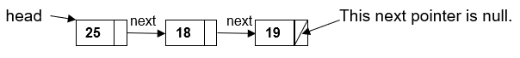

To insert a new node to the front of the list:

// ==== insert() ======================================
void insert(Box *& head)
{
Box * temp = new (Box);
cout << "Enter ID: ";
cin >> temp->id;
temp->next = head; // Connect the new node to the list
head = temp; // put head to front of the list
}
// ====================================================

Explanation of the insert() function (above)

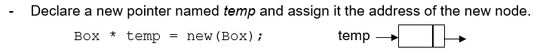

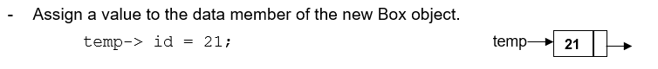

- Connect the new node at the front of the list.
temp-> next = head;
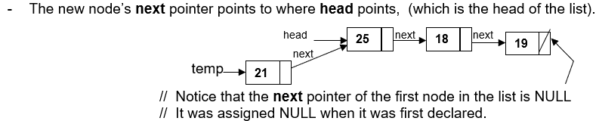

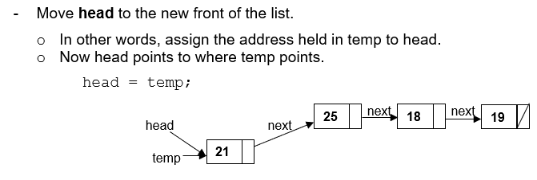

To delete an object from a list

- Use two pointers to delete a node. (see below)
// ==== deleteList() ==================================
void deleteList(Box*& head)
{
Box* lead = head; // lead and follow point to where head points,
Box* follow = head; // which is the front of the list. (see next page).
int item;

cout << "Enter ID to Delete: ";
cin >> item;

while ((lead ->next != NULL) && (lead ->id != item))
{
follow = lead;
location = location->next;
}

// Check to see if item is the first node
if (lead == head)
{
head = head->next;
delete lead;
}

// Check to see if item is the last node or not in the list
else if (lead ->next == NULL)
{
// Check to see if item is the last item in the list
if (lead ->id == item)
{
follow ->next = NULL;
delete lead;
}
else
cout << "ID is not in the list.\n\n";
}

// Otherwise the item is in the list, but not first or last
else
{
follow->next = lead ->next;
delete lead;
}
}
// ====================================================

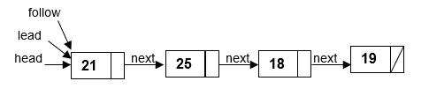

Ex #: Delete the node with id == 18

item = 18;
Box* lead;
Box* follow;
lead = follow = head;

while ((lead->next!= NULL) && (lead->id != item))
{
follow = lead;
lead = lead->next;
}
if (lead == NULL)
cout << “Item not in list.\n”;

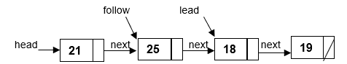

else
{
// Before deleting object 18, the next pointer of object 25 must point to object 19
follow->next = lead->next;

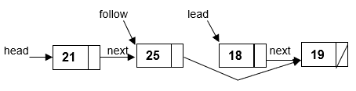

// Now delete the object. (The object is deleted, but location is not).
if (lead->next == NULL)
{
follow->next = NULL;
delete lead;
}

else
delete lead;
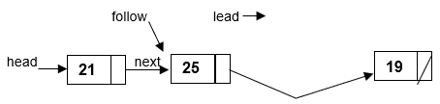

Note: The object that lead points to is deleted (not the pointer).
  - Memory is returned to the free store (heap)
  - The pointers must be moved to the proper location in the list, with lead pointing to
the node to be deleted, and follow pointing to the node in front of it.

// ==== displayLtoR() =====================================
// Iterative algorithm (uses a loop) to print left to right

void displayLtoR(Box*& head)
{
Box* temp = head;
cout << "Here are the values in the linked list:\n";
while(temp != NULL)
{
cout << "ID: " << temp->id << endl;
temp = temp->next;
}
}

// ==== displayRtoL() =====================================
// Recursive algorithm to print right to left

void displayRtoL (Box*& node)
{
if(node != NULL)
{
displayRtoL(node->next);
cout << node->id << " ";
}
}

Big O for linked list: Delete a node - O(n) - search = O(n) + O(1) to delete
Insert a node - O(1) - (Insert at front of list, so no need to search)
Display all nodes - O(n)

An array can be dynamically created using the new operator.

Ex #: Create a new array of char type:
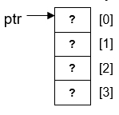
- The pointer is assigned the address of the 1st byte of the first array element.
- The new array has no name and no values.

char *ptr = new char[4];

Ex #: Create a new array of Box type:
Box *ptr = new Box[4];
_______________________________________________________________________________________________________
Ex #: To delete an array: delete [ ]ptr; // deletes the array but not the pointer
_______________________________________________________________________________________________________

Ex #: Create a new array of Box objects:
/* OUTPUT:
Enter 3 values into the array:
ID: 100
ID: 101
ID: 102

Here are the values in the array:
ID: 100
ID: 101
ID: 102
Press any key to continue . . . */

#include<iostream>
using namespace std;

struct Box
{
int id;
}; // No next pointer needed)

int main()
{
const int SIZE = 3;

Box *head = new Box[SIZE]; // Declare a dynamically-allocated array
Box *temp = head;

cout << "Enter " << SIZE << " values into the array:\n"
for (int i = 0; i < SIZE; i++)
{
cout << "ID: ";
cin >> temp->id;
temp++; // pointer math
}

temp = head; // Reset temp to the head of the list.
cout << "\n\nHere are the values in the array:\n"
for (int i = 0; i < SIZE; i++)
{
cout << "ID: " << temp->id << endl;
temp++;
}
return 0;
}

Ex_5 - Linked List of Student objects

Other linked list implementations: Doubly linked list - Circular linked list

struct Box
{
int id;
Box * next;
Box * back;
};
Doubly Linked - Use a struct object with 2 pointers
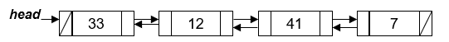

Doubly Linked List - Insert a new node at the front of the list

// ==== insert =========================================
void insert(Box *&head)
{
Box * temp = new Box;
cout << "\nID: ";
cin >> temp->id;
temp->next = head;
temp->back = NULL; // for inserting the first node
if (head != NULL)
{
head->back = temp;
}
head = temp;
}

Doubly Linked List - Delete function

void delete(Box *&head)
{
Box *location;
Box *place;
int idNum;

location = place = head;

cout << "\nEnter ID to delete: ";
cin >> idNum;

// Search the list for the item
while ((location->id != idNum)&&(location->next != NULL))
{
place = location;
location = location->next;
}

if ((location->id != idNum) && (location->next == NULL))
cout << "\nNot int the list.\n";

// In case deleting last node in list
else if ((location->id == idNum)&&(location->next == NULL))
{
place->next = NULL;
delete location;
}
// In case deleting first node in list
else if ((location->id == idNum)&&(location->back == NULL))
{
head = head->next;
head->back = NULL;
delete location;
}

// In case deleting a node other than first or last
else
{
place->next = location->next; // step (1)
location->next->back = place; // step (2)
delete location; // step (3)
}
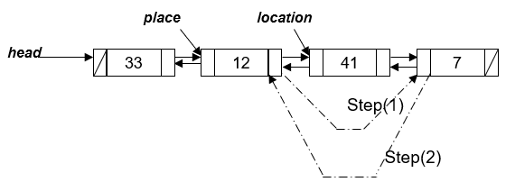
}

Doubly Linked List - Display all nodes (from left to right).

// ==== displayLtoR ====================================
void displayLtoR(Box *&head)
{
Box *temp = head;

cout << "\nHere is the list:\n";
while (temp != NULL)
{
cout << endl << setw(3) << "ID: " << temp->id << endl;
temp = temp->next;
cout << endl;
}
}

Doubly Linked List - Display all nodes (from right to left).

// ==== displayRtoL ====================================
void displayRtoL(Employee *&head)
{
Employee *temp = head;

while (temp->next != NULL)
{
temp = temp->next;
}

cout << "\nHere is the list:\n";
while (temp != NULL)
{
cout << "\nID: " << temp->id << endl;
cout << "NAME: " << temp->name << endl;
temp = temp->back;
cout << endl;
}
}

Circular Linked List – A list in which every node has a successor.

- The last element is succeeded by the first element.
struct Box
{
int id;
Box * next;
};
- Circular Linked List uses a struct with a next pointer.
- Unlike the doubly linked list, the last node’s next pointer is not NULL.
  - The last node’s next pointer points to the first node in the list.

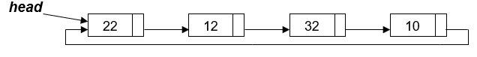

Circular Linked List - Display All Nodes (one time)

Box * location = new(Box);
location = head;

do {
cout << location->id;
location = location->next;
} while (location != head);

Circular Linked List - Display All Nodes - (repeatedly, until keyboard hit)

Box * location = new(Box);
location = head;

do {
cout << location->id;
location = location->next;
} while ( !kbhit() ); // keyboard hit is a member of <conio.h>
(console-input-output header file)

Circular Doubly Linked List

cout << location->next->id;
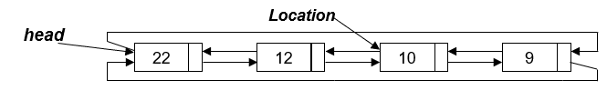

Circular Doubly Linked List - Display all Nodes (left to right)

location = head;

do {
cout << location->id;
location = location->next;
} while (location != head);

Circular Doubly Linked List - Insert and Delete are the same as Doubly Linked.

EXAMPLE: COMPLETE LINKED LIST PROGRAM
