CSC 4370 WEB
Homework 3
Joe Turner
11/6/26

Firefox 159.0.1 (64-bit)
U1 and U2

U1: The shared kiosk dilemma
I predicted that the second customer would see the first customers order even if you close the browser then go back to the ordering menu unless you clicked forget order before closing the browser. This made since to me because closing the browser doesn’t remove the selection data. To test this I made my selections, sent it to kitchen then made sure the correct selected items were on the receipt section. I then refreshed the page and nothing changed. I then completely closed the webpage then went back to it. Again the selections did not change. In the dev tools you can see the selection information inside local storage. We simulate a second customer by closing the webpage and reopening it. This shows that the second customer will get the first customers order by default. This is not ideal because you want each customer to be treated as a brand new person, not inheriting information from another customer. If you click forget order you can see the selections go back to default and in the dev tools you can see data disappear as well while the XP and badges remained the same. They did not reset. We can pretty much use the forget order button as a way to let a new customer be seen as new but it would be better if it was automatic or more obvious that the customer should hit it after they place their order. It would work very much like the forget order button but it would be easier for a customer to understand they should press it.
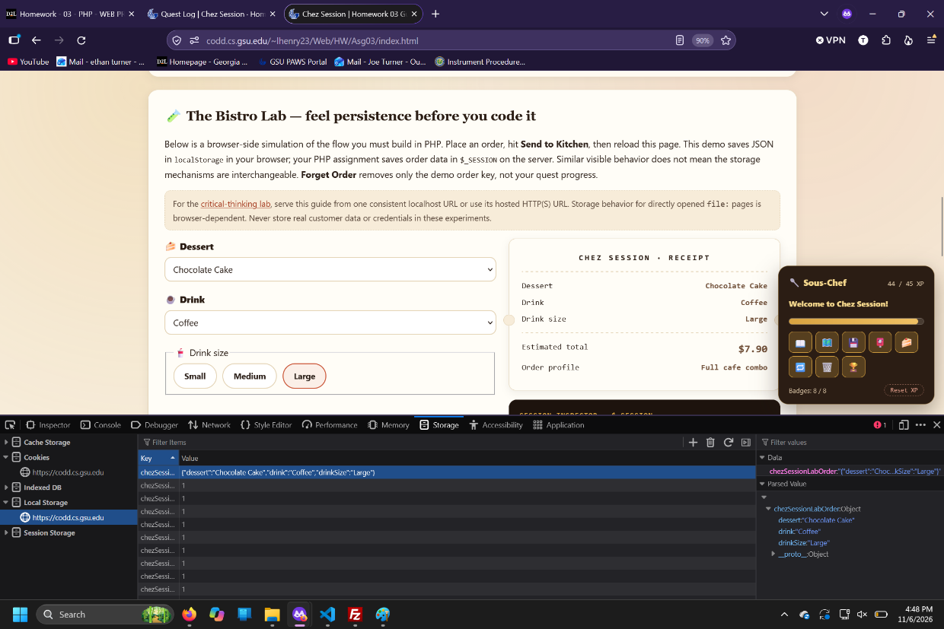
Dev tools show saved selection

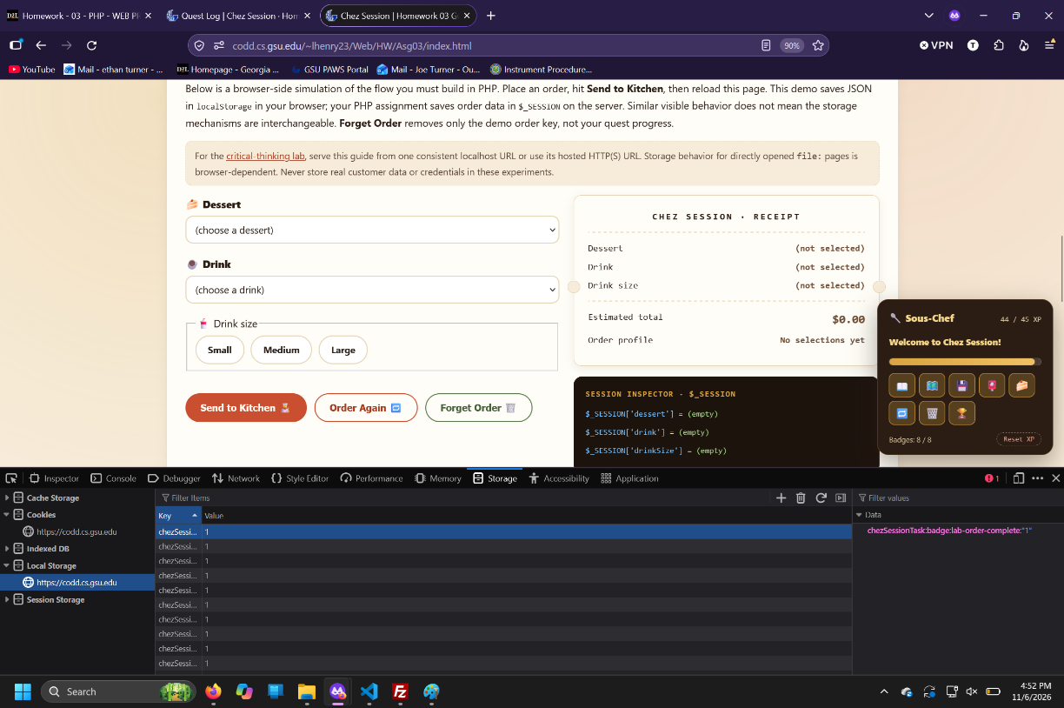
Dev tools show selections removed

U2: The dueling tabs
I predicted that if you have two tabs open, the most recent sent order tab would send its data to the other tab after you refresh the page. I thought this would happen because the tabs don’t really matter, it’s the saved data that the browser will grab so it doesn’t matter if you have multiple tabs or reload a single tab. They both get the data in the same way from the same place.
To test this I created tab 1 and tab 2. In tab 1 I made a selection of each option and made sure the receipt section showed what I selected. Then in tab 2 I made completely different selections and made sure they showed up correctly. When you go back to tab 1 it doesn’t change. After you refresh tab 1 it changes its selection to what ever tab 2 had. This means the most recent selection is the data that gets saved so any tab opened after that will load that data by default.
Inside the dev tools I wrote some small code in the console that would show if the selections were changed from another tab. It would prevent the change it would just give a text warning. It did this by comparing two strings, the old tabs selection and the most recent tab data that got sent to kitchen. If these were not the same it would tell you the order was changed. The two tabs are sharing the selection data but it requires a refresh of the tab for the selections to change to the most recent data.
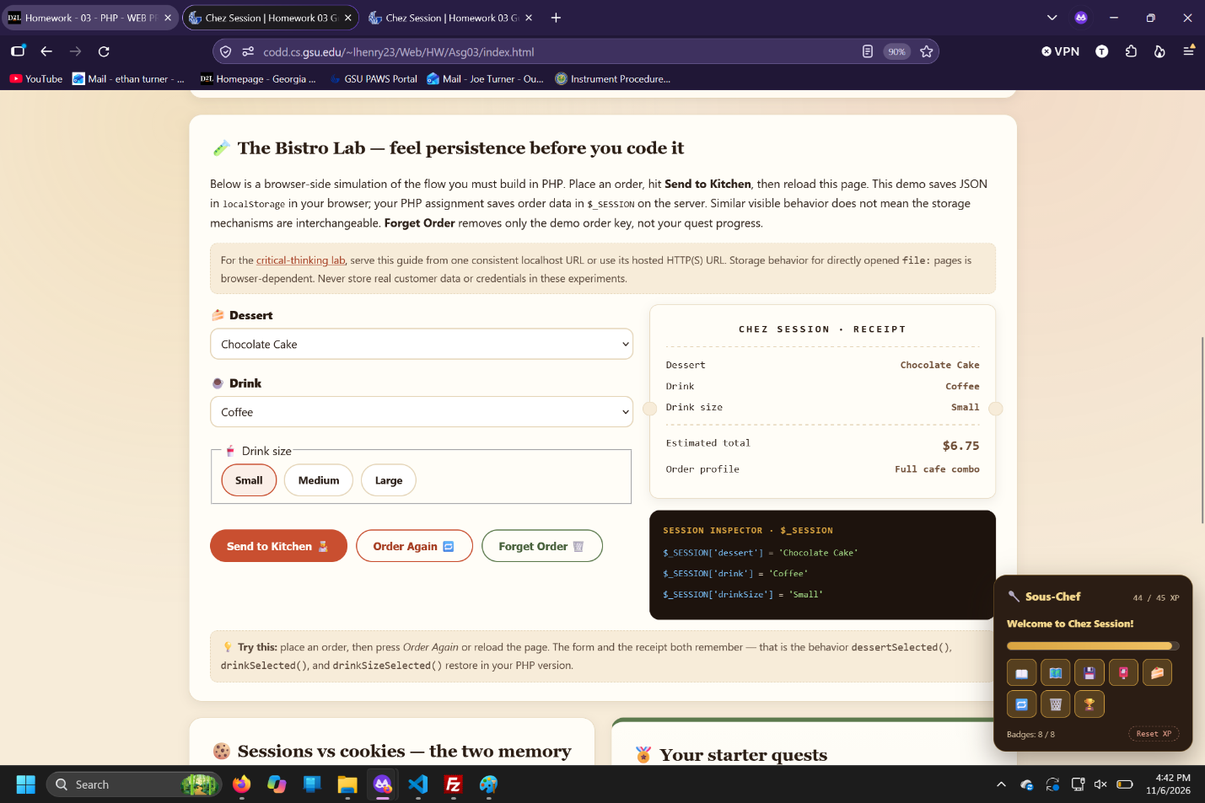
Before reloading tab
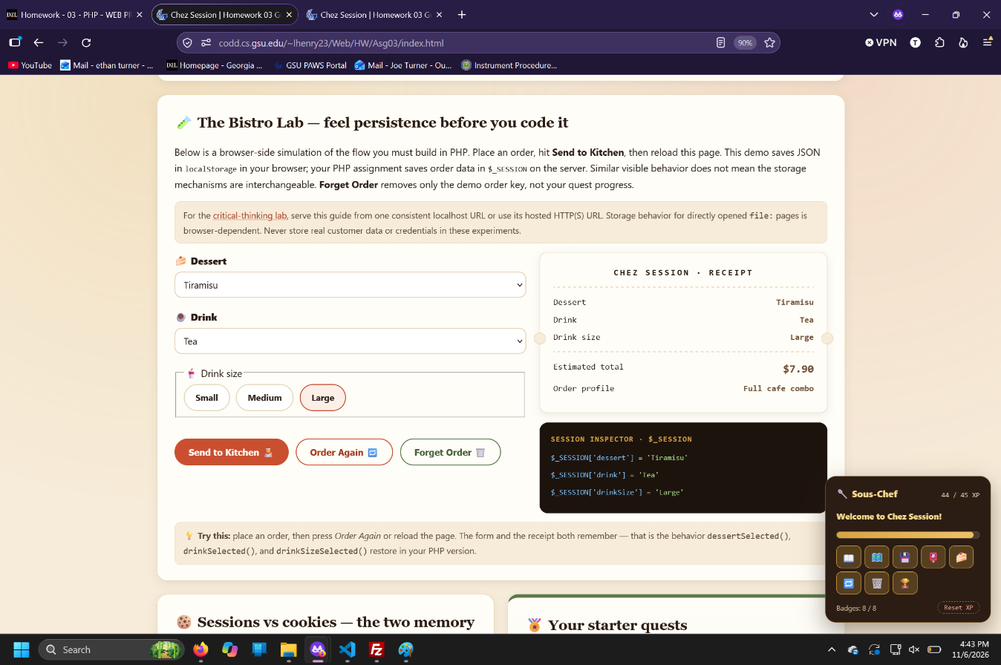
After reloading tab

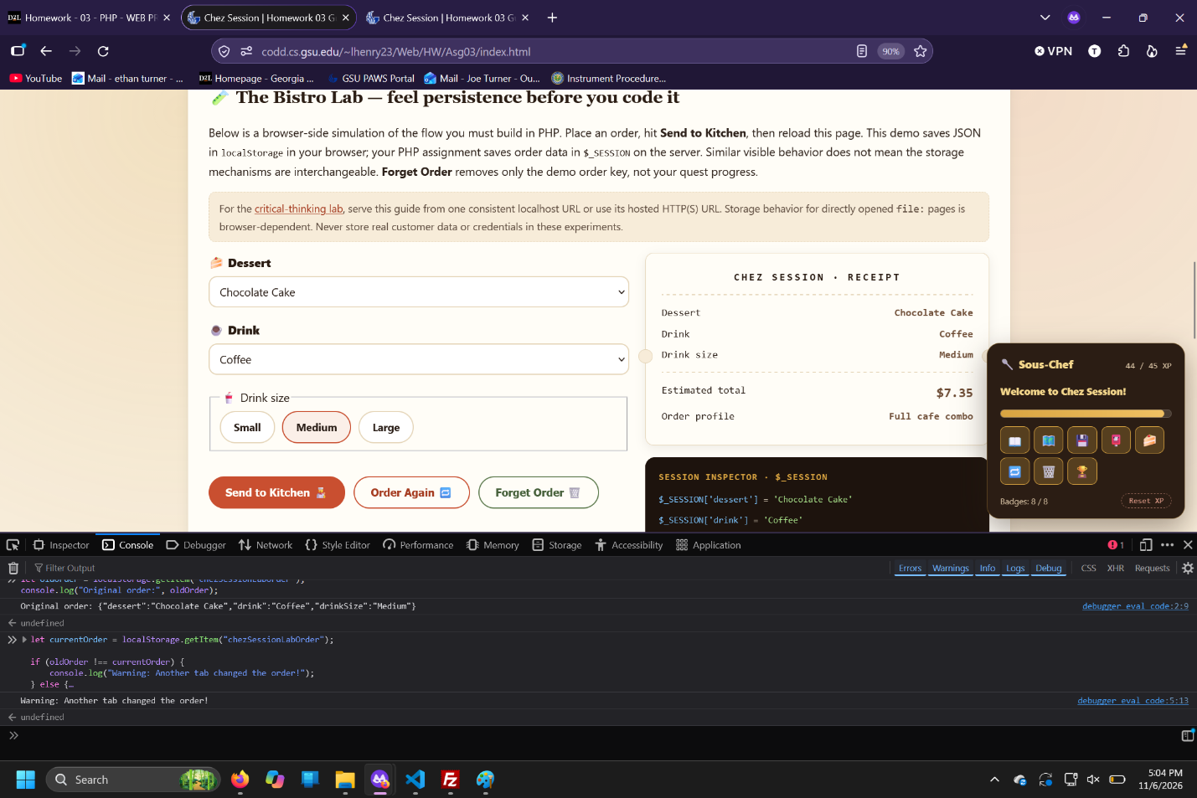
dev tools showing warning that data was changed

