Final Project: Academy Award Nominated Films, Violence, and the Bechdel Test
2026-04-15

Hypotheses
H1 The higher the level of violence in an Academy Award for Best Picture nominated film, the fewer Bechdel Test criteria the film will pass.
H2 Of Best Picture nominees, winners of the Academy Award for Best Picture are more likely to pass Bechdel Test criteria.
H3 Of Best Picture nominees, winners of the Academy Award for Best Picture are more likely to score a higher level of violence.
H4 The higher the Box Office revenue for an Academy Award for Best Picture nominated film, the more Bechdel Test criteria the film will pass.
H5 The higher the Box Office revenue for an Academy Award for Best Picture nominated film, the film will score a higher level of violence.

Findings

Hypothesis 1
H1 The higher the level of violence in an Academy Award for Best Picture nominated film, the fewer Bechdel Test criteria the film will pass.

Median and Mean H1
## # A tibble: 4 × 5
## violence n Mdn M SD
## <ord> <int> <dbl> <dbl> <dbl>
## 1 None 11 3 2.82 0.603
## 2 Mild 24 2 2.04 0.999
## 3 Moderate 18 3 2.5 0.857
## 4 Severe 14 3 2.14 1.23

Scatter H1
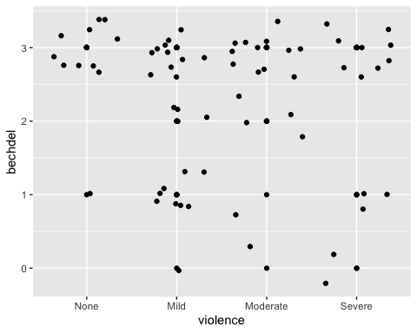

Violin H1
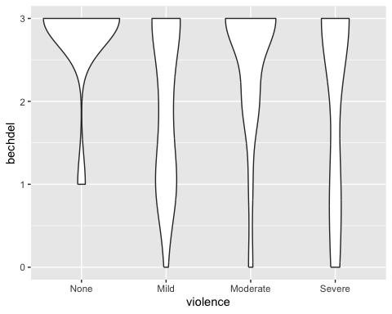

Boxplot H1
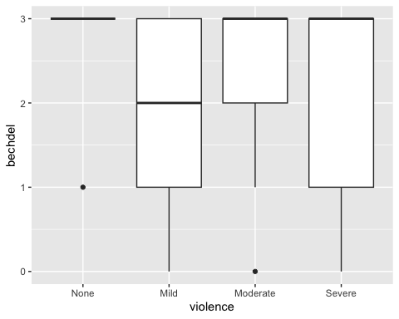

Spearman Test H1
## Warning in cor.test.default(x = mf[[1L]], y = mf[[2L]], ...): Cannot compute
## exact p-value with ties
##
## Spearman's rank correlation rho
##
## data: bechdel and violence_coded
## S = 53861, p-value = 0.5478
## alternative hypothesis: true rho is not equal to 0
## sample estimates:
## rho
## -0.07473071

Findings H1
There is no real correlation between Bechdel Test criteria passed and violence scores for Academy Award Best Picture nominees, because p = 0.548. PLEASE CHECK.

Hypothesis 2
H2 Of Best Picture nominees, winners of the Academy Award for Best Picture are more likely to pass Bechdel Test criteria.

Median and Mean H2
## # A tibble: 2 × 5
## result n Mdn M SD
## <ord> <int> <dbl> <dbl> <dbl>
## 1 Winner 7 3 2.86 0.378
## 2 Nominee 60 3 2.25 1.02

Scatter H2
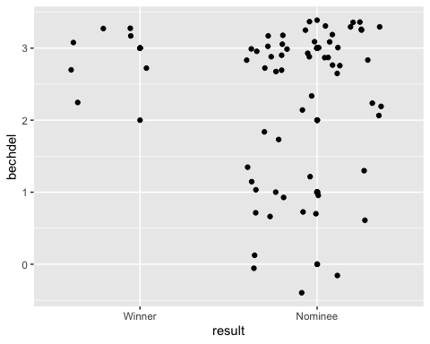

Violin H2
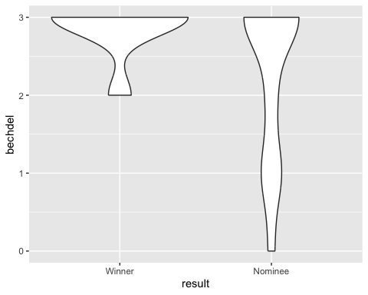

Boxplot H2
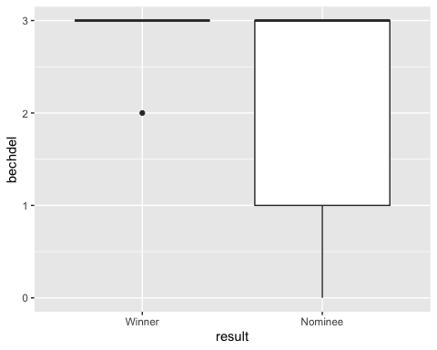

Spearman Test H2
## Warning in cor.test.default(x = mf[[1L]], y = mf[[2L]], ...): Cannot compute
## exact p-value with ties
##
## Spearman's rank correlation rho
##
## data: bechdel and result_coded
## S = 59275, p-value = 0.1388
## alternative hypothesis: true rho is not equal to 0
## sample estimates:
## rho
## -0.1827487

Findings H2
There is no real correlation between Bechdel Test criteria passed and winning the Academy Award Best Picture among Academy Award Best Picture nominees, because p = 0.139. PLEASE CHECK.

Hypothesis 3
H3 Of Best Picture nominees, winners of the Academy Award for Best Picture are more likely to score a higher level of violence.

Median and Mean H3
## # A tibble: 2 × 5
## result n Mdn M SD
## <ord> <int> <dbl> <dbl> <dbl>
## 1 Winner 7 2 2.29 1.11
## 2 Nominee 60 2 2.55 0.999

Scatter H3
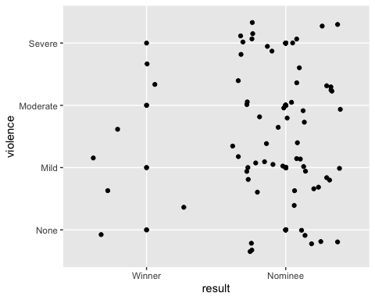

Violin H3
## Warning: Groups with fewer than two datapoints have been dropped.
## ℹ Set `drop = FALSE` to consider such groups for position adjustment purposes.
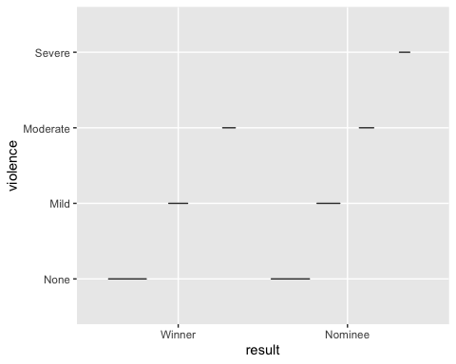

Boxplot H3
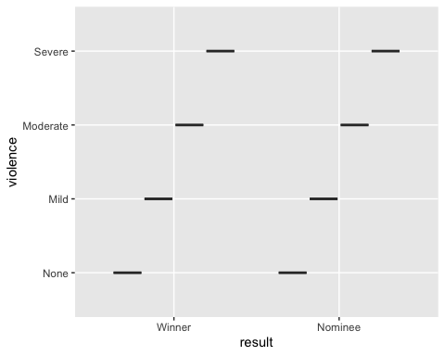

Spearman Test H3
## Warning in cor.test.default(x = mf[[1L]], y = mf[[2L]], ...): Cannot compute
## exact p-value with ties
##
## Spearman's rank correlation rho
##
## data: violence_coded and result_coded
## S = 46230, p-value = 0.5328
## alternative hypothesis: true rho is not equal to 0
## sample estimates:
## rho
## 0.07754618

Findings H3
There is no real correlation between violence score and winning the Academy Award Best Picture among Academy Award Best Picture nominees, because p = 0.533. PLEASE CHECK.

Hypothesis 4
H4 The higher the Box Office revenue for an Academy Award for Best Picture nominated film, the more Bechdel Test criteria the film will pass.

Median and Mean H4
## # A tibble: 4 × 5
## bechdel n Mdn M SD
## <dbl> <int> <dbl> <dbl> <dbl>
## 1 0 4 NA NA NA
## 2 1 13 NA NA NA
## 3 2 8 34831574 160866240 334432862.
## 4 3 42 51471937 265309461. 489957533.

Scatter H4
## Warning: Removed 4 rows containing missing values or values outside the scale range
## (`geom_point()`).
## Removed 4 rows containing missing values or values outside the scale range
## (`geom_point()`).
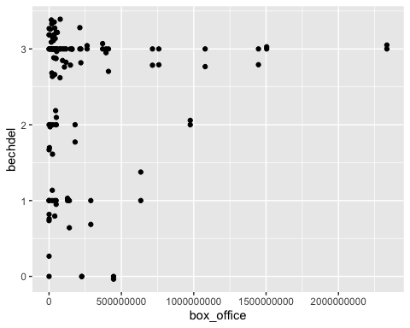

Violin H4
## Warning: Removed 4 rows containing non-finite outside the scale range
## (`stat_ydensity()`).
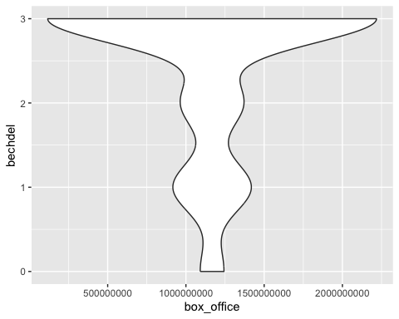

Boxplot H4
## Warning: Orientation is not uniquely specified when both the x and y aesthetics are
## continuous. Picking default orientation 'x'.
## Warning: Continuous x aesthetic
## ℹ did you forget `aes(group = ...)`?
## Warning: Removed 4 rows containing missing values or values outside the scale range
## (`stat_boxplot()`).
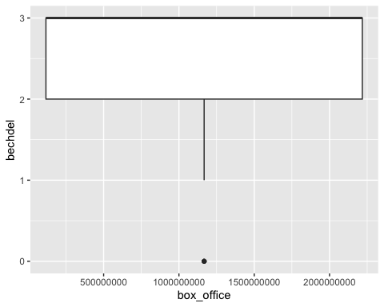

Spearman Test H4
## Warning in cor.test.default(x = mf[[1L]], y = mf[[2L]], ...): Cannot compute
## exact p-value with ties
##
## Spearman's rank correlation rho
##
## data: bechdel and box_office
## S = 36705, p-value = 0.3529
## alternative hypothesis: true rho is not equal to 0
## sample estimates:
## rho
## 0.1190165

Findings H4
There is no real correlation between Bechdel Test criteria met and Box Office revenue for Academy Award Best Picture nominees, because p = 0.353. PLEASE CHECK.

Hypothesis 5
H5 The higher the Box Office revenue for an Academy Award for Best Picture nominated film, the film will score a higher level of violence.

Median and Mean H5
## # A tibble: 4 × 5
## violence n Mdn M SD
## <ord> <int> <dbl> <dbl> <dbl>
## 1 None 11 39458207 195740224. 425661509.
## 2 Mild 24 NA NA NA
## 3 Moderate 18 NA NA NA
## 4 Severe 14 NA NA NA

Scatter H5
## Warning: Removed 4 rows containing missing values or values outside the scale range
## (`geom_point()`).
## Removed 4 rows containing missing values or values outside the scale range
## (`geom_point()`).
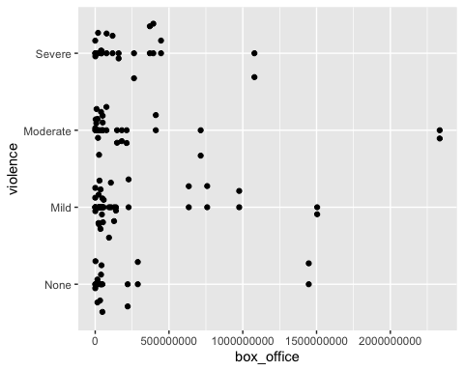

Violin H5
## Warning: Removed 4 rows containing non-finite outside the scale range
## (`stat_ydensity()`).
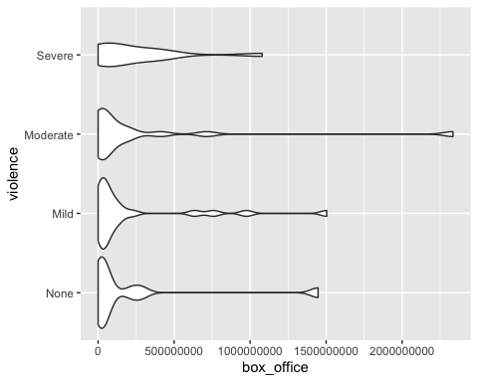

Boxplot H5
## Warning: Removed 4 rows containing non-finite outside the scale range
## (`stat_boxplot()`).
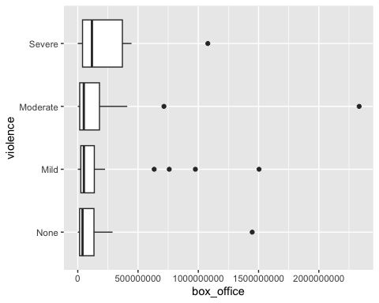

Spearman Test H5
## Warning in cor.test.default(x = mf[[1L]], y = mf[[2L]], ...): Cannot compute
## exact p-value with ties
##
## Spearman's rank correlation rho
##
## data: violence_coded and box_office
## S = 36711, p-value = 0.3534
## alternative hypothesis: true rho is not equal to 0
## sample estimates:
## rho
## 0.1188849

Findings H5
There is no real correlation between violence score and Box Office revenue for Academy Award Best Picture nominees, because p = 0.354. PLEASE CHECK.

