Sprint 1 - Endurance Design Document

October 28, 2024

Table of Contents

1. Executive Summary 2

1.1 Project Overview 2

1.2 Purpose and Scope of this Specification 2

2. Product/Service Description 2

2.1 Product Context 2

2.2 User Characteristics 2

2.3 Assumptions 2

2.4 Constraints 2

2.5 Dependencies 2

3. Requirements Error! Bookmark not defined.

3.1 Functional Requirements 2

3.2 Security 3

3.2.1 Protection 3

3.2.2 Authorization and Authentication 3

3.3 Portability 3

4. Requirements Confirmation/Stakeholder sign-off 3

5. System Design 4

5.1 Algorithm 4

5.2 System Flow 5

5.3 Software 5

5.4 Hardware 6

5.5 Test Plan 6

5.6 Task List/Gantt Chart 6

5.7 Staffing Plan 6

# Executive Summary

## Project Overview

In this project, we are piloting a mini robot around a specific rectangular course set up. The intended audience is anyone who has an interest in beginner coding and wants to start learning.

## Purpose and Scope of this Specification

The purpose of this specification is to introduce people to beginner programming and physically see the results of some simple work. Our main in-scope goal was to stick to the planned course accurately, but as we worked, we developed the out-of-scope goal of ensuring proper orientation for the robot in order to make this journey possible.

# Product/Service Description

General factors that affect the program and its requirements are access to the software, Bluetooth compatibility to connect to the robot, access to a testing space for the program. Without access to the software required, we cannot develop or test this program. We can code on a device without Bluetooth capabilities, but you need a device with these capabilities in order to connect to the robot. Additionally, you need access to the testing space to ensure that your design accurately reaches all goals.

## Product Context

This project is widely related to a variety of other coding projects. A similar approach can be used for other courses you want your robot to tackle such as the figure 8 or obstacle course. Every project utilizing the Sphero robots uses the Sphero Edu software and coding inside to connect and control the robots. These projects can be shared with other people for them to enjoy too.

## User Characteristics

People who will be utilizing this project are beginner programmers who are looking to learn more and get comfortable with block code. This could be students or the public. They don’t have any experience but should have some general expertise.

## Assumptions

Our robot must be charged and ready to sync up to our devices. We must also be familiar with the coding software that connects to our robot. The Sphero Edu software must be available to use and not have any server issues. Additionally, the testing room must be available for us to conduct testing

## Constraints

You must have access to the Sphero Edu software and a device that is compatible with it. This project isn’t nearly large enough to have any impact on disk space or other hardware limitations. Your device must have Bluetooth capabilities in order to connect with the robot. This program should be easily accessible by anyone with this software. No data encryption is required.

## Dependencies

Basic coding based on the algorithm is required before the endurance testing, including ENDUR_01 – 03, can be taken. ENDUR_04 – 06 can only be confirmed once the coding software is downloaded and properly connected. In order to for the robot to track and run, it needs its built in sensors so it can properly calibrate to the aim you want. People must understand how to use the software for any of these requirements to be fulfilled

## Functional Requirementsf

| Req# | Requirement | Comments | Priority | Date Rvwd | SME Reviewed / Approved |
| --- | --- | --- | --- | --- | --- |
| ENDUR_01 | Get back to the starting point | This is the main goal of the program | 1 | 10/28 | 10/28 |
| ENDUR_02 | Don’t leave the taped path | The main requirement is to stay on track an on the taped path | 2 | 10/28 | 10/28 |
| ENDUR_03 | Delays are included for stability | This will give the robot time to fully stop and prevent it from going off course | 2 | 10/28 | 10/28 |
| ENDUR_04 | Robot is ready | The robot must be charged and connected to our devices to test our code | 1 | 10/29 | 10/29 |
| ENDUR_05 | Sphero Edu software is running correctly | The software must be working properly for us to code, connect to our robot, and test | 1 | 10/29 | 10/29 |
| ENDUR_06 | Properly set the robot’s aim | If the robot is not aimed directly forward in line with the path, it will veer off course | 1 | 10/29 | 10/29 |

## Security

### Protection

# All progress was logged, and data integrity was checked along the way to ensure that there wasn’t any unintended access or modification

### Authorization and Authentication

The software used to develop and execute this program doesn’t require any authentication, as it isn’t very important and can be easily replaced if compromised. It’s simply block code inside of a coding app that controls robots, which aren’t very useful if hacked.

## Portability

All of the code is not very host-dependent due to the block code only working inside of the Sphero Edu software. Block code isn’t as portable as most text codes. A specific operating system isn’t required, as anything that can run Sphero Edu is all you need to complete this project alongside the robot.

# Requirements Confirmation/Stakeholder sign-off

|  |  |  |
| --- | --- | --- |
| Meeting Date | Attendees (name and role) | Comments |
| 10/28/2024 | Sami (debugger), Ethan (coder), Gavin (documenter) | Confirmed all except ENDUR_04, 05, and 06 (not talked about yet) |
| 10/29/2024 | Sami (debugger), Ethan (coder), Gavin (documenter) | Everything confirmed |

# System Design

## Algorithm

* On the start of the program, roll forward at 122.5 speed for (blank) seconds at a 0-degree angle
* Delay for two seconds
* Roll forward at 122.5 speed for (blank) seconds at a 90-degree angle
* Delay for two seconds
* Roll forward at 122.5 speed for (blank) seconds at a 180-degree angle
* Delay for two seconds
* Roll forward at 122.5 speed for (blank) seconds at a 270-degree angle

## System Flow

(blank)

(blank)

(blank)

(blank)

(blank)

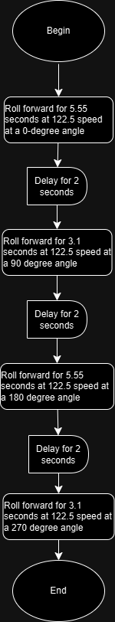

## Software

We utilized block coding, the Sphero Edu application platform, and a Sphero Bolt to develop, debug, and deploy this application.

## Hardware

The hardware platforms we used to develop this project were our laptops, which contain hardware components such as CPUs, motherboards, power supplies, SSDs, and memory

## Test Plan

| **Test Date** | **Expected Output** | **Observed Output** | **Staff Name** | **Pass/Fail** |
| --- | --- | --- | --- | --- |
| 11/1 | Slight overshot of the end point | Slight overshot of the end point | Ethan | Fail |
| 11/1 | Slight overshot of the endpoint | Slight overshot of the end point | Sami | Fail |
| 11/1 | Accurate length achieved | The robot undershot the length of the path | Ethan | Fail |
| 11/1 | Accurate length achieved | The robot undershot the length of the path | Sami | Fail |
| 11/1 | Accurate length achieved | The robot rolled the proper distance | Ethan | Pass |
| 11/1 | Accurate length achieved | The robot rolled the proper distance | Sami | Pass |
| 11/1 | Accurate path taken | The robot stayed on path and reached the end goal | Ethan | Pass |

## Task List/Gantt Chart

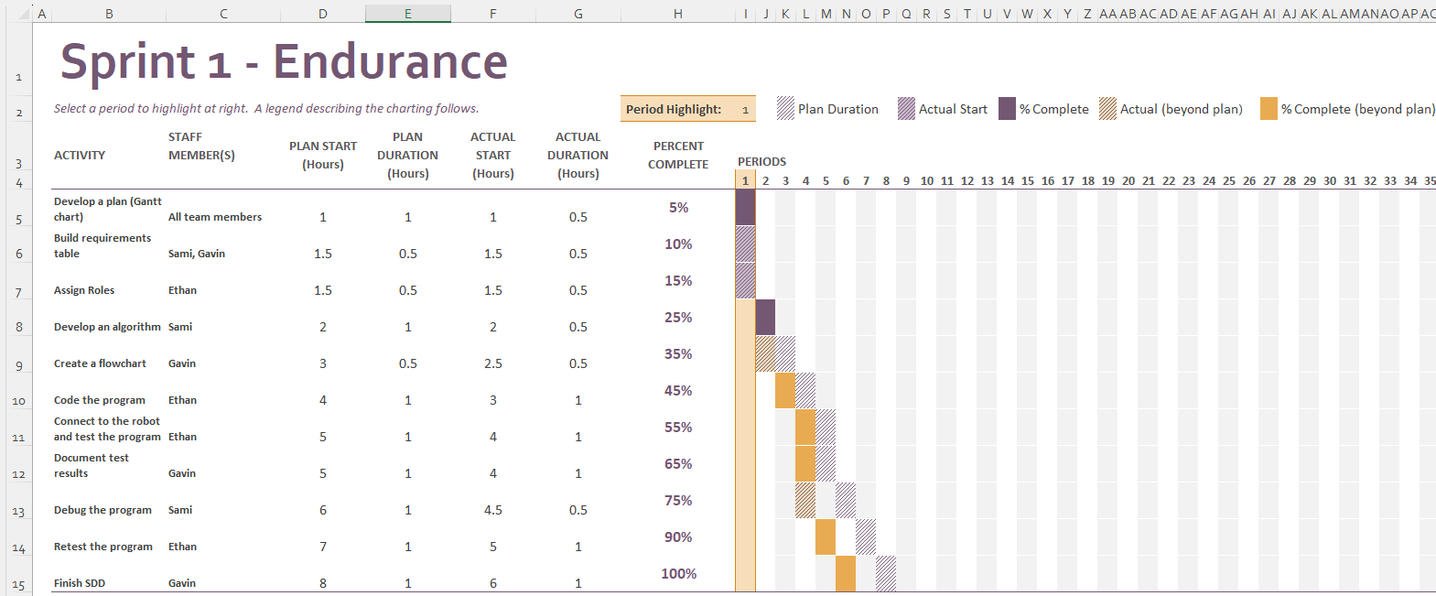

## Staffing Plan

| Name | Role | Responsibility | Reports To |
| --- | --- | --- | --- |
| Ethan Willard | Coder / Tester | Use the algorithm to develop the code and test it | Himself (Group Leader) |
| Sami Shah | Tester / Debugger | Debug any issues with the code and assist with testing again | Ethan |
| Gavin Rossi | Algorithm Writer and Logger | Develop the algorithm, log results of tests | Ethan |