SYLLABUS

ECE3 Fall Quarter 2021

**NOTE: lectures and labs in this course will be in-person. However, we have some students who cannot come to campus. Therefore, all lectures will be recorded using Zoom and posted on CCLE. All lab sections, while being held live in Engrg IV 18-132J, will also be simultaneously streamed via Zoom. Stay tuned for more details.**

**NOTE FURTHER: all UCLA rules regarding COVID-19 will be enforced. As of September 8, this means that to gain admittance to the lecture room or lab, all students must have received clearance to enter the building, and must wear a mask while inside the building. If you cannot meet these two requirements, then please do not come to lecture or lab.**

**Lab Equipment:** [**Analog Discovery 2**](https://digilent.com/shop/analog-discovery-2-100ms-s-usb-oscilloscope-logic-analyzer-and-variable-power-supply/) **units are available at the SEL Loan Desk (Boelter 8th floor). Circuit components needed for conducting lab experiments will be made available. Project cars are available at the Powell Library.**

Instructor: Dr. Dennis M. Briggs

Teaching Assistants: Xin Li, Tianyi Zhao, Szu-Yao Hung

Lectures (will be recorded): Thursday 8:00 AM – 9:50 AM US Pacific Time

Labs (all times US Pacific Daylight Time; accommodations will be made for those in time zones where the scheduled lab time is awkward):

(1A) Monday 8:00 AM-9:50 AM

(1B) Monday 10:00 AM-11:50 AM

(1C) Tuesday, 8:00 AM-9:50 AM

(1D) Tuesday, 10:00 AM-11:50 AM

(1E) Thursday, 12:00 Noon-1:50 PM

(1F) Friday, 8:00 AM-9:50 AM

(1G **currently closed**) Friday 10:00 AM-11:50 AM

Final Exam: Tuesday, December 7, 2021, 8:00 AM-10:00 AM (Accommodations will be made for those in time zones where 8:00 AM PST is awkward.)

Office Hours: Monday 5:00 PM-6:00 PM, Thursday 7:00 PM-8:00 PM, both US Pacific Time, both via Zoom. Also, other times by appointment.

**Content**

The course is an introduction to EE fundamentals. Both theory and hands-on experience are presented to provide technical explanation of (tentative schedule; all remote via Zoom):

–Lectures 1&2: Circuits

−Lecture 3: Transients

−Lecture 4: Project Details

–Lecture 5: Motors, Generators, and The Electrical Grid

–Lecture 6: Devices: PN-junction and Logic

–Lecture 7: Systems and Control

–Lecture 8: Telecommunications

−Lecture 9: Instrumentation with Grounding and Power

−Lecture 10: Technology Trends and The Funny Farm

The overall goal is to become familiar with concepts described in lecture, learn about instruments and components, and produce a working design, plus provide a basic understanding of the great EE inventions and those to come. I will be including some historical details during lectures, and talk about current and future trends in EE.

The project is an autonomous path-following mobile robot. Your team will be lent a robot, which you will program to follow a prescribed path. 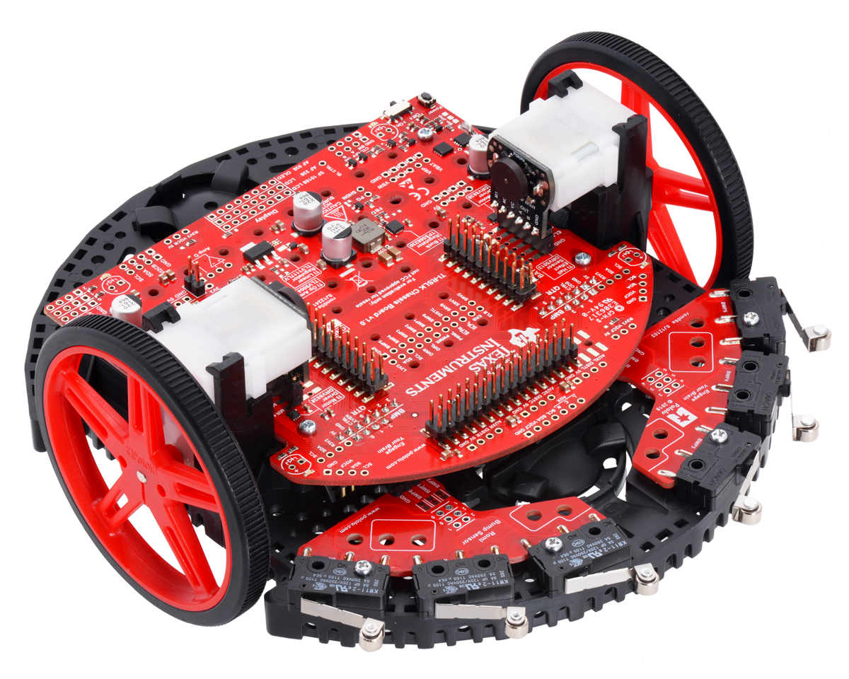

After four weeks of normal lab experiments to illustrate equipment and device operation, there will be five weeks to work on the project. Race Day is in Week 10. (It's not really a race; we take times merely for bragging rights. The only requirement is to finish the course.)

**Grades**

* Course Evaluation Survey 2%
* Labs 13%
* Project 50% or 60%, depending on Final Exam percentage
* Quizzes 10%
* Homework 10%
* Final Exam 15% or 5%, depending on which yields the higher final score

**Quizzes (lasting 10 minutes)**

–2nd through 9th meeting, at start of class

**Project**

–Evaluation based on performance at end, and in final written reports.

–Labs and project illustrate concepts presented in lecture

**Textbook/Equipment Requirements**

There is no required textbook for this course. Any basic circuits textbook in the SEL stacks is good. There are many on-line references as well (be sure that the references you use are authoritative!).