Ethan Wright

5 August 2023

Alphabet Soup Neural Network Report

**Overview**:

The purpose of this analysis was to create a machine learning tool designed to help Alphabet Soup select the applicants for funding with the best chance of success in their ventures. The goal was for the predictive model to achieve an accuracy level >= 75% on the test set. By funding applicants with a higher likelihood of success, Alphabet Soup will attain a better return on investment (ROI) thereby optimizing their use of financial resources and overall business success.

**Results**:

* Data Preprocessing:
  + The target variable for our model is “IS_SUCCESSFUL”, the binary numerical field indicating whether or not the project was successful.
  + The features for our model are: 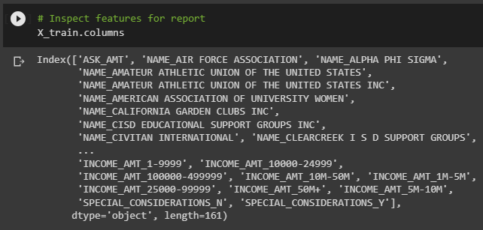
  + “EIN” was removed from the input data, because it was not a target or a feature.
* Compiling, Training, and Evaluating the Model
  + How many neurons, layers, and activation functions did you select for your neural network model, and why?
    - We arbitrarily selected the number neurons and layers with logical intuitive heuristics drawn class and extracurricular research. Relu was chosen as the activation function for the input and hidden layers in order to best identify discrete patterns in our data. Sigmoid was selected for the output layer because of the binary nature of the problem at hand.
  + Were you able to achieve the target model performance?
    - Yes! We were able to achieve the target performance, but only with NAME included as a feature.
  + What steps did you take in your attempts to increase model performance?
    - Deployed a RandomForestClassifier to find feature importance and subset the model’s input features accordingly.
    - Added a drop layer in an attempt to prevent overtraining.
    - Added multiple drop layers.
    - Used hyperparameter tuning in an attempt to find the best neural network for the problem.
    - Reintroduced NAME into the set of features to successfully create, train, and deploy a model with an accuracy score of 76%.

1. **Summary**: Summarize the overall results of the deep learning model. Include a recommendation for how a different model could solve this classification problem, and then explain your recommendation.
   1. The final version of this deep learning model predicts the historical success of Alphabet Soup’s affiliate non-profit organization’s campaigns with a 76.43% accuracy rate on the test dataset.
   2. A Support Vector Machine (SVM) could solve this classification problem too. They are also good at binary classification problems, particularly those where the data is linearly separable.