Sean Kennedy - Homework 6

# Question 1:

1. 



µ1, µ2, µ3, µ4, and µ5, are the mean scores in the none, amputee, crutches, hearing, and wheelchair groups respectively. Be careful when identifying ‘k’ here. This study is mentioned throughout Chapter 6 of Statistical Sleuth.

# Construct Simultaneous CLs using Bonferroni Method:

DF = 65 (number of observations – number of groups = 70-5)

k = 3 (3 pre-planned comparisons)

Calculate pooled Standard Deviation (Excel)

|  |  |  |  |
| --- | --- | --- | --- |
| s | s-pooled |  |  |
| 1.706 | 1.633 |  |  |
|  | Sample DF | Sample Std Dev | Group Mean s |
| None | 13 | 1.794 | 4.90 |
| Amputee | 13 | 1.586 | 4.43 |
| Crutches | 13 | 1.482 | 5.92 |
| Hearing | 13 | 1.533 | 4.05 |
| Wheelchair | 13 | 1.748 | 5.34 |
|  |  |  |  |
| Standard Error for any two comparisons (all sample sizes are equal) | | | |
| 0.617 |  |  |  |

Critical t = 2.458 (SAS)

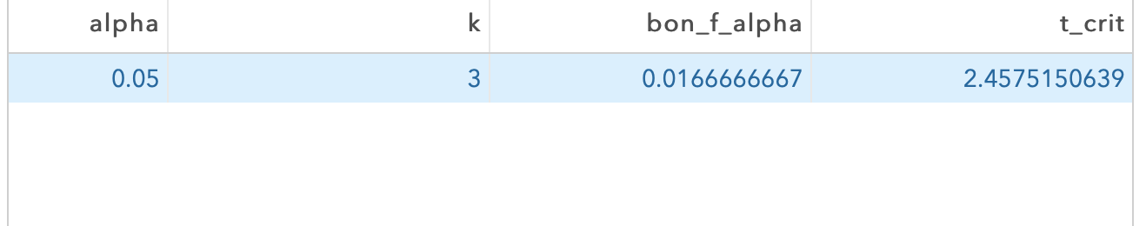

|  |  |  |  |
| --- | --- | --- | --- |
| t-critical (bf) | 2.458 |  |  |
| 95% CL interval width (bf) | 1.517 |  |  |
|  |  |  |  |
|  |  | 95% CL Lower | 95% CL Upper |
| m2-m3 | -1.49 | -3.010 | 0.0242 |
| m2-m5 | -0.91 | -2.431 | -0.9143 |
| m3-m5 | 0.58 | -0.938 | 0.5786 |

# Question 2: Verify the Simultaneous CLs for Each Test

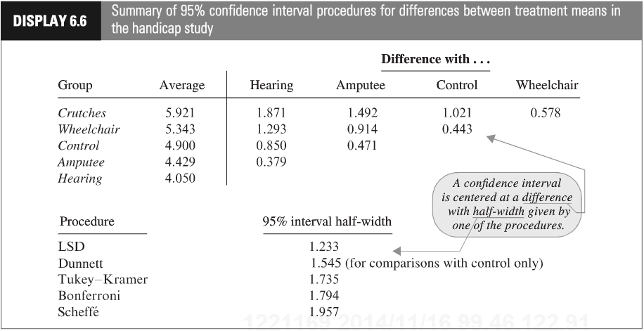

Using SAS:

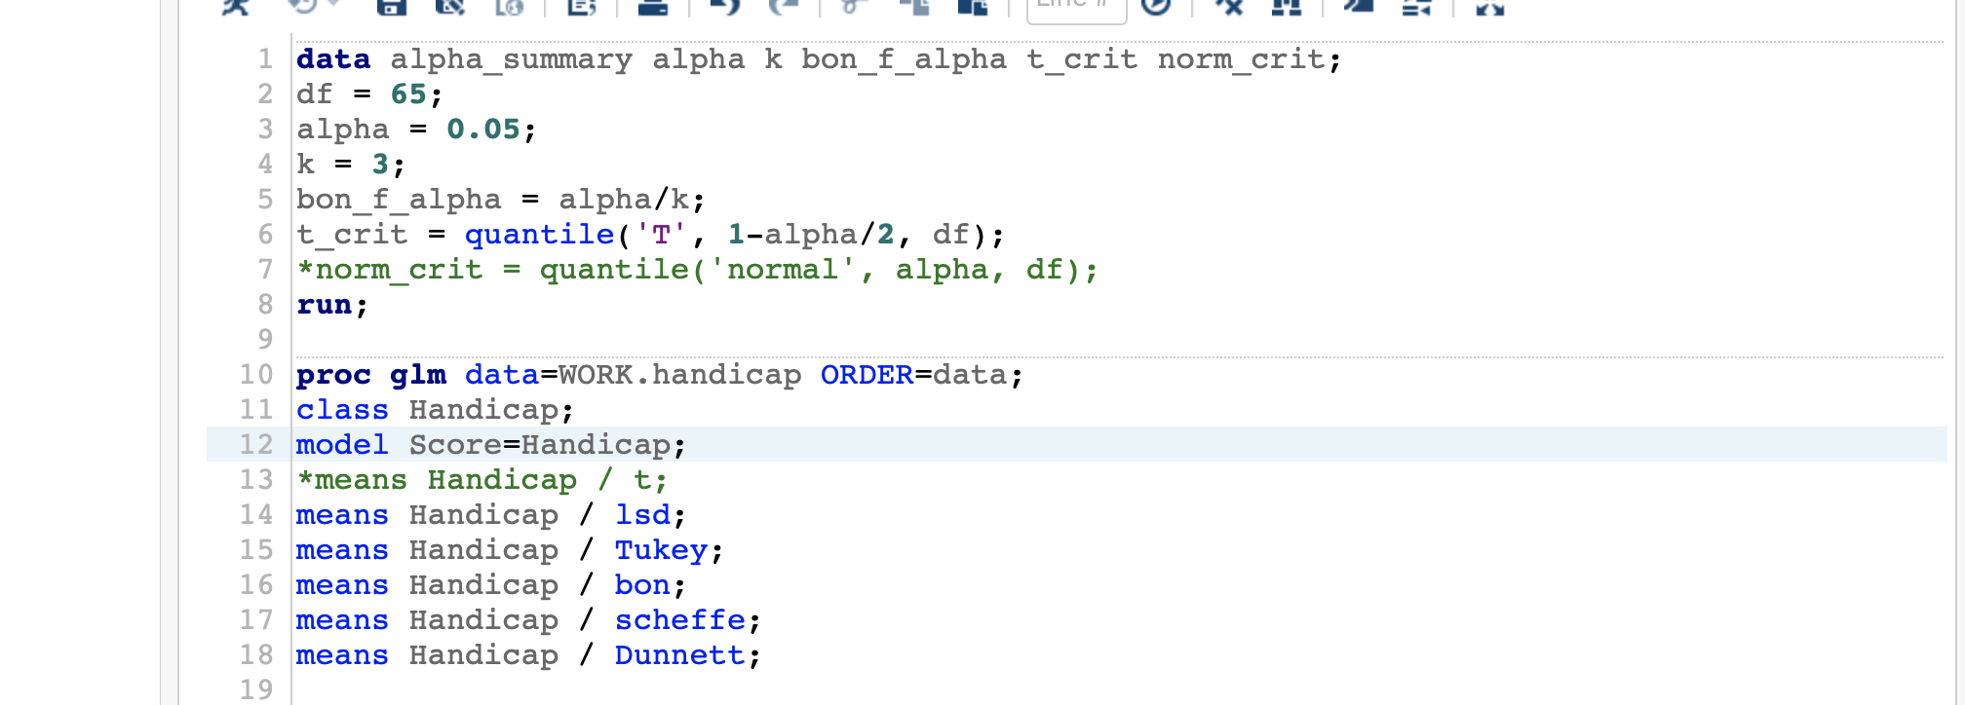

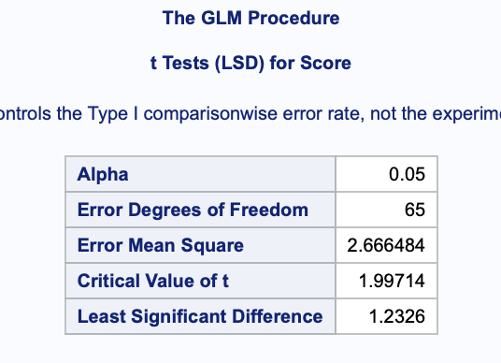

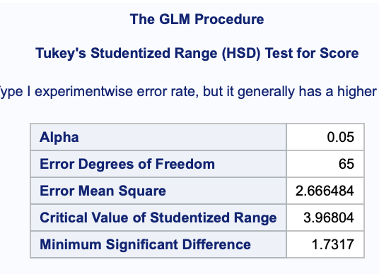

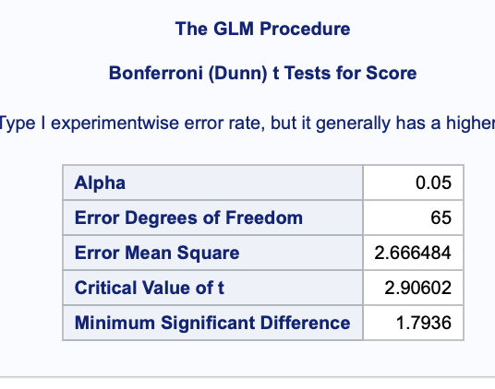

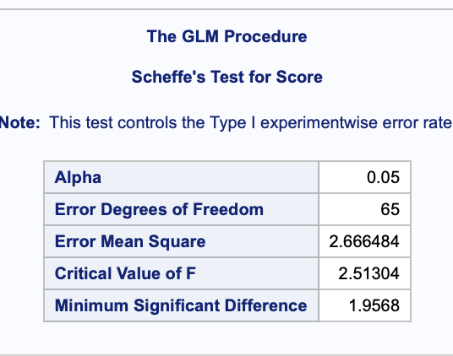

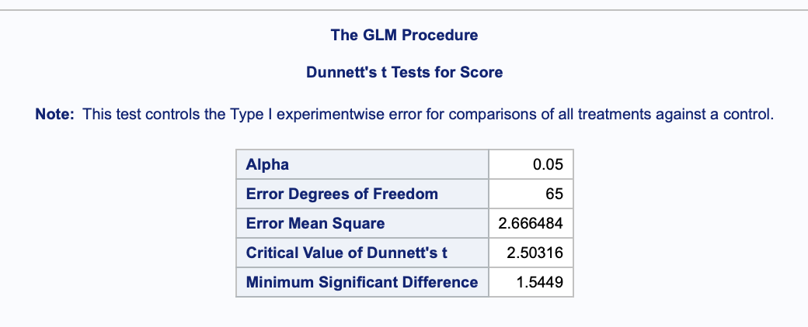

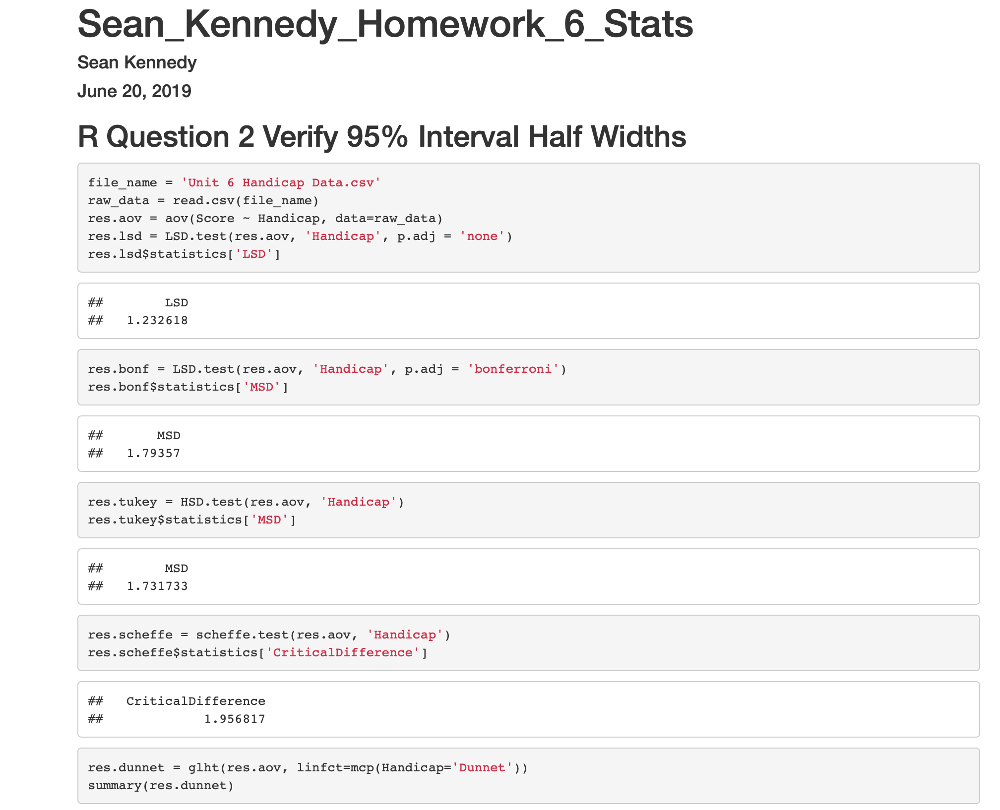

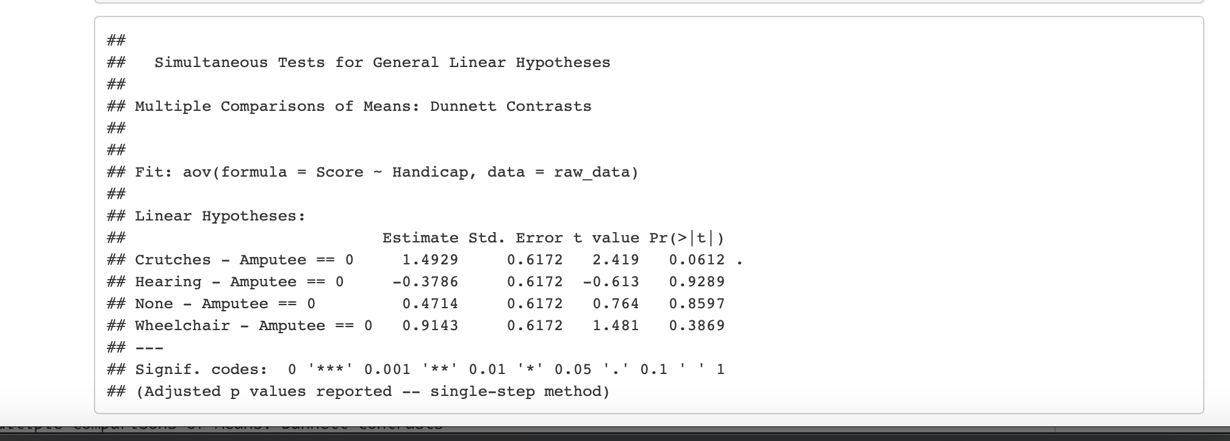

## Question 3:

Running the analysis in SAS to answer the question: *How strong is the evidence that at least one of the five population distributions (corresponding to the different years of education) is different from the others?*

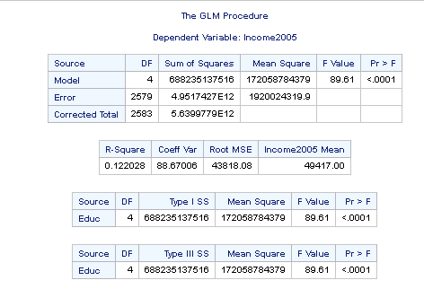

Given the extremely high F value (89.51) and extremely small p-value (p<0.0001) – it is highly likely that at least one of the means in the groups of education levels is different.