Sean Kennedy – Midterm DS-6371

Multiple Choice:

1. **B**
2. **C**
3. **FALSE**
4. **B**
5. **TRUE (is this worded poorly? Seems like an extra word in there…)**
6. **FALSE**
7. **A**
8. **D**
9. **D**
10. **(were there only 9)?**

# Question 1:

## State The Problem:

In order to assess the level of concern surrounding global warming , a random sample of 188 citizens from 6 different countries were given a survey and asked to rate the seriousness of the potential issue of global warming. Participants were asked to rate their responses according to the following scale:

***0*** *= not serious as all … global warming is the least of our concerns … even if it is real, it does not pose and economic or environmental threat in the least.*

***50*** *= it should constantly monitored and studied but there is no need to make any drastic changes to energy sources (aka fossil fuels) , or environmental choices (deforestation, beef production, airline travel) that are thought to be influencing the climate.*

***100*** *= needs urgent attention immediately … left unaddressed global warming will soon become an imminent threat to the survival of most life on Earth.*

The first QOI is whether or not there is a significant difference in the mean rating of males versus females. In order to analyze this question, we will undertake a two sample t-test to compare the means of these two groups.

## Check the Assumptions:

* Normality:

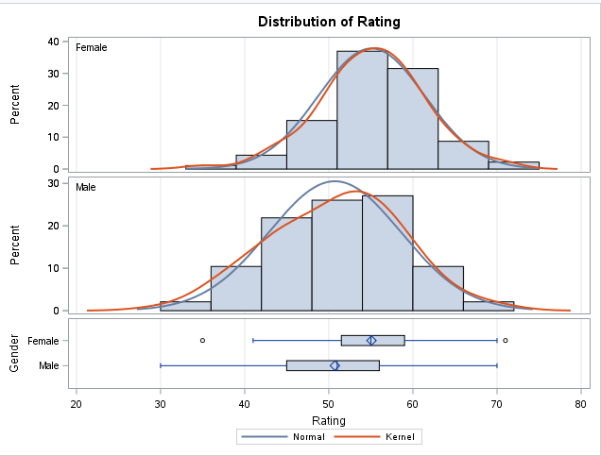

From the histograms above, the data appear normally distributed. Male data shows evidence of slight positive (right) skew, but not enough to violate normality assumption.

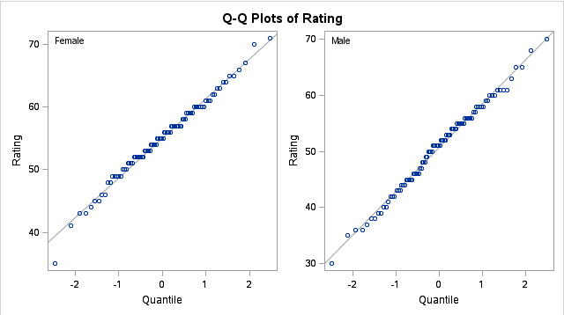

Q-Q Plots are also approximately linear.

* Sample sizes:

Both are large enough to invoke the CLT (>30)

* Equal Variance:

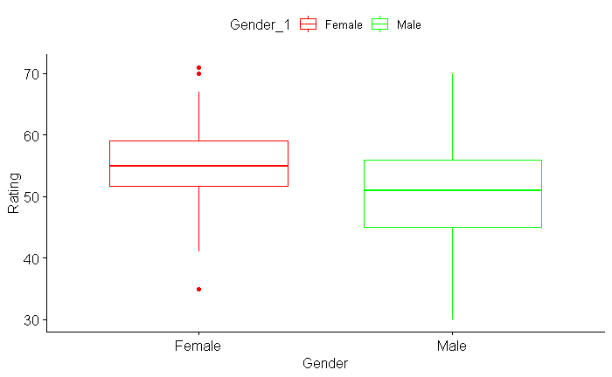

Box plots above show that visual evidence exists for unequal variances (interquartile ranges are different), as does numerical evidence (folded F-Value < alpha). Accordingly – we will be conservative and use the Satterthwaite approximation for unequal variances. Though this seems to have minimal impact on the outcome of the test.

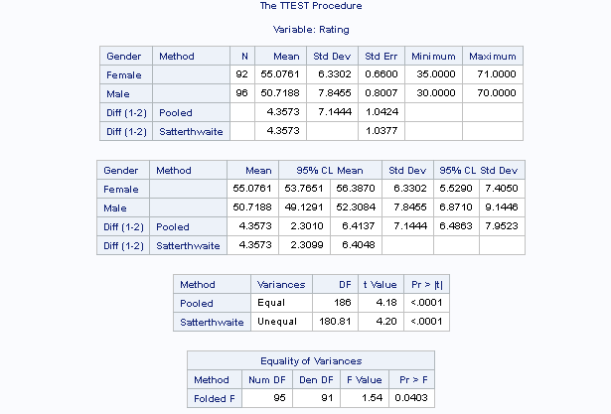

# 6-Step Hypothesis Test:

## Hypotheses:

*Null Hypothesis* H0: Means are equal m1=m2

*Alternative Hypothesis:* Ha: m1<>m2

## Critical Value:

From t-distribution (df = 180.81, alpha=0.05) gives tcrit = +/-1.973

2-sided

## Test Statistic:

T = 4.20 (Satterthwaite approx)

## P-Value:

2-side p value <.0001

## Decision:

Reject H0 (means are not equal)

## Conclusion:

The results of our analysis in the previous section show strong evidence in favor of rejecting the null hypothesis of the mean rating between men and women to be zero. With a 2 sided p-value of <0.0001 from a Welch’s two sample t-test we were able to establish a 95% CL (alpha = 0.05) that puts the mean difference in ratings between 2.301 and 4.357 (males rated higher on average).

## Scope of Inference:

Since the selection of participants was at random, we can extend the result to the larger population of males and females. But because the study was observational in nature, no causal inference can be made on the effect of gender and rating.

# Question 2/3a:

Researchers wanted to investigate if there was a significant difference between the rating of any of the countries. Test the claim that there is no difference in the ratings of any of the countries.

## State the problem:

Building off the previous analysis – we now seek to answer the question as to whether the mean rating varies by country. As this is a comparison of multiple group means, we will perform a one-way ANOVA to asses whether any of the group means are different and warrant further investigation.

## Check the Assumptions:

* Normality

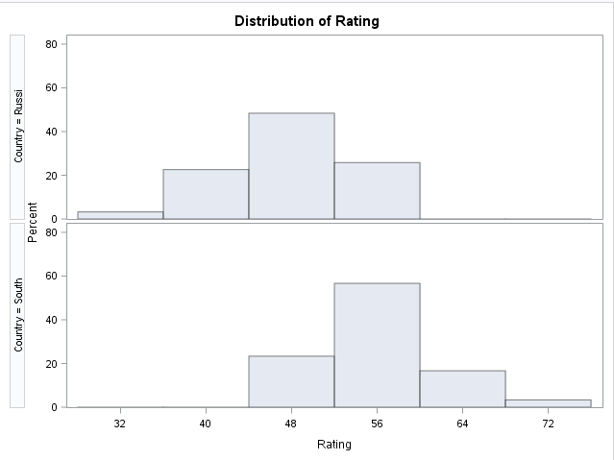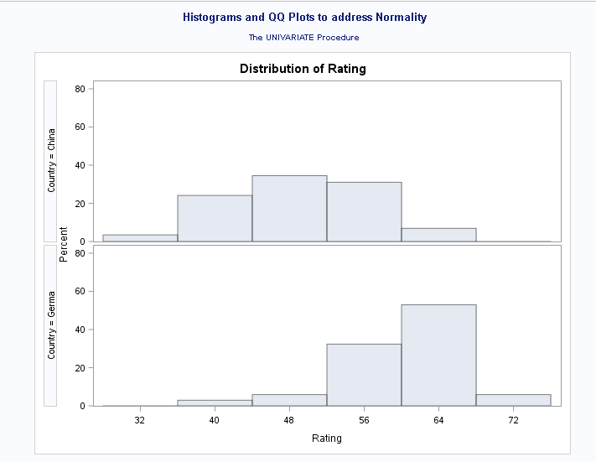

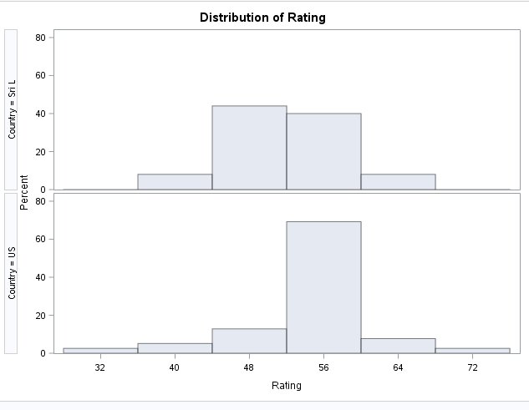

Assumptions of normality appear suspect for Germany, Russia and South Africa. QQ plots confirm.

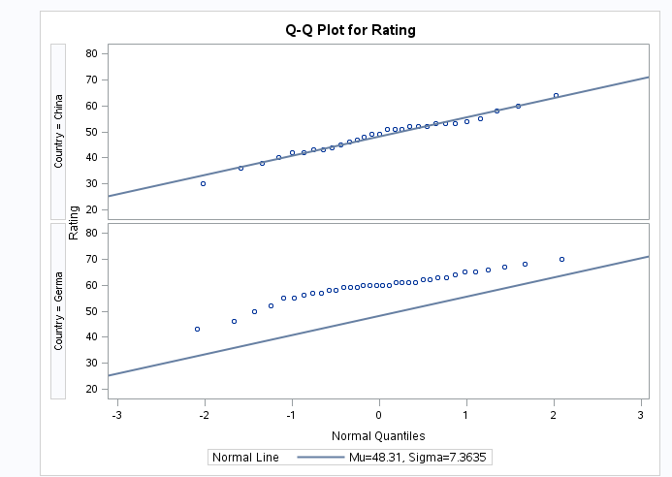

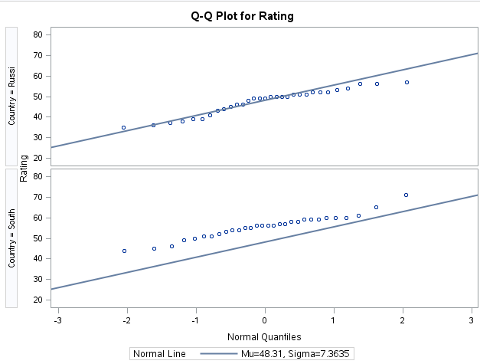

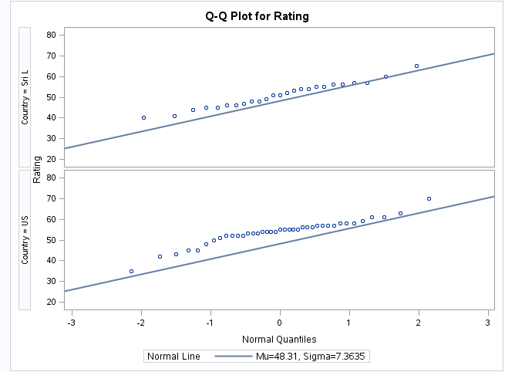

* Equal SD:

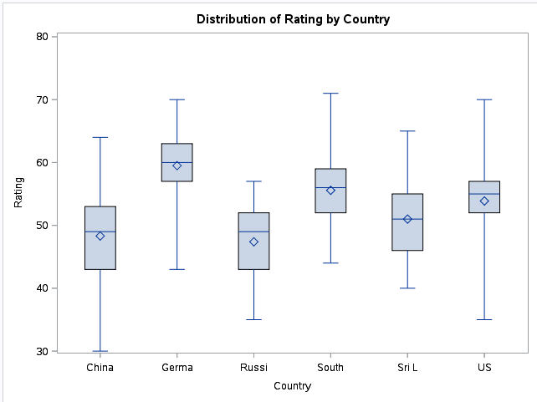

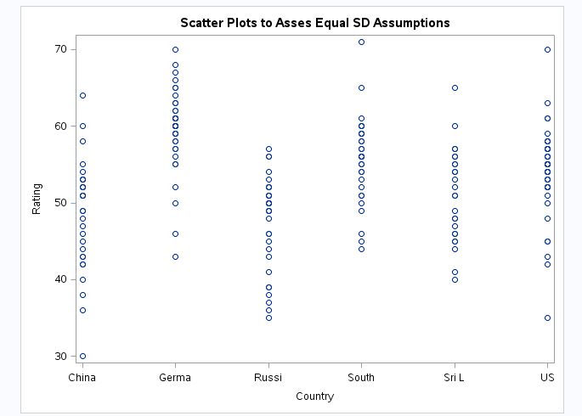

Assumptions of equal standard deviations are also sketchy, at-best. Some countries are skewed, others are not. We will proceed as if SD are not equal.

* Independence

There is no reason to assume that the opinion of any individual is dependent on country.

To be safe, we will run the Tukey-Kramer HSD to make an inference on the means

# 6-Step Hypothesis Test:

## Hypotheses:

*Null Hypothesis* H0: all means are equal m1 = m2 = m3 = m4 = m5 = m6

*Alternative Hypothesis:* Ha: one pair of the mi is different

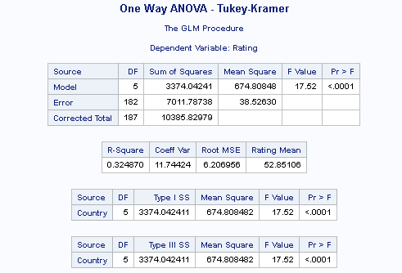

## Critical Value:

NONE - ANOVA

## Test Statistic:

F-Value 17.52

## P-Value:

p value <.0001

## Decision:

Reject H0 (means are not equal)

## Conclusion:

The results of our analysis in the previous section show strong evidence in favor of rejecting the null hypothesis of the mean rating across countries being the same. With p-value of <0.001 from a Tukey-Kramer ANOVA. The observed F Value of 17.52 would be extremely unlikely were the null hypothesis true. As such – we can assume some structural difference among group means and calc confidence intervals to see which groups show significant difference. Simultaneous 95% confidence intervals adjusted according to the TK process are below:

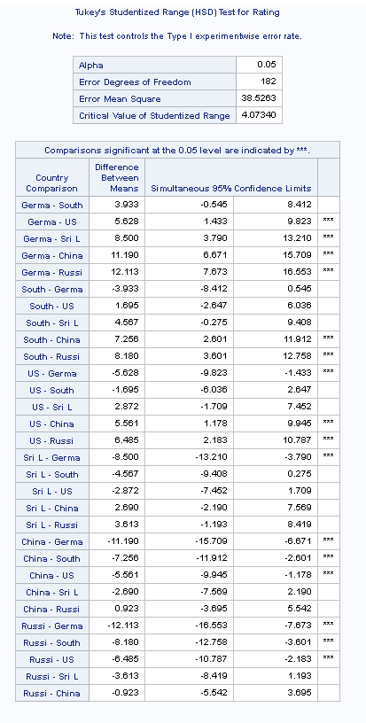

Adjusting our CL levels outward to account for simultaneous estimations of confidence (critical t of -1.97 w/ 182 DF) brings our multiplier for the 95% CL out to 4.07. At this CL, we see significant (zero is not in CL) differences between the following pairs:

* Germany/Russia
* Germany/Sri Lanka
* Germany/US
* Germany/China
* South Africa/China
* South Africa/Russia
* US/China
* US/Russia
* China/South Africa

The largest difference amongst these pairs is between Germany and Russia, with a mean estimated difference of 12.133 points with an associated (adjusted) 95% CL of 7.673-16.553 points

## Scope of Inference:

Since the selection of participants was at random, we can extend the result to the larger populations in each country. But because the study was observational in nature, no causal inference can be made as to the effect of country on rating.

## Question 4:

The researchers were also interested in investigating the difference in rating of the seriousness of global warming between communist and non-communist countries. Use a contrast to test for this difference. You may consider China and Russia to be communist and U.S., Germany, Sri Lanka and South Africa to not be communist. Again, quantify your uncertainty with confidence intervals where appropriate.

## Hypotheses:

*Null Hypothesis* H0: Average of Communist Countries = Average of Non-Communist:

In SAS – Contrast Equation: (note that China and Russia occupy spots 1 and 3 respectively)

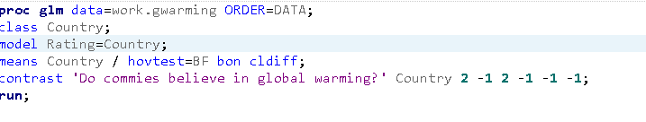

*Alternative Hypothesis:* Ha: Average of Communist Countries <> Average of Non-Communist



## Test Statistic:

F-Value 53.49

## P-Value:

p value <.0001

## Decision:

Reject H0 (means are not equal)

## Conclusion:

The contrast test provided strong evidence of mean difference in sentiment for communist vs non-communist countries. This leads us to believe that the amount and type of information disseminated on the topic of Global Warming by communist governments may be different than those of non-communist countries. Indeed it was the case that the mean scores for china and Russia were lower than those of their non-communist counterparts. This could be due to the fact that government control of information in those countries leads to a population that is overall less informed on matters of scientific importance.