ECE-UY 3613, Spring 2024, Quiz 3
Name: ID:
- a) how does TCP detect corrupted bits in a received TCP segment?
b) what are the two mechanisms TCP use to detect packet losses? how does TCP change its congestion control window immediately after each type of packet loss detection?
Answer: a) TCP uses checksum field in the TCP header to detect bit corruption.
b) TCP can detect packet loss using either time-out, or triple duplicate ACKs.
After a timeout loss, TCP reduces its congestion window to 1, then do slow-start; after a triple-dup-ACK loss, TCP reduces its congestion window by half, then enter congestion avoidance.
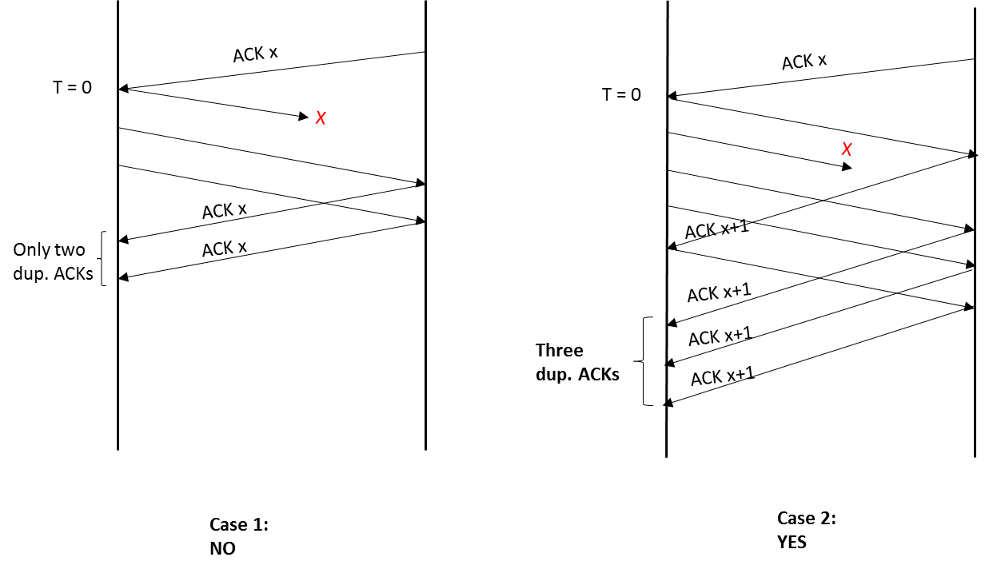
- If a TCP connection’s congestion control window is 3 segments at time t=0. Assuming the receiver has infinite receiving buffer and the sender always has data to send. (In other words, the sender can send out as many segments as the congestion window allows.) If the first segment is lost, will the TCP sender resend the lost packet through fast-retransmit? Explain why or why not. Repeat the question if the congestion window is 4 at time t=0 and the second segment is lost.

