Project Plan

IS683 – Final Project

NJIT

Table of Contents
1. Introduction 3
1.1 Foreword 3
1.2 Background 3
2. Project Organization 3
2.1 Development Model 3
2.2 Project Team 4
3. Risk Analysis 5
4. Hardware and Software Requirements 5
5. Schedule and Breakdown Structure 6
6. Market and Design Research 7

1. Introduction

1.1 Foreword
The purpose of this document is to provide information about the IS683 – Final Project. It will include the project schedules, risks, project team, and the work break down structure. This plan will:
- Provide a general product description.
- Identify required resources.
- Identify schedules and activities to be performed.

1.2 Background
As diseases affect all life, the study of them is widely performed to understand their origins, cause and cessation. With regard to human life, the information gained from tracking disease outbreaks helps to facilitate successful administration of prophylaxis. In some cases, this prevention may lead to complete eradication.
In most cases, the data collected regarding various disease activity remains in textual forms, reports or static charts. An easily absorbed form of disseminating data through which to identify the patterns and linkages between regions, people and disease may be beneficial to those dealing with this data. As a result this project will attempt to first isolate the basic linkages between diseases. Time permitting, the visualization will be further expanded to include links between people, then region.

2. Project Organization

2.1 Development Model

2.2 Project Team
The table below lists the members of the XXX project team. The project Team consists of xxx

Project Team
Eric Bauer (Project Management, Developer, Tester)
Alex Koshy (Developer, Tester)

3. Risk Analysis

3.1 Risk Analysis
Risk | Affects | Descriptions
EB – node.js | Raw | This is the first Eric is working with this technology
EB - mongoDB | Raw | This is the first Eric is working with this technology
EB – D3.js | Inexperienced | Library is based in JS which Eric has experience
AK - HTML | Inexperienced
AK - CSS | Inexperienced
AK - D3.js | Raw

3.2 Risk Analysis (i)
Risk | Probability | Effects
EB – node.js: Unable to stream data | Medium | None
EB – mongoDB: Unable to create relational data sets | High | Cannot create more complex visualizations
EB – D3.js : Unable to layer visualizations | High | Result of project becomes simplified, less valuable
AK - HTML
AK - CSS
AK - D3.js

3.2 Risk Analysis Strategy
Risk | Solution / Mitigation
EB – node.js: Unable to stream data | Read all data immediately.
EB – mongoDB: Unable to create relational data sets | Begin with basic visualization which does not require multiple layers and relations.
EB – D3.js : Unable to layer visualizations
AK - HTML
AK - CSS
AK - D3.js

4. Hardware and Software Requirements

Hardware:
- Supplied through professor.
- Server-side work to be performed via invengion.org SSH connection or IDE with remote file capabilities.

Software:
- Open-source, and freely available via the web.
  - mongoDB
  - node.js
  - D3.js
  - Unidentified IDE, vi, vim

5. Schedule and Work Breakdown Structure

See graph below. Refer to Shedule_Work_breakdown.xlsx for editable content
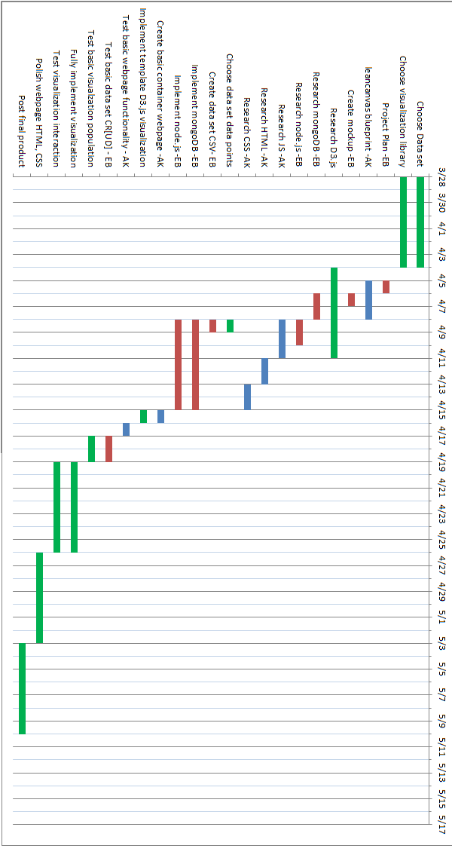

6. Market and Design Research

