Disease associations

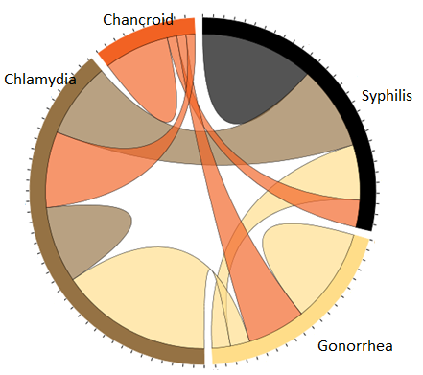

Eric Bauer

Alex Koshy

As diseases affect all life, the study of them is widely performed to understand their origins, cause and cessation. With regard to human life, the information gained from tracking disease outbreaks helps to facilitate successful administration of prophylaxis. In some cases, this prevention may lead to eradication.

Data collected regarding various disease activity often remains in textual forms, reports or static charts. An easily absorbed form of disseminating data through which to identify the patterns and linkages between regions, people and disease may be beneficial to those dealing with this data.

The above graphic will attempt to first isolate the common links between diseases. A hover-over of a disease name will isolate it and the links made to all other diseases within an entity.