SINGAPORE POLYTECHNIC
SCHOOL OF COMPUTING

COMMON INFOCOMM TECHNOLOGY PROGRAMME (Year One) DIPLOMA IN APPLIED AI AND ANALYTICS (Year One) DIPLOMA IN CYBERSECURITY AND DIGITAL FORENSICS (Year One)
DIPLOMA IN INFORMATION TECHNOLOGY (Year One)

ST0501 Front-End Web Development AY2526S1
CA1 Website Requirements Template

- Home Page

  - Ideation (You can list down a few ideas below)
Have 5 blocks showing all the zero-waste principle.
Have graphs and statistics after
Have real life examples with embedded videos

  - Contents (Include contents that you will be using in your home page)
Refusing
Refusing at its core is just to say NO. Refuse single use plastic - packaging, bags and straws so no unnecessary waste will be generated.
For example, REFUSE single use plastic bags when offered during checkouts, instead bring your own reusable bags.
By doing so, we can reduce the amount of waste generated.

Reducing
Reducing means to use less and NOT waste. The idea is to reduce the use of harmful and non recyclable products.
For example, when printing documents, ensure that both sides of the paper are used. This REDUCES the amount of paper used when printing.
By doing so less paper is used and wasted resulting in reduced waste generation.

Reusing
Reusing or Repurposing is reusing existing products and materials and NOT throw them away.
For example, one can REUSE tin cans for the potting of new plants.
By doing so we can give waste items another purpose and less waste will be generated as items are reused.

Recycling
Recycling is simply to "use something again". Waste material can be broken down into their raw material and be made into another product instead of going to a landfill.
For example, after drinking a bottle of water, the one time use plastic bottle can be thrown into the recycling bin instead of into general waste. This RECYCLES the plastic bottle and allows it to be made into something else that is of use.
By doing so, we can reduce the amount of waste generated and slow down the rate of waste that ends up in landfills.

Composting/Rot
Composting is the managed aerobic (oxygen required) biological decomposition of organic materials by microorganisms. Organic (Carbon based) materials. Compost is obtained after composting. Compost can build soil health and provide nutrients to plants.
For example, after eating a meal, instead of throwing away the leftovers, you can COMPOST them instead and use the compost to grow more produce reducing food waste.
By doing so, we can reduce food waste as they are repurposed as compost to grow more produce and provide food.

In 2022, Singapore generated a total of 6.39 million tonnes of solid waste. Domestic wastes contributes to 1.86 million tonnes. Singapore's population in 2022 was around 5.6 million. Using all these information, we can calculate that every person generates around 332kg of waste every year domestically and around 1141kg per person every year if we include waste per capita.
As seen from the graphs, there is a overall decrease in the amount of waste generated Per Day Per Capita from 2013 to 2023.
However, despite the overall decrease in the amount of waste generated Per Day Per Capita from 2013 to 2023, the overall recycling rate has also decreased from approximately 62% to 52% within the same time frame as seen from the Overall Recycling Rate graph. So what are some things we can do to work towards a ZERO waste lifestyle?
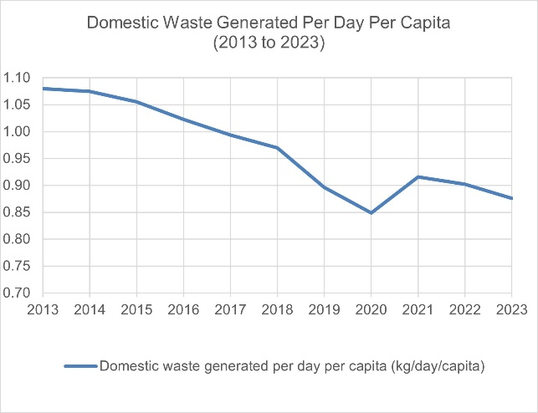
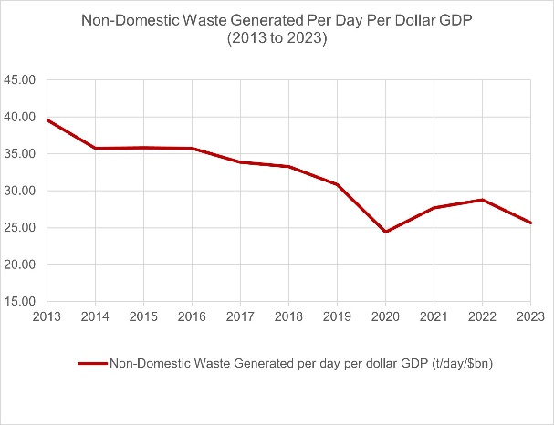
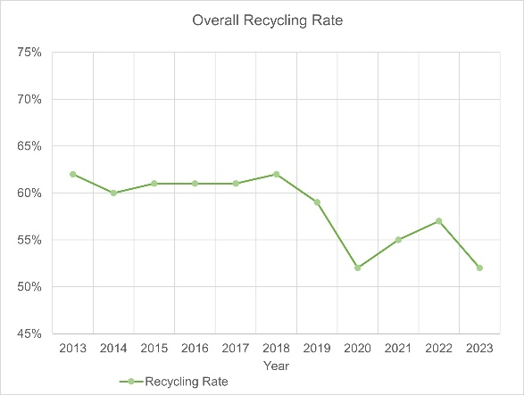
Singapore's first Zero Waste Grocery Store
Unpackt is Singapore's first Zero Waste Grocery and Lifestyle Store. It is a zero-waste bulk store that offer package free shopping and encourages customers to bring their own containers. Items are also sold by weight to ensure customers only get what they need. Products like nuts for example are stored in bulk dispensers. This encourages customers to refill instead of buying new containers. Unpackt also helps reduce food wastages by reselling or giving away 'ugly' produce that are perfectly edible. For example, Unpackt helped save over 100kg of mandarin oranges from being wasted during Chinese New Year. Unpackt usually brings in unsold fruit from wholesalers to prevent wastage. These practices ensure that there are no unnecessary waste produced
Town in a Garden
Tampines is slowly making enhancements and making its community more green and environmentally sustainable, working its way to achieve zero waste step by step. It has a variety of measures put in place to work towards sustainability. One of its measures aims to let its residents reduce food waste. The Town Council works with other stakeholders to manage Sustainability@Tampines Park - Singapore's first community based circular eco-system. Residents contribute food waste to the Black Soldier Fly Facility and this helps support the vertical farm and tilapia fish farm in the vicinity that helps reduce food waste. In Tampines West N8, merchants seperate and contribute food waste to its food waste digester to produce fertilisers. To make recycling more accessible, there is an ample amount of recycling bins for different types of waste. This helps to reduce unnecessary waste overall throughout Tampines.
  - Include a rough sketch of how your home page?

- Personal Aspiration Page

  - Ideation (You can list down a few ideas below)
3 zero waste goals
3 obstacles
3 solutions

  - Contents (Include contents that you will be using in your home page)
Eliminate Single Use Plastics
Goal: Completely Remove Single Use Plastic from daily life
How to Achieve it?
- Replace plastic bags with reusable bags or jute bags when shopping for groceries.
- When taking away food, bring your own reusable containers instead of using the provided single use containers.
- Stop using disposable straws when drinking refreshments, instead bring reusable straws or drink straight from the cup.
Composting Food Waste
Goal: Composting any food waste after every meal
How to Achieve it?
- Buy a food waste compost bin.
- Compost my food scraps after every meal.
- Use composts to grow produce. Produce can be then harvested and eaten.
Declutter Responsibly
Goal: Get rid of unwanted waste without sending them to the landfill
How to Achieve it?
- Donate items to local charity or shelters
- One man's junk is another man's treasure, sell or swap on second-hand platforms
- Recycle electronics through certified e-waste programs
Challenges
By partaking in these Goals to work towards a Zero Waste Lifestyle, there are bound to be challenges. So what are some of these challenges that I might face?
- Eliminate Single Use Plastics:
Lack of convenient alternatives — Many places still default to plastic containers and straws, especially in takeout and delivery. It is easy to forget to bring reusable items or finding myself without an alternative in situations. Some businesses may not even allow outside containers for hygiene reasons.
Compost Food Waste After Every Meal:
Space, odor, and pest control — Composting at home (especially in small apartments) can be tricky. Without proper management, compost bins can attract insects or emit unpleasant smells. Additionally, not having ample outdoor space for composting can be an issue and indoor systems can require upfront investment and maintenance.
Declutter Responsibly:
Limited local donation or recycling options — Not all areas have reliable donation centers or e-waste facilities. Some items (like old electronics or furniture) are hard to give away or expensive to recycle properly. Time constraints can also be an issue when trying to responsibly sort and transport items to the correct locations.
Eliminate Single Use Plastics
Challenge: Lack of convenient alternatives
Solution:
- Pack a small reusable bag with my daily essentials—container, straw, utensils, and water bottle—so that I am always prepared.
- Ask cafes or restaurants if they allow bringing my own containers.
- Start small and build habits: I can focus on one item at a time, then add more swaps gradually.
Declutter Responsibly
Challenge: Limited access to donation or recycling options.
Solutions:
- I can search for local recycling centers, shelters, or donation hubs that accept specific items—some offer pick-up services.
- I can use apps like Carousell or Facebook Marketplace to make it easy to give away or trade items in my area.
- I can plan ahead. Setting aside time monthly to sort items rather than doing it all together at the last minute.

  - Include a rough sketch of how your home page?

- Self-Introduction Page

  - Ideation (You can list down a few ideas below)
1 introduction
1 experience
3 green hacks

  - Contents (Include contents that you will be using in your home page)
👋 Introduction & Passion
Hi, I'm Ethan Chuwa, and I've been on a journey toward eco-friendly living for the past few years. What started as curiosity about cutting down plastic has turned into a full-on lifestyle shift—and now, a passion I carry into everyday decisions. I believe that sustainability isn't about being perfect—it's about being mindful, intentional, and open to change. I care deeply about our planet and believe that with a little creativity, anyone can build a greener, more meaningful way of life. Whether it's through reusing materials, reducing waste, or simply talking about environmental choices, I'm committed to living lighter and helping others do the same.

♻️ My Experiences with Waste Reduction
My journey into low-waste living began when I started noticing just how much single-use waste I was generating—plastic bags, takeaway containers, packaging from online orders. I decided to start small by making just one change at a time: bringing my own bags to the store, saying no to straws, composting kitchen scraps. Over time, these tiny efforts snowballed into a full lifestyle shift. There were definitely challenges. Finding bulk shops wasn't always easy. Some habits took time to form. But each step, even the setbacks, taught me something new. I've joined local community groups, learned to repair instead of replace, and even helped friends begin their own sustainability journeys. What I've learned is that waste reduction is as much about building connection as it is about personal habits—it's about being part of a bigger change.

1. DIY Cleaning Products
One of my most satisfying eco-discoveries has been making my own cleaning supplies. Store-bought cleaners often come in single-use plastic bottles and contain harsh chemicals that aren't always necessary. I now make an all-purpose cleaner by soaking citrus peels in white vinegar for two weeks, then straining and mixing it with water and a few drops of essential oil. It's safe, effective, and smells amazing. Plus, it gives a second life to citrus peels that would otherwise go to waste.

2. Use Cloth Instead of Paper
Switching from disposable paper products to reusable cloth was a surprisingly simple and impactful change. I now use cloth napkins, handkerchiefs, and reusable paper towels made from old T-shirts or linen. They're durable, easy to wash, and save money in the long run. I even carry a small cloth with me when I'm out, which comes in handy more often than you'd think—whether for spills, wiping hands, or wrapping snacks.

3. Buy in Bulk (Package-Free)
Shopping from bulk bins has completely changed how I stock my pantry. I bring my own jars and cloth bags to the store and fill them with everything from pasta and rice to nuts and spices. Not only do I avoid unnecessary packaging, but I can also buy exactly how much I need, which helps reduce food waste too. It's also a great way to support local refill shops and farmers' markets that prioritize sustainability.

  - Include a rough sketch of how your home page?

