WEALTHLINE
Software Metrics-Driven, AI-Powered Personal Finance Management System

Project Report
Software Metrics (Modules 1 – 4) with Application Implementation

Submitted by
K Druthendra — 23MIS0213
G Sai Santhosh — 23MIS0227
P Siva Kiran — 23MIS0674
Shaik Nihal — 23MIS0491

Live application: https://wealthline-eight.vercel.app
Source code: https://github.com/ethical0101/Personal-Finance-Management-System

1. Problem Statement
Most people do not lack money-tracking apps; they lack the habit of using them. Entering every expense by hand is slow, so records become incomplete, budgets are set once and ignored, and the user only discovers an overspend after the month has ended. Existing apps either require tedious manual entry, show charts without telling the user what to do, or use AI as a decoration with no checking of its output.
At the same time, we are building this system as a software-engineering project, and a software project that cannot be measured cannot be managed. We therefore need to answer two questions together:
- Product question — How can a personal-finance system reduce the effort of recording spending (for example by reading a photographed bill), keep the budget up to date automatically, and give the user a concrete reason to open it every day?
- Engineering question — How do we use software metrics (GQ(I)M, ISO/IEC 25010 quality attributes, defect taxonomy, statistical and probabilistic models) to plan, monitor and predict the quality and risk of building that product?
This report presents Wealthline, a working full-stack system that answers both questions, together with the measurements that show how well each part works and where it does not.
2. Introduction and Abstract
Abstract
Wealthline is a web-based personal-finance management system that combines everyday financial tools with software-metrics analysis. A user can scan a photographed bill; a vision model reads the merchant, date, total, category and line items, and the server then computes what saving the bill would do to the matching budget, checks for duplicates, and asks the user to confirm. The application also provides a safe-to-spend daily allowance, subscription detection, goal completion estimates, a what-if simulator, a month-end projection, automatic budget suggestions, a 0–100 financial health score, and a natural-language "Ask AI" assistant that answers only from the user's own data. Spending anomalies are detected with a z-score rule and next-month spending is forecast with exponential smoothing. On the engineering side, a Python pipeline applies GQ(I)M, decision-tree classification, box plots, an individuals–moving-range control chart, three correlation measures and two Bayesian networks to project data, and the resulting dashboard is embedded in the application. Measured results on our test sets: the bill reader obtained the exact total on 100% of 10 bills and rejected the one non-bill image; the anomaly rule reached precision 0.984 at recall 0.631; and exponential smoothing reduced forecasting error (MAPE) from 15.95% to 13.76% against linear regression.
Introduction
Personal-finance management sits at the intersection of everyday usability and data analysis. Three observations shaped the design. First, the largest barrier to good financial tracking is data entry, so reducing entry effort has more impact than adding charts. Second, numbers are only useful when they change a decision; a user needs to know "can I afford this today?", not only "what did I spend last month?". Third, any AI feature that touches money must be bounded: the model may read and suggest, but deterministic code must verify, and the user must confirm.
The project was developed across four review modules. Modules 1–2 defined the goals and measurement plan using the Goal–Question–(Indicator)–Metric approach and mapped them to the ISO/IEC 25010 quality model. Module 3 collected and analysed software metrics (classification, distribution, control and correlation analysis). Module 4 applied Bayesian networks to project risk and defect prediction. This final stage turned the plan into a deployed application and added direct bill scanning, budget updating from scanned bills, more everyday features, a redesigned interface, and a measured evaluation.
3. Summary
Aspect | What was done
Application | React 19 single-page app + Node/Express API on Vercel, MongoDB Atlas storage, JWT authentication
Direct bill scanning | Photo → Gemini vision → merchant/date/total/category/items → budget impact + duplicate + date-sanity check → user confirms
Budget manipulation | Scanned or manual expenses update the category budget instantly; auto-budget suggests limits from history; the scan screen warns before a limit would be exceeded
Reasons to use it daily | Safe-to-spend today, subscription detector, goal ETA, what-if simulator, month-end projection, health score, Ask AI
AI methods | z-score anomaly detection, exponential-smoothing forecast, LLM extraction / recommendations / Q&A with model fallback and caching
Metrics program | GQ(I)M, ISO 25010, error→fault→failure→bug taxonomy, decision tree, box plot, I-MR chart, Pearson/Spearman/Kendall, two Bayesian networks
Evaluation | 10 labelled bills + 1 non-bill; 300 simulated anomaly trials; 2,400 forecast backtests; leave-one-out decision-tree test; API latency
UI | Complete redesign: warm canvas with pastel tiles, slim icon rail, docked AI assistant panel with animated orb, motion effects; light and dark themes, mobile layout

Honest headline findings: bill-total extraction was exact on every test bill, and a date sanity check caught the one date the model misread; the anomaly rule is very precise but misses small anomalies; exponential smoothing beat linear regression; and the decision tree that scores 91.7% on its own training data scores only 58.3% under leave-one-out testing, so it is explanatory rather than predictive on our 12-module dataset.
4. Methodology (with Classification Methods)
4.1 Measurement planning — GQ(I)M and ISO/IEC 25010
We used the Goal–Question–(Indicator)–Metric method (Park, Goethert and Florac, 1996). A business goal is refined into questions, each question into indicators (how the answer will be displayed) and then into metrics that can be collected. The overall goal was to deliver a reliable, maintainable finance application on schedule. Sub-goals covered code quality, defect behaviour, schedule and delivery, and AI accuracy. The ISO/IEC 25010 product-quality characteristics were mapped to measurable attributes: functional suitability (extraction accuracy), performance efficiency (API latency), reliability (fault handling, retry and fallback), maintainability (complexity, coupling, cohesion, coverage) and security (hashed passwords, token authentication).
4.2 Defect taxonomy
We separate four terms and measure each one: an error is a human mistake; a fault is the incorrect code that results; a failure is the observable wrong behaviour when the fault executes; a bug is the report that gets tracked. The module dataset records errors logged, fault count, defect count and failures observed per module, which lets us compute defect density (defects per thousand lines of code, KLOC).
4.3 Classification methods used
Task | Classes | Method | Rule / parameters
Defect-proneness of a module | High / Low | Decision tree (CART, scikit-learn) | Label = defect density above / below median; features: complexity, CBO, LCOM, coverage; max depth 3, min leaf 2
Is an expense unusual? | Normal / Anomaly | z-score rule | z = (x − μ) ÷ σ over the same user's previous expenses in that category; anomaly if |z| ≥ 2.5 and at least 4 prior transactions
Process stability | In control / Out of control | I-MR control chart | Limits = mean ± 2.66 × average moving range; points outside flagged
Bill category | One of the user's categories | Large language model, constrained output | Model must return exactly one category name from the user's list; the server falls back to “Other” if no match
Is this image a bill? | Bill / Not a bill | Large language model | Returns {"error":"not_a_receipt"}; server answers HTTP 422
Project risk | Low / Medium / High | Bayesian network (variable elimination) | Nodes: requirement volatility, team experience, schedule delay, defect density, project risk
Forecast confidence | Low / Medium | History length rule | Medium with 6 or more months of history, otherwise Low

4.4 Statistical analyses
- Box plot — distribution, median, inter-quartile range and outliers of the metrics per module.
- Individuals–moving-range (I-MR) control chart over sprint metrics to detect special-cause variation (week 12 was flagged).
- Correlation — Pearson (linear), Spearman (rank) and Kendall (concordance) on the same pairs, because small samples can make any one coefficient misleading; we report all three and mark a finding as robust only if they agree.
- Hypothesis test — a two-sample t-test comparing defect density in low-coverage and high-coverage modules.
4.5 Forecasting
Monthly spending per category is forecast with simple exponential smoothing, S(t) = α·x(t) + (1 − α)·S(t−1) with α = 0.4. Linear regression was used first, but a backtest against three simpler baselines (see Section 9) showed it was the weakest of the trend-following methods on noisy household data, so it was replaced.
4.6 Bill scanning method
The photo is resized in the browser and sent to the API. The server first looks for an identical earlier request in the cache. Otherwise it sends the image and the user's category list to a Gemini vision model with a strict JSON schema prompt (merchant, date, total, currency, category, items, confidence). A fallback chain tries other models if one is out of quota or unavailable, and retries once on server overload. The response is then checked by ordinary code: the total must be positive, the date must parse and lie within about a year of today (otherwise the user sees a “check the date” warning), the category must exist, and a transaction with the same date and amount raises a duplicate warning. The budget impact is computed from the stored transactions. Nothing is saved until the user presses Confirm, and the image itself is never stored.
4.7 Bayesian networks
Network 1 models project risk: requirement volatility (R) and team experience (T) influence schedule delay (S) and defect density (D), which together determine project risk (P). Posterior probabilities are computed by exact enumeration for different evidence scenarios. Network 2 predicts whether a module is defect-prone from code complexity and test coverage.
4.8 Evaluation protocol
- Bill scanning: 10 labelled bill images (8 clean; 2 deliberately hard: one rotated 5° with blur and low contrast, one in a handwritten-style font; with ground truth in report/eval_receipts/ground_truth.json) plus one image that is not a bill. Fields compared: total (exact), date (exact), merchant (token overlap ≥ 60%), category (exact).
- Anomaly detector: 300 simulated users × 200 transactions, 10% of transactions multiplied by a random factor between 1.5× and 5×, thresholds 2.0, 2.5 and 3.0.
- Forecaster: 300 simulated monthly series (three trend slopes) × 8 one-step-ahead forecasts = 2,400 forecasts, compared with last-month, 3-month moving average and linear regression using MAPE.
- Decision tree: leave-one-out cross-validation on the 12 modules, compared with the majority-class baseline.
- API latency: 11 timed requests per endpoint after one warm-up, on the local server and on the Vercel deployment.
5. Related Work
Measurement planning. The GQM family was introduced by Basili and colleagues, and the SEI guidebook by Park, Goethert and Florac extended it with indicators, which is the version used in Modules 1–2 [1]. ISO/IEC 25010 gives the quality vocabulary for what to measure [2].
Code metrics and defect prediction. McCabe's cyclomatic complexity [3] and the Chidamber–Kemerer object-oriented metrics (coupling between objects, lack of cohesion) [4] are the standard code-level predictors; Fenton and Neil's review shows that simple size and complexity measures predict defects only weakly and that causal models such as Bayesian networks explain more [5]. Our correlation and decision-tree results are consistent with this caution: lack of cohesion was the single strongest signal, and the tree did not generalise.
Anomaly detection. Chandola, Banerjee and Kumar survey statistical anomaly detection and note that simple parametric rules such as z-scores are strong when the data are roughly Gaussian and history is available, but weak on small deviations [6]. This matches our measured behaviour.
Forecasting. Hyndman and Koehler discuss MAPE and related accuracy measures and why naive and smoothing baselines are hard to beat on short, noisy series [7]; this motivated our baseline comparison.
Receipt understanding. The ICDAR 2019 SROIE competition defined the task of extracting company, date, address and total from scanned receipts, which is the same set of fields we extract [8]. Earlier systems used OCR followed by rule-based or sequence-labelling models; large multimodal models such as Gemini read the image directly and can also classify the purchase category [9]. Our contribution is not a new recogniser but the surrounding verification: deterministic checks, budget impact, duplicate and date warnings, caching, model fallback, and a measured evaluation.
Authentication. Sessions use JSON Web Tokens as specified in RFC 7519 [10].
6. Architecture Diagram
Figure 1 shows the complete system. The browser loads a React single-page application from the Vercel CDN. Requests to /api are rewritten to one serverless Express function, which authenticates the JWT, runs the route, and reads or writes MongoDB through a small data layer. AI routes build a compact snapshot of the user's data, consult a MongoDB-backed cache, and only then call the Gemini API. The Python metrics pipeline runs offline; its self-contained dashboard is served as static content inside the Metrics tab.
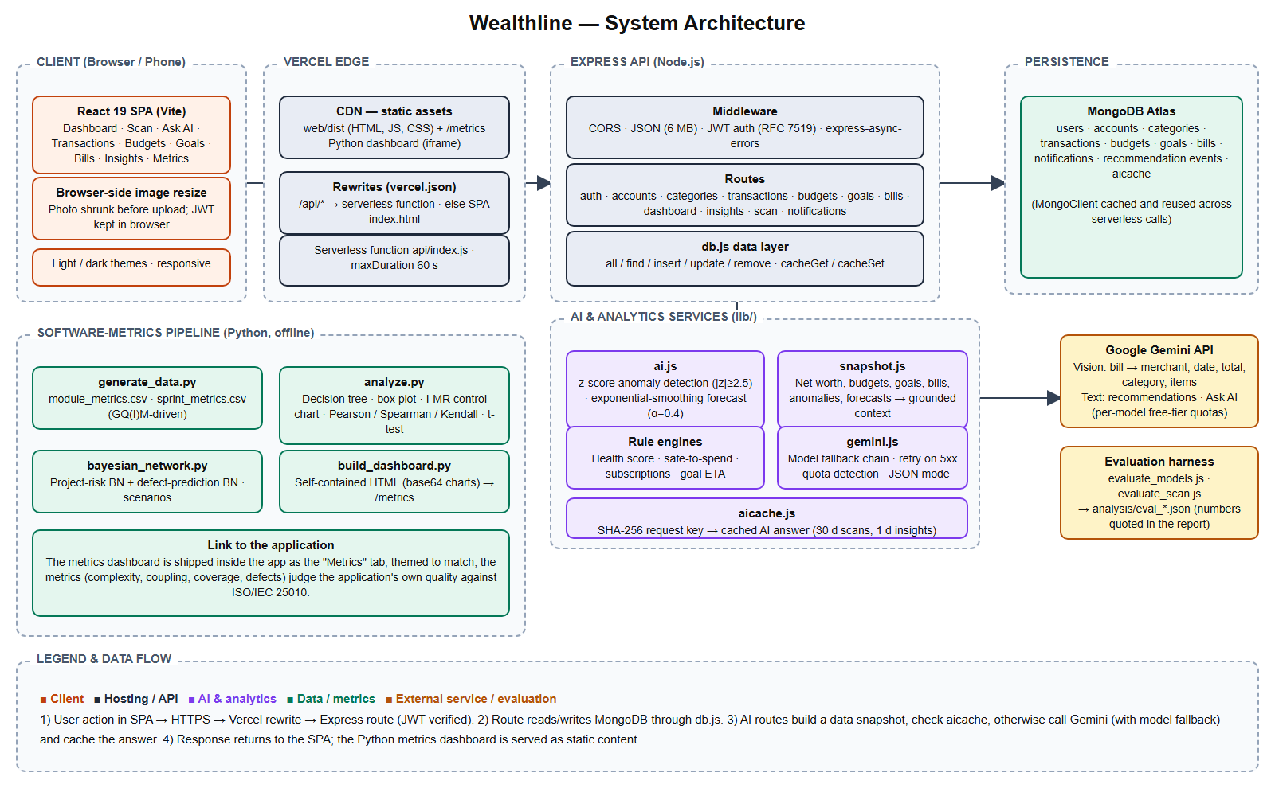
Figure 1. Wealthline system architecture (detailed)
Figure 2 expands the bill-scanning path from the photo to the budget decision.
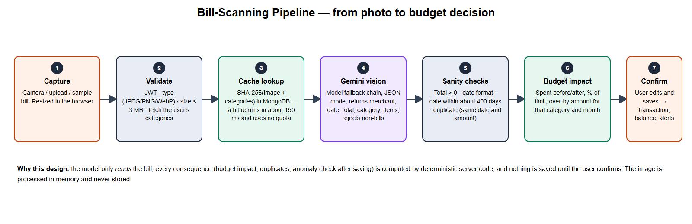
Figure 2. Bill-scanning pipeline
Component responsibilities
Component | Responsibility | Key design decision
React SPA | All screens, charts, theme, image resize | Plain CSS design tokens; light/dark by media query and toggle
Express routes | Auth, CRUD, dashboard, insights, scan | express-async-errors so a failed database call returns an error instead of crashing
db.js | Collection access and AI cache | Predicate-based interface kept from the first version; fine for small per-user data
ai.js | Anomaly z-score, exponential-smoothing forecast | Pure functions, unit-testable, evaluated by simulation
gemini.js | Every LLM call | Model fallback chain, retry on 5xx, “quota” reason, never throws
aicache.js | Cache AI answers by request hash | Repeated identical requests cost no quota and answer in about 150 ms
Python pipeline | Module 3 and 4 analyses | Self-contained HTML output embedded in the app

7. Proposed System
The proposed system is Wealthline. It is organised around one idea: the app should do the boring work and tell the user what matters today.
7.1 Why a user needs it — features and the reason for each
Feature | What the user gets | Why they would open the app
Scan a bill | Photo becomes a ready-to-save expense | Saves typing; shows the budget effect before saving
Safe to spend today | One number: what can be spent today without breaking the plan | Answers the daily question “can I afford this?”
Budget auto-update and warnings | Budgets move as bills are saved; the scan screen warns when a bill would push a budget over its limit | Prevents overspending before it happens
Auto-budget | Suggested limits from past spending | No blank-page budgeting
Subscription detector | Finds recurring charges and yearly cost | Often finds forgotten subscriptions
Goal ETA | Date a savings goal will be reached at the current pace | Makes goals concrete
What-if simulator | Effect of cutting a category by x% | Turns advice into a decision
Month-end projection | Where this month will finish at the current rate | Early warning
Financial health score | 0–100 with four-part breakdown | A single number to improve
Ask AI | Plain-English questions about the user's own money | Faster than reading charts; answers only from the user's data
Anomaly alerts and forecast | Unusual expenses flagged; next-month spend predicted | Catches mistakes and fraud, prepares the next month
Metrics tab | Engineering-quality dashboard of the project itself | Shows the system is engineered and measured

7.2 Screens of the working system
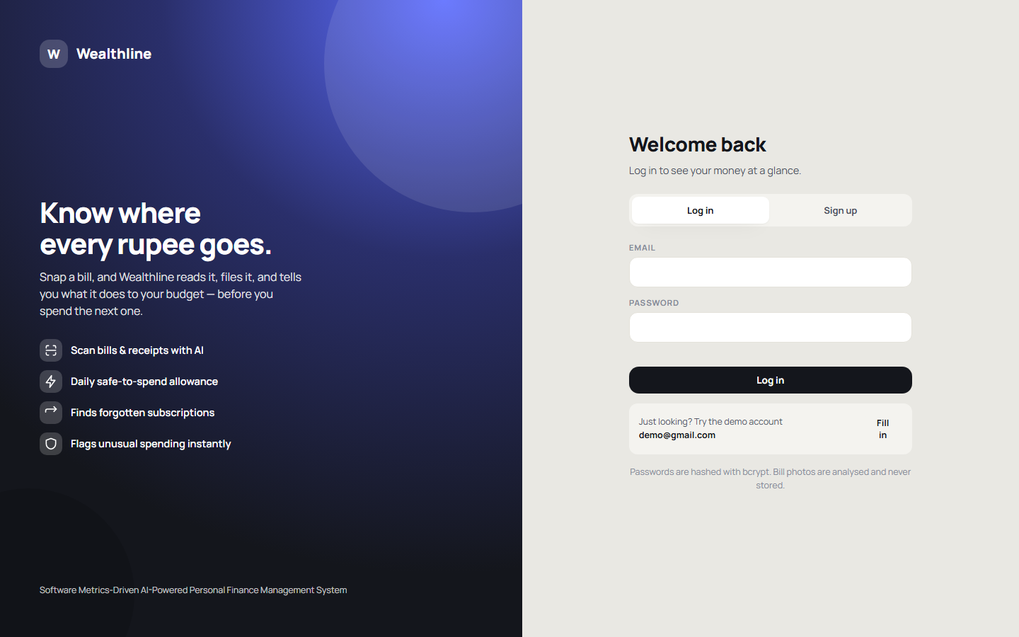
Figure 3. Sign-in screen
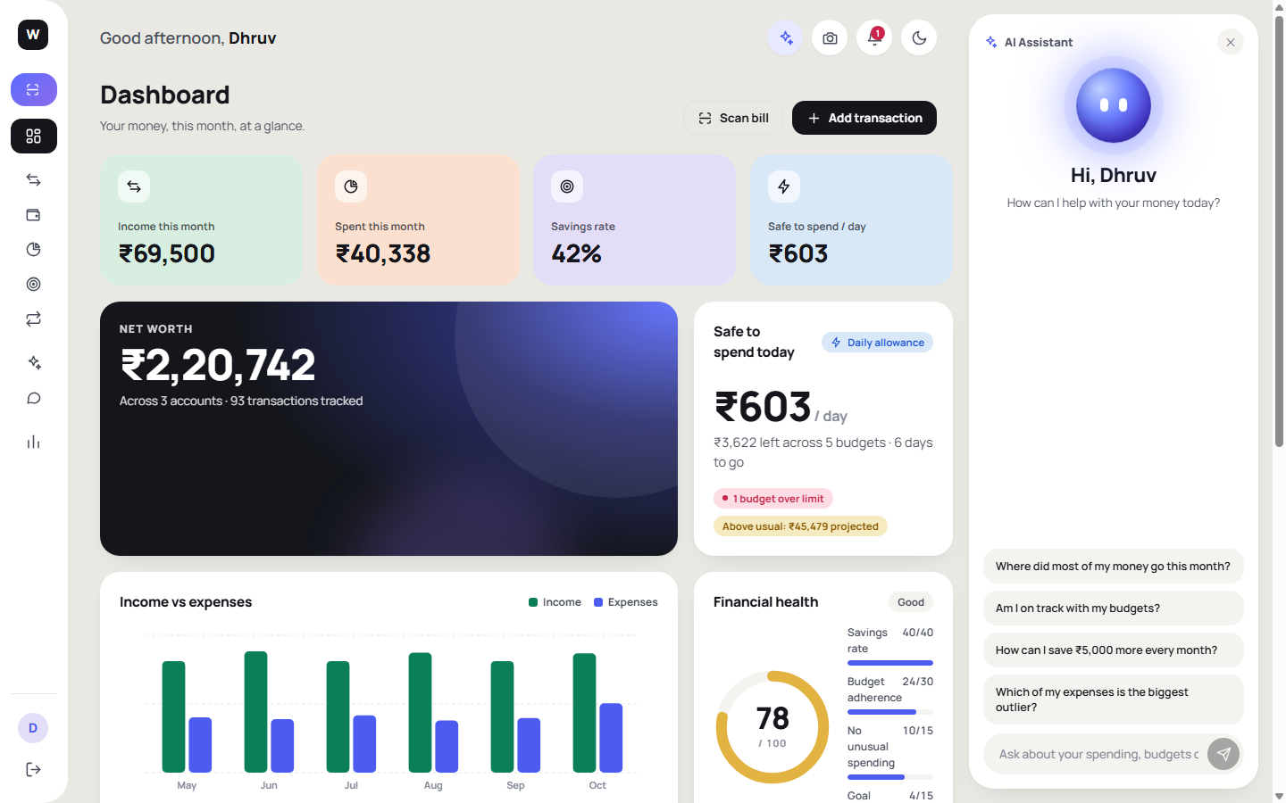
Figure 4. Dashboard: health score, safe-to-spend, trend, upcoming bills
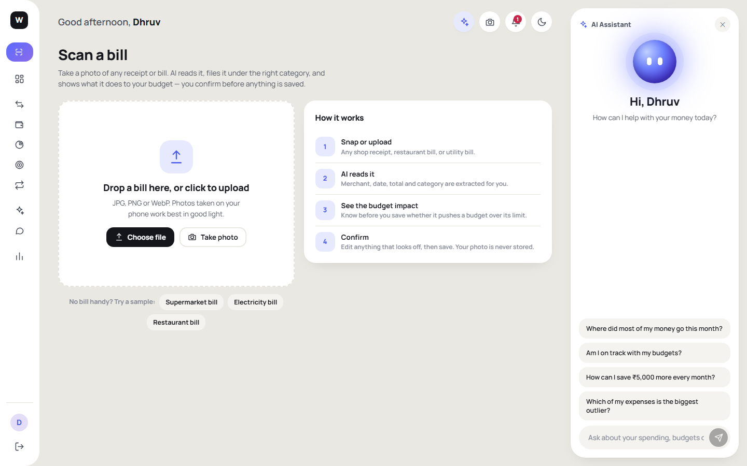
Figure 5. Scan Bill — choose a photo, use the camera, or try a sample
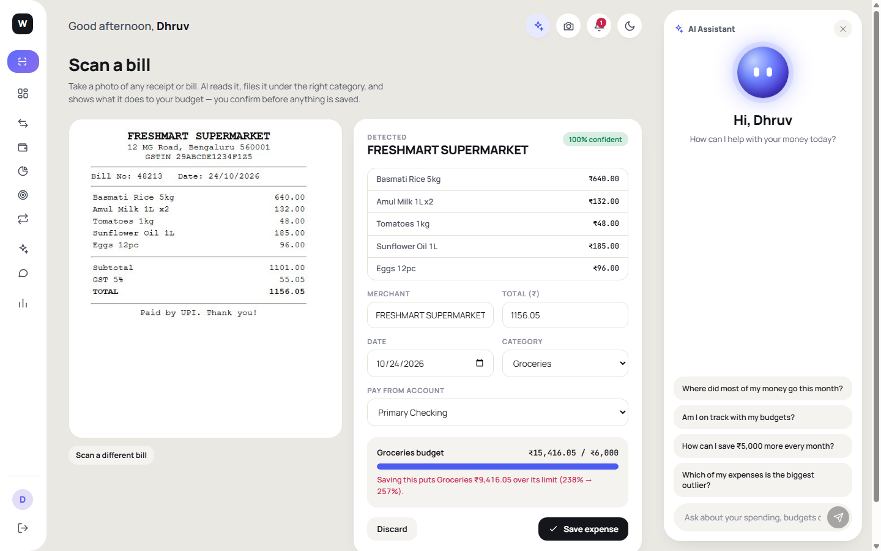
Figure 6. Scan result — extracted fields, budget impact warning and confirmation
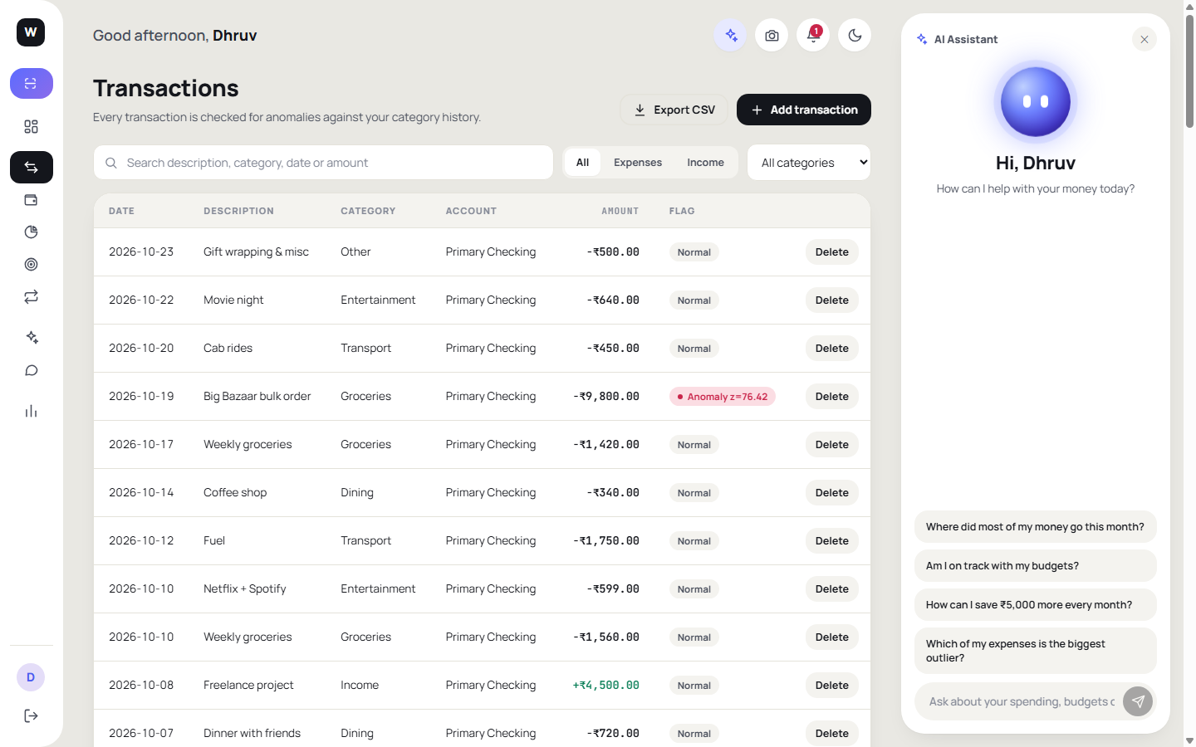
Figure 7. Transactions with search, filters and CSV export
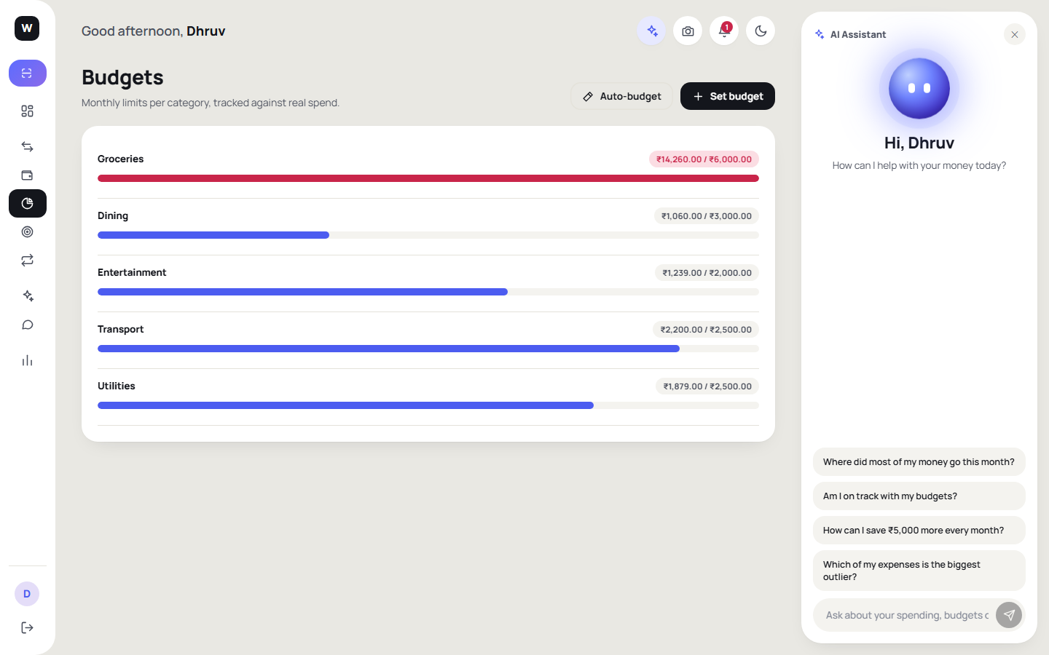
Figure 8. Budgets with live spent / remaining
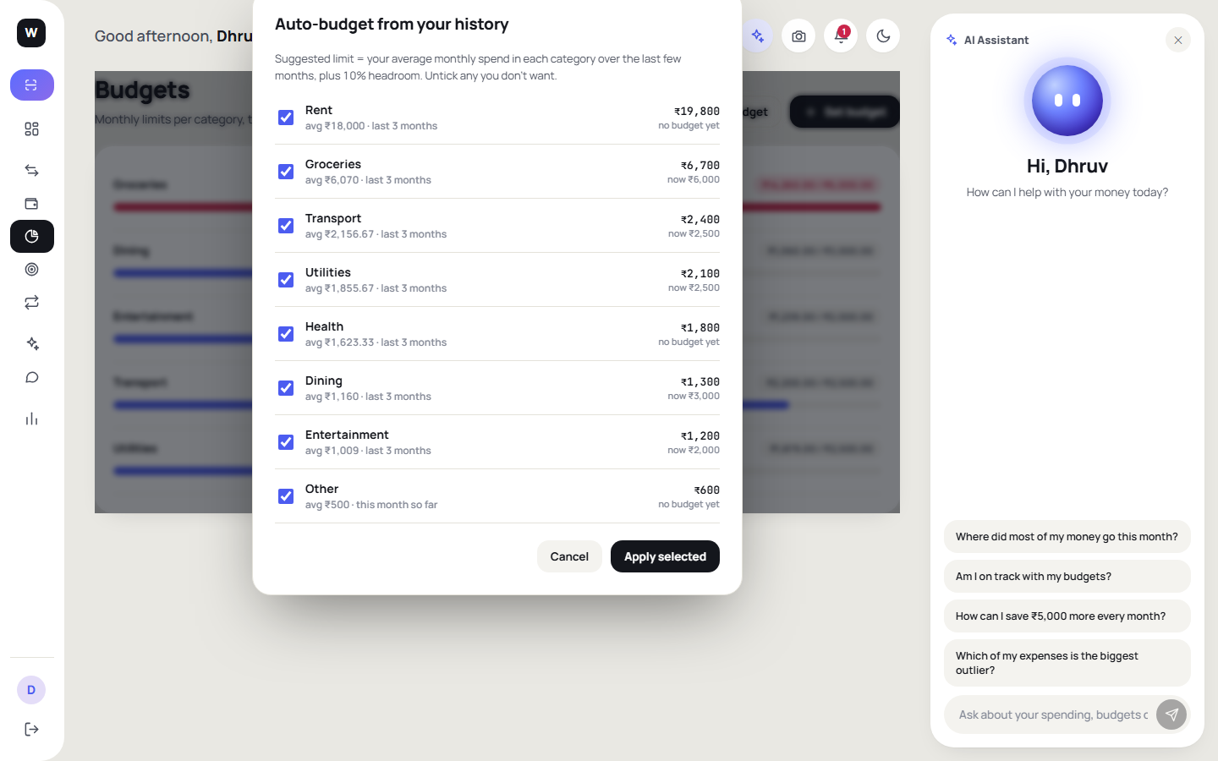
Figure 9. Auto-budget suggestions
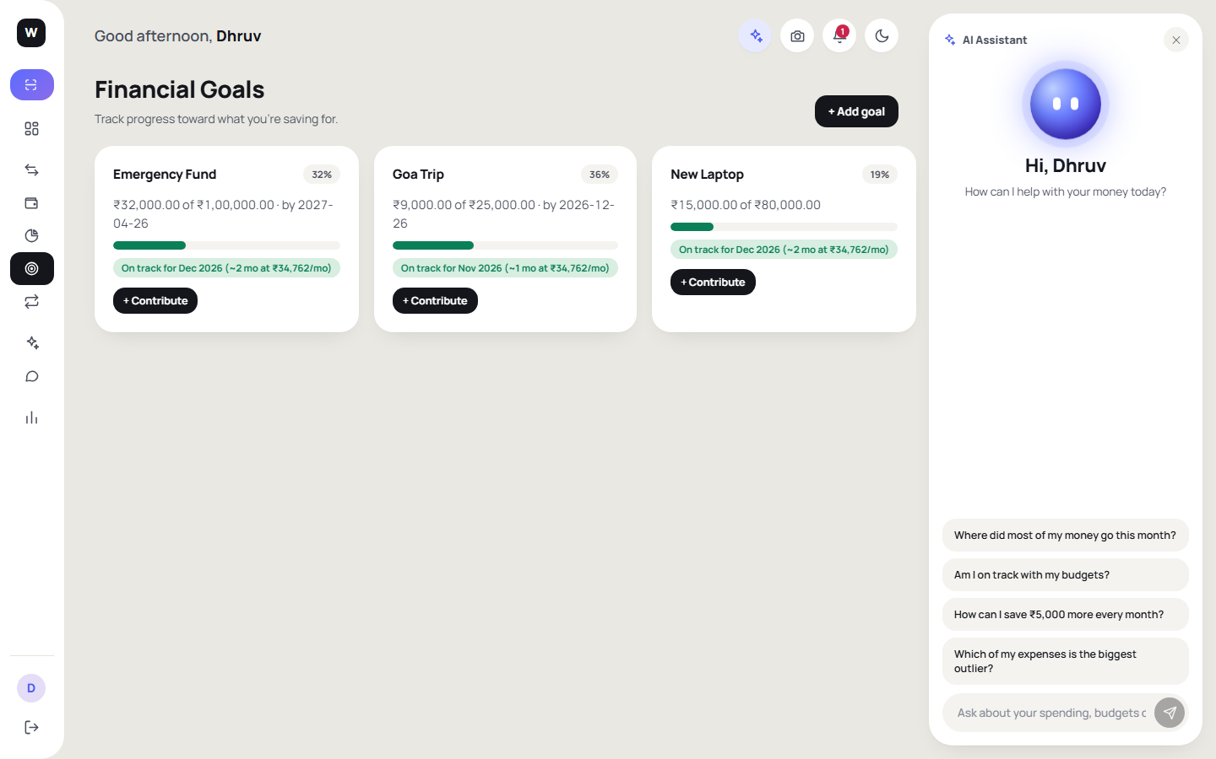
Figure 10. Goals with estimated completion date
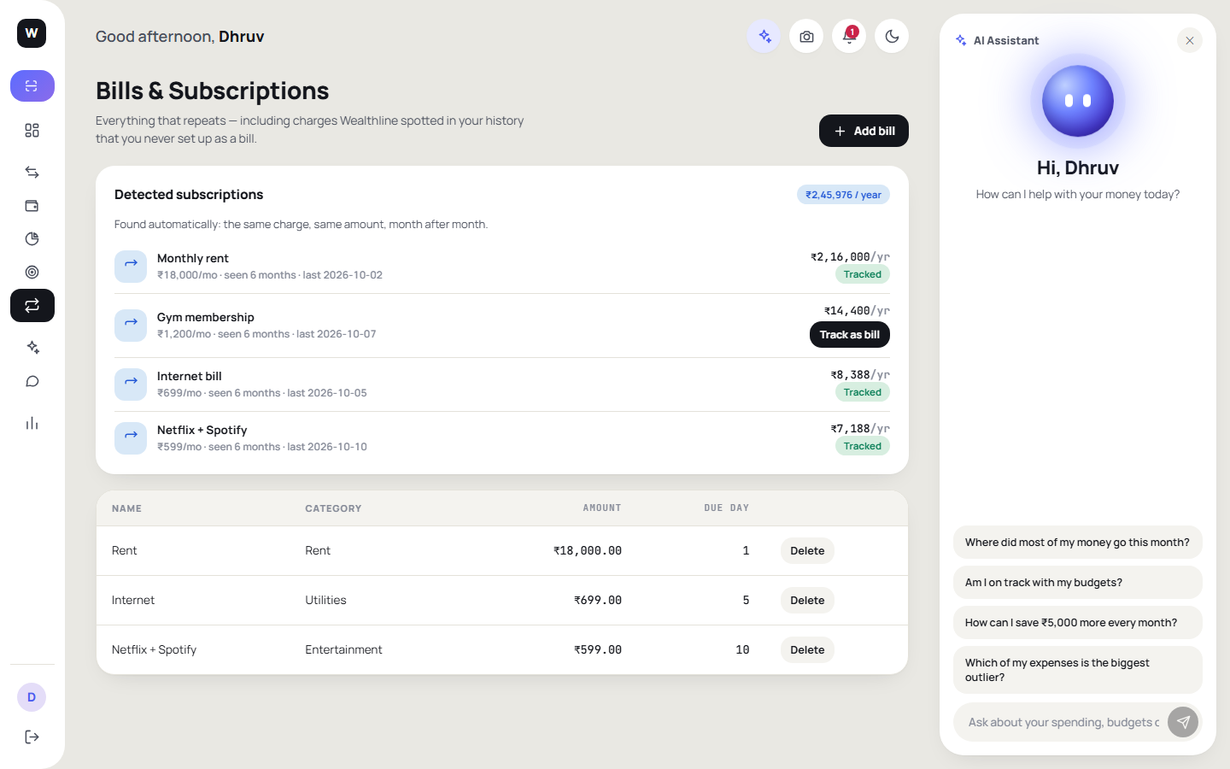
Figure 11. Recurring bills
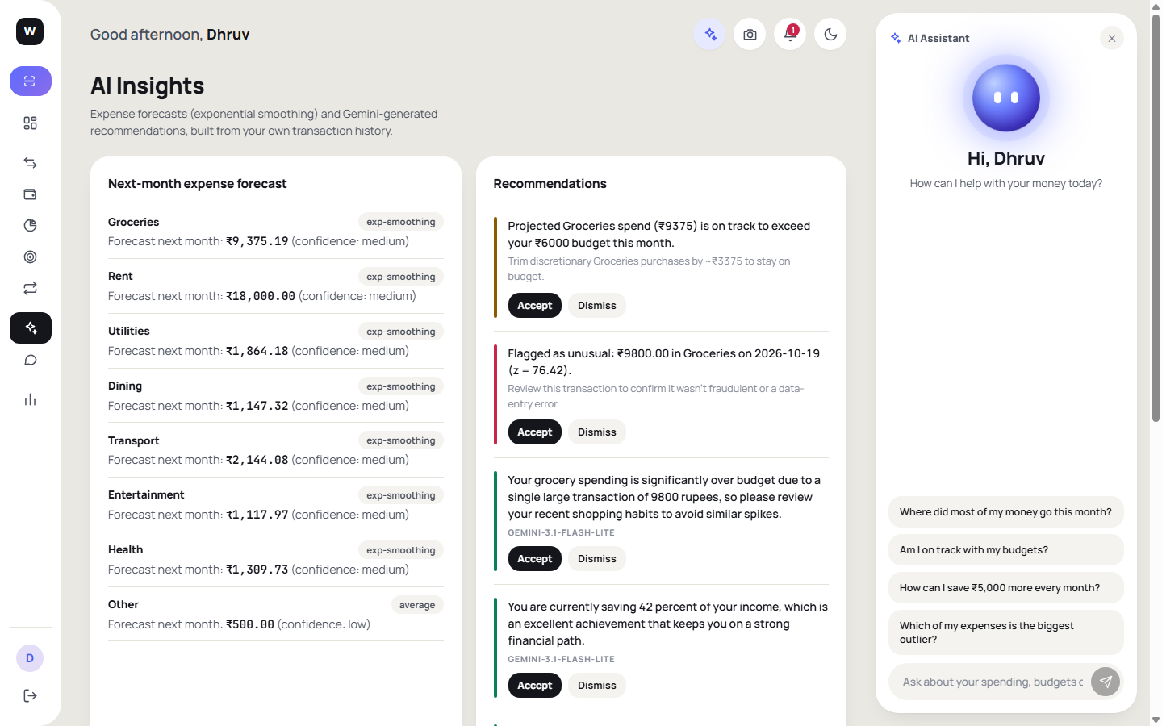
Figure 12. Insights: anomalies, forecast, subscriptions and recommendations
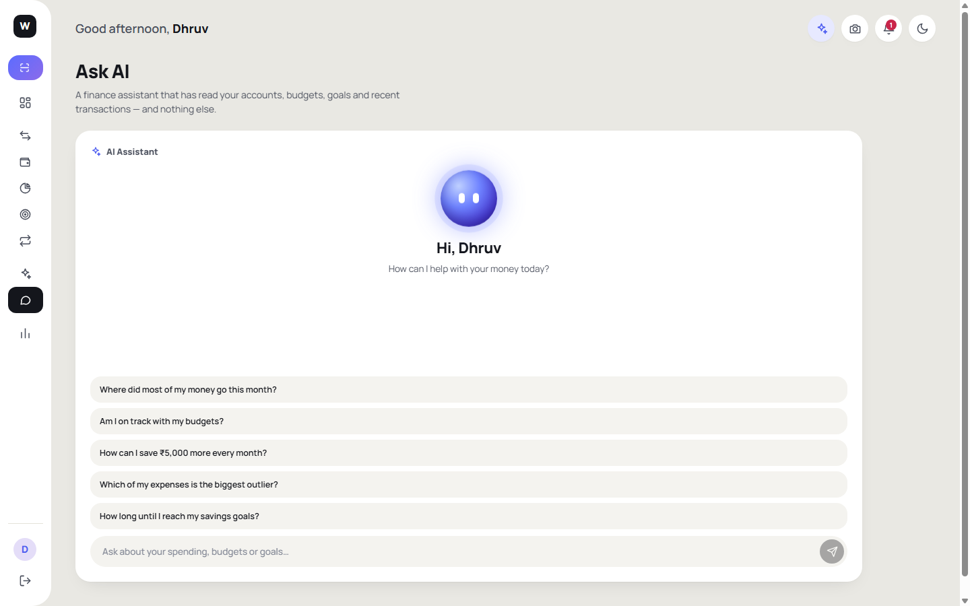
Figure 13. Ask AI answering from the user's own data
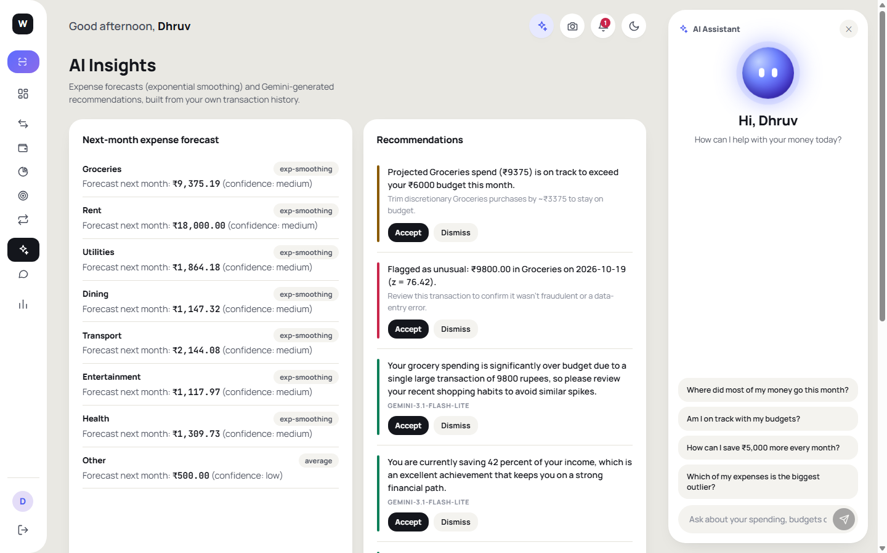
Figure 14. Notifications
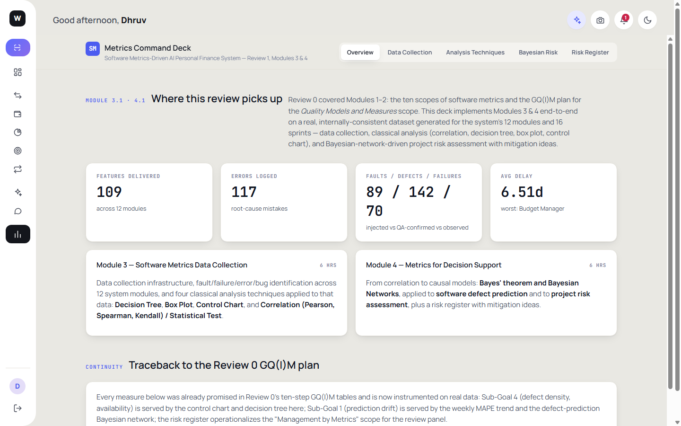
Figure 15. Metrics tab (Modules 3 and 4 dashboard embedded in the app)
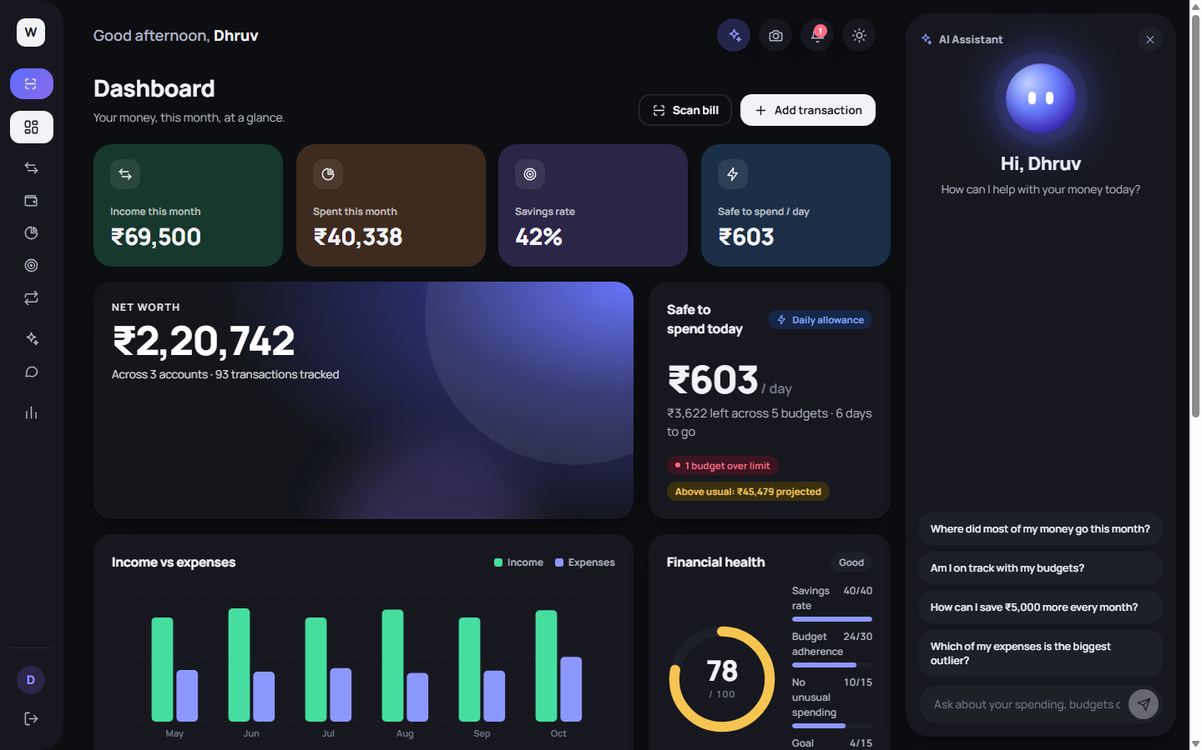
Figure 16. Dark theme
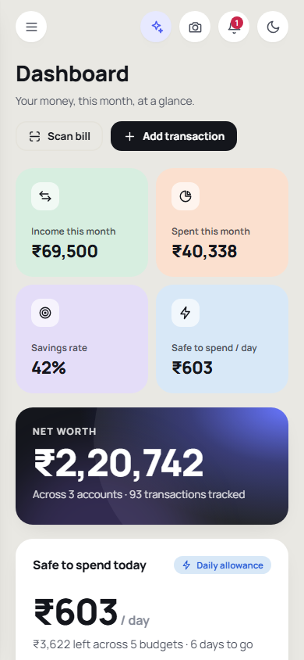
Figure 17. Mobile layout
7.3 Security and privacy
- Passwords are hashed with bcrypt; sessions use signed JWTs; every route except sign-in and sign-up checks the token and filters data by user.
- Bill images are processed in memory and are not stored. Only the extracted fields the user confirms are saved.
- Ask AI sends a compact summary of the user's own data, never other users' data, and is instructed to answer only from that summary.
- API keys and database credentials live in environment variables and are excluded from the repository.
8. Dataset / Data / Database
8.1 Application database (MongoDB Atlas, database “wealthline”)
Collection | Main fields | Purpose
users | id, name, email, passwordHash | Accounts and login
accounts | userId, name, type, balance | Savings, checking, credit card
categories | userId, name, colour | Spending categories (Income + expense categories)
transactions | userId, accountId, categoryId, type, amount, date, note | Income and expenses (scanned bills become expenses)
budgets | userId, categoryId, month, monthlyLimit | Monthly category limits
goals | userId, name, target, saved, deadline | Savings goals
bills | userId, name, amount, dueDay | Recurring bills
notifications / recommendation events | userId, message, status | Alerts; accepted / dismissed recommendations
aicache | key, value, expiresAt | Cached AI responses (scan 30 days, insights 1 day)

A demo account with realistic data (demo@gmail.com) is created by app/server/scripts/seed_demo.js, with all dates generated relative to today so that the current month is never empty.
8.2 Software-metrics datasets (data/ folder)
- module_metrics.csv — 12 application modules; columns: LOC, cyclomatic complexity, coupling (CBO), lack of cohesion (LCOM), test coverage %, features delivered, errors logged, fault count, defect count, failures observed, delay days, average severity, defect density per KLOC.
- sprint_metrics.csv — 16 weekly sprint observations used for the control chart and trend analysis.
Both files are generated by analysis/generate_data.py from a fixed random seed using GQ(I)M-driven distributions. They are synthetic project data created for this course, not measurements from an industrial project, and conclusions drawn from them are illustrative.
8.3 Evaluation datasets
- report/eval_receipts/ — 11 generated images (e01–e11) and ground_truth.json. The bills are synthetic renderings of typical Indian retail formats (grocery, restaurant, fuel, pharmacy, utility, etc.); two are degraded on purpose; e11 is a non-bill image.
- Simulated anomaly and forecast series are produced inside analysis scripts with a fixed seed (20261026) so the results can be reproduced with node app/server/scripts/evaluate_models.js.
Source code, data and scripts: https://github.com/ethical0101/Personal-Finance-Management-System
9. Performance Metrics, Working Model and Prediction Model Description
9.1 Bill scanning accuracy
Measure | Result
Bills evaluated (clean + degraded) | 10 (including 2 degraded)
Total amount exactly correct | 100%
Category correct | 100%
Date exactly correct | 90%
Merchant matched (≥60% word overlap) | 90%
All four fields correct | 90%
Non-bill image rejected | 1 of 1
Wrong date caught by date sanity check | 1/1
Latency, first (uncached) run, mean | about 3.3 s per bill
Latency, repeated identical bill (cache hit), mean / max | 157 ms / 198 ms

The single error (bill e04) was a fuel receipt whose date was printed as “18-10-26”. The model read it as 2018 instead of 2026. The server's date-sanity rule now flags any date more than about a year from today, and the scan screen shows a “check the date” warning, so this error cannot be saved silently. The model's self-reported confidence was 1.0 on every bill, including the wrong one, so confidence is not a usable reliability signal and the app does not rely on it.
Limitations: ten bills is a small test; the bills are synthetic renderings rather than photographs taken with a phone; results will be lower on crumpled, rotated or handwritten bills. The Gemini free tier allows a limited number of requests per day per model, which is why caching and a fallback chain were added; when every model is out of quota the app shows a clear message and the user adds the expense manually.
9.2 Anomaly detector
Threshold |z| | Precision | Recall | F1 | False-positive rate
2 | 0.961 | 0.724 | 0.826 | 0.0034
2.5 (used) | 0.984 | 0.631 | 0.769 | 0.0011
3 | 0.994 | 0.535 | 0.696 | 0.0004

Injected anomaly size | Number injected | Recall at |z| ≥ 2.5
1.5-2x normal spend | 890 | 6.7%
2-3x normal spend | 1735 | 28.1%
3-5x normal spend | 3490 | 94.9%

At the chosen threshold almost every alert is real (precision 98%), but only 63% of injected anomalies are found. The detector is excellent at large spikes (95% of 3–5× expenses) and poor at mild ones (7% of 1.5–2× expenses). That is acceptable for a notification feature where false alarms annoy users, but it should be described as a “large unusual expense” detector, not a general fraud detector.
9.3 Spending forecaster
Method | MAPE (lower is better) | Std. deviation
Exponential smoothing, α = 0.4 (used) | 13.76% | 13.28
3-month moving average | 14.05% | 13.61
Linear regression (previous method) | 15.95% | 15.36
Naive (last month repeated) | 17.04% | 15.55

Over 2400 forecasts exponential smoothing beat linear regression on 60.0% of cases and the naive baseline on 63.4%. The advantage over the 3-month moving average is small (52.1% win rate), so the honest conclusion is that smoothing and moving averages are about equally good and both are better than regression on short noisy history. These series are simulated; real accuracy must be checked on real user data.
9.4 Module 3 — metrics analysis results
Decision tree. The tree classifies modules as High or Low defect risk. It reaches 91.7% accuracy on the data it was trained on, but leave-one-out cross-validation gives only 58.3% against a 50.0% majority-class baseline (n = 12). Lack of cohesion carries 91.8% of the importance and coupling 8.2%. With only 12 modules the tree is an explanatory picture, not a dependable predictor.
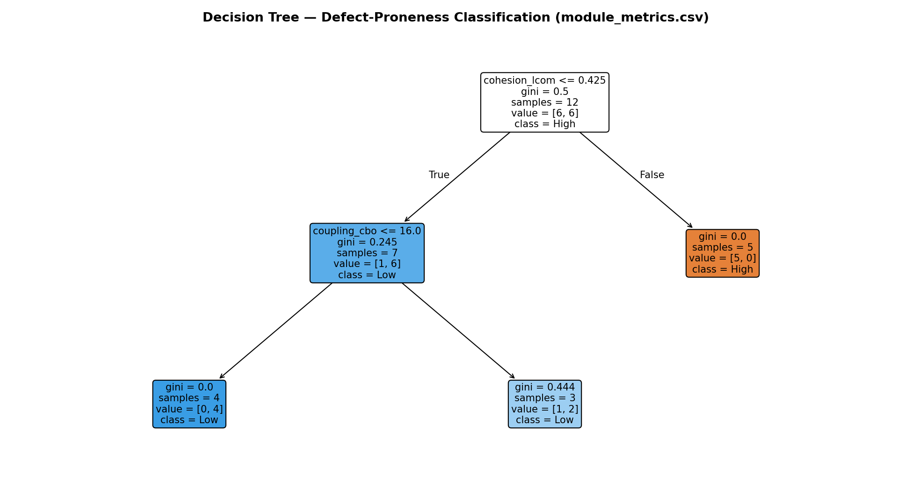
Figure 18. Decision tree for defect-proneness
Box plot and control chart. The box plot summarises the spread of each metric across modules, and the individuals–moving-range chart over the sprint series flags week 12 as outside the control limits, i.e. special-cause variation to investigate rather than normal noise.
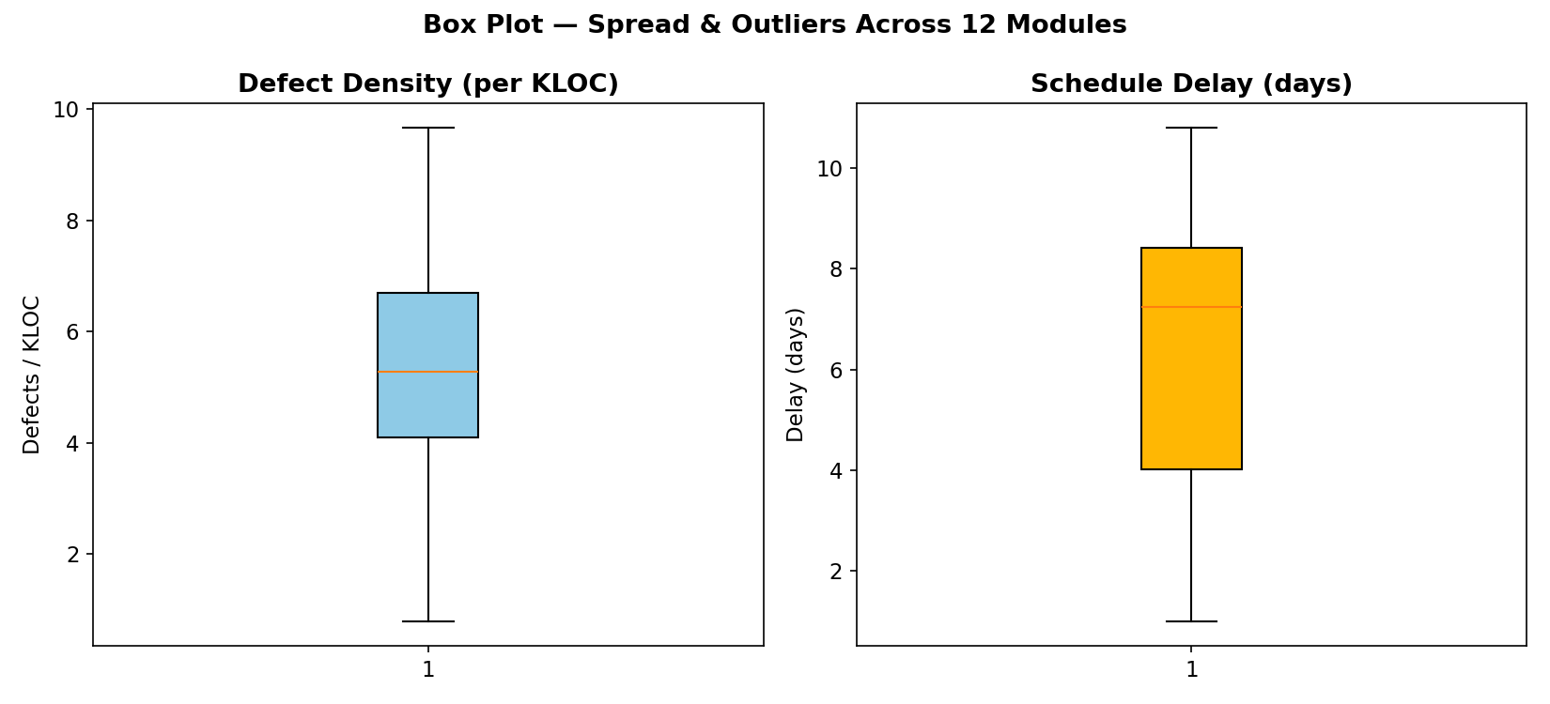
Figure 19. Box plot of module metrics
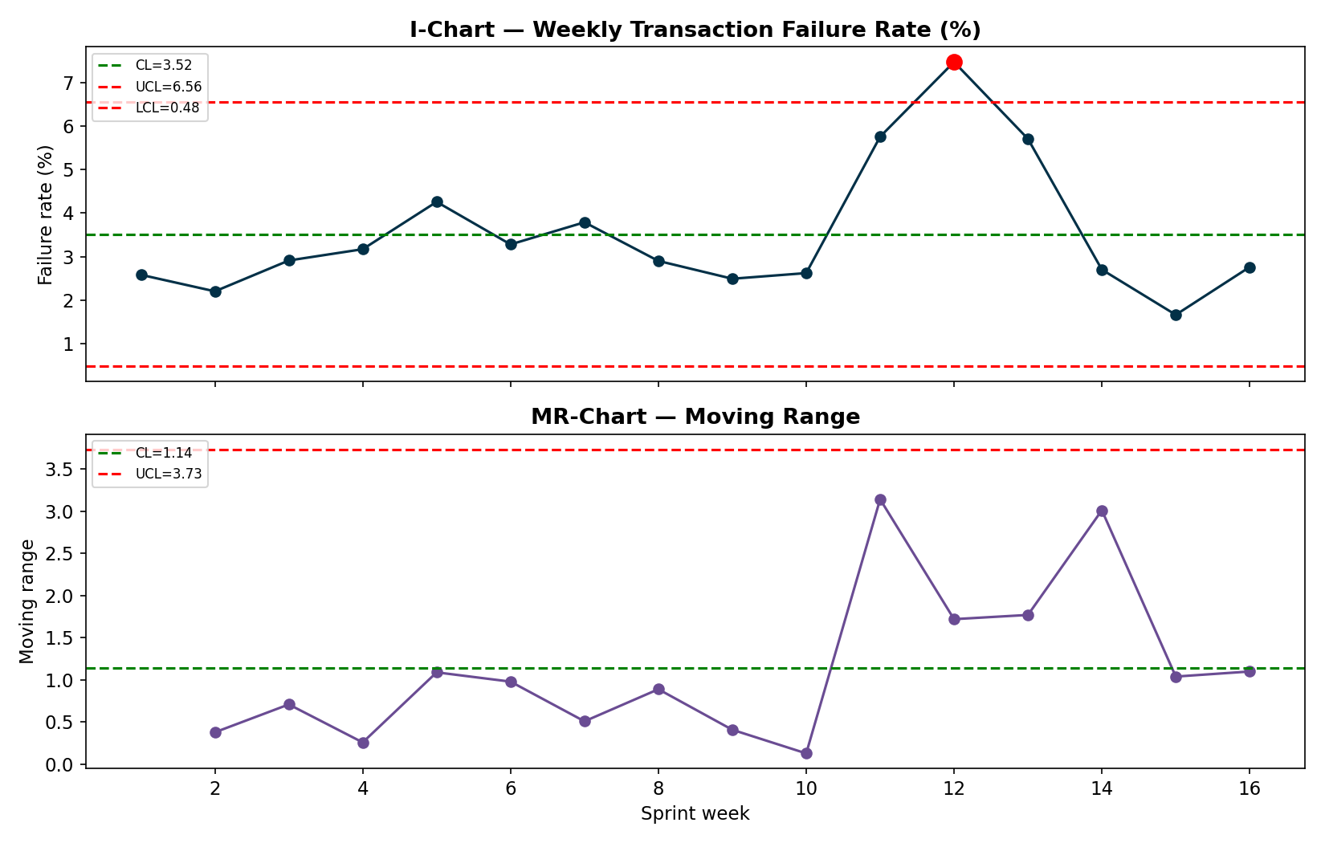
Figure 20. I-MR control chart
Correlation. The same three pairs were tested with all three coefficients.
Pair | Pearson r (p) | Spearman ρ (p) | Kendall τ (p)
Cyclomatic Complexity vs Defect Density | 0.559 (0.0591) | 0.592 (0.0426) | 0.473 (0.0331)
Test Coverage vs Defect Density | -0.37 (0.2367) | -0.231 (0.4705) | -0.152 (0.5452)
Coupling (CBO) vs Delay (days) | 0.647 (0.0229) | 0.558 (0.0594) | 0.369 (0.0982)

Complexity vs. defect density is positive under all three measures, and the Spearman (p = 0.043) and Kendall (p = 0.033) tests are significant at 5%. Coupling vs. delay is positive under all three but only Pearson reaches 5%. Test coverage vs. defect density is negative but not significant under any measure, and the t-test for low-coverage vs. high-coverage modules is also not significant (t = 1.131, p = 0.2847); we therefore do not claim that coverage reduces defects on this dataset.
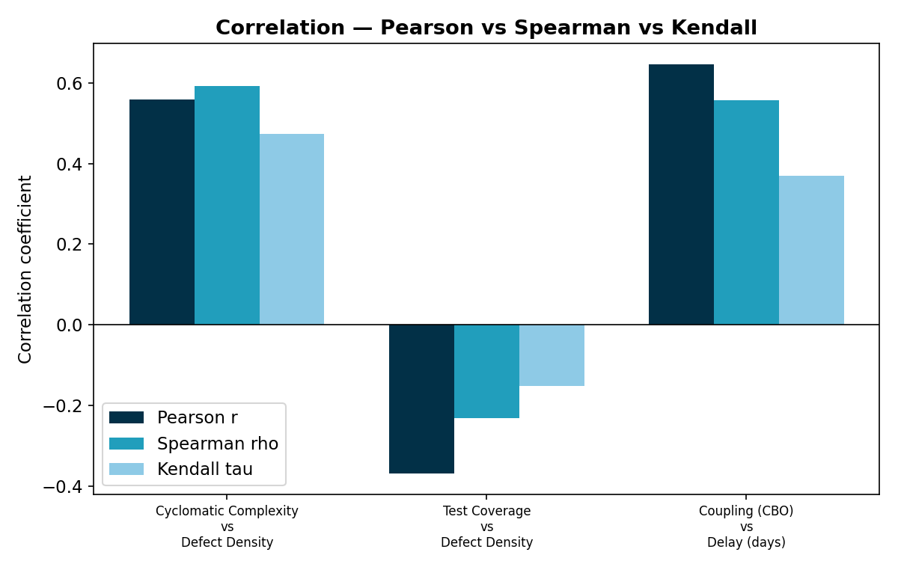
Figure 21. Pearson, Spearman and Kendall comparison
9.5 Module 4 — Bayesian network results
Scenario (evidence) | P(Low) | P(Medium) | P(High)
Baseline (no evidence — population prior) | 0.3755 | 0.3432 | 0.2812
Volatile requirements + inexperienced team (worst case) | 0.1069 | 0.3431 | 0.55
Stable requirements + experienced team (best case) | 0.5774 | 0.2951 | 0.1275
Observed schedule already slipping (High delay) | 0.1054 | 0.3942 | 0.5004
Observed high defect density in current sprint | 0.1321 | 0.3767 | 0.4912
Mitigation applied: inexperienced team upskilled mid-project (T -> High) despite volatile requirements | 0.3619 | 0.3731 | 0.265

The network quantifies how risk changes: with no evidence the probability of High project risk is 28.1%; volatile requirements with an inexperienced team raise it to 55.0%; upskilling the team under the same volatile requirements brings it back to 26.5%, which is a measurable argument for the mitigation. Network 2 predicts a module as defect-prone with probability 0.75 when complexity is high and coverage is low, and 0.0 when both are low. The conditional probability tables are expert-set, not learned from data, so these results show how to reason with the model rather than prove its numbers.
9.6 System performance (API latency)
Endpoint | Local p50 / p95 (ms) | Vercel p50 / p95 (ms)
/dashboard/summary | 58 / 84 | 653 / 675
/transactions | 52 / 56 | 653 / 669
/insights/forecast | 174 / 197 | 870 / 881
/budgets | 91 / 95 | 869 / 902
/insights/subscriptions | 56 / 79 | 657 / 717

Vercel times include the network round trip from the test machine and a data layer that filters in memory; all endpoints respond in under one second at the median, which is adequate for this scale. If data volume grows, filters should be pushed into MongoDB queries.
9.7 Working model of the application (end-to-end)
- A user signs in, sees the dashboard with health score and safe-to-spend, taps Scan Bill, and selects a photo.
- The server returns the merchant, date, total and category, the effect on that category's budget (for example a category going from under its limit to over it, with the over-by amount), and whether it looks like a duplicate.
- The user edits any field and confirms; the transaction is stored, the account balance and budgets update, and an unusually large expense raises a notification through the anomaly check against the user's history.
- The Insights page then shows the forecast, anomalies, subscriptions and AI recommendations, and Ask AI answers questions from the same data.
10. Conclusion
Wealthline demonstrates that a personal-finance system can reduce data-entry effort with direct bill scanning while keeping the user in control: the AI reads, deterministic code checks, and the user confirms. The system updates budgets from scanned bills, warns before a limit is crossed, and offers features that give a reason to return daily. The measurements show where it is strong (exact totals on all test bills, 98% precision on anomaly alerts, forecasting better than regression) and where it is not (small anomalies are missed, confidence scores are uninformative, the decision tree does not generalise, and the free AI quota limits heavy use). Reporting those limits, and fixing the ones we could (the date check, the forecaster, caching and fallback), is part of applying software metrics to our own work.
The software-metrics modules gave the project a structure: GQ(I)M connected goals to measurements, the defect taxonomy defined what to count, the statistical tools showed which signals are robust (complexity and cohesion) and which are not (coverage on this dataset), and the Bayesian networks turned risk into numbers that support mitigation decisions.
11. Future Work
- Evaluate bill scanning on real phone photographs (rotated, crumpled, multi-language, handwritten) and a larger set of at least 100 bills; add a local OCR fallback so scanning works without the cloud quota.
- Calibrate the extraction confidence (for example by checking that the line items sum to the total) so low-quality reads can be flagged.
- Bank-statement and UPI SMS import, and multi-currency support.
- Push data filters down into MongoDB queries and add indexes for larger user volumes; add automated unit and integration tests with coverage reporting in CI.
- Replace the simulated metrics datasets with real repository data (commits, issues, CI results) and re-run the correlation and Bayesian analyses; learn the Bayesian network tables from data.
- Mild-anomaly detection using robust statistics (median and MAD) or seasonal models; per-merchant rules.
- Shared household budgets, receipts attached to transactions with user consent, and push notifications.
- Accessibility audit and localisation (Telugu, Hindi, Tamil) of the interface.
12. References
[1] R. E. Park, W. B. Goethert, W. A. Florac, “Goal-Driven Software Measurement — A Guidebook,” CMU/SEI-96-HB-002, Software Engineering Institute, 1996. https://insights.sei.cmu.edu/library/goal-driven-software-measurement-a-guidebook/
[2] ISO/IEC 25010:2011, “Systems and software engineering — Systems and software Quality Requirements and Evaluation (SQuaRE) — System and software quality models.” https://www.iso.org/standard/35733.html
[3] T. J. McCabe, “A Complexity Measure,” IEEE Transactions on Software Engineering, vol. SE-2, no. 4, pp. 308–320, 1976. https://doi.org/10.1109/TSE.1976.233837
[4] S. R. Chidamber and C. F. Kemerer, “A Metrics Suite for Object Oriented Design,” IEEE Transactions on Software Engineering, vol. 20, no. 6, pp. 476–493, 1994. https://doi.org/10.1109/32.295895
[5] N. E. Fenton and M. Neil, “A Critique of Software Defect Prediction Models,” IEEE Transactions on Software Engineering, vol. 25, no. 5, pp. 675–689, 1999. https://doi.org/10.1109/32.815326
[6] V. Chandola, A. Banerjee, V. Kumar, “Anomaly Detection: A Survey,” ACM Computing Surveys, vol. 41, no. 3, article 15, 2009. https://doi.org/10.1145/1541880.1541882
[7] R. J. Hyndman and A. B. Koehler, “Another look at measures of forecast accuracy,” International Journal of Forecasting, vol. 22, no. 4, pp. 679–688, 2006. https://doi.org/10.1016/j.ijforecast.2006.03.001
[8] Z. Huang et al., “ICDAR2019 Competition on Scanned Receipt OCR and Information Extraction,” ICDAR 2019. https://doi.org/10.1109/ICDAR.2019.00244 (task description also at arXiv:2103.10213)
[9] Gemini Team, Google, “Gemini: A Family of Highly Capable Multimodal Models,” arXiv:2312.11805, 2023. https://arxiv.org/abs/2312.11805
[10] M. Jones, J. Bradley, N. Sakimura, “JSON Web Token (JWT),” RFC 7519, IETF, 2015. https://www.rfc-editor.org/rfc/rfc7519
[11] Project repository and live application: https://github.com/ethical0101/Personal-Finance-Management-System ; https://wealthline-eight.vercel.app

