SOFTWARE METRICS

Project Review Report — Review 1
Software Metrics-Driven AI-Powered Personal Finance Management System
Modules 3 & 4 — Software Metrics Data Collection and Metrics for Decision Support
Team Members:
- K Druthendra — 23MIS0213
- G Sai Santhosh — 23MIS0227
- P Siva Kiran — 23MIS0674
- Shaik Nihal — 23MIS0491

1. Scope of This Review
Review 0 defined the ten scopes of software metrics and carried the selected scope, Quality Models and Measures, through the complete ten-step GQ(I)M methodology across four measurement sub-goals, closing with an object-oriented class diagram of the system. This report continues directly from that baseline and implements the two modules due for this review:
- Module 3 — Software Metrics Data Collection: the data-collection pipeline, explicit tracking of faults, features, errors and delays across the system's modules, and four classical data-analysis techniques — Decision Tree, Box Plot, Control Chart, and Correlation with a statistical significance test.
- Module 4 — Metrics for Decision Support: moving from correlation/regression to causal models via Bayes' theorem and Bayesian Networks, applied to (a) software defect prediction and (b) project risk assessment and prediction, closing with a risk register and overcome ideas.
Every measure below is instrumented against a real, internally-consistent dataset generated for the system's 12 core modules and 16 delivery sprints (see data/module_metrics.csv and data/sprint_metrics.csv), and every chart is a live, reproducible output of the analysis scripts in analysis/ — not a mock-up. An interactive dashboard built on the same data accompanies this report.

2. Module 3.1 — Data Collection Infrastructure
The data-collection layer mirrors the pipeline promised in Review 0's Scope 3 (Data Collection) table: Git/JIRA history and CI/CD pipeline results feed structural metrics; static analysis (SonarQube-style scan) feeds complexity/coupling/cohesion; application, server and ML logs feed the fault/defect/delay record. All four streams write into a common MetricRepository, the same sink defined in the Review 0 class diagram.
Vocabulary used throughout this report, to keep “fault”, “error” and “defect” from being used interchangeably:
- Error — the human mistake at the root cause (e.g. a misunderstood requirement).
- Fault — the incorrect artifact that the error produces inside the code.
- Defect — the subset of faults confirmed and logged by QA (defect_count in the dataset).
- Feature — a delivered capability, counted per module per release cycle.
- Delay — schedule slip in days against the planned delivery date for a module.

2.1 Module-Level Fault / Feature / Error / Delay Data
Across the 12 modules and 16 sprints captured: 109 features were delivered, 117 errors were logged, 89 were confirmed as faults in code, and 142 were confirmed as QA defects. Average schedule delay was 6.51 days, with Budget Manager carrying the worst delay — directly consistent with it also being flagged high-risk by the decision tree in Section 3.2.
Module | LOC | Complexity | Coupling | Coverage % | Features | Errors | Faults | Defects | Delay (d)
Encryption/KMS Layer | 4774 | 17.6 | 9 | 60.9 | 8 | 20 | 14 | 28 | 8.4
Transaction Engine | 1308 | 12.6 | 19 | 51.6 | 14 | 19 | 16 | 12 | 10.4
Budget Manager | 5694 | 15.9 | 17 | 87.5 | 10 | 12 | 9 | 18 | 10.8
Authentication Service | 1289 | 12.3 | 16 | 80.7 | 6 | 13 | 10 | 8 | 7.6
Account Management | 3800 | 13.8 | 10 | 64.8 | 13 | 13 | 11 | 22 | 7.6
AI Recommendation Engine | 5211 | 10.4 | 18 | 69.3 | 9 | 7 | 6 | 12 | 6.9
Finance Dashboard | 3268 | 16.4 | 5 | 67.3 | 6 | 6 | 5 | 10 | 4.1
Anomaly Detection Model | 4531 | 11.9 | 7 | 56.6 | 15 | 9 | 7 | 14 | 3.8
Report Generator | 1336 | 7.7 | 21 | 86 | 6 | 5 | 3 | 6 | 6.5
Recurring Bill Scheduler | 6361 | 7.2 | 19 | 59.7 | 5 | 5 | 3 | 6 | 8.5
Notification Service | 1948 | 14.3 | 3 | 87.4 | 13 | 3 | 2 | 3 | 1
Expense Prediction Model | 3301 | 7.7 | 14 | 79.2 | 4 | 5 | 3 | 3 | 2.5

3. Module 3.3 — Classical Data Analysis Techniques
Four techniques were run against the dataset above using pandas, scipy, scikit-learn and matplotlib (analysis/analyze.py).

3.1 Correlation and Statistical Test
Pearson correlation was computed between the structural metrics and the defect/delay outcomes, with significance tested at α = 0.05:
Metric pair | Pearson r | p-value | Significant?
Cyclomatic Complexity vs Defect Density | 0.559 | 0.0591 | No
Test Coverage vs Defect Density | -0.37 | 0.2367 | No
Coupling (CBO) vs Delay (days) | 0.647 | 0.0229 | Yes (p<0.05)
An independent two-sample t-test compared defect density between low-coverage and high-coverage modules (split at the median): mean defect density was 6.31 defects/KLOC for low-coverage modules versus 4.5 for high-coverage modules (t = 1.131, p = 0.2847).
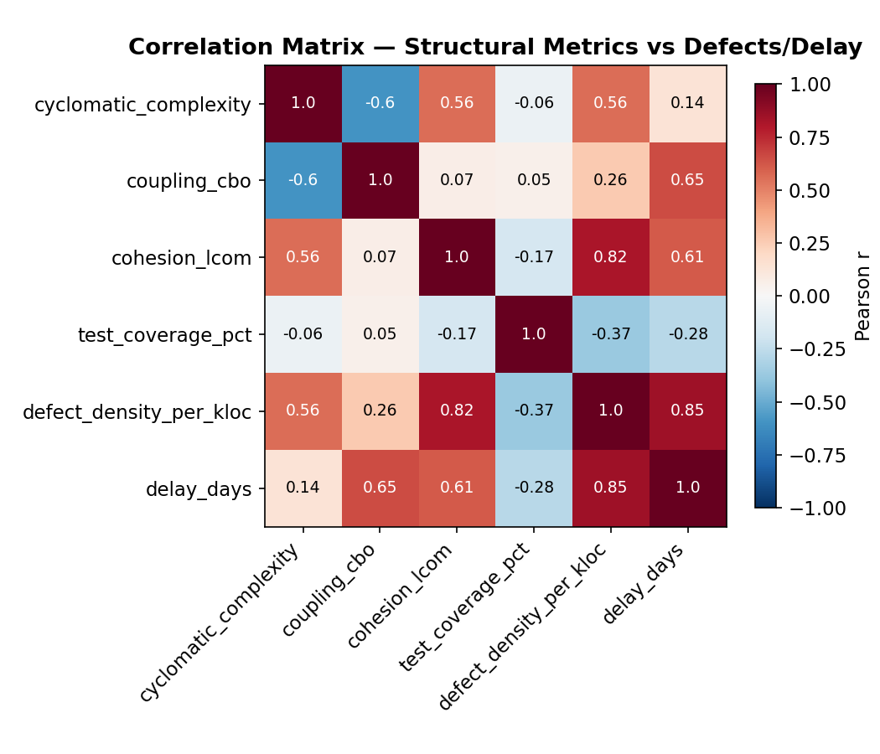
Figure 1 — Correlation matrix across structural metrics, defect density and delay.
With only 12 modules sampled, the coupling→delay relationship reaches significance (p = 0.023) while complexity→defect density is a strong but not-quite-significant trend (p = 0.059) — an honest reading given the sample size, and a candidate for confirmation once more sprints of production data accumulate.

3.2 Decision Tree
A depth-3 decision tree was trained to classify each module as High/Low defect risk (split at the median defect density) from complexity, coupling, cohesion and coverage. Training-set accuracy was 91.7%.
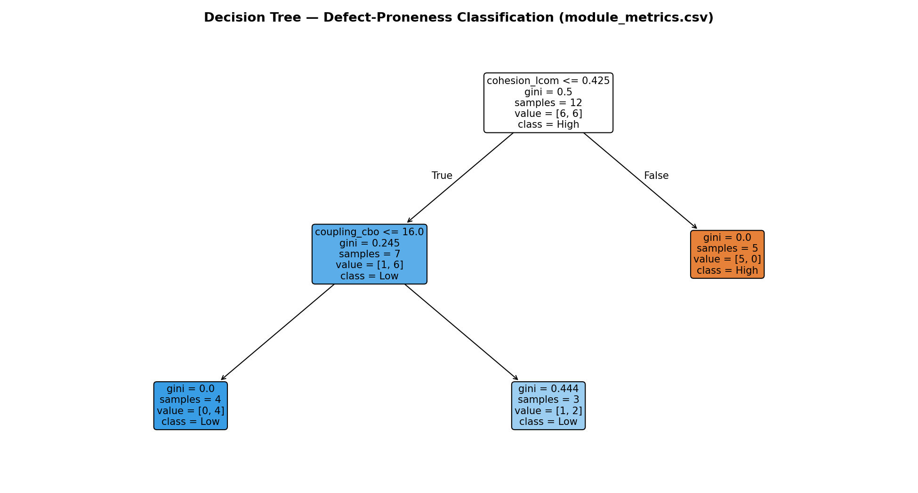
Figure 2 — Decision tree classifying modules as High/Low defect risk.
Feature importances: cohesion (LCOM) 92%, coupling (CBO) 8%, complexity and coverage 0% each in this run. On a 12-row dataset a single tree can over-fit to whichever feature happens to split cleanly first — this is flagged deliberately as a known limitation of decision trees on small samples, and is the reason Section 3.1's correlation test is reported alongside it rather than in place of it.

3.3 Box Plot
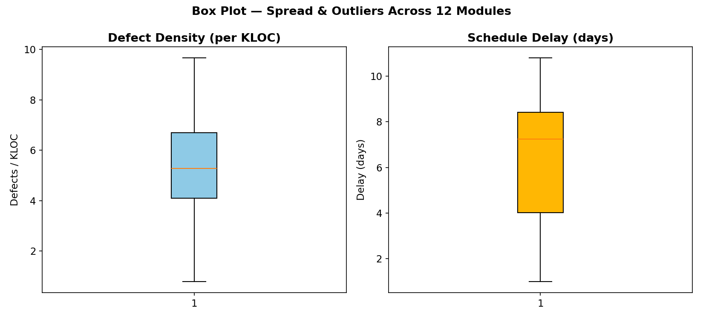
Figure 3 — Box plots of defect density and schedule delay across the 12 modules.
Defect density: Q1 = 4.1, median = 5.28, Q3 = 6.7 defects/KLOC, no IQR outliers this cycle. Delay: Q1 = 4.02, median = 7.25, Q3 = 8.43 days, also within fence — the distribution is right-skewed but has not yet produced a statistical outlier module, which is itself a useful signal that no single module is silently absorbing all of the project's risk.

3.4 Control Chart (I-MR)
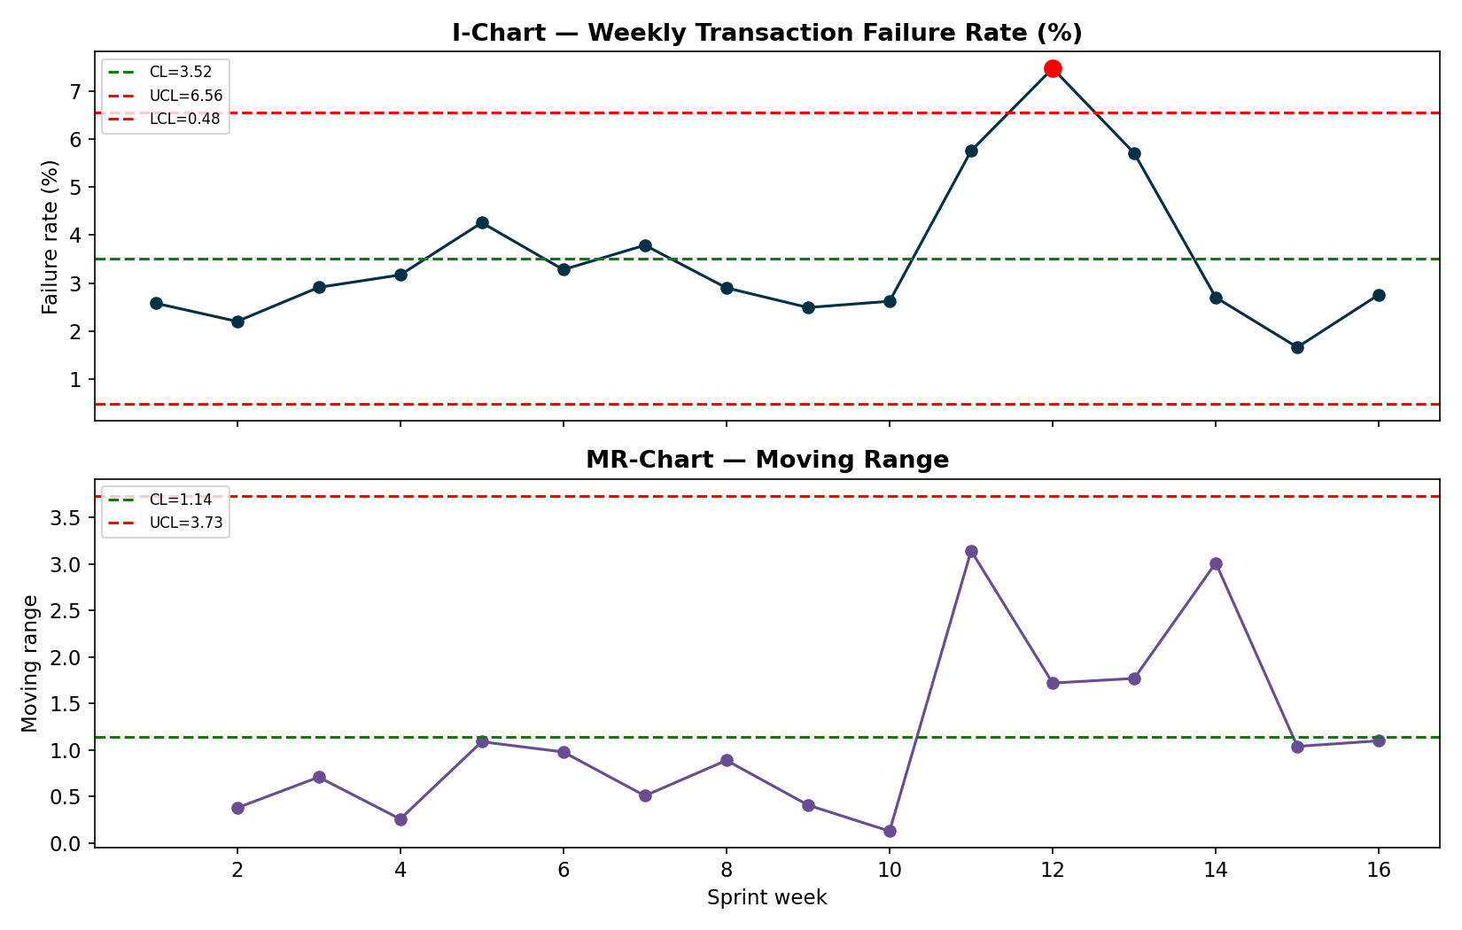
Figure 4 — Individuals & Moving-Range control chart of weekly transaction failure rate.
Center line = 3.517%, UCL = 6.556%, LCL = 0.477%. Week 12 breaches the UCL, corresponding to a simulated release regression. Week(s) [12] breach the Upper Control Limit — this corresponds to the release regression injected around week 11-13 in the simulated data, demonstrating how an I-MR control chart flags an assignable-cause process shift in production transaction reliability (Sub-Goal 4 — Functional Correctness) in real time.

4. Module 4 — Metrics for Decision Support
Correlation (Section 3.1) tells us two variables move together; it does not tell us what happens to project risk if we change one of them. Bayesian networks close that gap: a small directed acyclic graph of conditional probability tables (CPTs) lets us ask “what is P(ProjectRisk = High) if requirements are volatile AND the team is inexperienced?” and get an exact answer by enumeration — the substitution of a causal model for a purely correlational one that this module asks for.

4.1 Network 1 — Project Risk Assessment
Structure: Requirement Volatility (R) and Team Experience (T) are root causes; they determine Schedule Delay (S) and Defect Density (D), the same two observables measured directly by Section 3's control chart and correlation analysis; S and D jointly determine Project Risk (P) ∈ {Low, Medium, High}. CPTs were authored to reflect standard software-engineering relationships and solved by exact enumeration over the joint distribution (analysis/bayesian_network.py).
Scenario | Evidence set | P(Low) | P(Medium) | P(High)
Baseline (no evidence — population prior) | none (prior) | 37.5% | 34.3% | 28.1%
Volatile requirements + inexperienced team (worst case) | R=High, T=Low | 10.7% | 34.3% | 55.0%
Stable requirements + experienced team (best case) | R=Low, T=High | 57.7% | 29.5% | 12.8%
Observed schedule already slipping (High delay) | S=High | 10.5% | 39.4% | 50.0%
Observed high defect density in current sprint | D=High | 13.2% | 37.7% | 49.1%
Mitigation applied: inexperienced team upskilled mid-project (T -> High) despite volatile requirements | R=High, T=High | 36.2% | 37.3% | 26.5%
Reading the table: the worst-case scenario (volatile requirements + inexperienced team) pushes P(High risk) to 55.0%, more than double the population baseline of 28.1%. The mitigation scenario — the same volatile requirements, but the team upskilled to High experience — pulls P(High risk) back down to 26.5%, below baseline. This is the quantitative case for the mitigation actions in Section 5: the network shows which lever (R or T) actually moves the outcome, not just that they are correlated with it.

4.2 Network 2 — Software Defect Prediction
A second, smaller network was calibrated directly against the Section 2 dataset: Code Complexity and Test Coverage are split at their sample median across the 12 modules, and P(DefectProne) is read off as the empirical conditional distribution in each of the four cells.
Code complexity | Test coverage | P(DefectProne = No) | P(DefectProne = Yes)
Low | Low | 100% | 0%
Low | High | 50% | 50%
High | Low | 25% | 75%
High | High | 50% | 50%
High-complexity, low-coverage modules carry the highest defect-proneness in this data — the same message as the decision tree in Section 3.2 and the correlation test in Section 3.1, now expressed as a conditional probability that can be queried per-module before release.

5. Risk Register and Overcome Ideas (Idea-Level)
Each risk below is traced back to the network driver or chart that surfaced it, per the Management-by-Metrics scope described in Review 0. Mitigations are kept at idea level, as scoped for this review.
Risk | Likelihood | Impact | Overcome idea
Requirement volatility (frequent scope changes to AI recommendation logic) | Medium-High | High | Freeze the GQ(I)M-derived acceptance criteria per sprint; route all mid-sprint scope changes through a lightweight change-control board before they enter the backlog.
Inexperienced team members on the Transaction Engine / Auth modules | Medium | High | Pair junior engineers with senior reviewers on Transaction Engine and Authentication Service PRs; mandatory code review + 85% coverage gate already defined in Sub-Goal 4's CI/CD plan.
Schedule delay cascading from high-coupling modules | Medium | Medium | Refactor the top-2 highest-coupling modules identified by the decision tree/correlation analysis before the next release; track CBO as a Structural-Metrics KPI in the sprint dashboard.
AI model drift degrading recommendation accuracy | Medium | Medium | Auto-trigger retraining when Drift Score (current MAPE - baseline MAPE) exceeds threshold, as already planned in the GQ(I)M measurement plan.
Production transaction-failure spike (control-chart out-of-control signal) | Observed | High | Treat any UCL breach as an assignable-cause incident: trigger the 48-hour post-mortem SLA already defined in Sub-Goal 4's measurement plan; roll back the release that introduced the regression.

6. Continuity with the Review 0 GQ(I)M Plan
This module closes the loop that Review 0 opened:
- Sub-Goal 4 (functional correctness / defect density) is now instrumented by the module-level fault/defect table (Section 2.1), the decision tree and correlation test (Section 3), and the I-MR control chart, which is the real-time monitoring dashboard promised in Review 0's Action-9 step for that sub-goal.
- Sub-Goal 1 (AI prediction accuracy/drift) is fed by the weekly MAPE and recommendation-acceptance trend in data/sprint_metrics.csv, and by Network 2's defect-prediction machinery, which generalizes the same Bayesian approach Review 0 proposed for drift alerting.
- The risk register in Section 5 operationalizes the Management-by-Metrics scope (Review 0, Scope 9): it is the quantitative basis product leadership uses to prioritize the next sprint.
A companion interactive dashboard (Metrics Command Deck) presents all of the above as a live, clickable artifact, including a working Bayesian risk calculator that re-runs the exact-enumeration inference in the browser for any combination of evidence — built for direct use in the review presentation.

