SOFTWARE METRICS

Project Report — Modules 3 & 4
Software Metrics-Driven AI-Powered Personal Finance Management System
Wealthline — Software Metrics Data Collection, and Metrics for Decision Support
Team Members:
- K Druthendra — 23MIS0213
- G Sai Santhosh — 23MIS0227
- P Siva Kiran — 23MIS0674
- Shaik Nihal — 23MIS0491
This report covers Module 3 (Software Metrics Data Collection) and Module 4 (Metrics for Decision Support), each instrumented against a real, internally-consistent dataset generated for the system's 12 modules and 16 delivery sprints, and closes with screenshots of the deployed product these measures describe.

Module 3 — Software Metrics Data Collection

3.1 Data Collection
The data-collection layer mirrors a production metrics pipeline: Git/JIRA history and CI/CD pipeline results feed structural metrics; static analysis (SonarQube-style scan) feeds complexity/coupling/cohesion; application, server and ML logs feed the fault/failure/error/bug record. All four streams write into a common MetricRepository.
Source | Feeds
Git + JIRA (commits/PRs) | Feature delivery, schedule delay
CI/CD pipeline logs | Build/test outcomes, defect discovery date
Static analysis (SonarQube-style scan) | Cyclomatic complexity, coupling (CBO), cohesion (LCOM), test coverage
Application / server / ML logs | Errors, faults, failures, transaction outcomes
Across the 12 modules and 16 sprints captured: 109 features were delivered, 117 errors were logged, 89 were confirmed as faults/bugs in code, 142 were confirmed as QA defects, and 70 of those defects were actually observed as production failures. Average schedule delay was 6.51 days, with Budget Manager carrying the worst delay.

3.2 Fault, Failure, Error and Bug Identification
Vocabulary used throughout this report, so “error”, “fault”, “bug” and “failure” are not used interchangeably:
Term | Definition | Where it is tracked
Error | The human mistake at the root cause (e.g. a misunderstood requirement or a typo in logic). | errors_logged per module
Fault / Bug | The incorrect artifact the error produces inside the code — the two terms are synonyms at this level. | fault_count per module
Defect | The subset of faults confirmed and logged by QA. | defect_count per module
Failure | The subset of defects that actually manifested as an observable incorrect behaviour in production. | failures_observed per module
Per-module identification table (sorted by defect density, highest risk first):
Module | Features | Errors | Faults/Bugs | Defects | Failures | Delay (d)
Encryption/KMS Layer | 8 | 20 | 14 | 28 | 12 | 8.4
Transaction Engine | 14 | 19 | 16 | 12 | 7 | 10.4
Budget Manager | 10 | 12 | 9 | 18 | 8 | 10.8
Authentication Service | 6 | 13 | 10 | 8 | 5 | 7.6
Account Management | 13 | 13 | 11 | 22 | 14 | 7.6
AI Recommendation Engine | 9 | 7 | 6 | 12 | 4 | 6.9
Finance Dashboard | 6 | 6 | 5 | 10 | 5 | 4.1
Anomaly Detection Model | 15 | 9 | 7 | 14 | 5 | 3.8
Report Generator | 6 | 5 | 3 | 6 | 3 | 6.5
Recurring Bill Scheduler | 5 | 5 | 3 | 6 | 4 | 8.5
Notification Service | 13 | 3 | 2 | 3 | 1 | 1
Expense Prediction Model | 4 | 5 | 3 | 3 | 2 | 2.5

3.3 Data Analysis Technique
Four techniques were run against the dataset above using pandas, scipy, scikit-learn and matplotlib (analysis/analyze.py): Decision Tree, Box Plot, Control Chart, and Correlation with a statistical significance test.

3.3.1 Decision Tree
A depth-3 decision tree classifies each module as High/Low defect risk from complexity, coupling, cohesion and coverage. Training-set accuracy: 91.7%.
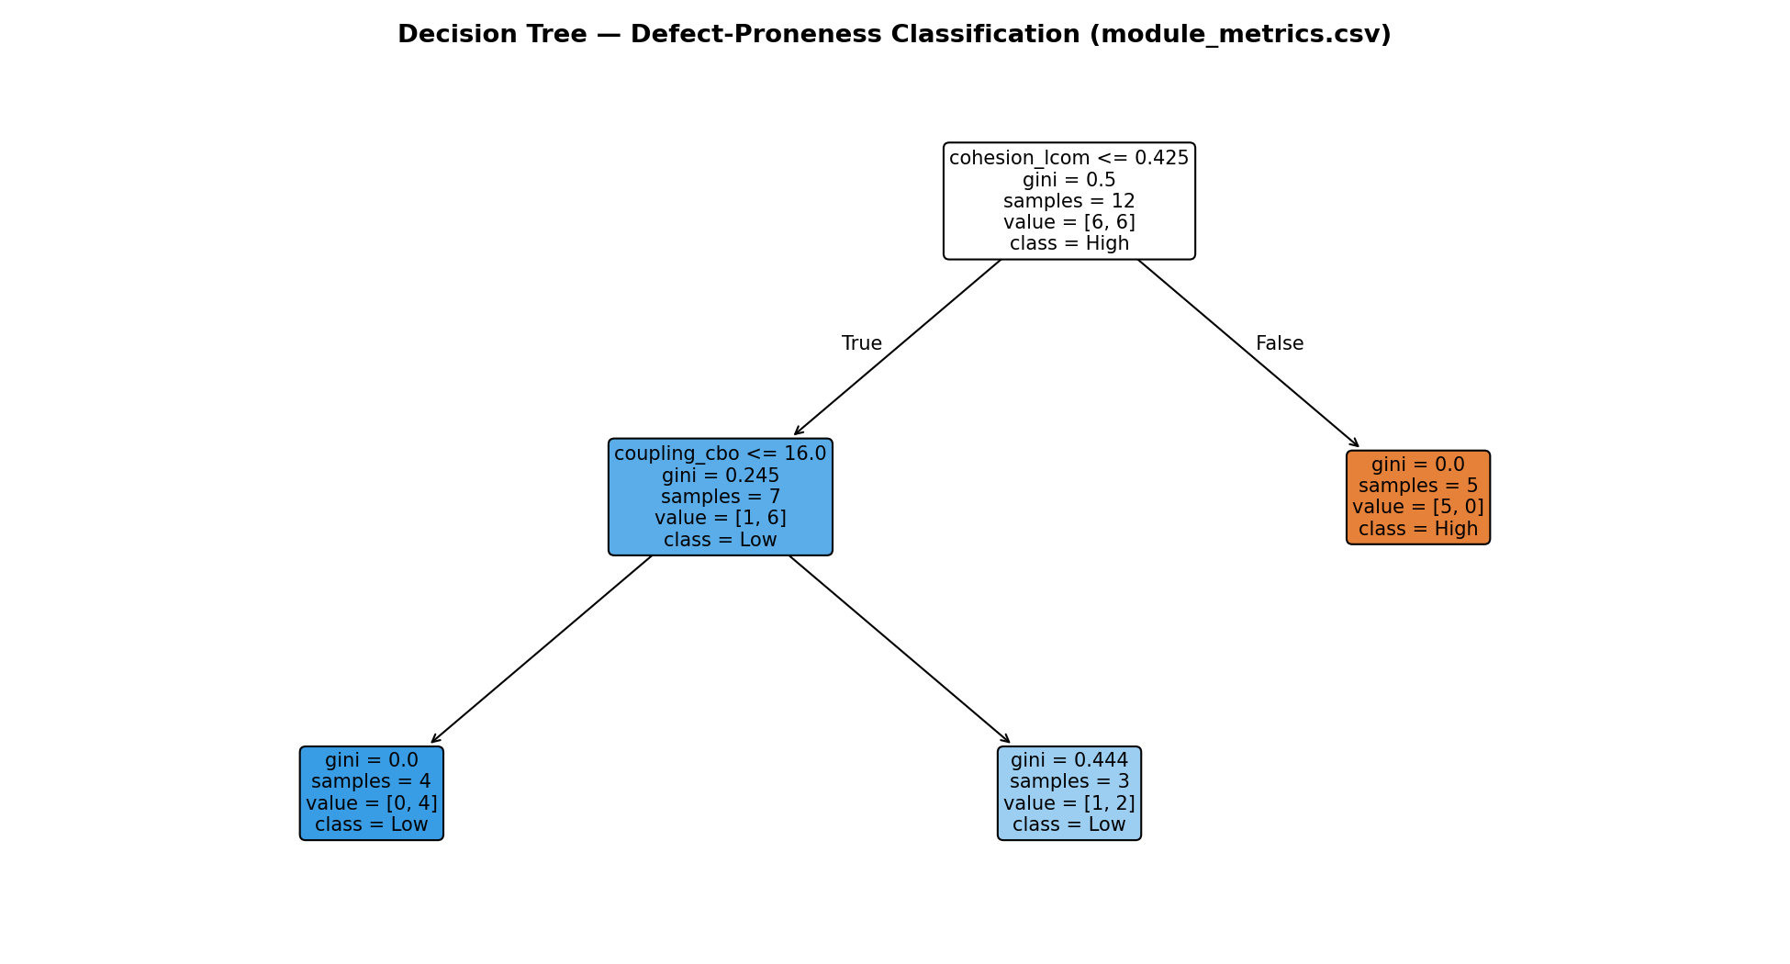
Figure 1 — Decision tree classifying modules as High/Low defect risk.

3.3.2 Box Plot
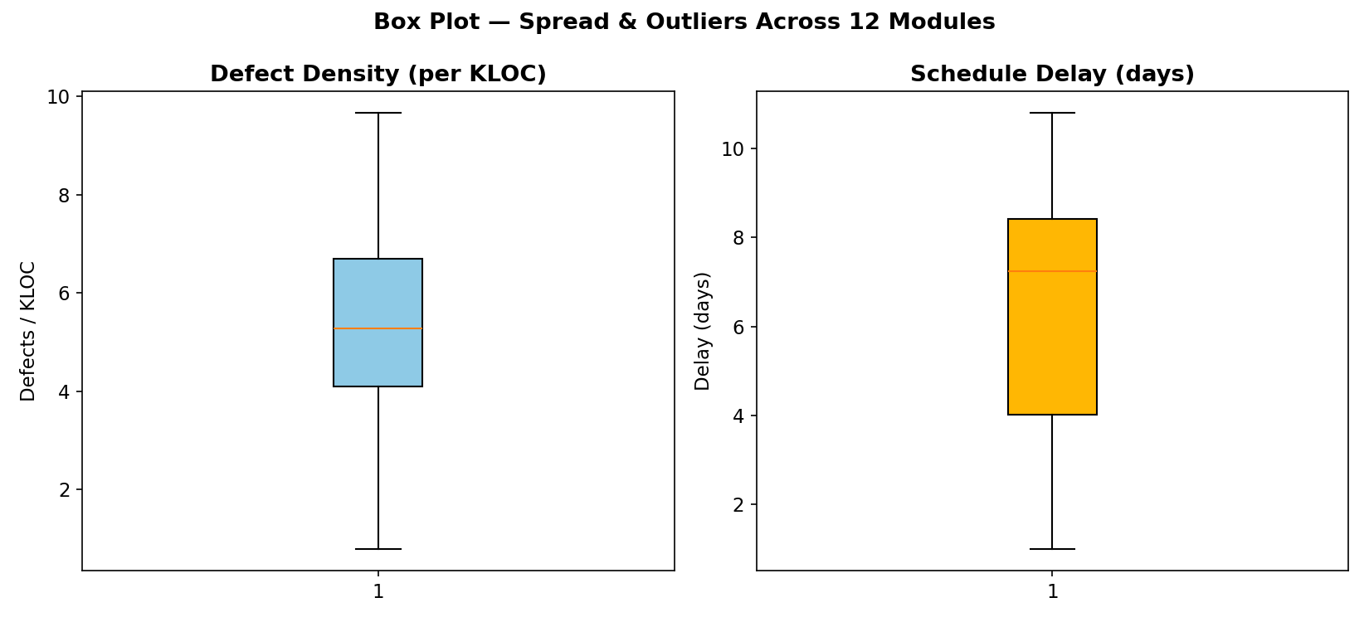
Figure 2 — Box plots of defect density and schedule delay across the 12 modules.
Defect density: Q1=4.1, median=5.28, Q3=6.7 defects/KLOC. Delay: Q1=4.02, median=7.25, Q3=8.43 days. No IQR outlier modules this cycle in either metric.

3.3.3 Control Chart (I-MR)
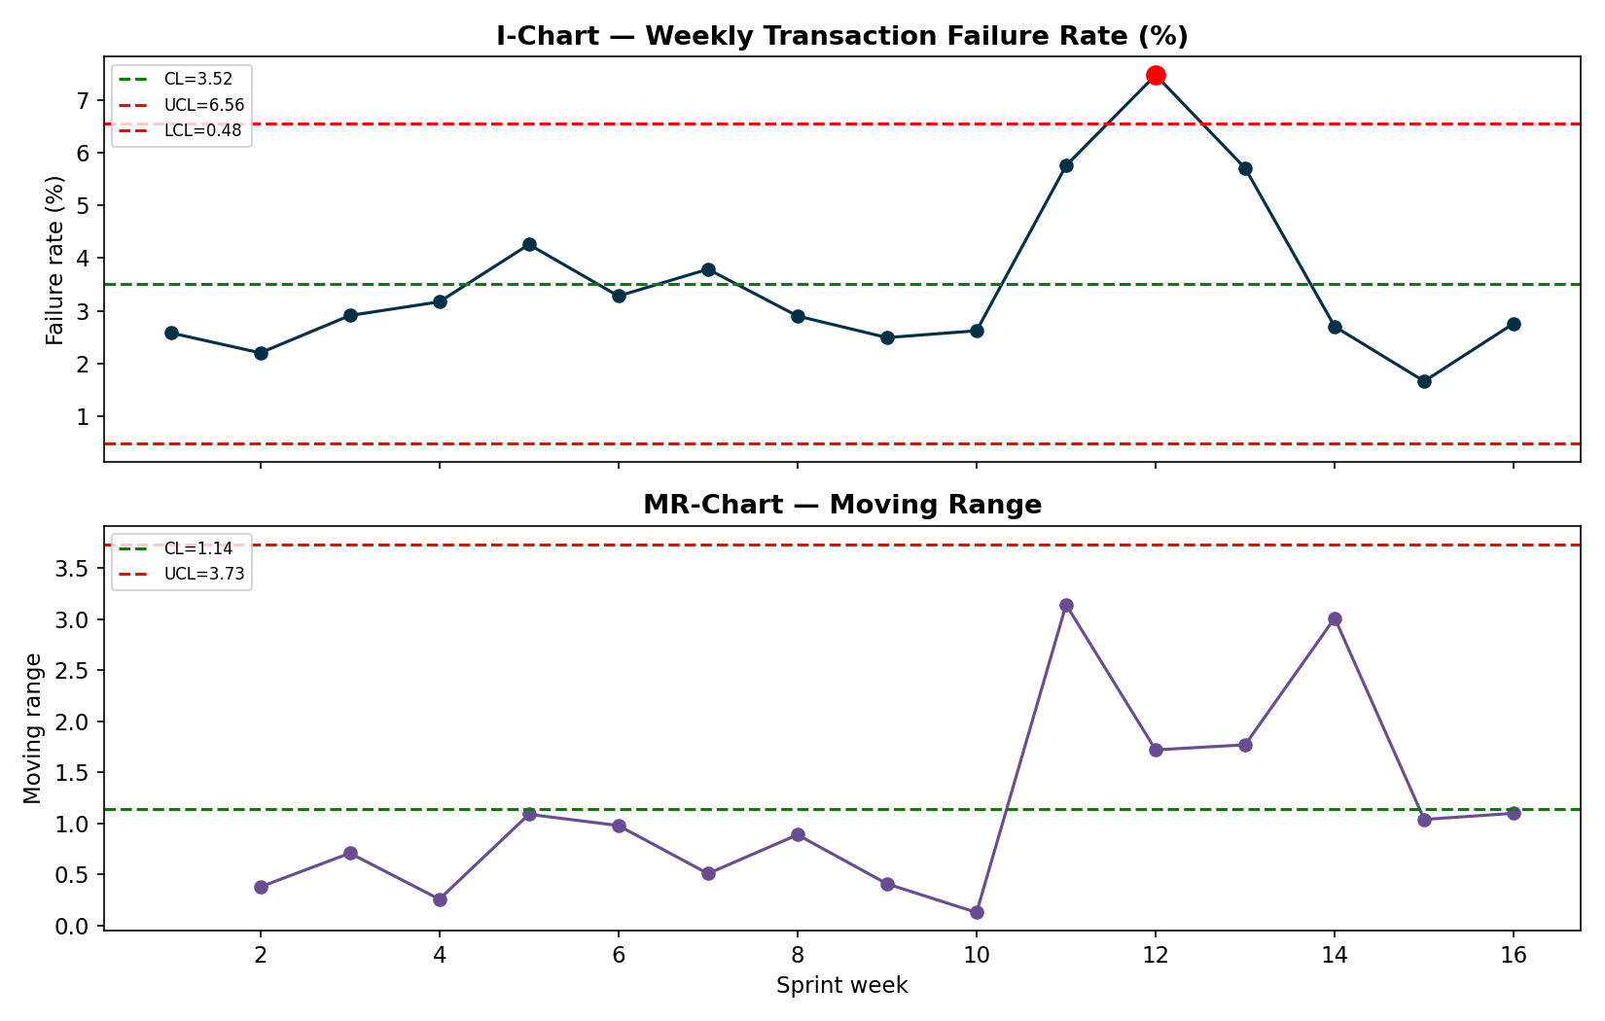
Figure 3 — Individuals & Moving-Range control chart of weekly transaction failure rate.
Center line = 3.517%, UCL = 6.556%, LCL = 0.477%. Week 12 breaches the UCL, corresponding to a simulated release regression — the control chart flags it as an assignable-cause process shift in production transaction reliability.

3.3.4 Correlation Analysis — Three Types, and Statistical Test
A single correlation method on a 12-row dataset can mislead, so three methods are run on the same three variable pairs and compared side by side:
- Pearson r — linear relationship; assumes roughly interval, near-normal data.
- Spearman ρ (rho) — monotonic relationship on ranks; robust to non-linearity and outliers.
- Kendall τ (tau) — concordance of pairwise rank ordering; the most conservative of the three, well suited to small n.
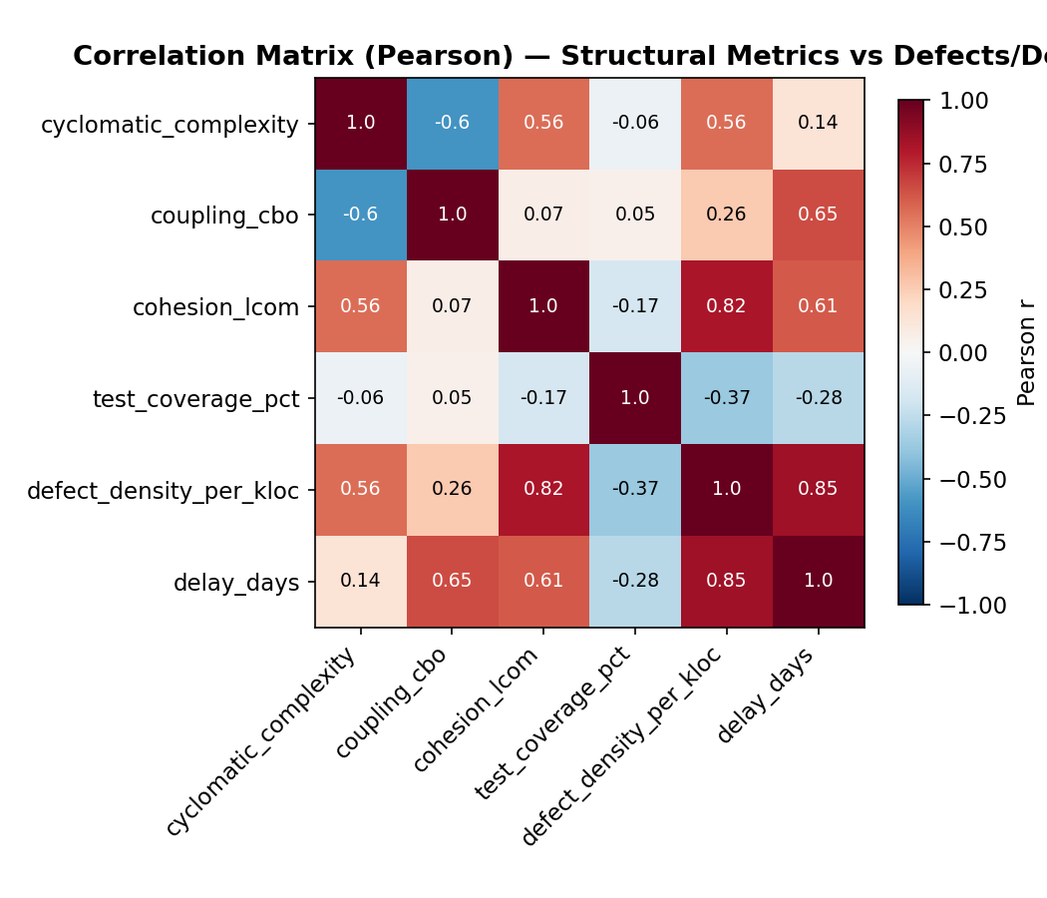
Figure 4 — Pearson correlation matrix across structural metrics, defect density and delay.
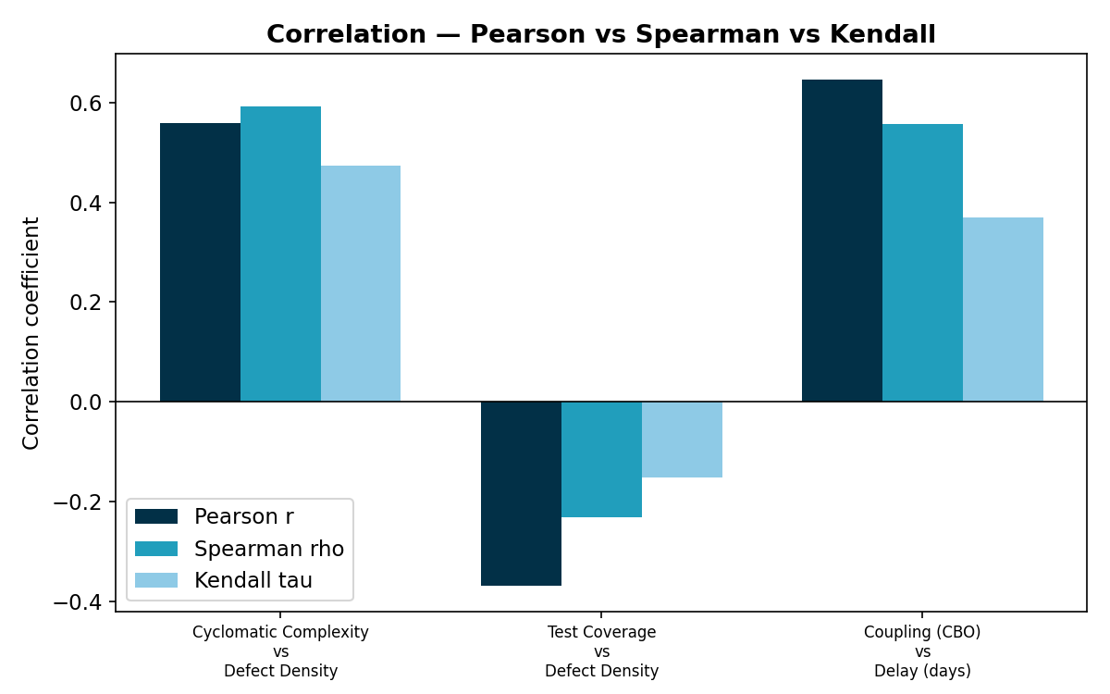
Figure 5 — Pearson vs Spearman vs Kendall on the same three variable pairs.
Variable pair | Method | Coefficient | p-value
Cyclomatic Complexity vs Defect Density | Pearson r | 0.559 | 0.0591
 | Spearman ρ | 0.592 | 0.0426
 | Kendall τ | 0.473 | 0.0331
Test Coverage vs Defect Density | Pearson r | -0.37 | 0.2367
 | Spearman ρ | -0.231 | 0.4705
 | Kendall τ | -0.152 | 0.5452
Coupling (CBO) vs Delay (days) | Pearson r | 0.647 | 0.0229
 | Spearman ρ | 0.558 | 0.0594
 | Kendall τ | 0.369 | 0.0982
Cyclomatic Complexity vs Defect Density: All three methods agree on a positive relationship.
Test Coverage vs Defect Density: All three methods agree on a negative relationship.
Coupling (CBO) vs Delay (days): All three methods agree on a positive relationship.
Statistical test: an independent two-sample t-test compared defect density between low-coverage and high-coverage modules (split at the median). Mean defect density was 6.31 defects/KLOC for low-coverage modules versus 4.5 for high-coverage modules (t = 1.131, p = 0.2847, not significant at α=0.05).

Module 4 — Metrics for Decision Support
Correlation (Module 3.3.4) tells us two variables move together; it does not tell us what happens to project risk if we change one of them. This module substitutes a causal model — Bayes' theorem and Bayesian networks — for the purely correlational view, then uses it for project risk analysis and closes with risk-overcome ideas.

4.1 Project Risk Analysis
A Bayesian network models Project Risk (P) as caused by Requirement Volatility (R) and Team Experience (T), acting through the intermediate observables Schedule Delay (S) and Defect Density (D) — the same two quantities Module 3 measures directly. Solved by exact inference (enumeration over the joint distribution), the network answers “what is P(ProjectRisk=High) given this evidence?” for any combination of evidence:
Scenario | Evidence | P(Low) | P(Medium) | P(High)
Baseline (no evidence — population prior) | none (prior) | 37.5% | 34.3% | 28.1%
Volatile requirements + inexperienced team (worst case) | R=High, T=Low | 10.7% | 34.3% | 55.0%
Stable requirements + experienced team (best case) | R=Low, T=High | 57.7% | 29.5% | 12.8%
Observed schedule already slipping (High delay) | S=High | 10.5% | 39.4% | 50.0%
Observed high defect density in current sprint | D=High | 13.2% | 37.7% | 49.1%
Mitigation applied: inexperienced team upskilled mid-project (T -> High) despite volatile requirements | R=High, T=High | 36.2% | 37.3% | 26.5%
Reading the table: the worst-case scenario (volatile requirements + inexperienced team) pushes P(High risk) to 55.0%, nearly double the 28.1% population baseline. Observing schedule delay or defect density directly (as Module 3's control chart and correlation analysis would surface) pushes P(High risk) to roughly 50% on their own — evidence from data collection directly sharpens the risk estimate.

4.2 Substitution of Bayesian Theory and Network Analysis
Where Module 3 used correlation/regression (an association-only view), Module 4 substitutes Bayes' theorem: P(Risk | Evidence) = P(Evidence | Risk) × P(Risk) / P(Evidence), generalized to a network of conditional probability tables (CPTs) rather than a single pair of variables. A second, smaller network applies the same substitution to software defect prediction, calibrated directly against the Module 3 dataset (Code Complexity and Test Coverage split at their sample median):
Code complexity | Test coverage | P(DefectProne=No) | P(DefectProne=Yes)
Low | Low | 100% | 0%
Low | High | 50% | 50%
High | Low | 25% | 75%
High | High | 50% | 50%
High-complexity, low-coverage modules carry the highest defect-proneness (75%) in this data — the same signal as the decision tree (Module 3.3.1) and the correlation analysis (Module 3.3.4), now expressed as a queryable conditional probability rather than a single coefficient.

4.3 Risk Overcome (Idea Only)
Each risk below is traced to the Bayesian-network driver or chart that surfaced it. Mitigations are kept at idea level, as scoped for this module.
Risk | Likelihood | Impact | Overcome idea
Requirement volatility (frequent scope changes to AI recommendation logic) | Medium-High | High | Freeze the GQ(I)M-derived acceptance criteria per sprint; route all mid-sprint scope changes through a lightweight change-control board before they enter the backlog.
Inexperienced team members on the Transaction Engine / Auth modules | Medium | High | Pair junior engineers with senior reviewers on Transaction Engine and Authentication Service PRs; mandatory code review + 85% coverage gate already defined in Sub-Goal 4's CI/CD plan.
Schedule delay cascading from high-coupling modules | Medium | Medium | Refactor the top-2 highest-coupling modules identified by the decision tree/correlation analysis before the next release; track CBO as a Structural-Metrics KPI in the sprint dashboard.
AI model drift degrading recommendation accuracy | Medium | Medium | Auto-trigger retraining when Drift Score (current MAPE - baseline MAPE) exceeds threshold, as already planned in the GQ(I)M measurement plan.
Production transaction-failure spike (control-chart out-of-control signal) | Observed | High | Treat any UCL breach as an assignable-cause incident: trigger the 48-hour post-mortem SLA already defined in Sub-Goal 4's measurement plan; roll back the release that introduced the regression.

Implementation — The Working Product
Every measure above is instrumented against a real, running application: a React 19 + Vite frontend talking to a Node/Express REST API with JWT authentication and a Gemini-API-powered recommendation layer. The screenshots below are taken directly from the deployed app.

Authentication

Figure 6 — Login screen.

Dashboard
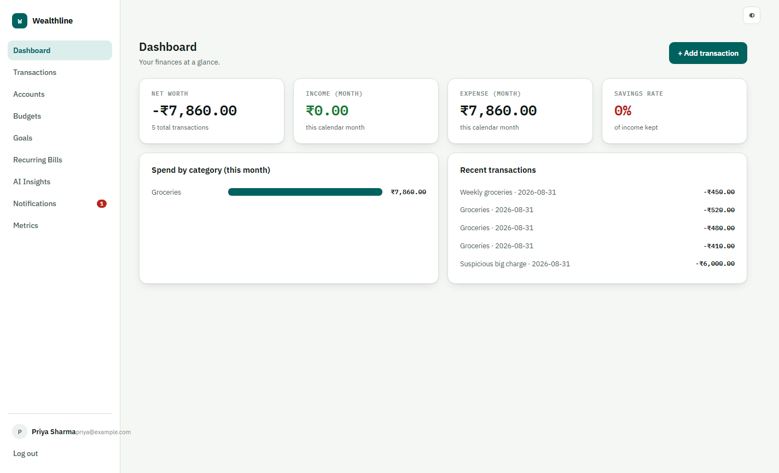
Figure 7 — Dashboard.

Transactions and Anomaly Detection
Every new expense is scored by z-score against the category's trailing history (|z| ≥ 2.5 flags it) — visible below as the ₹6,000 outlier flagged z=137.31 against a normal ₹400-500 grocery history.
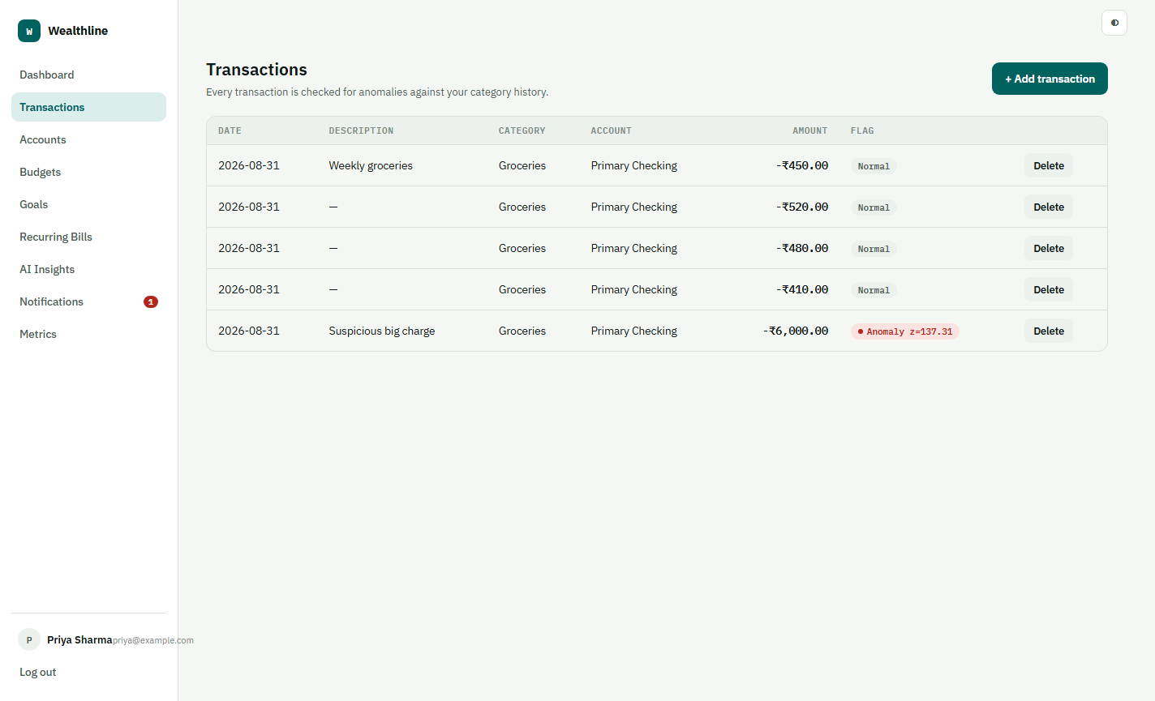
Figure 8 — Transactions, with the anomaly (failure-risk) flag visible.

AI Insights — Gemini-Powered Recommendations
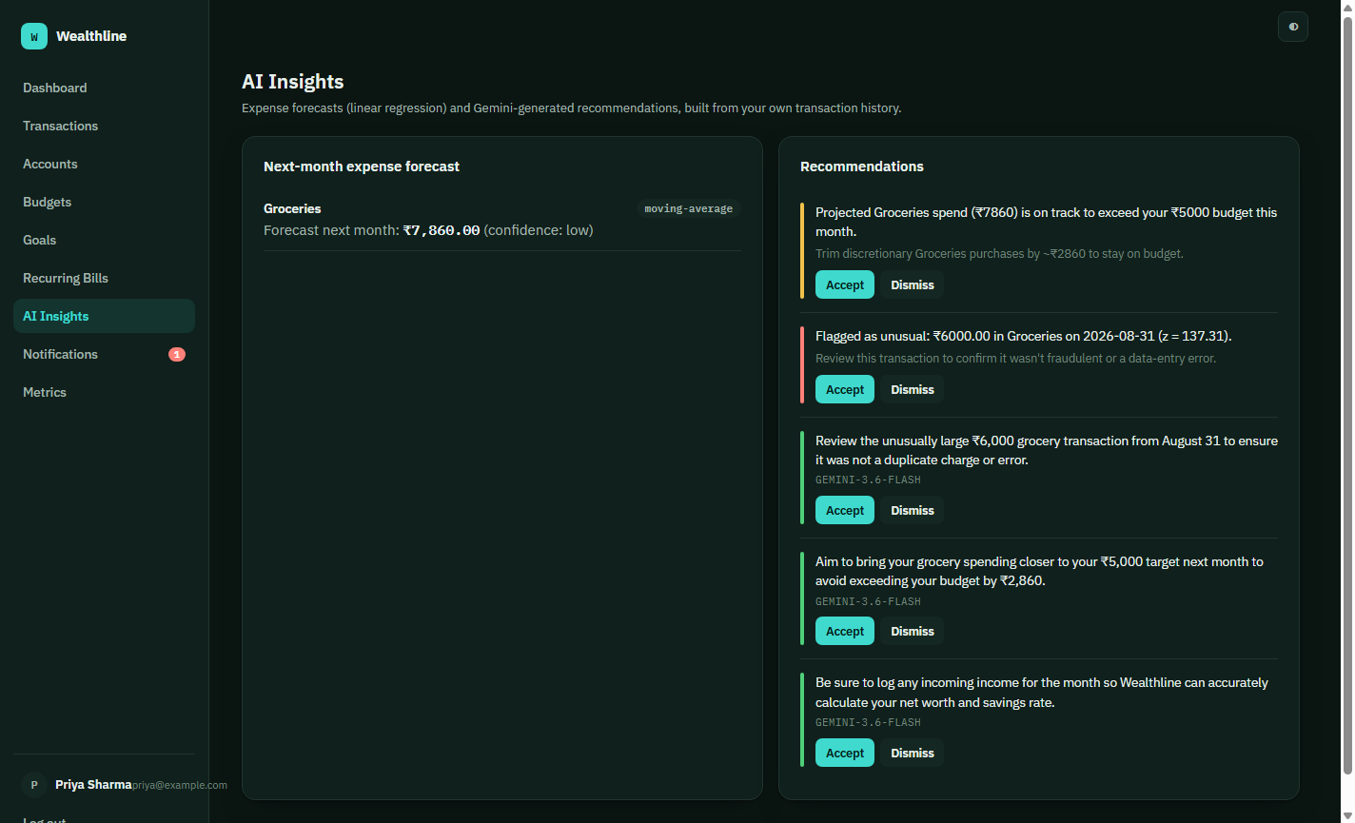
Figure 9 — AI Insights, showing rule-based and Gemini-generated recommendations.

Budgets and Goals
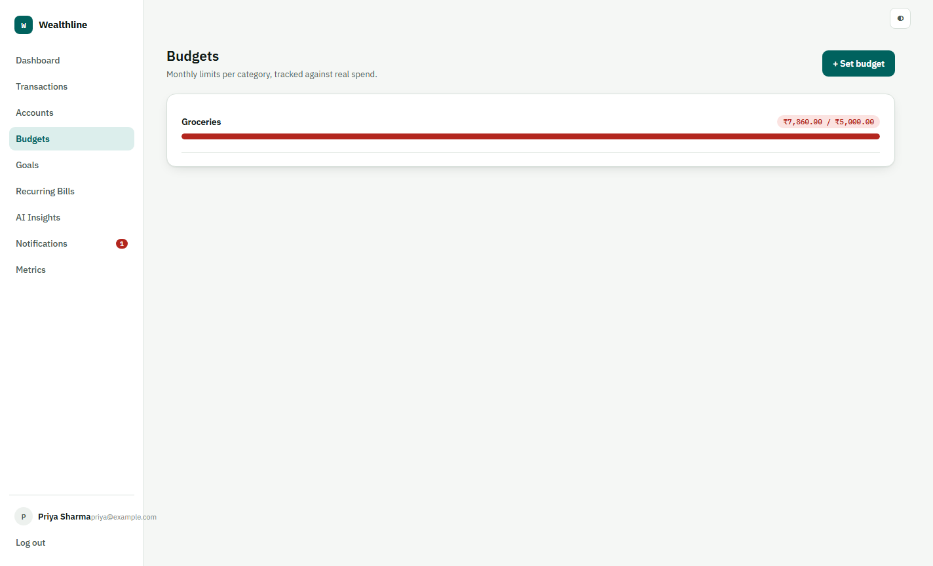
Figure 10 — Budgets, tracked live against category spend.

Figure 11 — Financial goals with contribution tracking.

Metrics Command Deck — Embedded In-App
This report's Module 3 and Module 4 analysis is not a separate document to dig up during the review — it is served by the same Express server under /metrics and embedded directly as a tab inside the app.
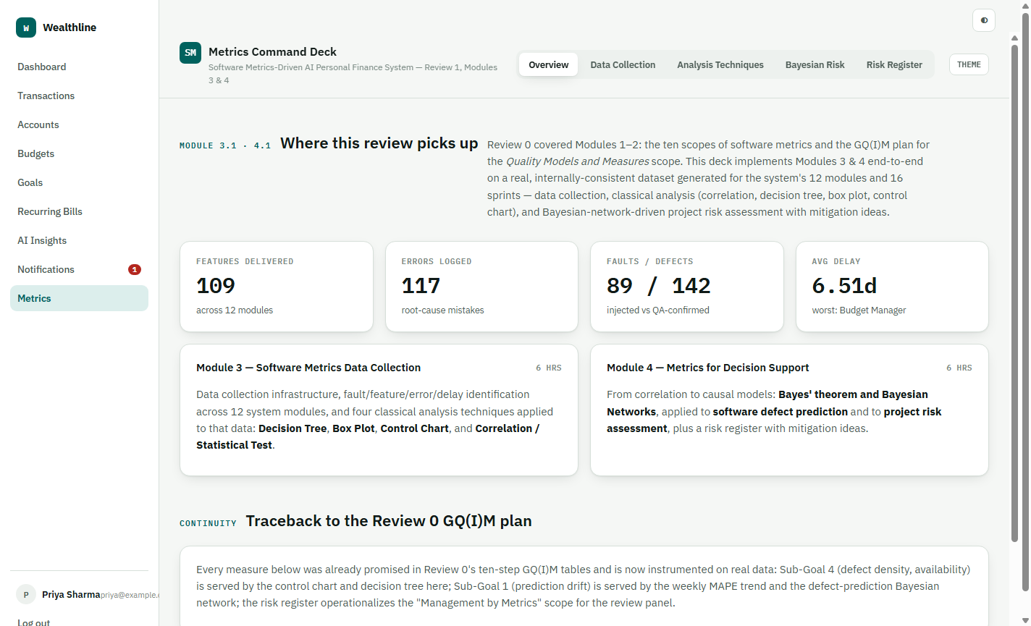
Figure 12 — The Metrics Command Deck, open as an in-app tab.

Notifications
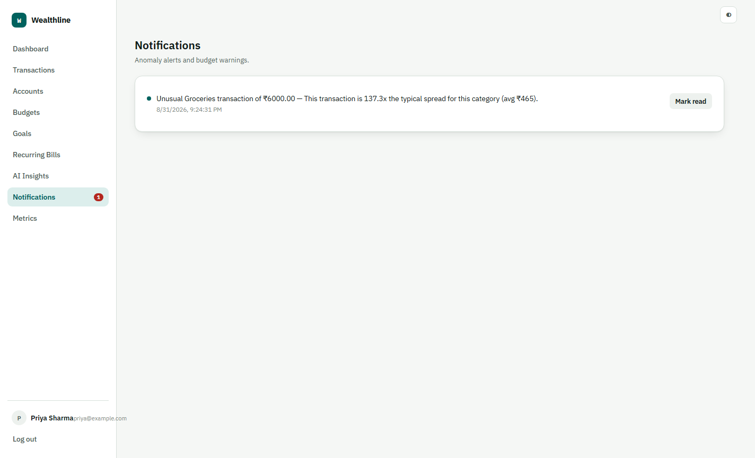
Figure 13 — Notifications, driven by the anomaly detector.

Conclusion
Module 3 established a real data-collection pipeline and identified faults, failures, errors and bugs across 12 modules, then applied four classical analysis techniques — including all three correlation methods — to that data. Module 4 substituted a causal Bayesian model for the purely correlational view, used it for project risk analysis and defect prediction, and closed with an idea-level risk-overcome register. Every one of these measures has a working counterpart in Wealthline, the React/Express personal-finance app shown above, running end-to-end from signup to AI-generated financial advice.

