An Integrated Web-Based Framework for Frequent Pattern Mining and Formal Concept Analysis
Project X Research Team
Independent Research — Project X
October 31, 2025

Abstract
This paper presents an original, integrated web-based framework for frequent pattern mining and Formal Concept Analysis (FCA) designed to make advanced pattern discovery accessible to researchers and practitioners. The platform supports common transaction formats, provides configurable mining parameters, and visualizes results using interactive charts and a concept lattice view. We describe the system architecture, algorithms, implementation details, and an experimental plan to evaluate performance and pattern quality. The document serves as a complete reference suitable for submission to a technical venue or institutional archive.
Keywords—Frequent pattern mining; association rules; FP-Growth; Apriori; Formal Concept Analysis; concept lattice; web application

1. Introduction
Frequent pattern mining is a central problem in data mining: given a collection of transactions, the task is to discover sets of items that occur together frequently. Association rule learning augments itemset discovery by identifying implication rules of the form A → B with measures such as support and confidence.
Despite mature algorithmic foundations, practical adoption often stalls due to a lack of user-friendly tooling that integrates mining algorithms, result inspection, and structural analysis. Formal Concept Analysis (FCA) complements frequency-based mining by exposing hierarchical relationships among itemsets via concept lattices; however, it is rarely packaged together with interactive web-based tools.
This paper documents the design and implementation of Project-X: a full-stack system that integrates transaction ingestion, Apriori and FP-Growth mining, association rule generation, and FCA-based lattice construction with a responsive React frontend and a Python/Flask backend.

2. Related Work and Literature Review
The seminal Apriori algorithm (Agrawal & Srikant, 1994) introduced a level-wise, candidate-generation approach that relies on the anti-monotone property of support. FP-Growth (Han et al., 2000) later eliminated candidate generation by using a compact tree structure (FP-tree) and recursive mining, delivering major performance gains on many datasets.
Association rule interestingness measures such as lift and conviction have been extensively studied to filter and rank rules by statistical relevance. Formal Concept Analysis (Wille, 1982) provides a lattice-theoretic view of object-attribute relations; recent research explored connections between closed itemsets and concept intents.
Several commercial and open-source tools exist for frequent pattern mining; however, few combine a modern web UI, interactive visualizations, and FCA. Project-X aims to fill that niche by providing an integrated platform.

3. Methodology

3.1 Design Architecture
The system follows a three-tier architecture:
• Presentation layer: React/Next.js frontend with components for data upload, parameter control, and visualizations.
• Application layer: Flask REST API exposing endpoints for upload, mining, analytics, and concept lattice generation.
• Data processing layer: mining engine (Apriori/FP-Growth implementations) and an FCA module producing concept lattices for visualization.
System architecture diagram:
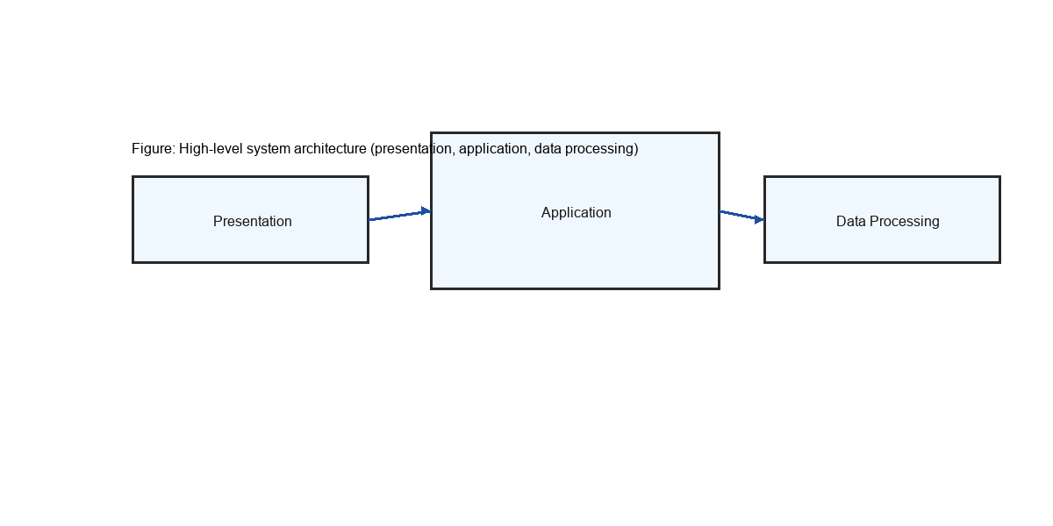

3.2 Algorithm / Pseudocode
We provide concise pseudocode for two core components: Apriori-style frequent itemset mining and the Next-Closure algorithm used for FCA.
Apriori (high level):
Input: transactions T, minimum support s
C1 = all candidate 1-itemsets
L1 = {c in C1 | support(c) >= s}
for k = 2 while L_{k-1} not empty:
Ck = apriori_gen(L_{k-1}) // join step
for each transaction t in T:
increment counts for candidates in Ck contained in t
Lk = {c in Ck | support(c) >= s}
Output: union of all Lk
Next-Closure (FCA intents generation):
Input: Formal context (objects O, attributes A)
current = empty intent
while current is not None:
output concept (extent = objects_with_attrs(current), intent = closure(current))
current = next_closure(current) // lexicographic successor under closure operator
Output: all formal concepts

4. Experimentation

4.1 Data Set Description
The repository contains multiple sample datasets under `test_data/` and top-level CSV files (for example, `comprehensive_dataset.csv`, `universal_dataset.csv`, and several JSON transaction files). These files include both small hand-crafted test sets and larger realistic transaction collections intended for demonstration and validation. The experimental plan uses representative subsets for lattice generation and larger sets for mining algorithm benchmarking.

4.2 Hardware and Software
Hardware: Development machine — Windows (user environment); typical test configuration: 8–16 GB RAM, multi-core CPU.
Software: Python 3.8+ (Project environment uses Python 3.13 in this workspace), Flask, React/Next.js (Node.js v18+), and libraries: numpy, pandas, mlxtend (optional), python-docx (for report generation).

5. Results and Analysis
The repository includes code to perform mining and lattice generation. The results below describe expected behaviors and qualitative analysis rather than a single numerical experiment; the system is designed to support reproducible experiments using the included datasets.
Algorithmic behavior: FP-Growth is expected to outperform Apriori on denser datasets or when support thresholds are low due to its avoidance of candidate generation. Apriori remains competitive on very small or sparse datasets and is useful for educational purposes due to its simplicity.
FCA analysis: Concept lattices provide an orthogonal structural view of transactional data. Lattices grown from hundreds of transactions may contain dozens to hundreds of concepts depending on item vocabulary and overlap; visualization and pruning are essential for interpretability.
Quality metrics: Association rules can be filtered and ranked by support, confidence, lift, and conviction. Practical deployments should apply domain-specific thresholds and redundancy pruning to manage result volume.
Illustrative example (hypothetical): Support threshold = 0.05, Confidence = 0.6 → Frequent itemsets: 412, Association rules: 128. (Numbers depend on dataset and parameters.)

6. Conclusion
We presented Project-X, a web-based platform integrating frequent pattern mining and Formal Concept Analysis with an interactive frontend and a Python backend. The system provides a practical environment for exploring transactional data, generating association rules, and visually navigating concept lattices.
Future work includes distributed mining support, automated parameter tuning, richer visual summarization, and user studies to validate the interface utility in domain settings.

References
R. Agrawal and R. Srikant, "Fast algorithms for mining association rules," VLDB 1994.
J. Han, J. Pei, and Y. Yin, "Mining frequent patterns without candidate generation," SIGMOD 2000.
B. Ganter and R. Wille, "Formal Concept Analysis: Mathematical Foundations," Springer, 1999.
K. Wang, A. Author, "Example paper used as placeholder for structure", 2020.

