[PAGE 1, CONSISTENT OF 6 BLOCKS, OF WHICH YOU SHOW JUST ONE]

Please consider the ads below for different self-driving cars. Based on these ads, please choose which vehicle you would be most willing to ride in.

1. Yondex Self-Driving: Protecting **Our** Roads
2. Zoot Self-Driving: Protecting You **Before** Others
3. Mumotor Self-Driving: Protecting **You**, No Matter What

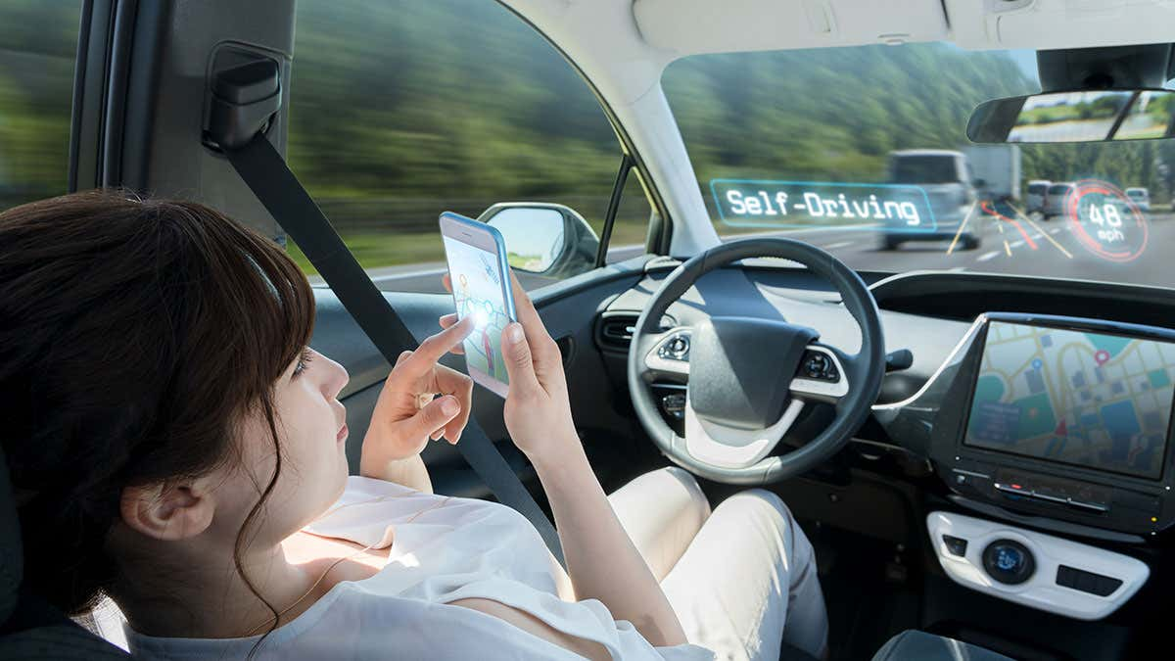

<https://images.newscientist.com/wp-content/uploads/2017/10/13174202/gettyimages-829192848.jpg?crop=16:9,smart&width=1200&height=675&upscale=true>

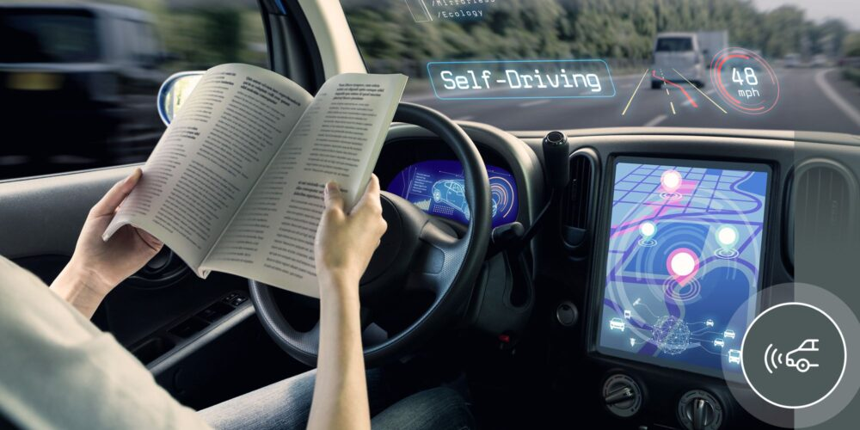

<https://piernext.portdebarcelona.cat/wp-content/uploads/2021/05/f3-1000x500.jpg>

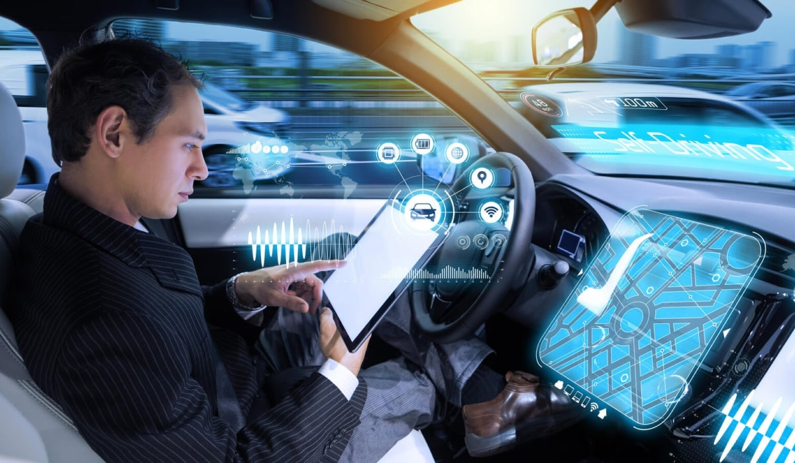

<https://www.cprime.com/wp-content/uploads/2022/07/archer_blog_security_testing_for_self-driving_cars__5_best_practices_cprimestudios_image.jpeg>

Based on these ads, please choose which vehicle you would be most willing to ride in.

1. Yondex
2. Zoot
3. Yondex

=======================================================

[PAGES 2-4, EACH OF WHICH SHOWS ONE OF THREE BLOCKS; SO YOU CREATE THREE BLOCKS AND SHOW ALL THREE, AND ALL THAT WE VARY IS THE ORDER IN WHICH THOSE THREE ARE SHOWN, I.E., WHICH IS ON PG.2, 3, OR 4]

Noe, please consider the following ad’s wording again:

1. Yondex Self-Driving: Protecting **Our** Roads

OR

1. Zoot Self-Driving: Protecting You **Before** Others

OR

1. Mumotor Self-Driving: Protecting **You**, No Matter What

Imagine that you choose to ride in this vehicle on a regular basis, and a friend of yours discovers this.

Please rate the extent to which you agree with the following statements (1=completely disagree, 100=completely agree) [Francesca: Please put each of these on 1-100 point sliding scales]

1. Your friend would think that the real reason you chose the vehicle is to selfishly protect yourself.

1. Your friend would believe that you know that they realize the real reason you picked the vehicle is to selfishly protect yourself.
2. You and your friend would both know that you both know that the real reason you picked the vehicle was to selfishly protect yourself.