The 3D-Printers

 | University Hawassa

Young entrepreneur exchange project

Together we print

2022

Overview

1. Business model 3

1.1. Overview 3

1.2. Actual pains / problems 3

1.2.1. Main tasks of the 3D-printers 3

1.3. Market / Stakeholders 3

1.4. Marketing-Activities 4

1.5. The way to be more sustainable 4

1.6. Roadmap (short-term) 5

1.6.1. Week 1 (Hackathon Week) 5

1.6.2. Week 2 – 3 (Marketing and organising) 5

1.6.3. Week 4 - 5 (Marketing and organising) 5

1.6.4. Week 6 – 7 (First ordering) 5

1.7. Roadmap (long-term) 6

1.7.1. The first 6 month: 6

1.7.2. For the next 1 year: 6

1.7.3. For the next 2 years: 6

1.7.4. For the next 5 years: 6

1.8. Financials 6

1.9. Value Offer 7

1.9.1. Colors 7

1.9.2. Materials for the build 7

1.9.3. Price 7

1.9.4. Maximum size of the product 7

1.9.5. Warranty and discount price 7

1.10. Overview of team-structure 8

2. Additional Informations 9

2.1. Maintenance-plan 9

2.1.1. Definitions maintenance fees: 9

2.2. Priority list 11

2.3. Pricelist 11

2.4. Spare parts 12

2.4.1. Shops 12

2.4.2. Process 13

3. Attachment 14

3.1. Comparison of filament melting machine 14

3.2. Material comparison 15

3.3. Question for market research 16

3.4. Financial calculations 17

3.4.1. Filament 17

3.4.2. Maintenance 17

3.4.3. Salary 17

3.4.4. Security fees 18

3.4.5. Options of printing quality 18

# Business model

## Overview

**Mission:**

Using creativity of each students to convert their idea into reality. Give them the power of creating!

**Vision:**

Creating a sustainable 3D-printer shop in Ethiopian

**Values:**

User friendly, because we have two options of ordering!

Environment friendly, because we think about the future!

Fair price-quality ratio, because we have 3 different quality/costing options!

Strong quality, because we care for tidiness and cleanliness!

## Actual pains / problems

* Not enough opportunity, to get new parts if they are broken
* High costs of buying new parts
* No experiences with using 3D-printers
* Not existing sustainable circle-economy of plastic
* The solution – The 3D Printers

### Main tasks of the 3D-printers

A deeply market research has found out, there is a big need of 3D-printed parts, especially for students. The main goal is to create a 3D-printer shop, which will work as follow:

**Option 1, for users with experience in AutoCAD:**

Export your created model into a STL file and give it to the shop. Afterwards we will take responsibility for the rest of it.

**Option 2, for users without experience in AutoCAD:**

Give the shop a sketch of your idea, and we will do the rest.

## Market / Stakeholders

* Engineering department (civil, mechanical, electromechanical, urban, chemical)
  + Using parts for a project
  + Broken parts user

## Marketing-Activities

* Send E-Mails for each stakeholder group
* Creating a big advertisement on the school campus
* Take movie, to explain future customers the different options they have
* Create some flyers / cards, give it customers after finished their printings.
* Create a Facebook platform with the most important informations about the shop

## The way to be more sustainable

* Using a melting machine which can produce some filament again
* Different processes are possible
  + Useless parts -> melting -> producing new filament -> using again
  + Plastic bottles -> melting -> producing new filament -> using again
  + Useless structure -> melting -> producing new filament -> using again
* Maintenance of each 3D-printer, this includes:
  + Keep the printer and the office clean and tidy
  + Frequently controlling of any kind of lacking
* Education of yourself

## Roadmap (short-term)

### Week 1 (Hackathon Week)

**Tasks:**

* Assembly 3D printer
* Construct an enclosure for the printer
* Program an interface to remote-control the printer
* Develop video tutorials
* Carry out a market research
* Develop a business model

### Week 2 – 3 (Marketing and organising)

**Tasks:**

* Hiring people for each position
  + 1x Coordinator, 2x Designer, 1x Maintenance, 1x Financial
* Marketing activities
  + See in business-plan
* Finding a place for the shop

### Week 4 - 5 (Marketing and organising)

**Tasks:**

* Organise your shop
* Create awareness for the 3D-printer
  + Give flyers to the different stakeholders
  + Talk to all possible people about your shop -> propaganda
  + Take care for all social media platform
  + …
* Board meeting, planning for next month
  + What are the goals?
  + How much money do you want to earn?

### Week 6 – 7 (First ordering)

**Tasks:**

* Ongoing process with business

**Important:**

* Do all month at least one meeting together, and talk about your vision, your plans for the future, your goals with the 3D printer shop

## Roadmap (long-term)

### The first 6 month:

* Have done all the important task for starting the business
* Increasing marketing strategies
* Business is working

### For the next 1 year:

* Do another market research for new stakeholders, also on the campus of Hawassa
  + Find new market: for example 3D-parts for personal

### For the next 2 years:

* Decreasing your costs by using:
  + A melting machine (Watch out the attachment, there are some possibilities to buy)
    - Recycling bottle
    - Recycling all the old plastic waste of the streets
    - Recycling old and useless parts

### For the next 5 years:

* New market research to get recognition from the city administration
* Expanding business through Hawassa industry

## Financials



Please notice, detailed calculations you can find in the attachment!

## Value Offer

### Colors

* Sky blue
* Blue
* Luminous Green
* Electric, vertigo ad metallic Grey
* Pink
* Gold
* Signal yellow
* Orange

### Materials for the build

* PLA
* TPU
* PVA

### Price

* Costs for printing itself
  + Quality options
    - Low = 5 birr / gram
    - Normal = 7,5 birr / gram (1,5 times more)
    - High = 15 birr / gram (3 times more)
* Costs for designing itself
  + 30 birr / hour

### Maximum size of the product

* Volume = 0.01m3  (L = 0.24892 m, W = 0.21082 m, H = 0.21082 m)

### 1.9.5. Warranty and discount price

If the part will be broken after the following shorts of time, then has the customer the opportunity to get a new part without any additional costs

🡪 1 month for medium quality customers

🡪 3 month for high quality customers

**Special customer offer**

1. **Based on annual events**

* **5% discount (** can be done on holiday season ) **(discount Is considered from the profit)**

*Can be modified later on

**b. based on the quantity they order to be printed**

* 2.5% discount for customers ordering 10 product (all at once)
* 3% discount for customers ordering 15 product
* 5% discount for customers ordering more than 20 product

## Overview of team-structure

To handle all task which will have to be done by running a 3D-printer shop, it is needed to have 5 people for it. There are:

* 1x Coordinator
  + Segne has taken already the responsibility for this task. After finishing the Hackathon week, he is going to take care about the future of the 3D-printer shop!
* 1x Financial Manager
* 1x Maintenance and Operator
* 2x Designer

The following overview will give an idea, which task should be done in each position.

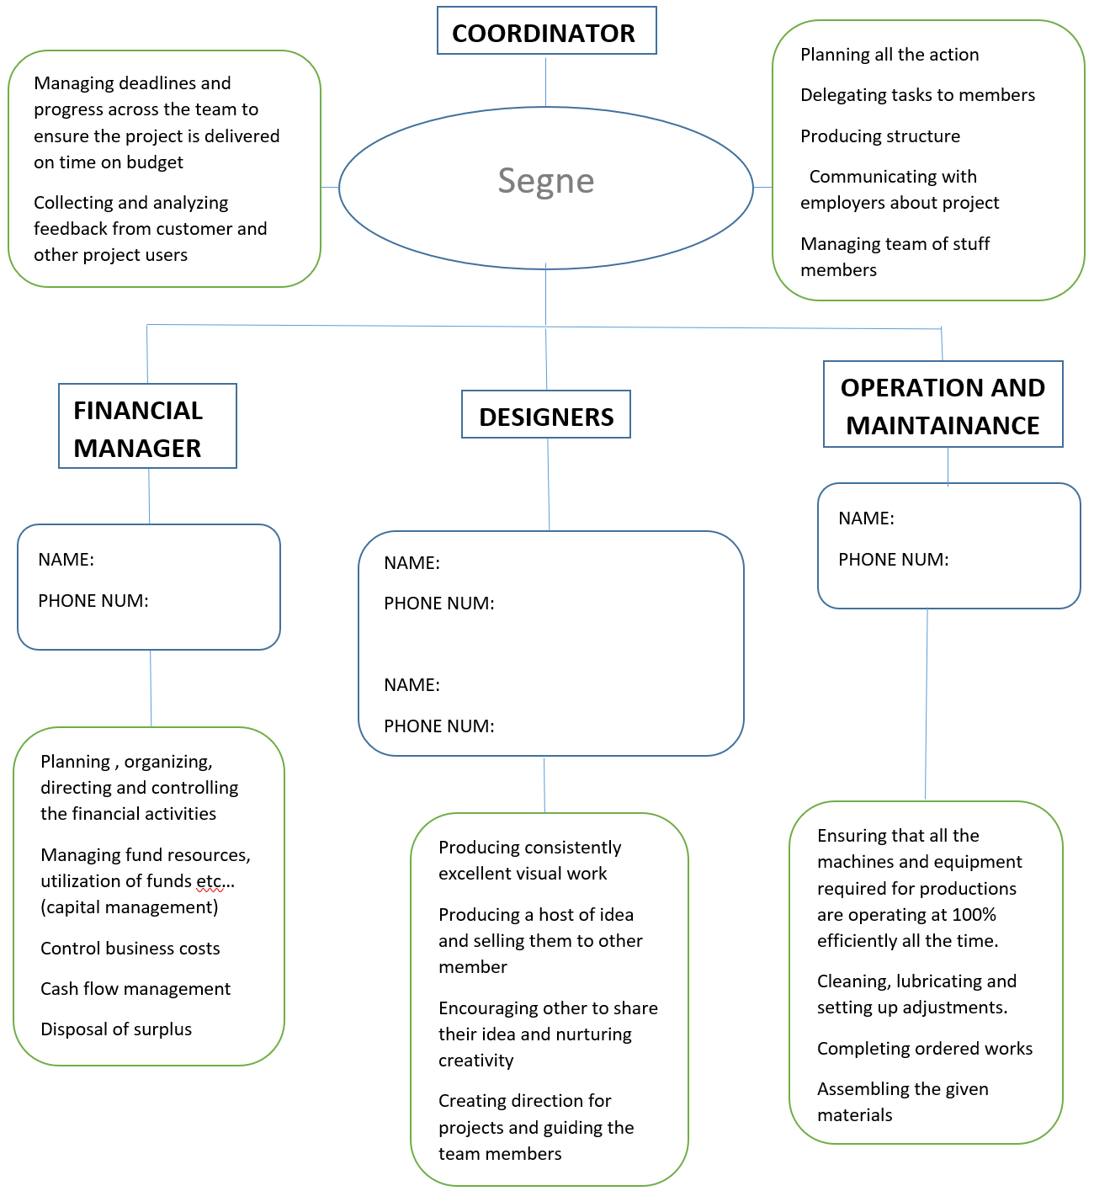

# Additional Informations

## Maintenance-plan

To make sure everything works as it shoulds the maintenance plays a big role. Because technical machines, like our 3D-printer is one, are really sensitive against dirt and other foreign stuff. Because of this the team has decided to gather some informations about the maintaince from this 3D-printer. As well it’s possible to avoid high costs. Because if the printer is maintenanced well, all the parts will last longer and marks of the using could been reduced to the minimum. Because of all these facts we have developped an maintenance-plan for the 3D-printer. This plan will be given to the responsible person and hopefully followed as good as possible. We create the plan as an Excel list, so the responsible can confirm, all the controlled points with an cross. Also the dates when the tasks have to be done are given. The list looks like this:



It has to be respected, that these maintenance fees are calculated with the full working time. This means, if the 3D-printer is printing eight hours per day. Otherwise the fees can be calculated by the operaters.

### Definitions maintenance fees:

**Control the filament:** Check the roll of filament. Make sure the filament is enough for the next printing task. Make sure the filament is rolled up pleasant. This task has to be done bevor every start oft he printer

**Control the wires:** Have a look at all wires of the printer. Make sure the wires aren’t broken or demaged.

**Control the extruder:** Have a look at the extruder. Make sure the filamnet can pass through it without any problems. Make sure the extruder is clean.

**Control the printing bed:** Make sure the printing bed is clean. If necessary clean it with a towel.

**Visible control:** Have a look at all moving pasrts of the printer. Make sure they are in a good technical state. This task has to be done befor every start oft he printer.

**Clean the intake filter:** Remove the enclosure of the filter. Clean up the net who is inside. Make sure there is no more dirt in it.

**Control the spindles for Z-axis :** Have a look at both spindles. Make sure they are not damaged. Have a look at the sledge of the Z-axis when it’s moving towarts the spindle. Make sure it moves without problems.

**Control Y-axis :** Make sure the Y-axis can be moved by hand. There is no air between the sledge and the rails.

**Control X-axis :** Make sure the X-axis can be moved by hand. There is no air between the sledge and the rails.

**Make sure the raspberry is safe :** Have a look at the raspberry. Make sure there is no dirt inside the box. Make sure there is no water inside the box.

**Make sure the ventilator works as it should :** Move the ventilator by hand. Make sure it doesn’t make some noise if it’s moved by hand. Make sure the ventilator rolls without problems.

**Control the scrolling wheel :** Make sure the display reacts if the scrolling wheel is moved. Make sure the scrolling wheel is fixed exactly.

**Control the display :** Make sure every pixle of the display works. Make sure it reacts if the scrolling wheel is moved.

**Control all the screws :** Make sure all screws are tightened. If not, tighten them down. This task hast to be done every month.

**Clean the extruder :** Take a little screwdriver or a needle to clean up the extruder. Work sensitive. Make sure you don’t break any parts of the extruder. Make sure, that the filament is floating through the extruder without problems. It fee has to be done all two months.

**Replace the activ-carbon filter :** Replace the filter who is located behind the ventilator. Make sure the polluted air can pass without problems through the new filter. This task has to be done all 12 months.

**Replace the intake filter:** Replace the filter on top of the enclosure. Make sure the new filter fits right. Make sure the air passes through the filter without problems. This task has to be done all 12 months.

**Do a calibration :** Calibrate the 3D-printer. Make sure the calibration was successful. This task has to be done all six months.

**Change the belts :** Change the belts. Make sure the belt fits right. Make sure the tension from the belt is enough. Do a calibration afterwards. This task has to be done all 24 months.

**Change the spindles for Z-axis:** Change the spindles for Z-axis. Make sure the sledge moves right over the spindles. Do a calibration afterwards. This task has to be done all 24 months.

**Replace the ventilator:** Replace the ventilator. Make sure the new ventilator works as it should. Make sure the new ventilator doesn’t touch the enclosure from the ventilator. This task has to be done all 24 months.

## Priority list

The business group decided to make a maps with all the decision factors in it. So we could be sure, that the coordinater will choose the right decision afterwards. Because sometimes it’s really hard to choose the right plan for the costumers. But with this list this work is already done. The coordinater has to fill in the name, the importance, the number of parts, the application date and the time which is needed to print one oft he parts. In relation to this intakes which has to be done, only the importance of the project has to be estimated from the coordinator. All other factors will be given after the slice withe the slicer software. Ort he application date is given from the customer hisself. After filling in all the parameters the map will calculate a ranking in which the orders have tob e made to be as efficient as possible.

In this picture is an example how it should work like. There are a few students from switzeland who were taken to show the principal:

In the picture above you can see, the application date for Michael is the latest one. But because of the importance and the number of parts this order has to be as second one.

## Pricelist

To have an overview about the price for an order we decided to make a pricelist. In this list all costs who have to be covered for the team are included. So the applicater has to fill in the quality and the weight from the part. After the map will calculate the price for the whole part. In this price is the salary, the filament, the maintenance, a security fee and the profit included. So if the map will be use, the team will be economical independant.



In this example you can see the calculated price. For this there must be the weight in gram and the decision for the quality. After the map calculated the price they have to offer fort e part.

**Important:** You can find all these things in the excel sheet “Working_sheets”

## Spare parts

### Shops

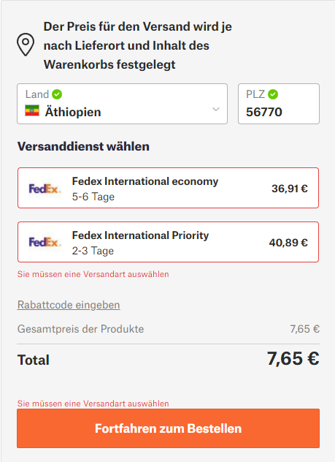Even if a maintenance program is available for the printer, there could be damages. Because of this it’s very important to have one or several adresses to order some spare parts. In realtion to this we found a few shops where parts can be ordered. Naturally the prusa webshop is always available and also the delivery to Ethiopia is possible. But the price is very high as you can see in the picture on the right side. In conclusion to this we started a research for cheaper shops.

There are a few shops that import parts from china. As if we would like to support regional shops, but there is no possibility. Because there aren’t any shops in Ethiopia, which sell parts for Prusa i3 MK3S+. Because of this we looked for other shops in the whole world. We propose to order parts in the future from those two shops.

<https://www.3djake.com/spare-parts-upgrades/original-prusa?page=2>

<https://www.3dprintronics.com/Prusa-3D-Printer-Spares-c40975239>

### Process

The whole process begins with the broken part. The operater has to inform the coordinator about this issue. After the coordinator will take a decision from which shop the team will order the part. This means he must have the infomations about the broken part and where it’s located at the printer. If the coordinater has decided a shop, the part will be ordered there. In case that both shops don’t sell the part who is needed, it’s also possible to order it on the official website from prusa. But the other shops should be prefered so we didn’t show the way with prusa in the process picture.

When the part is arrived, the coordinater will bring it to the operater, who will replace the broken part. For this step he needs all the instructions to fix the printer correctly.

# Attachment

## Comparison of filament melting machine

|  |  |  |  |  |  |
| --- | --- | --- | --- | --- | --- |
| Name | Difficulty | Price | Speed | Supported material | Link |
| 3devo | easy | $7,500 | 1Kg/hr | PLA, ABS, PC, nylon, and more | <https://3devo.com/> |
| Wellzoom | easy | $650 | 100g/hr | PLA | <http://wellzoomextruder.com/> |
| ReDeTec | easy | $3,500 | 500g/hr | PLA, ABS, nylon 12, and more | <https://redetec.com/> |
| Noztek Pro | easy | $1,600 | 500g/hr | PLA, ABS, PP, and more | <https://www.noztek.com/product/noztek-pro/> |
| Lyman Extruder | Medium | $600 | 250g/hr | PLA, ABS, and more | https://all3dp.com/2/best-filament-extruder-maker-diy-buy/ |
| Felfil Evo | Easy to medium | $350-$700 | 200g/hr | PLA, ABS, and more | <https://felfil.com/> |
| Filastruder Kit | Medium | $300 | 150g/hr | PLA, ABS, PP, PC, and more | <https://www.filastruder.com/products/filastruder-kit> |
| Precious Plastic Extruder | hard | $200-500 | 5 kg per hour | HIPS, LDPE, PP, and more | https://all3dp.com/2/best-filament-extruder-maker-diy-buy/ |

## Material comparison

|  |  |  |
| --- | --- | --- |
| Material | Advantage | Disadvantage |
| PLA | -biodgradeble (reusable)  -made by natural components  -high quality | -low temprature resistance  -deform on summary season  -not durable (not used for storing something) |
| PVA | -good quality  -wide application  -dries fastest at room temperature  -quick drying  -flexible  -permanent | -toxic if we eat it (may be for kids at home)  -degreded and broken easily by algae, bacteria and yeast.  -can´t use outdoor |
| TPV | -non-toxic and safe  -wide range of hardness  -has excellent coloring  -weather resistance  - fatigue resistance and temprature resistance  -can be recycled and effectively save energy | -it´s physical property decreases with increasing temperature  -limited application |
| NYLON | -abresive resistance  -variety application  -light weight  -water resistance  -drier quickly  -durable  -resistance to stains, UV rays, heat and other chemicals | -lacks dimensional stability  -poor resistant to sunlight  -heat sensitive |
| PET | -Durability  -heat resistance  -smooth  -resist degradetion | -very sensitive to heat  -can be damaged in dump situation |

## Question for market research

Introduce yourself to and tell them what you are doing…

* From which department are you?
* Do you know what a 3D-printer is?
* What kind of parts do you imagine to print with the 3D-printer?
* How familiar are you with CAD- programms (5=very familiar/1=never seen)

1 2 3 4 5

* Have you ever designed a part with CAD?
* How much would you pay for each example printed part?
* How should a 3D-Printer shop looks like in your opinion? Have you ever seen a kind of 3D printer shop in your environment?

## Financial calculations

### Filament

* Researched
  + 8 filament / year
  + 1 filament is 1000 gram
  + 1 kg of filament gives 60 hours of printing
  + Average price of a filament: 2250 birr / 1 kg
    - From Ethiopian: 4000 birr / 1 kg
    - From foreign countries: 500 birr / 1 kg
* Own calculations
  + 20 hours of printing in one week
    - 4 hours of printing in one day
  + There are 250 working days / year
    - 4 * 250 = 1000 working hours / year
  + Amount of filament / year
    - 1000 working hours of one year / 60 hours of printing for one filament

= 16,6 filament / year

* + - -> around 20 filaments / year
    - -> 20´000 gram / year
  + Costs for the filament / year
    - 20 * 2250 birr = 45`000 birr / year

### Maintenance

* Researched
  + Maintenance costs are around 3500 birr / year
    - For nozzle
    - For printing bed and adhesives
    - For parts replacements
* Own calculations
  + Includes a safety factor of 1.5
    - 1.5 * 3500 birr / year = 5250 birr / year
  + Costs for one gram
    - 5250 birr / 20´000 gram = 0,26 birr / gram
    - **-> 0,3 birr / gram for maintenance**

### Salary

* Own calculations
  + Amount of working hours for one month
    - 2 parts are needed to design by ourself
      * 1 part needs around 8 – 12 hours
    - Estimated working hours
      * Designing: 10 hours * 2 parts = 20 hours / month
      * Maintenance: 2 hours per week = 8 hours / month
      * Coordination: 2 hours per week = 8 hours / month
      * Financing: 2 hours per week = 8 hours / month
    - -> 44 hours / month (for all 5 people)
    - -> 2,2 hours per day (44 hours / 20 days)
  + Cost for salary per gram
    - 30 birr / one hour of working
    - 30 birr * 2,2 hours = 66 birrs / day
    - 66 birr * 250 working days = 16´500 birr / year
    - 16´500 birr / 20´000 gram = 0,825 birr / gram
    - **-> 1 birr / gram for salary**

### Security fees

* Own calculations
  + 200 birr / month
  + 2400 birr / year
  + 2400 birr / 20´000 gram = 0,12 birr / gram
  + **-> 0,15 birr / gram**

### Options of printing quality

* Amount of per gram
  + Best option: 1 g / 0,63 h
  + Medium option: 1 g / 0,135 h
  + Normal: 1 g / 0,09 h
* Factor of different options
  + 1 – 1,5 – 3 (Low – Medium – High)

## Ordering Process