PERSONAL MEDIPAL APPLICATION
(aNDROID App)

Unit 1: BASIC SOFTWARE ENGINEERING DISCIPLINE (SG4101)

M.tech Software engineering (2017)
Group: FT 05

Aakash Deep Mangalore (A0163317J)
Abinaya Devarasu (A0163283E)
Ashish Shrikant Katre (A0163248A)
Dhruv Madan Gopal (A0163389R)
Ethiraj Srinivasan (A0163404N)
Moushumi Seal (A0163243M)

UML Class Diagram:

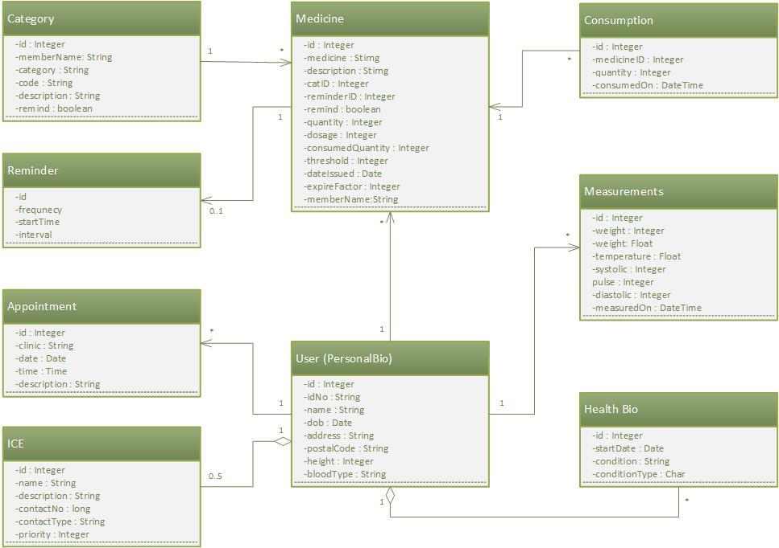
Figure 1: UML diagram with Domain classes

