Model Selection

Our team will be using the waterfall model of software development to create a website. We chose this model for a variety of reasons including: creating a website has clear milestones that can be easily modeled, we have limited resources/time and need a model to push development quickly, and because the waterfall model can easily be documented which is important for this project and class.

It is possible that other models would be better suited for website development, but given our circumstances such as timeframe and team experience, we believe that the waterfall model will allow for a clear and easy to follow development process.

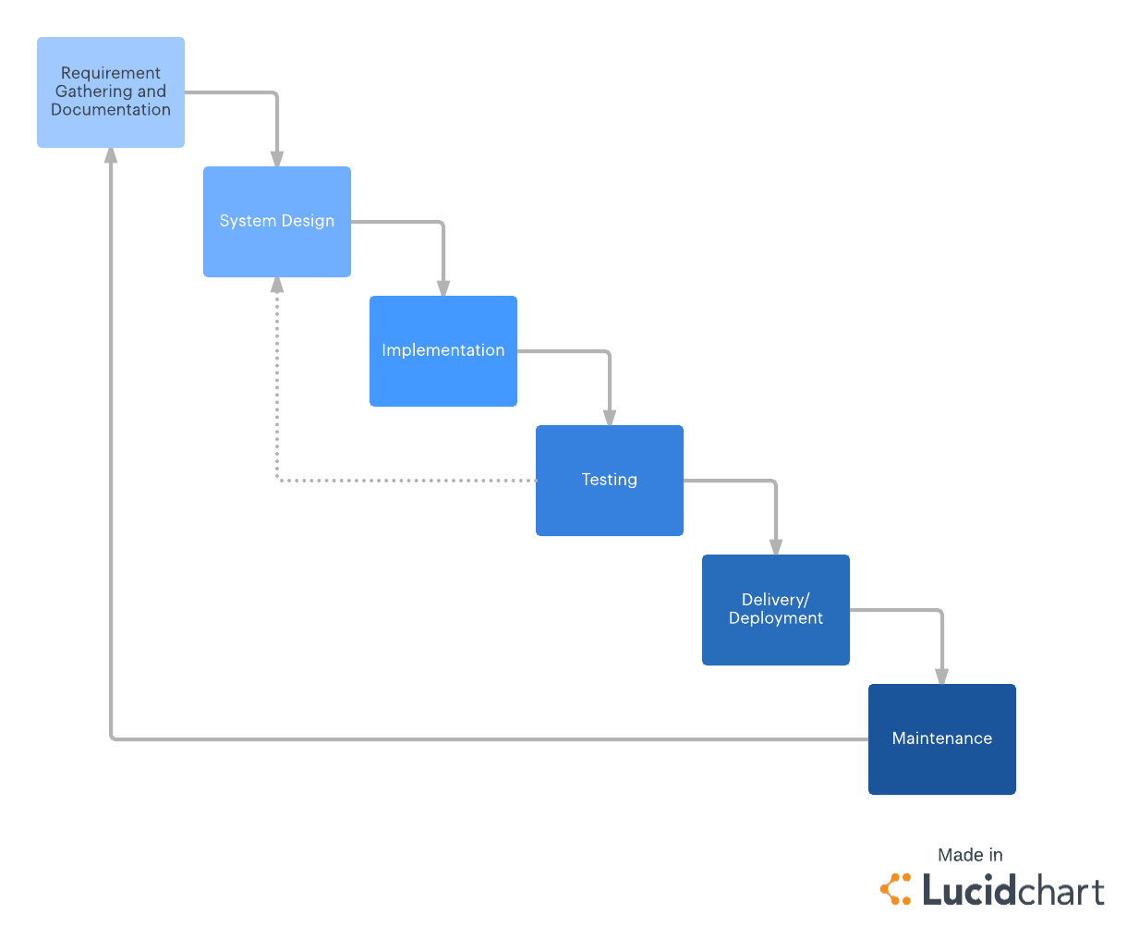

These steps may be optional depending on how well the website turns out and whether we use the website

These will be basic steps as our website will have limited features

The actual coding of our website

Our current starting point