DRAFT PROPOSAL

Characterization of N₂O emissions from California landfills, golf courses, and waste water treatment systems

Principal Investigator:
Frank Mitloehner, PhD
Co-Principal Investigator:

Yongjing Zhao, PhD
Prepared for:
State of California Air Resources Board
Research Division
PO Box 2815, Sacramento CA 95812

Prepared by:
Air Quality Research Center
University of California, Davis
One Shields Avenue
Davis, CA 95616
(530) 219-9014

March 10, 2015

Table of Contents

Abstract 3
Objectives 6
Technical plan 7
Task A. Identify monitoring sites for landfills, WWT systems, and golf courses in California. 7
A-1. Landfill. 7
A-2. WWT systems 9
A-3. Golf course 10
Task B. Develop and implement monitoring plans to capture the N₂O emissions. 10
B-1. Prepare equipment for field experiment 11
B-2. Deploy field experiments at the monitoring sites 12
Task C. Collection of associate ancillary data 16
Task D. Develop technical recommendations 17
Discussion 17
Data management plan 18
Key Scientific Personnel 19
References 20
Appendix A. Curriculum vita of the key scientific personnel 22
Appendix B. Preliminary costs 31
Appendix C. PROJECT SCHEDULE BY TASK 32
Appendix D. ESTIMATED COST BY TASK 33

Abstract

The current nitrous oxide (N₂O) emission inventory for California, which is predicted using international protocols, seems to deviate from actual measurements by threefold. In order to improve the current N₂O inventory, it is imperative to identify and quantify previously insufficiently characterized sources such as landfills, golf courses, and waste water treatment (WWT) systems. In this proposal, we aim to identify four suitable sites in California and monitor the N₂O emissions. The four monitoring sites will be one landfill, one WWT system, and two golf courses. Because of the climate difference between southern and northern California, the landscape of the golf course vary. To account for this variability, we will monitor one golf course in southern and one in northern California. At each site, the monitoring will be conducted at multiple locations based on the facility’s management plans. The monitoring will be conducted during both the wet (December-March) and the dry (June-September) seasons to cover the seasonal variation of N₂O and other select gas emissions. The monitoring will also be repeated in year two to increase number of sampling events over time. In total, there will be 16 periods to conduct the field measurements at multiple sampling spots at each of the four sites. The majority of our gas analyzers used in the present project can be used to continuously to monitor air emissions, and therefore, diurnal variations of the air emission data will be collected.

We will use flux chambers in this project to sample air emissions from the four sites. The flux chamber method can provide detailed information on air emission from various locations of the facility. A concurrent proposal to another funding agency seeks additional funding to deploy a tracer method for the same sites. Overall, our aim is to capture gaseous emissions of the target gas using various methods to benefit from each method’s particular strength without being limited by their weakness.

The target gas to be addressed in this proposal is N₂O to respond CARB’s research solicitation. In addition to N₂O, we also propose to measure the emissions of other gases, such as methane (CH₄), methanol (MeOH), ethanol (EtOH), nitrogen oxides (NO_{x}), ammonia (MH₃), and hydrogen sulfide (H₂S) from the selected monitoring sites.

In order to interpret the observed air emission data, scale the observed data up to estimate statewide emissions, and incorporate them into the future California N₂O inventory, associated data will be collected, such as environmental variables, nitrogen content in soil and liquid samples, urban fertilizer sale and use data in California, waste treatment practices and urban golf course management in California. Finally, technical recommendations will be developed to reduce the N₂O emissions from California landfills, WWT systems, and golf courses. Overall, this proposed work will fill a void of knowledge for some of the state’s most uncertain sources for one of the more potent greenhouse gases and eventually lead to reductions of California’s impact on our climate.
Introduction

Nitrous oxide (N₂O) is a potent greenhouse gas (GHG) with a global warming potential of 298, compared to CO₂ (IPCC 2013). N₂O can be emitted from many sources containing nitrogen (N), including landfills, wastewater treatment (WWT) systems, and urban landscapes (e.g., golf courses) (Czepiel et al., 1995; Kampschreur et al., 2009; Zhang et al., 2009; Ahn et al., 2010; Foley et al., 2010; Bogner et al., 2011; Townsend-Small et al., 2011; Law et al., 2012; Harborth et al., 2013; Zhang et al., 2013).
There are about 370 landfills in California. Approximately 1.2 billion tons of solid waste has accumulated in the State’s landfills with an additional 30 million tons being added each year (ARB, 2009; CalRecycle, 2013).
Globally, WWT is estimated to emit approximately 264 Gg N₂O annually, which is 2.4% of the total anthropogenic N₂O emission (US EPA, 2012). Non-CO₂ GHG emission from WWT process is expected to increase by 28% from 2005 to 2030 due to population increase in developing countries and implementation of centralized WWT (US EPA 2012). Since population in California has increased by 3.3 million (about 10%) in the past decade, waste from human activities and its air emissions could have increased as well and will continue to increase.
Golf is a fast-growing sport activity and the National Golf Foundation (Tetra Tech and CDPHE, 2002) reported that nationwide, one new golf course opened every day in 2000. During the same period, California had 891 facilities with golf courses, occupying 120,907 acres of land (Templeton et al, 2010). Golf courses as a landuse form are an urban landscape emitting N₂O emissions comparable to traditional agricultural sources (Townsend-Small et al, 2011).
However, the current California N₂O inventory was developed based on statewide activity data and default emission factors (EFs) derived from state, national, and international emission data. There are potentially unaccounted and uncertain N₂O sources in the California inventory due to lack of accurate EFs or activity data including landfills, WWT systems, and urban landscapes.
In order to characterize the full spectrum of N₂O emissions from California landfills, WWT systems, and golf courses, and therefore, improve the California N₂O inventory, it is necessary to conduct field measurements to capture the spatial and temporal variability of the related emission fluxes.
Quantification of air emissions from landfill, WWT process, and urban landscapes has often been based on flux chamber measurements (Czepiel et al, 1996; Christophersen et al., 2001; Law et al, 2012; Scheutz et al., 2003; Spokas et al., 2006, Townsend-Small et al, 2011; Yver-Kwok, et al, 2013). Because the spatial variations of air emissions from landfills are more significant than those from the WWT process and urban landscape, it is very labor intensive to estimate air emissions of an entire landfill facility based on the flux chamber method alone, particularly when the facility is of large scale. In cases like this, an alternative method may be employed in addition to the one proposed in this proposal (flux chambers).
This additional method, proposed in a concurrent proposal to another agency, uses the atmospheric tracer-dispersion method, that has been developed to assess CH₄ emissions from large sources such as whole landfills (Czepiel et al., 1996; Tregoures et al., 1999; Galle et al., 2001; Scheutz, et al., 2011; Yver-Kwok, et al., 2013; Moster, 2014). The method involves the continuous release of an inert atmospheric tracer such as SF₆, N₂O, CO, C₂H₂, and 222Rn) on site, while measuring concentrations of both tracer and CH₄ in transects crossing the downwind plume. Because the C₂H₂ tracer has less environmental impact, it was used in more recent studies. However, this tracer-dispersion method has rarely been used to assess the N₂O emissions from large emission sources. Moster (2014) tested this method to monitor N₂O emission from both landfills and WWT plants using C₂H₂ as a tracer. He concluded that the tracer-dispersion method is good for monitoring N₂O from a WWT plant and fugitive emissions but may not be suitable for an entire landfill. However, he did not discuss the reason in details.
The UC Davis research team built a Mobile Agricultural Air Quality (MAAQ) laboratory on a mobile-trailer. Because all analytical instruments are permanently integrated inside the MAAQ Lab, the MAAQ Lab can be easily moved from one location to another to conduct field experiments, which is very useful for monitoring multiple locations in a large scale facility. The MAAQ Lab has a capacity to measure multiples gases, such as N₂O, CH₄, CO₂, SO₂, H₂S, NO_{x}, NH₃, etc., with possibility to house additional gas analyzers to fulfill the requests of the field experiment. In addition, the MAAQ controls up to six flux chambers, including supplying sweep air to and taking air samples from the chambers for a field experiment. After the MAAQ Lab was built up in 2013, it has been used for several projects monitoring air emissions from agricultural emissions sources, some funded by CARB. The MAAQ Lab is proven to be a very powerful and convenient platform to monitor air emissions from various emission sources.
The UCD research team is highly qualified and well prepared to successfully conducting this project. The team members have conducted many projects monitoring air emissions from agricultural sources, such as dairy silage, anaerobic digesters, dairy corrals, freestalls, and lagoons. They also conducted research on methane emissions from landfill, landfill gas collection efficiency measurement using tracer gas, and landfill biocover demonstration project to reduce methane emissions. The team members are good at analytical equipment to collect high quality monitoring data.

Objectives

1) To identify the emissions sources of N₂O and other gases from California landfills, WWT systems, and golf courses that are not yet accounted for in the current California greenhouse gas (GHG) inventory.
2) To conduct field measurements of N₂O and other gases in a California landfill facility to improve the inventory accuracy and provide updated activity and emission factors.
3) To conduct field measurements of N₂O and other gases in a California WWT facility to improve the inventory accuracy and provide updated activity and emission factors.
4) To conduct field measurements of N2O and other gases in two California golf courses to improve the inventory accuracy and provide updated activity and emission factors.
5) To develop technical recommendations to reduce N₂O emissions from California landfills, WWT systems, and golf courses.

Technical plan

Task A. Identify monitoring sites for landfills, WWT systems, and golf courses in California.

A-1. Landfill.
One landfill will be selected as the monitoring site. The project team has selected the Yolo County Central Landfill (YCCL) as a potential landfill site. Figure 1 shows the YCCL facility’s layout. The YCCL is a Class III non-hazardous municipal solid waste facility owned and operated by Yolo County, located in Woodland, CA. In addition to municipal solid waste (MSW), the YCCL accepts grits and rags, dewatered sewage, liquid waste, green and wood waste. To date, landfill sectors WMUs 1 through 6D have been developed and has received waste, with WMU 3 and part of WMU 2 at final closure.
Due to the various types of landfill operations, the flux testing was designed to capture the various levels of emission contributed by each of these activities. Table 1 below describes the areas where flux tests will be performed as well as the location of leachate sampling.

Table 1. Areas where flux testing will be performed.
Test Areas-  Name and Type | Total Area (Acres) | Type of Waste and Daily Cover Type | Type, Thickness of Cover System
WMU 1, 2, & 3-Landfill Cells & Leachate Sump 1 & 2 | 84 | Aged waste with green waste as alternative daily (6 inches) cover (ADC)- Closed landfill area | 1 ft of soil over on top of synthetic cover liner
WMU 4 & 5-Landfill Cells & Leachate Sump 3 | 40 | Fresh waste, active waste filling area, with green waste and C&D fines as alternative daily cover (6 to 8 inches) | 1 ft of soil as intermediate cover
WMU 6A, 6B, 6C-Landfill Cells & Leachate Pump Station #2 | 60 | Green waste as alternative daily cover, WMU6A received dewatered sludge | 6B, 6C are inactive area with 1 ft to 2 ft of intermediate cover soil
Portion of  WMU 6D-2-Landfill Cells & Leachate sump 6D-2 | 2 | Intermediate cover soil over waste with compost | Intermediate cover soil over waste with compost 1 ft of cover soil with 0.5 ft to 3 ft of compost biocover
WMU G & H- Leachate ponds | 12 | Liquid waste, leachate and condensate receiving and aeration for treatment | 1 ft to 6 ft depth

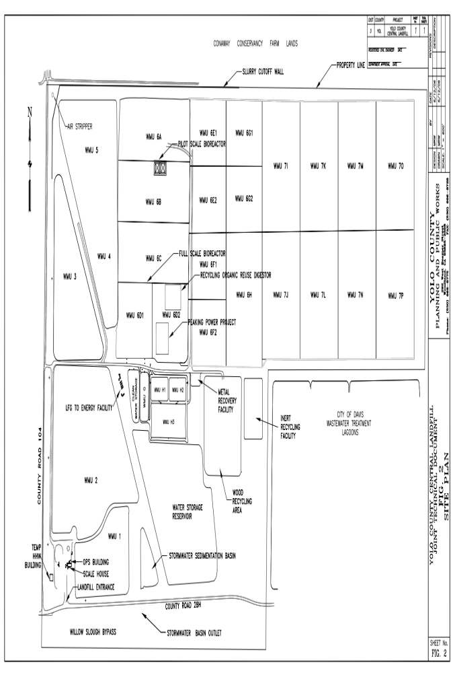
Figure 1. Layout of the Yolo County Central Landfill

A-2. WWT systems
One WWT system will be selected as the monitoring site. WWT systems use a combination of physical, biological, and chemical processes for treatment. These various processes are shown in Figure 2. There are about 268 wastewater treatment plans in California that have a discharge capacity of one million gallons per day or more. Majority of these treatment plants are owned and operated by cities and counties. The treatment process begins by removal of inorganic materials such as sticks, rags, rocks, sand, and trash followed by secondary and tertiary treatments of the waste stream. The residual waste stream (sludge) after the processing of waste is either dried mechanically or spread in drying beds and then transported to either composting sites, or landfills where it is used beneficially as an alternative daily cover or just landfilled. In some areas (where it is allowed) the sludge is spread on agricultural fields. The project team has conducted some preliminary research to identify a few local WWT systems that would be suitable for emissions testing such as the one owned by the City of Woodland or the one at UC Davis. As stated in the solicitation for research proposals, the identified WWT systems must be accepting residential, industrial, and commercial wastewater. The project team will use further evaluation to select other possible WWT systems; however, the team has identified these two nearby facilities as the potential sites for the study. Table 2 lists the location of potential flux testing at these sites.

Table 2-Flux testing areas at the WWTP
Test Area @ WWTP | Type of Treatment | Type to Test& Liquid and Solid Testing Sampling
Pretreatment | Treatment area prior to Secondary and Tertiary treatment | Flux testing and leachate testing
Secondary treatment | Oxidation ditches where organic material is breaking down by microorganism | Flux testing and leachate testing
Facultative sludge lagoons | Waste sludge from the secondary treatment process is directed to facultative sludge lagoons for stabilization and drying | Flux testing and solids testing

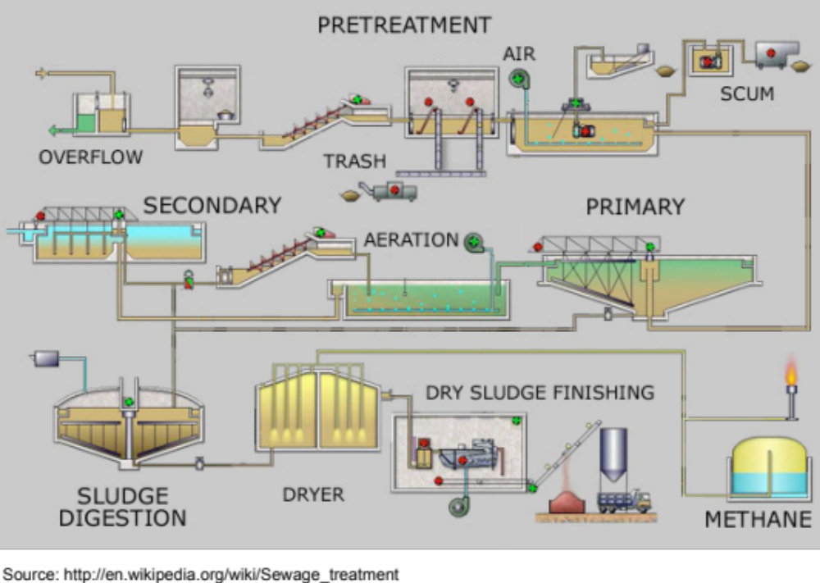
Figure 2. Typical WWT facility

A-3. Golf course
Two sites will be selected as the monitoring sites. The N₂O production as a result of denitrification of N-fertilizer in the golf course soil profile is affected by different physical (i.e., temperature, moisture, rainfall, drainage, bulk density, and texture) and chemical (i.e., nutrient availability, labile C, soil pH, and C/N ratio) factors. N-fertilizer management practices at the golf course as wells as the soil type and rainfall will be the used to select one site in Northern and one site in Southern California. California has over 1,140 golf courses (http://www.golflink.com/golf-courses/state.aspx?state=CA) that are either publicly- or privately operated. Once the two sites are selected in Northern and Southern California, respectively, there will be four testing campaigns at each site. One campaign occurs during the wet season and the other during the dry season. The campaigns will be repeated in the second year, each lasting for two weeks. The number of tests and the location of each test will be determined at a later date.

Task B. Develop and implement monitoring plans to capture the N₂O emissions.

B-1. Prepare equipment for field experiment
The following equipment will be used for the present project to monitor the emissions of N₂O and other gases from California landfills, WWT systems, and golf courses.

B-1.1. UC Davis MAAQ Lab
The UC Davis Mitloehner Lab Mobile Agricultural Air Quality Laboratory (MAAQ Lab) was built in 2013, and has been used for several field experiments since then. Figure 3 shows a photo of the MAAQ Lab and Figure 4 shows analyzers inside the MAAQ Lab. The MAAQ lab can take air samples from 8 sapling locations in sequence and send the samples to gas analyzers inside the MAAQ Lab via a rotary valve to monitor the gas concentrations. Gas analyzers available in the MAAQ Lab are listed in Table 3 with the gases that can be monitored by the MAAQ Lab.
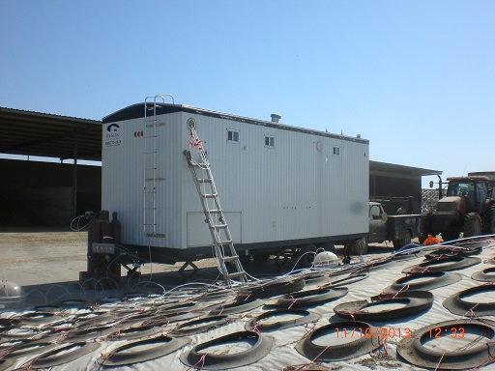  Figure 3. UC Davis MAAQ Lab | 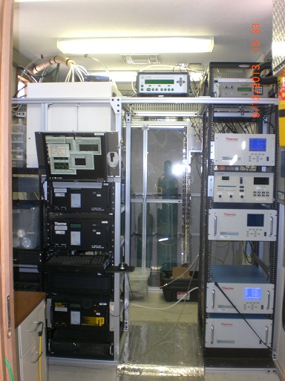  Figure 4. Analyzers inside MAAQ Lab

Table 3. Gas analyzers available in the UCD MAAQ Lab.
Gas Analyzer | Monitoring gases | Detection limits | Detection ranges
Innova 1412 photo-acoustic multi-gas analyzer | MeOHª,  MeOH^{b}  CO₂  N₂O  NH₃  H₂O | 0.08 ppm  0.08 ppm  - ppm  0.03 ppm  1.0 ppm | Up to 10⁶ ppm
Thermo 17i NO/NOx.NH3 analyzer | NO  NO_{x}  NH₃ | 1 ppb | 0-20 ppm
Thermo 55C CH₄ and NMHC^{c} analyzer | CH₄  NMHC | 20 ppb  50 ppb | 0-1000 ppm
Thermo 410i CO2 analyzer | CO₂ | 0.2 ppm | 0-1000 ppm
Thermo 450i SO2/H2S analyzer | SO₂  H₂S | 1.5 ppb | 0-10 ppm
Thermo 46i N₂O analyzer | N₂O | 0.02 ppm | 0-20 ppm
Notes: ª-Methanol, ^{b}-Ethanol, ^{c}-Non-Methane Hydrocarbons

B-1.2. Flux chambers
There are six flux chambers available for field experiments to capture the gas fluxes. These six flux chambers can be directly connected to the MAAQ lab. Flow rates of the sweep air to the six flux chambers are controlled inside the MAAQ lab and the air samples from the six flux chambers are analyzed by the gas analyzers inside the MAAQ lab.

B-1.3. Picarro G2508 multiple gas analyzer.
Because the sensitivity and precision of the analyzers available in the MAQ Lab listed in Table 1 may not be suitable for all of measurements in the present project, we plan to purchase a G2508 multiple gas analyzer manufactured by the Picarro. Inc. The Picarro G2508 multiple gas analyzer can measure N₂O, CO₂, CH₄, NH₃ and H₂O. The 2508’s precise cavity ring-down technology is capable of measuring concentrations with parts-per-billion (ppb) sensitivity and negligible drift, which enables excellent rate-of-rise quantification, even of very small fluxes. The total cost of this Picarro gas analyze is about $100k. We propose to cover $60k from the present project and the remaining $40k from university sources to cover the purchase of the Picarro analyzer.

B-1.4. Fourier Transform Infrared (FTIR) Spectrometers.
Two Broker Tensor 27 FTIR systems are available for the present project. The Tensor 27 FTIR systems can be used for both open path and white cell to monitor the emission gas concentrations. Since the spectral resolution of the Bruker Tensor 27 FTIR system is 1 cm⁻¹, it is capable to monitor multiple gases, such as N₂O, CO₂, CH₄ and so on at from sub-ppm to ppm levels.

B-2. Deploy field experiments at the monitoring sites
B-2.1. Monitoring methods
The following methods will be used to capture the spatial and temporal emission patterns of N₂O from California landfills, WWT systems, and golf courses.

Static flux chamber method
Figure 5 demonstrates the set-up of a static flux chamber and its connection with a gas analyzer (http://www.picarro.com). Because both sample land exhaust lines of the gas analyzers are connected to the flux chamber, a closed air loop is formed between the flux chamber and the gas analyzer. For the static flux chamber method, the gas analyzer does not destroy the air samples. The Innova multi-gas analyzer and the Picarro G2508 multiple-gas analyzer can be used for the static flux chamber method.
Because the air samples inside the flux chamber are not destroyed, the air emissions from the area below the flux chamber are accumulated inside the static flux chamber. Therefore, the gas concentrations in the flux chamber increase over time. This method can be used for low emission rate because the gas concentrations may reach over the detection limits of the gas analyzers over time. But, not all analyzers can be used for this method, which limits the number of gases that can be monitored. Using our Innova and Picarro analyzers, MeOH, EtOH, N₂O, CO₂, NH₃, CH₄, and water vapor can be monitored.
Assuming the a gas concentration is C₀ at time t₀ and increased to C₁ at time t₁, the emission rate of this gas is
E = (Q₁-Q₀) / (t₁-t0)
Where Q represents the mass of the monitored gas inside the flux chamber and
Q = (V x C / MV) x MW
Where, V, MV, and MW are volume of the flux chamber, volume of 1 mole gas molecules, and molar weight of the monitored gas, respectively.

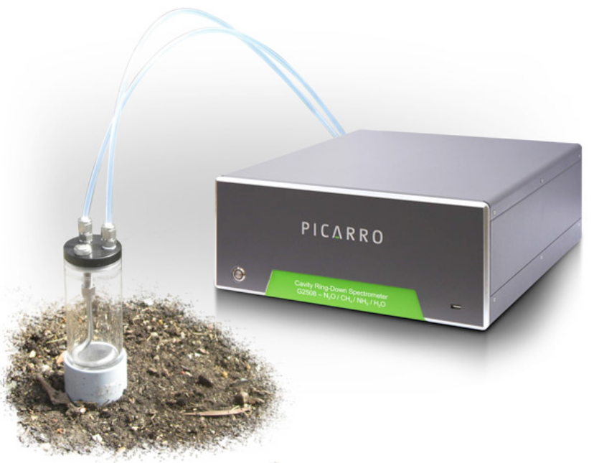

Figure 5. Connection between analyzer and static flux chamber (http://www.picarro.com).

Dynamic flux chamber method
Figure 6 illustrates a set-up of the dynamic flux chamber. A dynamic flux chamber can be used to monitor the changes in gas concentrations in real time. Because of the sweep air constantly flowing through the flux chamber, the gas concentrations cannot build-up inside the chamber. In addition, the sweep air also dilutes the gas concentrations inside the flux chamber. Therefore, the dynamic flux chamber method is suitable when the air emission rate is high and the gas concentration is detectable by the gas analyzers after being diluted by the sweep air. But, this method can be used for analyzers that do destroy air samples, such as FID based analyzers, that allows more gas molecules to being monitored.
The emission rate of a gas under the flux chamber can be determined by

E = (C x FL) / MV x MW

Where C is the gas concentration and FL is flow rate of the sweep air.

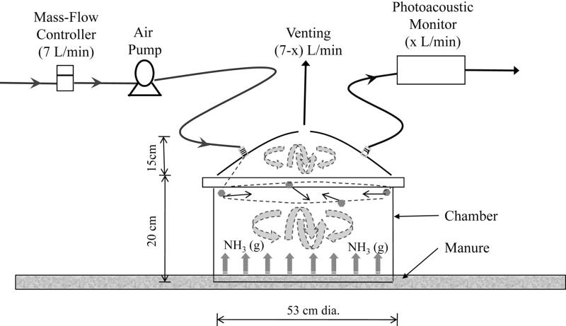
Figure 6. Illustration of the set-up of a dynamic flux chamber.

Tracer-dispersion method.
The flux chamber methods can be used in various locations at the monitoring site to characterize the air emissions for different managements (materials, treatments, etc.). But, it will be very labor intensive to estimate the total emissions of an entire facility due to the extended scale of the facility and the spatial variation of the gas concentrations across the facility. The tracer-dispersion method is often used to monitor the air emissions from an entire facility of extended scale. Figure 7 shows the schematic view of the tracer-dispersion method applied at a landfill. In this method, a tracer gas is released at the landfill and the amount of the released tracer gas is known. Both emission gas (such as N₂O) and the tracer gas are monitored simultaneously at the downwind of the landfill. When the monitoring platform travels across the plumes downwind the landfill, concentration profiles of both emission gas and tracer gas are recorded along the travel path and the emissions rate of the emission gas can be determined from the following equation:

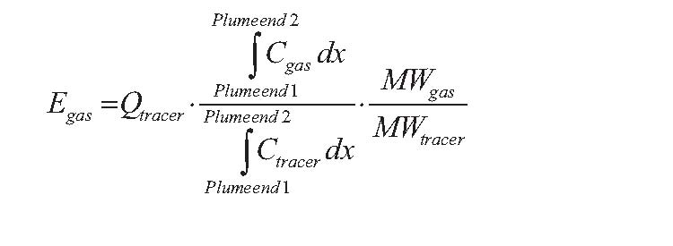
Where, Q_{tracer} is the release rate of the tracer gas (kg h⁻¹), C_{gas} and C_{tracer} denote cross-plume concentrations above the background concentration, MW denotes molecular weight and x corresponds to the distance across the plume.
To monitor the CH₄ emissions from landfill and waste water treatment system, Acetylene (C₂H₂) has been used as the tracer gas (e.g Monster, 2014, and Yver-Kwok et. al, 2013) because the C₂H₂ has less environmental impact. We have searched but could not find a commercially available, gas analyzer that can measure both N₂O and C₂H₂. In order to monitor the N₂O emissions using the C₂H₂ tracer-dispersion method, two analyzers have to be combined which will exceed the budget of this proposal. Therefore, we will search for extra funding to explore this method. .
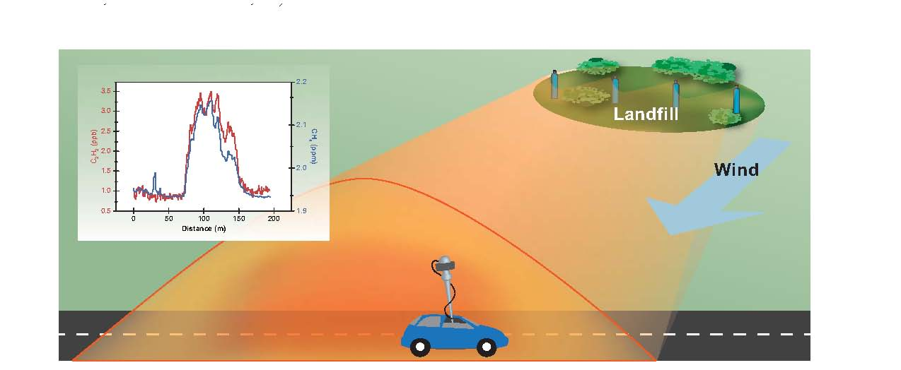
Figure 7. Schematic view of the tracer-dispersion method applied at a landfill, copied from Monster (PhD Thesis, 2014).

B-2. 2. Monitoring gas
Because additional gas analyzers are available in the UC Davis MAAQ lab, we propose to measure gases in addition to N₂O, namely NH₃, NO_{x}, CH₄, H₂S, and selected VOCs (MeOH and EtOH). These data will be used to interpret the measurements of N₂O emissions.
B-2.3. Monitoring schedule
Four monitoring sites will be selected for this project. Field experiments will be conducted twice a year at each site, one in the wet season (December-March) and one in the dry season (June-September). The field experiments will be replicated in year two. A project schedule by task is attached in Appendix C.
B-2.4. Environmental variables
Environmental variables such as wind speed, wind direction, ambient pressure, ambient temperature, ambient relative humidity (RH), and solar radiation will be collected to facilitate data interpretation and emission calculation.

Task C. Collection of associate ancillary data
C-1. Collection of associated ancillary data, such as Total Kjeldahl-N and N speciation, total organic and dissolved organic carbon (DOC), total solids, pH, biochemical oxygen demand (BOD), dissolved oxygen (DO will be collected from the monitoring sites.
Landfill- Table 1 describes the location where leachate sampling will be collected. Leachate samples collected will be tested for the following parameters by the UC Davis Analytical Lab: TKN and N speciation, TOC, DOC, pH, BOD, DO. Soil samples from each location will be tested in field for physical parameters (temperature, moisture content, bulk density). Samples will also be collected at each test location for chemical parameters (TKN and N speciation, nutrient availability, labile C, soil pH, and C/N ratio).
WWTP- Table 2 describes the location where wastewater sampling will be collected. Wastewater samples collected will be tested for the following parameters by either an outside contracted laboratory or at U. C. Davis Laboratories: TKN and N speciation, TOC, DOC, pH, BOD, DO. Sludge samples will be tested in field for physical parameters (temperature, moisture content, bulk density). Sludge sample will also be collected at each test location for chemical parameters (TKN and N speciation, nutrient availability, labile C, soil pH, and C/N ratio). Analysis will be performed at the UC Davis Analytical Lab.
Golf Course- Soil samples from each location will be tested in field for physical parameters (temperature, moisture content, bulk density). Samples will also be collected at each test location for chemical parameters (TKN and N speciation, nutrient availability, labile C, soil pH, and C/N ratio). Analysis will be performed at the UC Davis Analytical Lab.

C-2. Collection of urban fertilizer sale and use data in California
California has over 1,140 golf courses. To estimate the fertilizer use, one must determine the total acreage of these golf courses in California. The industry standard rate and type of N-fertilizer applied per acre will be used to estimate the total tons of N-fertilizer used in California. In addition, we will contact the California Golf Course Owners Association to obtain additional data on fertilizer use and check their data versus our estimates for N-fertilizers. Other agencies, such as the California Department of Agriculture and the Agriculture Sustainability Institute at UC Davis will be contacted for further N-fertilizer sales information.

C-3. Conducting surveys of landfill and wastewater treatment practices and urban landscape (especially golf course) management in California to develop a statewide management database or statistics so that results of this project can be scaled up to estimate statewide emissions and incorporated into future California N₂O inventory.
Data from the following sites will be gathered and compiled to develop a statewide management database:
For landfills, the Solid Waste Information System (SWIS) facility database that contains information on solid waste facilities, operations, and disposal sites throughout State of California will be utilized to create a statewide database.
For WWT systems, the California Regional Water Quality Control Board (RWQCB) will be contacted to obtain information about the 268 WWTPs in California. The GeoTracker database will be used to collect information about each WWTP such as number of gallons treated per day as well as tons of sludge produced. This information will be used to develop a database for estimating the emissions statewide.
For golf courses, the California Golf Course Owners Association will be contacted to obtain a list of golf courses in California. The available data will be compiled for: size of turf area, soil type, and tons of fertilizer used annually. Other information about the soil properties that are available from the USDA soil survey will be complied. Weather data from the local weather station (CIMIS.water.ca.gov) for evapo-transpiration, average monthly temperature, and average annual rainfall will be utilized when estimating statewide emissions.

Task D. Develop technical recommendations
Once results from flux testing and the associated ancillary data have been analyzed, recommendations will be developed to reduce N₂O emissions from these sources. For example at landfill site we expect that highest level of N₂O will be measured near the active filling area of the landfill where oxygen is abundant and nitrification is most likely occurring. Mitigation measures will discuss ways to reduce oxygen intrusion into the landfill during filling. Similarly at WWT systems we expect the oxidation ponds will have the highest level of N₂O production and mitigation measures to reduce N₂O production will be provided. Results from this research in addition to literature published will be utilized to provide recommendations on potential mitigation measures at landfills, WWT systems, and golf courses.

Discussion

Several methods can be used to characterize the N₂O emissions from California landfills, WWT systems, and golf courses. Monster (2014) discussed several methods and compared them in very details. Due to the advantages and disadvantages of the discussed methods, there is not a single method that can be used for all three emission sources. Ideally, a combination of several methods would be most to optimize results. However, the funding reality limits the use of multiple methods for this proposal. Therefore, we selected a flux chamber method as our basic sampling method to capture the N₂O emissions from the three emission sources. To overcome the disadvantages of this method, we proposed to select as many sampling spots as necessary to cover the spatial variations, particularly in the landfill facility. Because the tracer-dispersion method is a good solution to monitor landfill with extended scale and strong spatial variation, we propose to explore this method with extra funding but this lies beyond the scope of the current proposal.

Data management plan

- Gas analyzers listed in the Equipment section of Chapter Measurement Plan will be used for this project to monitor the emissions of N₂O as well as other gases (such as MeOH, EtOH, CH₄, NO_{x}, NH₃, and H₂S) from California landfills, WWT systems, and Golf courses.
- All gas analyzers will be properly maintained and calibrated following their standard operation procedures (SOPs).
- Sensors of wind speed, wind direction, ambient temperature, ambient relative humidity (RH), ambient pressure, and solar radiation will also be used to collect ambient variables to interpret the gas concentration data.
- All sensors will be properly maintained and calibrated following their SOPs.
- All analyzer and sensor data will be collected continuously at 15 second intervals and stored in an onsite data acquisition PC in real time.
- All analyzer and sensor data will be copied daily from the data acquisition PC to an external hard drive. The back-up hard drive will be stored separately from the data acquisition PC.
- Solid and liquid samples will be properly collected and duplicated following the sampling SOPs.
- The solid and liquid samples will be stored in a cooler, refrigerator, or freezer after collection.
- The solid and liquid samples will be either analyzed soon after collection for total Kjeldahl-N and N speciation, total organic and dissolved organic carbon (DOC), total solids, pH, biochemical oxygen demand (BOD), dissolved oxygen (DO).
- The solid and liquid sample data will be stored in at least two separate locations.
- The MAAQ Lab and it’s power generator will be properly maintained following their SOPs.

Key Scientific Personnel

The key personnel of UCD research team for this project are Dr. Frank Mitloehner who will serve as the Principal Investigator (PI) on this project, Dr. Yongjing Zhao who will be the Co-PI, Dr. Ramin Yazdani who will be a Co-Investigator, and Ms. Yuee Pan who will be a Research Assistant. Curriculum vita of the four key scientific personnel are attached in Appendix A.
Dr. Frank Mitloehner is a Professor and Air Quality Specialist in the Animal Science Department at UC Davis. He will make available his equipment assets (i.e. MAAQ Lab including all analyzers) that will be used in the present research. Dr. Mitloehner has conducted many projects monitoring air emissions from agricultural sources, such as dairy silage, anaerobic digesters, dairy corrals, freestalls, and lagoons. Since 2002, he has been PI over approximately $15M in research grants and has published over 90 peer reviewed scholarly papers. Besides his monitoring air quality work, he had been core team member in the DNDC modelling work that aimed at quantifying gaseous emissions from agricultural sources. He also serves as the chairman for a United Nations FAO project to develop the methodology to estimate the environmental impacts from livestock agriculture.
Dr. Yongjing Zhao is a Project Scientist in Air Quality Research Center of UC Davis. He has worked on air quality studies for more than 20 years. He particularly focused his research on monitoring of air emissions, including N₂O, CH₄, NH₃, from agricultural sources in the past 10 years. He built the UCD MAAQ lab and used it for several projects in the past two years. He highly specialized in project management, operation of gas analyzers, and interpretation of the observational results. Both Drs. Mitloehner and Zhao will share responsibilities in overseeing of the project, communicating externally with CARB project management and internally with other team members. Both will be involved in conducting of the field experiments, share the writing of reports.
Dr. Ramin Yazdani is a Senior Civil Engineer Services in the Division of Integrated Waste Management of the Yolo County Planning, Public Works, and Environment. He joined UCD Air Quality Research Center in 2013 as an Assistant Professional Researcher. He has been involved in research, design, and operation on various aspects of solid waste and WWT system since 1990 and conducted research on methane emissions measurement from landfill, landfill gas collection efficiency measurement using tracer gas, and landfill biocover demonstration project to reduce methane emissions.
Ms. Yuee Pan is a Staff Research Associate in Air Quality Research Center of UC Davis. Ms. Pan has been an assistant in the UCD research team on air quality studies since 2004. She is good at preparation of experiments, operation of the gas analyzers, analysis of the monitoring data, and interpretation of the observational results. She has participated in many projects on air quality and agricultural air quality studies.

References

Ahn, J.H., et al., “N2O emissions from activated sludge processes, 2008-2009: results of a national monitoring survey in the United States”, Environ. Sci. Technol. 44:4505-4511, 2010.

Bogner, J.F., et al., “Seasonal Greenhouse Gas Emissions (Methane, Carbon Dioxide, Nitrous Oxide) from Engineered Landfills: Daily, Intermediate, and Final California Cover Soils”, J. Environ. Qual. 40:1010-1020, 2011

Christophersen, M., et al., “ Lateral gas transport in soil adjacent to an old landfill: factors governing emission and methane oxidation”, Waste Management and Research 19, 595–612, 2011.

Czepiel, P., et al.,, “Nitrous Oxide Emissions from Municipal Wastewater Treatment. Environ”, Sci. Technol. 29:2352-2356, 1995.

Czepiel, P.M., et al., “Landfill methane emissions measured by enclosure and atmospheric tracer methods”, Journal of Geophysical Research. 101 (D11), 16,711–16,719, 1996.

Delkash M., et al., “Short-Term Analysis of Airborne and Ground Measurements for Quantifying Methane Emissions from Landfills”, draft paper, 2014.

Foley, J.D., et al, “Nitrous oxide generation in full-scale biological nutrient removal wastewater treatment plants”, Water Res. 44:831-844, 2010.

Fredenslund, A. M., et al., “Tracer method to measure landfill gas emissions from leachate collection systems”, Waste Management 30, 2146–2152, 2010

Galle, B., et al., “Measurements of methane emissions from landfills using a time correlation tracer method based on FTIR absorption spectroscopy”, Environmental Science and Technology 35, 21–25, 2001.

Harborth, P.R., et al., “Spatial variability of nitrous oxide and methane emissions from an MBT landfill in operation: Strong N₂O hotspots at the working face”, Waste Management 33:2099–2107, 2013.

IPCC, “Climate Change 2013: The Physical Science Basis. Contribution of Working
Group I to the Fifth Assessment Report of the Intergovernmental Panel on Climate
Change”, [Stocker, T.F., D. Qin, G.-K. Plattner, M. Tignor, S.K. Allen, J. Boschung, A.
Naues, Y. Xia, V. Bex and P.M. Midgley (eds.)]. Cambridge University Press, Cambridge,
United Kingdom and New York, NY, USA, 1535 pp, 2013.

Johansson, K.M., et al., “Sewage sludge handling with phosphorus utilization – life cycle assessment of four alternatives”, J. Cleaner Prod. 16:135–151, 2008.

M.J. Kampschreur, et al., “Nitrous oxide emission during wastewater treatment”, Water Res. 43:4093-4103, 2009.

Law, Y., et al., “Nitrous oxide emissions from wastewater treatment processes”, Phil. Trans. R. Soc. B, 367, 1265–1277, 2012, doi:10.1098/rstb.2011.0317.

Monster, J., “Quantifying greenhouse gas emissions from waste treatment facilities”, PhD Thesis, DTU Environment, Technical University of Denmark, July 2014 (available as a pdf-file for download from the DTU research database ORBIT: http://www.orbit.dtu.dk).

Scheutz, C., et al, “Comparative oxidation and net emissions of methane and selected nonmethane organic compounds in landfill cover soil”, Environmental Science and
Technology 37 (22), 5150–5158, 2003.

Scheutz, C., et al., “Quantification of multiple methane emission sources at landfills
using a double tracer technique”, Waste Management 31, 1009–1017, 2011.

Spokas, K., et al., “Methane mass balance at three landfill sites: what is the
efficiency of capture by gas collection systems? Waste Management 26, 516–
525, 2006.

Townsend‐Small, A.D., et al., “Nitrous oxide emissions and isotopic composition in urban and agricultural systems in southern California”, J. Geophys. Res. 116, G01013, 2011, doi:10.1029/2010JG001494.

Templeton, S.R., et al., “Golf Courses in California As Modern Agricultural Enterprises”, Agricultural and Resource Economics Update, vol 13, No. 3, 2010. Available at http://giannini.ucop.edu/media/are-update/files/issues/v13n3.pdf

Tetra Tech EM Inc. (Tetra Tech) and the Colorado Department of Public Health and Environment (CDPHE), “Greening Your Golf Course: A Pollution Prevention Quid For Colorado Golf Courses”, 2002, available at http://cospl.coalliance.org/fedora/repository/co:1654.

Tregoures, A., et al., “Comparison of seven methods for measuring methane flux at a municipal solid waste landfill site”. Waste Management Research 17, 453–458, 1999.

US EPA, “Summary Report: Global Anthropogenic Non-CO₂ Greenhouse Gas Emissions:
1990 – 2030”, Office of Atmospheric Programs, Climate Change Division, US EPA, 2012,
Http://www.epa.gov/climatechange/Downloads/EPAactivities/Summary_Global_Non
CO2_Projections_Dec2012.pdf

Yver-Kwok, C.E., et al., “Estimation of waste water treatment plant methane emissions: methodology and results from a short campaign”, Atmos. Meas. Tech. Discuss., 6, 9181–9224, 2013 (www.atmos-meas-tech-discuss.net/6/9181/2013/).

Zhang, H., et al, “N₂O emissions at municipal solid waste landfill sites: Effects of CH₄ emissions and cover soil”; Atmos. Environ. 43:2623-2631, 2009.

Zhang, H., et al., “Effects of nitrogen conversion and environmental factors on landfill CH₄ oxidation and N₂O emissions in aged refuse”, J. Environ. Qual. 126:174-181, 2013.
Appendix A. Curriculum vita of the key scientific personnel

Frank Mitloehner, PhD
Professor and CE Specialist
Department of Animal Science
University of California, Davis
Davis, CA 95616

Education
MS, University of Leipzig, Germany, Animal Science & Ag Engineering, 1996
PhD, Texas Tech University, TX, Animal Science, 2000

Post Doctoral Experience
Research Associate at Texas Tech University from Aug 2000 - Dec 2001.

Appointment
• Professor & CE Specialist; since Jul 2012
• Associate Professor; Oct 2007 - 2012
• Associate Cooperative Extension Specialist for Air Quality; Animal Science, UC Davis; July 2006 - 2012
• Assistant Cooperative Extension Specialist for Air Quality; Jan 2002 - June 2006

Professional Experience (selected appointments)
• Chairman, United Nations Food and Agriculture Organization (UN FAO), Partnership Project for the Benchmarking of Environmental Impacts of the Global Livestock Supply Chains; LEAP (2012 - present)
- Member, National Academy of Science, Institute of Medicine, Committee on Assessment of the Environmental and Health Effects of the Food System (since March 2013)
• Member, President's Council of Advisors on Science and Technology, PCAST (since June 2012)

Awards
• 2005 Outstanding Paper Award – Journal: ‘Measurement, Science and Technology’
• 2006 Academic Federation Excellence in Research Award - University of California, Davis, awarded by Chancellor Vanderhoeff
• 2007 Environmental Award - Environmental Protection Agency
• 2009 Distinguished Service Award for Outstanding Research - University of California Division of Agricultural and Natural Resources, awarded by UC VP Dooley
• 2011 Outstanding Dairy Industry Researcher Award - awarded by Western Dairy Business, through selection by Western States dairy stakeholders.
- 2014 ASUCD Excellence in Education Award for the CA&ES

Professional Societies
American Geophysical Union (AGU); American Chemistry Society (ACS); American Society of Animal Science (ASAS); American Society of Agricultural and Biological Engineers (ASABE)

Recent Grants (grant total as PI since 2002: $15M)
- Good Clinical Practice Study (GCP): Effect of Feeding LY488756 on Environmental Emissions when fed to Finishing Beef Cattle for 91 Days. ELANCO. $2,356,000. PI: Mitloehner. 10/12 - 12/15
- Reducing Dairy Silage Emissions for Improved Air Quality and Productivity. California Air Resources Board (CARB). $400,000. PI: Mitloehner. 07/12 - 06/16
- Combined Heat and Power Research on Commercial Dairy Farm. California Energy Commission (CEC). $848,000. PI: Mitloehner. 06/12 – 02/15

Recent Publications (2013-2015; total since 2001 = 94 peer reviewed publications)
- Clay,S., J. Dangl,J., D. Fischhoff, M. Jahn, D. Latham, F.M. Mitloehner, T. Sinclair, and C. Somerville. 2013. Agricultural Preparedness and the Agricultural Research Enterprise. President’s Council of Advisors on Science and Technology (PCAST). Washington DC. pp 1-55
- Garcia, J., D. H. Bennett, D. Tancredi, M.B. Schenker, D. Mitchell, and F.M. Mitloehner. 2013. A survey of particulate matter on California dairy. J. Environm. Qual. 42(1):40-7.
- McGarvey. J.A, R.B. Franco, J.D. Palumbo, R. Hnasko, L. Stanker and F.M. Mitloehner. 2013. Bacterial Population Dynamics and Chemical Transformations During the Ensiling of Medicago sativa (Alfalfa) and Subsequent Exposure to Air. Journal of Applied Microbiology. 114, 1661-1670.
- Hafner, S, Cody Howard, Richard E. Muck, Roberta B. Franco, Felipe Montes, Peter G. Green, Frank Mitloehner, Steven L. Trabue, C. Alan Rotz. 2013. Emission of Volatile Organic Compounds from Silage: Compounds, Sources, and Implications. Atmospheric Environment. 77: 827-839.
- Neumeier, C.J. and F.M. Mitloehner. 2013. Cattle biotechnologies reduce environmental impact and help feed a growing planet. Anim. Front. 3:36-41.
- Stackhouse-Lawson, K., C.A. Rotz, J.W. Oltjen, F.M. Mitloehner. 2013. Growth promoting technologies reduce greenhouse gas, alcohol, and ammonia emissions from feedlot cattle. J. Anim. Sci. 90:4656-4665.
- Wang, Q., M. Burger, T. A. Doane, W. R. Horwath, A. R. Castillo, and F. M. Mitloehner. 2013. Effects of inorganic versus organic copper on denitrification in peat soil. Adv. Anim. Biosciences. 4: 42-49.
- Place S.E. and Mitloehner F.M. 2013. Air quality issues in sustainability: Greenhouse gases and volatile organic compounds. In: Sustainable Animal Agriculture, E. Kebreab (ed). pp124-126.
- Place S.E., Y. Pan, Y. Zhao, and F.M. Mitloehner. 2013. Short-term dose effects of feeding monensin on methane emissions from lactating Holstein dairy cattle. Wageningen Academic Publishers. J. Oltjen & E. Kebreab (eds), pp.493-494.
- Place, S., and F. M. Mitloehner. 2014. The Nexus of Environmental Quality and Livestock Welfare. Annual Review of Animal Biosciences. 2: 555-569.
- Pitesky, M., A. Gunasekara, C. Cook, F. M. Mitloehner. 2014. Adaptation of Agricultural and Food Systems to a Changing Climate and Increasing Urbanization. Current Sustainable Renewable Energy Reports 1: 43-50.
- Zhao, Y., S. Cliff, A. Wexler, W. Javed, K. Perry, Y. Pan, and F.M. Mitloehner. 2014. Measurements of Size- and Time-resolved Elemental Concentrations at a California Dairy Farm. Atmospheric Environment 94: 773-781.
- Werth S.J., E.G. Schusterman, C.B. Peterson, and F.M. Mitloehner. 2014. Concentrated Animal Facilities and Air Quality Issues. Encyclopedia of Agriculture and Food Systems. 1: 283-290.
- Hafner, S.D., R. B. Franco,L. Kung Jr, C.A. Rotz,and F.M. Mitloehner. 2014. Potassium sorbate reduces production of ethanol and 2 esters in corn silage. Journal of Dairy Science. 97:7870-8.
- Mitchell, D.C., T.L. Armitage, M.B. Schenker, D.H. Bennett, D. Tancredi C.Eastman Langer, S.J. Reynolds, G. Dooley, J. Mehaffy, F.M. Mitloehner. 2015. Particulate Matter, Endotoxin, and Worker Respiratory Health on Large Californian Dairies. Journal of Occupational and Environmental Medicine. 57:79-87.
- Stackhouse-Lawson, K. R., C.B. Tucker, M.S. Calvo-Lorenzo, F.M. Mitloehner. 2015. Effects of growth-promoting technology on feedlot cattle behavior in the 21 days before slaughter. Applied Animal Behaviour Science.162: 1-8.
- Nesheim, M.C, K. Clancy, J.K. Hammitt, R.A. Hammond, D. Haver, D. Jackson-Smith, R. S. Johnson, J.D. Kinsey, S.M. Krebs-Smith, M. Liebman, F.M. Mitloehner, K.M. Pollack, P.J. Stover, K.M. Swanson, and S.M. Swinton. 2015. A Framework for Assessing Effects of the Food System. 2015. National Academies Press. Washington DC. pp 1-500.

YONGJING ZHAO
Project Scientist
Air Quality Research Center
University of California-Davis
One Shields Avenue
Davis, CA 95616
Phone: (530) 754-4963 (AQRC Lab), 752-6148 (Animal Science Lab)
E-mail: yjzhao@ucdavis.edu

EDUCATION
Ph.D., Spectroscopic Technology and Application September, 1989
Dalian University of Technology (DUT), China

M.S., Optical Instruments, DUT, China July, 1985

B.S., Applied Physics, DUT, China August, 1982

EMPLOYMENT HISTORY
Air Quality Research Center, University of California, Davis 2007-present
Title: Project Scientist, Step III (2012-2015)
Title: Project Scientist, Step II (2010-2012)
Title: Project Scientist, Step I (2007-2010)

Mechanical and Aerospace Engineering, University of California, Davis 2001-2007
Title: Staff Research Associate III (2003-2007)
Title: Researcher (2001-2003)

Department of Physics, University of Toronto, Canada 1999-2001
Title: Researcher

Solar-Terrestrial Environment Laboratory, Nagoya University, Japan 1994-1999
Title: Research Associate (1997-1999)
Title: Research Fellow of Japan Society for the Promotion of Science (JSPS) (1994-1997)

Institute of Atmospheric Physics, Chinese Academy of Sciences, China 1990-1994
Title: Researcher

Department of Powering Engineering, Dalian University of Technology, 1989-1990
China
Title: Assistant Professor

RESEARCH EXPERIENCES
Air Quality Studies in USA:
(1) USEPA Supersite programs in Pittsburgh, PA and Baltimore, MD, 2001-2002.
(2) San Joaquin Valley Aerosol Health Effects Research Center (SAHERC), 2005-2010
(3) National Air Emissions Monitoring Studies (NAEMS), 2007-2010
(4) Aerosol Measurements and Source Identification in Support of the Southern California Sulfur Study, 2010-2012
(5) Building Mobile Agricultural Air Quality Laboratory, 2011-2013

SELECTED PUBLICATIONS
Yongjing Zhao, Steven S. Cliff, Anthony S. Wexler, Wasim Javed, Yuee Pan, Kevin Perry, and Frank Mitloehner, Measurements of Size- and Time-resolved Elemental Concentrations at a California Dairy Farm, Atmospheric Environment, 94, 773-781, doi: 10.1016/j.atmosenv.2014.06.011, 2014
K. R. Stackhouse-Lawson, M. S. Calvo, S. E. Place, T. L. Armitage, Y. Pan, Y. Zhao, and F. M. Mitloehner, Growth promoting technologies reduce greenhouse gas, alcohol, and ammonia emissions from feedlot cattle, Journal of Animal Science 91, 5438-5447, doi:10.2527/jas2011-4885, 2013.
Yongjing Zhao, Yuee Pan, Jerry Rutherford, and Frank M. Mitloehner, Estimation of the Interference in Multi-Gas Measurements Using Infrared Photoacoustic Analyzers, Atmosphere, 3, 246-265; doi:10.3390/atmos3020246, 2012.
Sara E. Place, Yuee Pan, Yongjing Zhao, and Frank M. Mitloehner, Construction and Operation of a Head Chamber System for Measuring Eructated Greenhouse Gas and Volatile Organic Compound Emissions from Cattle, Animals, 1, 433-446; doi:10.3390/ani1040433, 2011
K. L. Cooprider, F. M. Mitloehner, T. R. Famula, E. Kebreab, Y. Zhao, and A. L. Van Eenennaam, Feedlot efficiency implications on greenhouse gas emissions and sustainability, Journal of Animal Science, 89(8), 2643-2656, doi:10.2527/jas.2010-3539, 2011.
H. M. El-Mashad, R. Zhang, T. Rumsey, S. Hafner, F. Montes, C. Alan Rotz, V. Arteaga, Y. Zhao, F. M. Mitloehner, A Mass Transfer Model of Ethanol Emission from Thin Layers of Corn Silage, Trans. ASABE 53(6), 1903-1909, 2011.
Kimberly R. Stackhouse, Yuee Pan, Yongjing Zhao, and Frank M. Mitloehner, Greenhouse Gas and Volatile Organic Compound Emissions from Feedlot Steers and Calves, Journal of Environmental Quality, 40, 899–906, doi:10.2134/jeq2010.0354, 2011.
Ramin Yazdani, Ph.D., P.E.
Air Quality Research Center

University of California-Davis
One Shields Avenue
Davis, California 95616-5924
Phone: (530) 574-1499
Email: ryazdani@ucdavis.edu

EDUCATION
Ph.D., Civil and Environmental Engineering, University of California at Davis, Davis, California, 2002-2010
M. S., Agricultural Engineering, University of California at Davis, Davis, California, 1986-1988
B. S., Agricultural Engineering, California Polytechnic State University, San Luis Obispo, California
1984-1986

AWARDS and HONORS
Doctoral Scholarship-Environmental Research and Education Foundation, 2008-2010
Honorable Mention-M.S. Thesis Journal Paper (ASAE) Ranked as Top 20 out of 423 Papers, 1992
Alpha Epsilon Honor Society of Agricultural Engineering, 1988-1986
California Polytechnic State University Dean’s Honor List, 1986

REGISTRATION/CREDENTIAL
Registered Professional Engineer in State of California (C49910), 1992
California Community College Instructor’s Credential in Engineering, 1990

RESEARCH EXPERIENCE-EMPLOYMENT
Assistant Professional Researcher: Air Quality Research Center (part time), U.C. Davis, Ca., 2013-present.
Senior Research/Civil Engineer: Division of Integrated Waste Management, Yolo County, Ca., 2002-present.
Chief County Engineer/Assistant Director: Planning and Public Works Dept., Yolo County, Ca., 1997-2002.
Senior Civil Engineer: Public Works Department, Yolo County, Ca., 1993-1997.
Associate Civil Engineer: Public Works Department, Yolo County, Ca., 1992-1993.
Assistant Civil Engineer: Yolo County, Public Works Department, Woodland, Ca., 1990-1992.
Civil Engineer: U.S. Department of Agriculture, Soil Conservation Service, Santa Maria, Ca., 1988-1989.
Research Assistant: Agricultural Engineering Department, U.C. Davis, Ca., 1986-1988.

U.S. PATENT
Don Churchill Augenstein, John Rudiger Benemann, Ramin Yazdani (Issued Nov. 11, 2008) Landfill Design and Methods for Improved Landfill Gas Capture, Patent# 7,198,433

RESEARCH INTEREST
Organic waste to energy; landfill bioreactor; landfill fugitive methane emission; anaerobic digestion; aerobic composting; biocover; and renewable energy.

ACTIVE RESEARCH GRANTS
- Methane Enhancement by Anaerobic Composting of Food Waste and FOG (Co-PI, with Dr. Jean VanderGheynst, U.C. Davis, funded by California Energy Commissions-EISG, $149,999, 2014-2015).
- Optimizing Biogas Production from Organics through RNA/DNA Molecular Testing (Co-PI, with Dr. Matt Summers, Summers Consulting, funded by California Energy Commissions-EISG, $75,000, 2014-2015).
- Developing Co-Products from Anaerobic Digestion: Application of Composted Anaerobic Digestate to Soil to Enhance Sustainable Agriculture and Waste Management (Co-PI, with Dr. Christopher Simmons, U.C. Davis, funded by Developers of Dubai-UAE, $149,377, 2014-2016).
- Sequential Energy and Compost Production from Organic Residues (Co-PI, with Dr. Jean VanderGheynst, U.C. Davis, funded by Diamond Developers of Dubai-UAE, $150,000, 2014-2016).
- Collaborative Research: Fluorochemical Signatures in Municipal Waste and Landfill Leachate (Collaborator with Dr. Morton Barlaz, North Carolina State University (NCSU), funded by National Science Foundation, $233,881, 2011-2016).

RECENT PUBLICATIONS
- Yazdani, R., Han, B., Mei, C., Augenstein, D., Chiu, P., Imhoff. P. “Quantifying Capture Efficiency of Gas Collection Systems with Gas Tracers.” Waste Management. ** SUBMITTED **
- Mei, C., Yazdani, R., Han, B., Mostafid, M.E., Chanton, J., VanderGheynst, J., Imhoff, P. (2014) “Performance of Green Waste Biocovers for Enhancing Methane Oxidation.” Waste Management. ** IN PRESS **
- Saquing, J. M., Chanton, J. P.,Yazdani, R., Morton A. Barlaz, Scheutz, C., Blake, D., Imhoff, P. T. (2014) “Assessing methods to estimate emissions of non-methane organic compounds from landfills.” Waste Management, (34). pp. 2260-2270.
- Jung, Y. Han, B., Mostafid, M.E., Yazdani, R., and P.T. Imhoff. “Photoacoustic Infrared Spectroscopy for Conducting Gas Tracer Tests and Measuring Water Saturations in Landfills.” Waste Management, 32(2), pp. 297-304.
- Yazdani, R., Barlaz, M. A., Augenstein, D., Kayhanian, M. and G. Tchobanoglous (2012) “Performance Evaluation of a Landfill-Based Anaerobic Composting Digester for Energy Recovery and Compost Production.” Waste Management, 32(5), pp. 912-919.
- Jung, Y. Han, B., Mostafid, M.E., Yazdani, R., and P.T. Imhoff, (2012) “Photoacoustic Infrared Spectroscopy for Conducting Gas Tracer Tests and Measuring Water Saturations in Landfills”, Waste Management, 32(2), pp. 297-304.
- Yazdani, R., Mostafid, M.E., Han, B., Imhoff, P.T., Chiu, P., Augenstein, D., Kayhanian, M., and G. Tchobanoglous (2010), “Quantifying Factors Limiting Aerobic Degradation During Bioreactor Landfilling”, Environmental Science & Technology, vol. 44, no. 16, pp. 6215-6220.

Yuee Pan
Staff Research Associate
Air Quality Research Center
One Shields Avenue
University of California
Davis, CA 95616
Phone: (530) 752-6148，752-1201
E-mail: yepan@ucdavis.edu

EDUCATION

M.S., Optics, July, 1985, Dalian University of Technology, China
B.S., Physics, August, 1982, Dalian University of Technology, China

EMPLOYMENT HISORY

Air Quality Research Center 2014-
University of California, Davis
Title: Staff Research Associate

Air Quality Research Center 2009-2014
University of California, Davis
Title: Laboratory Assistant III

Animal Science Department 2007-2009
University of California, Davis
Title: Laboratory Assistant III

Animal Science Department 2005-2007
University of California, Davis
Title: Junior Specialist

Solar-Terrestrial Environment Laboratory 1995-1999
Nagoya University, Japan
Title: Engineer

Institute of Atmospheric Physics 1990-1994
Chinese Academy of Sciences, China
Title: Researcher

Department of Physics 1985-1990
Dalian University of Technology, China
Title: Assistant Professor
PUBLICATIONS

- Yongjing Zhao, Steven S. Cliff, Anthony S. Wexler, Wasim Javed, Yuee Pan, Kevin Perry, and Frank Mitloehner, “Size- and Time-resolved Element Emissions at a California Dairy Farm Observed with a RDI Sampler”, Atmospheric Environment, 94, 773-781, doi: 10.1016/j.atmosenv.2014.06.011, 2014
- K. R. Stackhouse-Lawson, M. S. Calvo, S. E. Place, T. L. Armitage, Y. Pan, Y. Zhao, and F. M. Mitloehner, Growth promoting technologies reduce greenhouse gas, alcohol, and ammonia emissions from feedlot cattle, Journal of Animal Science 91, 5438-5447, doi:10.2527/jas2011-4885, 2013.
- Yongjing Zhao, Yuee Pan, Jerry Rutherford, and Frank M. Mitloehner, Estimation of the Interference in Multi-Gas Measurements Using Infrared Photoacoustic Analyzers, Atmosphere, 3, 246-265; doi:10.3390/atmos3020246, 2012.
- Sara E. Place, Yuee Pan, Yongjing Zhao, and Frank M. Mitloehner, Construction and Operation of a Head Chamber System for Measuring Eructated Greenhouse Gas and Volatile Organic Compound Emissions from Cattle, Animals, 1, 433-446; doi:10.3390/ani1040433, 2011.
- Kimberly R. Stackhouse, Yuee Pan, Yongjing Zhao, and Frank M. Mitloehner, Greenhouse Gas and Volatile Organic Compound Emissions from Feedlot Steers and Calves, Journal of Environmental Quality, 40, 899–906, doi:10.2134/jeq2010.0354, 2011.
- Huawei Sun, Steven L. Trabue, Kenwood Scoggin, Wendi A. Jackson, Yuee Pan, Yongjing Zhao, Irina L. Malkina, Jacek A. Koziel, and Frank M. Mitloehner, Alcohol, Volatile Fatty Acid, Phenol, and methane Emissions from Dairy Cows and Fresh Manure, Journal of Environmental Quality, 37, 615-622, doi:10.2134/jeq2007.0357, 2008..
- Huawei Sun, Yuee Pan, Yongjing Zhao, Wendi A. Jackson, Lisa M. Nuckles, Irina L. Malkina, Veronica E. Arteaga, and Frank M. Mitloehner, Effects of Sodium Bisulfate on Alcohol, Amine, and Ammonia Emissions from Dairy Slurry, Journal of Environmental Quality, 37, 608-614, doi:10.2134/jeq2006.0446, 2008.
- ZHU ZHULIN，HUANG GONSYU，and PAN YUEE (朱竹林，黄公瑜，潘月娥)， In-line holography for analysis of dynamic particle field (动态微粒场分析的同轴全息技术)，Acta Optica Sinica (光学学报), No7, 1987.
- PAN YUEE, HUANG GONGYU, and LIU YANMING (潘月娥 黄公瑜 刘延明), Methods to improve the detection depth of in-line holography of particle field (提高微颗粒场同轴全息测量景深的途径), Journal of Dalian University of Technology, (大连理工大学学报), No. 4, 1987.

Appendix B. Preliminary costs
- Labor and benefit ($152,348 + $54,662)

Dr. Frank Mitloehner will spend 1 month (2.8%) on this project but his salary is already covered through state funds. He will not be paid by this grant.
Dr. Yongjing Zhao will spend 13.1 months (36.3%) on this project and is paid $109,000 for salary and $42,510 for benefit.
Dr. Ramin Yazdani will spend 3.36 months (9.33%) on this project and is paid $25,338 for salary and $2,787 for benefit.
Ms. Yuee Pan will spend 3.96 months (11%) on this project and is paid $18,010 for salary and $9,365 for benefit.
Note that Dr. Yazdani’s efforts are split into two parts, the time he spends at the Yolo County Central Landfill (YCCL) is counted in the sub-contract with YCCL and the time he spent for other sites is counted under this category.

- Sub-contract ($15,000).

A subcontract with YCCL will be signed for field experiments to be conducted at this facility, including Dr. Yazdani’s time spent at this particular site, and assistant from the YCCL staff.

- Picarro G2508 multiple gas analyzer ($60,000)

A Picarro G2508 multiple gas analyzer (Total $100,000) will be jointly purchased using the present grant ($60,000 without indirect costs) as well as UC equipment matching funding ($40,000).

- Travel costs ($39,550)

Travel costs include personal travel expenses (hotels, lodging, and meals) and fleet service fees (rent a ¾” ton pick-up truck to tow the MAAQ Lab). Total travel costs for field experiments (16 periods and 2 weeks per period) are estimated to be $39,550.

- Materials and Supplies ($47,530)

  - Costs to run a gasoline generator for 16 periods and 2 weeks per period will be $15,000.
  - Costs to run gas analyzers (calibrating and supporting gases) will be $11,000.

  - Costs to maintain gas analyzers, sensors, and supporting equipment will be $11,530.
  - Costs to analyze liquid and solid samples in UCD labs will be $10,000.

- Indirect cost @ 10% rate is $36,364

- Total cost of this proposal is $399,999

Appendix C. PROJECT SCHEDULE BY TASK
Task A. Identifying monitoring sites of landfills, WWT systems, and urban landscapes in California.
Task B. Deploying field experiments at the monitoring sites.
Task C. Collecting the associated ancillary data.
Task D. Developing technical recommendations on potential mitigation measures in landfill, WWT practices and golf course to reduce N2O emissions from these sources.
Task E. Project Reports.
Month  Task | 1st-3nd  Year#1 | 4th-6th  Year#1 | 7th-9th  Year#1 | 10th-12th  Year#1 | 1st-3nd  Year#2 | 4th-6th  Year#2 | 7th-9th  Year#2 | 10th-12th  Year#2 | 1st-3ng  Year#3 | 4th-6th  Year#3 | 7th-9th  Year#3 | 10th-12th  Year#3
A
B
C
D
E
Reports | Q | Q | Q | Q | Q | Q | Q | Q | Q | Q | Q | Q | Final

Appendix D. ESTIMATED COST BY TASK

Task | Salaries | Benefits | Sub-  contract | Equip | Travel | Materials  and Supplies | Misc. | Office  and  Comm. | Overhead | Sub-  Total
A | $10,330 | $2,252 | $3,000 | $0 | $2,000 | $0 | $0 | $500 | $1,808 | $19,890
B | $100,590 | $40,195 | $5,000 | $60,000 | $37,550 | $43,530 | $2,500 | $0 | $22,937 | $312,302
C | $7,390 | $813 | $4,000 | $0 | $0 | $0 | $0 | $500 | $1,270 | $13,973
D | $7,390 | $813 | $3,000 | $0 | $0 | $0 | $0 | $500 | $1,170 | $12,873
E | $26,637 | $10,601 | $0 | $0 | $0 | $0 | $0 | $0 | $3,724 | $40,926
Subtotal | $152,337 | $54,674 | $15,000 | $60,000 | $39,550 | $43,530 | $2,500 | $1,500 | $30,909 | $400,000

