Calm bl-w01
Polar bear
Brown (not dark brown) flooring

Check carpet and tile mart

https://www.behr.com/consumer/colors/paint/visualizer?colors=75

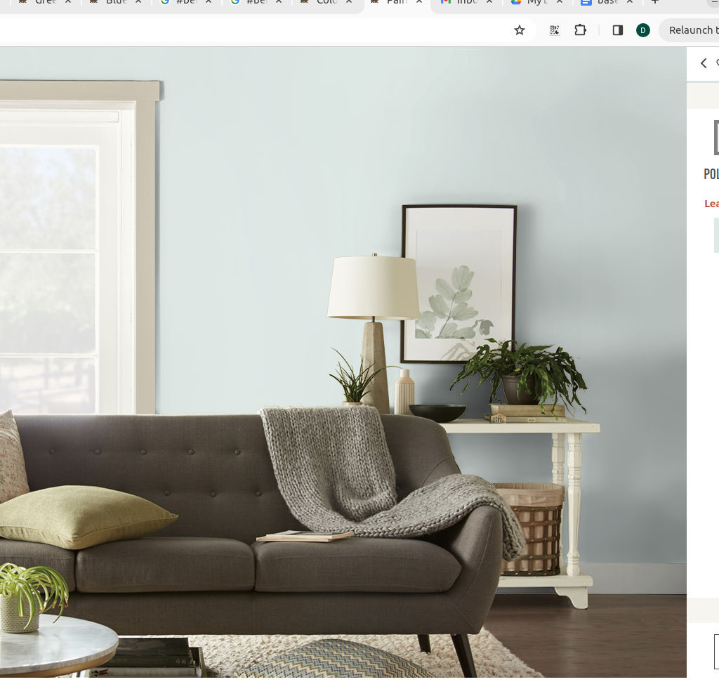

Magnet bottom access
Wall speaker connect
Mount gym bag and pull up bar and finish with flooring

10’ x 13’ , front aquarium foot by tv
24 X 23’ , closet side and extra
130 + 552 = 682 Sq total including extra

