PS07 - Answer Sheet

Assignment: | PS 07
Name: | Ethan Hotson, ehotson@purdue.edu
Team-ID | 009-01
Contributor(s): | <name> , <Purdue login> [repeat for each]

Security Camera Placement

Paired

Flowchart Paired Partner
Each member of the pair will submit their own answer sheet. List your paired partner here.
Flowchart Partner: | Otto Meccia

PS07_observatory_login.m Flowchart

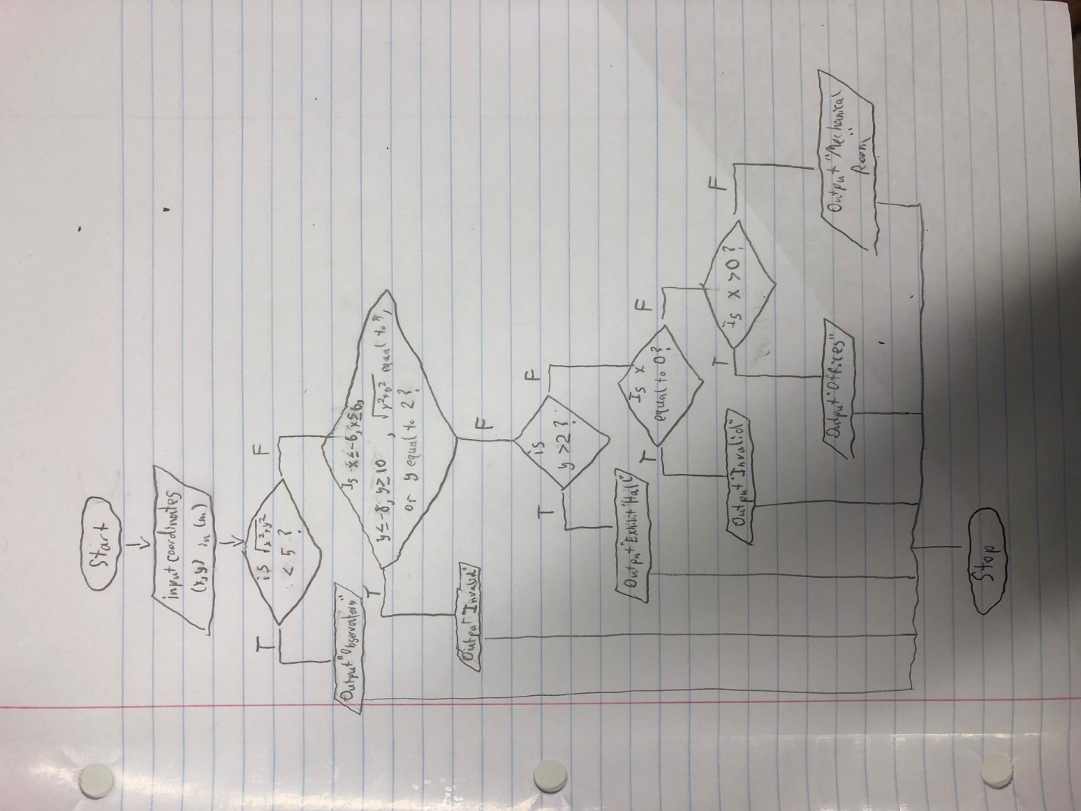

Coding Paired Partner
Each member of the pair will submit their own answer sheet. List your paired partner here.
Coding Partner: | Cole Jennewein, cjennewe@purdue.edu

Test Cases
A test case is a value or set of values that you use to test the completeness of the decisions in your code or flowchart structure. You need to select a set of test cases, with at least one test case for each decision path in your structure. You can use the test cases to help you test whether or not your structure addresses all the possible decision paths required by the problem.
Fill out the table with test case information.
- The Test Case Description is an English description of what path is being tested.
- The Test Case Values are the values you will use to test the path in the structure or flowchart.
- The Flowchart Output is an English description of the flowchart’s result when the test case values go through the structure; it should not be code or MATLAB generated results.
- Add as many rows as necessary to test all possible flowchart paths.
- An example test case is included.
Note: you will also use these test cases to test your completed code
Test Case Description  in English | Test Case Values  (x location, y location) | Flowchart Output  in English
Test a location inside the exhibit hall:  Anywhere in the rectangle defined by -6 < x < 6 and 2 < y < 10 that is also not on the overlapping observatory area | X = 0, Y = 7 | Camera location: in the exhibit hall
Test a location inside the observatory: Anywhere where the radius $\sqrt{x^{2}+y^{2}}$ is less than but not equal to 5. | X=2, y=-3 | Camera location: in the observatory
Test a location inside the Mechanical Room:  Any coordinate where -6<x<0 and  –8<x<2 that isn’t already found to be in the observatory | X=-2, y= -5 | Camera location: in the mechanical room
Test a location in the offices:  Any coordinate where 0<x<6 and -8<y<2 that is not in the observatory | X=2, y=-5 | Camera location: in the offices
Test a location that is invalid according to the first invalid statement:  Any coordinates not in the observatory floor space where: x <= -6, x >= -6 or y <= -8, y >= 10, $\sqrt{x^{2}+y^{2}}=5$, or y = 2 | Y=2 | Invalid
Test location that is invalid according to the second invalid in the flow chart:  Anywhere where y < -5 and x = 0. | X=0, y=-7 | Invalid

Flowchart and Code Comparison
Examine how well your code follows your flowchart. Explain any differences between the code and the flowchart, and state why those changes were necessary.
The code follows the flowchart well, as in all cases the code’s expected response is given by the flowchart.

Academic Integrity

Individual

Test Cases
A test case is a value or set of values that you use to test the completeness of the decisions in your code or flowchart structure. You need to select a set of test cases, with at least one test case for each decision path in your structure. You can use the test cases to help you test whether or not your structure addresses all the possible decision paths required by the problem.
Fill out the table with test case information.
- The Test Case Description is an English description of what path is being tested.
- The Test Case Values are the values you will use to test the path in the structure or flowchart.
- The Flowchart Output is an English description of the flowchart’s result when the test case values go through the structure; it should not be code or MATLAB generated results.
- Add as many rows as necessary to test all possible flowchart paths.
- An example test case is included.
Note: you will also use these test cases to test your completed code
Test Case Description  in English | Test Case Values  ([string_array]) | Flowchart Output
Test the function with one name | string_array = “student 1” | Displays the academic integrity statement signed by “student 1”
Test the function with three names | Name=[“student 1”,”student 2”, “student 3”] | Displays the academic integrity statement signed by “student 1”,”student 2”, and “student 3”
Test the function with five names | Name=[“student 1”,”student 2”, “student 3”, “student4”, “student5”] | Displays the academic integrity statement signed by “student 1”,”student 2”, “student 3”, “student4” and “student5”
Test the function with no names | Name = | Error is printed
Test the function with six names | Name =([“a”,”b”,”c”,”d”,”e”,”f”]) | Error is printed

Storage Tank Volume

Individual

PS07_tankVolume_login.m Flowchart
<place your flowchart here>

Test Cases
A test case is a value or set of values that you use to test the completeness of the decisions in your code or flowchart structure. You need to select a set of test cases, with at least one test case for each decision path in your structure. You can use the test cases to help you test whether or not your structure addresses all the possible decision paths required by the problem.
Fill out the table with test case information.
- The Test Case Description is an English description of what path is being tested.
- The Test Case Values are the values you will use to test the path in the structure or flowchart.
- The Flowchart Output is an English description of the flowchart’s result when the test case values go through the structure; it should not be code or MATLAB generated results.
- Add as many rows as necessary to test all possible flowchart paths.
- An example test case is included.
Note: you will also use these test cases to test your completed code
Test Case Description  in English | Test Case Values  (fluid height (m), orientation) | Flowchart Output  in English
Test when the tank is horizontal and the fluid height is any value  0 m ≤ fluid height ≤ 3.25 m | Fluid height = 3  Orientation = ‘h’ | Fluid volume = 166.9 m³
Test when the tank is vertical and the fluid height is between R and Lc+R | Fluid height=5  Orientation = ‘v’ | Unexpected Error
Test when the tank is vertical and the fluid height is less than Lc+2R | Fluid height=20  Orientation =’v’ | Unexpected Error
Test when height value is invalid for vertical orientation | Fluid height=100  Orientation=’v’ | Error
Test when the height value is invalid for horizontal orientation | Fluid height=5  Orientation=’h’ | Error
Test when the Orientation value is invalid | Fluid height=1  Orientation=’w’ | Error

Flowchart and Code Comparison
Examine how well your code follows your flowchart. Explain any differences between the code and the flowchart, and state why those changes were necessary.
My code generally follows the flowchart I created. However, some if statements have been added to ensure invalid height values are not processed in both horizontal and vertical states
