PS08 - Answer Sheet

Assignment: | PS 08
Name: | Ethan Hotson, ehotson@purdue.edu
Team-ID | 009-01
Contributor(s): | <name> , <Purdue login> [repeat for each]

Taylor Series for $\cos{x}$

Paired

Paired Partner
Each member of the pair will submit their own answer sheet. List your paired partner here.
Flowchart Partner: | Will Popovich, wpopovic@purdue.edu

Test Cases
Fill out the table with test case information.
- The Test Case Description is an English description of what path is being tested.
- The Test Case Values are the values you will use to test the path in the structure or flowchart.
- The Flowchart Output is an English description of the flowchart’s result when the test case values go through the structure; it should not be code or MATLAB generated results.
- Add as many rows as necessary to test all possible flowchart paths.
- An example test case is included.
Note: you will also use these test cases to test your completed code.
Test Case Description  in English | Test Case Values  (x, tolerance) | Flowchart Output  in English
Valid inputs for x and for the tolerance | (0.5,0.05) | - number of terms in series  - value of (x) approximation  - absolute difference between cos(x) approximation and MATLAB’s cos(x)
Invalid input for x | X=[0,2,3] | Prints statement “Invalid x value”
Invalid input for tolerance | Tolerance=2 | Prints statement “Invalid tolerance”

Variable Tracking Table – by hand
Complete the necessary parts of this table for input arguments (2.5, 0.001). Add rows as necessary.
 | nth term value | cos(x) approximation | Number of Terms
Initialization | 1 | 1 | 0
Iteration 1 | -3.125 | -2.125 | 1
Iteration 2 | 1.627604167 | -0.497395833 | 2
Iteration 3 | -0.3390842014 | -0.8364800344 | 3
Iteration 4 | 0.0378442189 | -0.7986358155 | 4
Iteration 5 | -0.0026280708 | -0.8012638863 | 5
Iteration 6 | 0.0001244351684 | -0.8011394511 | 6

Infinite Fin Model

Individual

Flowchart for PS08_fin_length

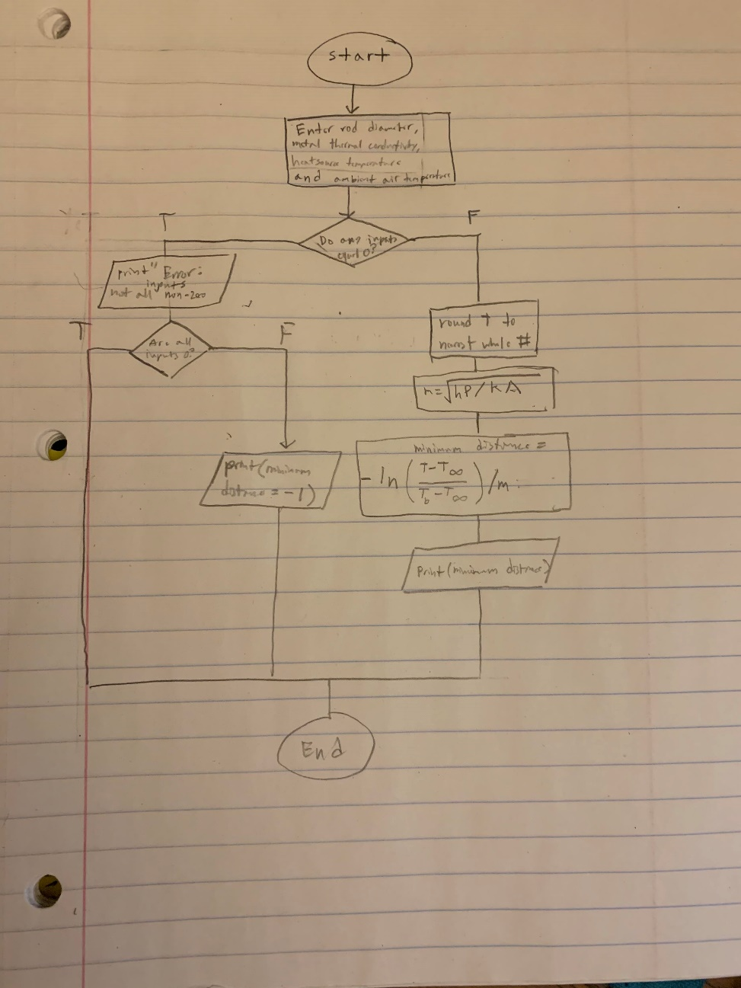

Variable Tracking Table – by hand
Complete the necessary parts of this table for the following input arguments:
Rod diameter: 0.005 m
Heat source temperature: 373 K
Ambient air temperature: 298 K
Thermal conductivity of stainless steel: 16 W/(m*K)
Add additional rows as necessary.
 | Distance from heat source (m) | Temperature at distance (K), rounded to nearest whole number
Initialization | 0 | 373
Iteration 1 | 1 | 298

Approximation of $\ln{3}$

Paired

Paired Partner
Each member of the pair will submit their own answer sheet. List your paired partner here.
Flowchart Partner: | Will Popovich, wpopovic@purdue.edu

Test Cases
Fill out the table with test case information.
- The Test Case Description is an English description of what path is being tested.
- The Test Case Values are the values you will use to test the path in the structure or flowchart.
- The Flowchart Output is an English description of the flowchart’s result when the test case values go through the structure; it should not be code or MATLAB generated results.
- Add as many rows as necessary to test all possible flowchart paths.
- An example test case is included.
Note: you will also use these test cases to test your completed code
Test Case Description  in English | Test Case Values  (n) | Flowchart Output  in English
Valid input for n: positive integer | 6 | - ln31.098588,  - 0.000024
n is not scalar | [1,12,3] | Prints message “Error: Invalid n  n must be a positive, scalar, integer value.”
n is less than 1 | 0 | Prints message “Error: Invalid n  n must be a positive, scalar, integer value.”
n is not an integer | 0.1 | Prints message “Error: Invalid n  n must be a positive, scalar, integer value.”

Variable Tracking Table – by hand
Complete the necessary parts of this table for input argument n = 3. Leave blank any unneeded cells.
 | Index | nth term in summation | Summation
Initialization | 0 | 1 | 1
Iteration 1 | 1 | 0.083333333 | 1.083333333
Iteration 2 | 2 | 0.0125 | 1.095833333
Iteration 3
Iteration 4
Iteration 5
Final Approximation of $\ln{3}$ |  |  | 1.095833333

