**Ethpays Exchange**

[www.ethpays.co](http://www.ethpays.co)

Whitepaper (v1)

Sommario

Introduction 3

Possible Problems 3

1. Security Vulnerabilities 3

2. Poor Technical Architecture 3

3. Poor Customer Support 3

4. Limited Fiat Support 4

5. Poor Internationalization 4

EthPays Exchange 4

1. Matching Engine 4

2. Margin Trading 5

3. Futures 5

4. Decentralized Exchange (DEX) 6

5. Features Rollout Order 6

6. Supported Cryptocurrencies 7

7. Supported Stablecoins 7

8. Device Coverage 7

9. Multilingual Coverage 8

10. UI Preview (Futures) 8

Revenue 11

Ethpays Coin ($ETP) 12

03.03.2024, Switzerland

# Introduction

In the cryptocurrency realm, two dominant exchange types have emerged: fiat exchanges and crypto-only exchanges. However, as the market evolves, there arises a need for a hybrid approach that blends the stability of fiat systems with the innovation of blockchain technology.

Enter **EthPays** – a fiat exchange poised to redefine crypto trading. In this whitepaper, we unveil **EthPays** unique features, innovative mechanisms, and our vision for reshaping the landscape of digital finance. Join us on this journey as we merge tradition with innovation to propel the future of global finance forward.

# Possible Problems

While cryptocurrency exchanges have revolutionized the way digital assets are traded, several challenges persist within the ecosystem. These challenges include:

1. Security Vulnerabilities: Many exchanges have experienced security breaches, leading to the loss of user funds. Despite efforts to enhance security measures, the threat of hacks and cyberattacks remains a significant concern.
2. Poor Technical Architecture: Certain exchanges have faced challenges stemming from poor technical architecture, leading to system downtimes, slow transaction processing, and other technical issues that impact user experience and reliability.
3. Poor Customer Support: Inadequate customer support is a common issue faced by many cryptocurrency exchanges. Users often encounter delays or difficulties when seeking assistance with account-related issues or transaction inquiries.
4. Limited Fiat Support: Several exchanges have limited support for fiat currencies, making it challenging for users to seamlessly deposit and withdraw funds. This limitation restricts access to the broader market and hinders the onboarding of new users.
5. Poor Internationalization: Some exchanges struggle with poor internationalization efforts, resulting in language barriers, limited support for international payment methods, and difficulties in providing localized services to users from different regions.

# EthPays Exchange

## Matching Engine

The matching engine is the core component of **EthPays** Exchange, responsible for facilitating the matching of buy and sell orders placed by users. It employs advanced algorithms to efficiently match orders based on predetermined criteria such as price and quantity, ensuring fair and transparent order execution. By leveraging cutting-edge technology, **EthPays** matching engine delivers high-speed order matching with minimal latency, enabling users to execute trades swiftly and capitalize on market opportunities in real-time. This robust infrastructure enhances liquidity and market efficiency, providing users with a seamless trading experience on **EthPays** Exchange.

## Margin Trading

Margin trading on **EthPays** Exchange empowers users to amplify their trading potential by borrowing funds to increase their purchasing power. Through margin trading, users can trade with leverage, effectively magnifying both potential profits and losses. **EthPays** Exchange provides a sophisticated margin trading platform that allows users to access various leverage ratios, enabling them to take advantage of market movements with increased flexibility and precision. With comprehensive risk management tools and margin requirements, **EthPays** ensures responsible trading practices while offering users the opportunity to diversify their investment strategies and optimize their trading outcomes.

## Futures

**EthPays** Exchange offers futures trading, allowing users to speculate on the future price movements of cryptocurrencies without owning the underlying assets. Futures contracts on **EthPays** enable users to enter into agreements to buy or sell a specific cryptocurrency at a predetermined price on a specified future date. This feature provides traders with the opportunity to profit from both rising and falling markets, as well as to hedge against price fluctuations. With **EthPays** futures trading platform, users can access a wide range of cryptocurrency futures contracts with varying expiration dates and leverage options, empowering them to tailor their trading strategies to their specific risk preferences and investment objectives. **EthPays** futures trading feature is designed to enhance market liquidity, foster price discovery, and provide users with advanced trading opportunities in the ever-evolving cryptocurrency market.

## Decentralized Exchange (DEX)

**EthPays** Exchange introduces a decentralized exchange (DEX) platform, offering users a trustless and secure environment to trade cryptocurrencies directly with one another without the need for intermediaries. Operating on blockchain technology, **EthPays** DEX facilitates peer-to-peer trading by leveraging smart contracts to automate order matching and settlement processes. By eliminating central points of control and custody, **EthPay**s DEX enhances security and transparency while providing users with full control over their funds throughout the trading process.

Through **EthPays** DEX, users can trade a wide range of cryptocurrencies with ease, enjoying benefits such as reduced counterparty risk, lower trading fees, and increased privacy. Furthermore, **EthPays** DEX supports decentralized finance (DeFi) protocols, enabling users to seamlessly access liquidity pools, participate in token swaps, and engage in other decentralized financial activities directly from the exchange platform.

**EthPays** commitment to decentralization empowers users to participate in a truly peer-to-peer trading ecosystem, aligning with the core principles of blockchain technology and fostering a more inclusive and resilient financial landscape.

## Features Rollout Order

We plan to rollout our features in the following order (may be subject to change)

* Spot Trading
* Futures Trading
* Margin Trading
* Decentralized Exchange (DEX)
* More features to come.

## Supported Cryptocurrencies

We will support (initially) the Top 100 Cryptocurrency based by Market Capitalization, such as:

* Bitcoin ($BTC)
* Ethereum ($ETH)
* Binance Coin ($BNB)
* Solana ($SOL)
* Ripple XRP ($XRP)
* Cardano ($ADA)

More cryptocurrency will be added after some time, depending on our user’s requests, and based on an internal valuation (based on some aspect of the given cryptocurrency, such as strong credibility, liquidity, user base, etc..)

## Supported Stablecoins

We will (initially) only support the following stablecoins, since they are well enstablished and with a ‘low risk to fail’.

* Tether USDt ($USDT)
* Coinbase USDc ($USDC)

## Device Coverage

We aim to provide the best user and cross-platform experience for the following clients:

* Web Based clients
* Android native clients
* IOS native clients
* PC (windows) native clients
* API (REST) (in the near future)

## Multilingual Coverage

Since we are a Swiss based Exchange we will be providing mainly the Swiss official language (initlially) and add more languges overtime as we grow.

At launch we will launch the platform only in English, after the launch the following languages will be added:

* Italian
* German
* French

## UI Preview (Futures)

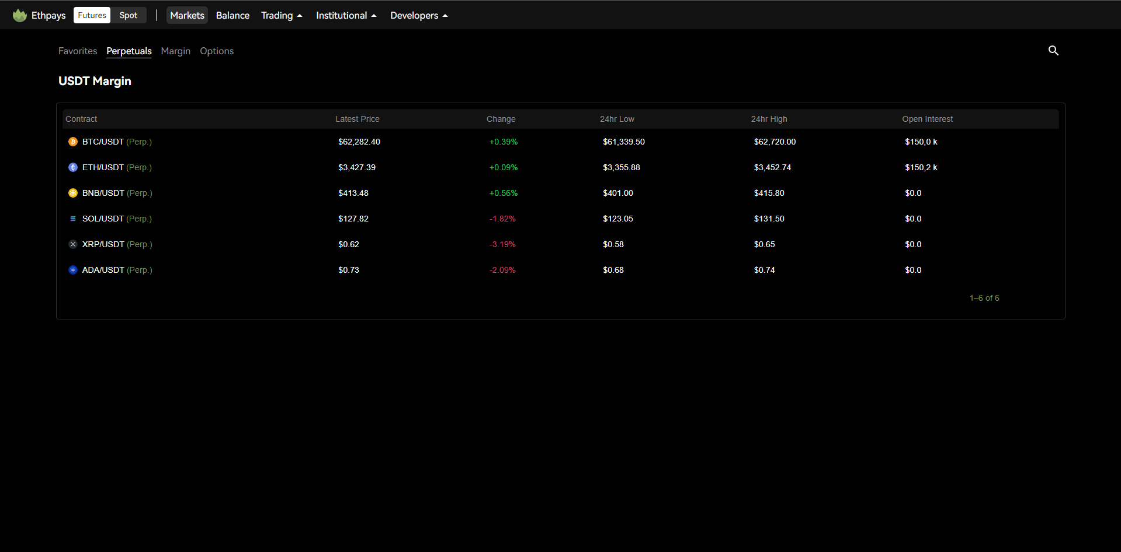

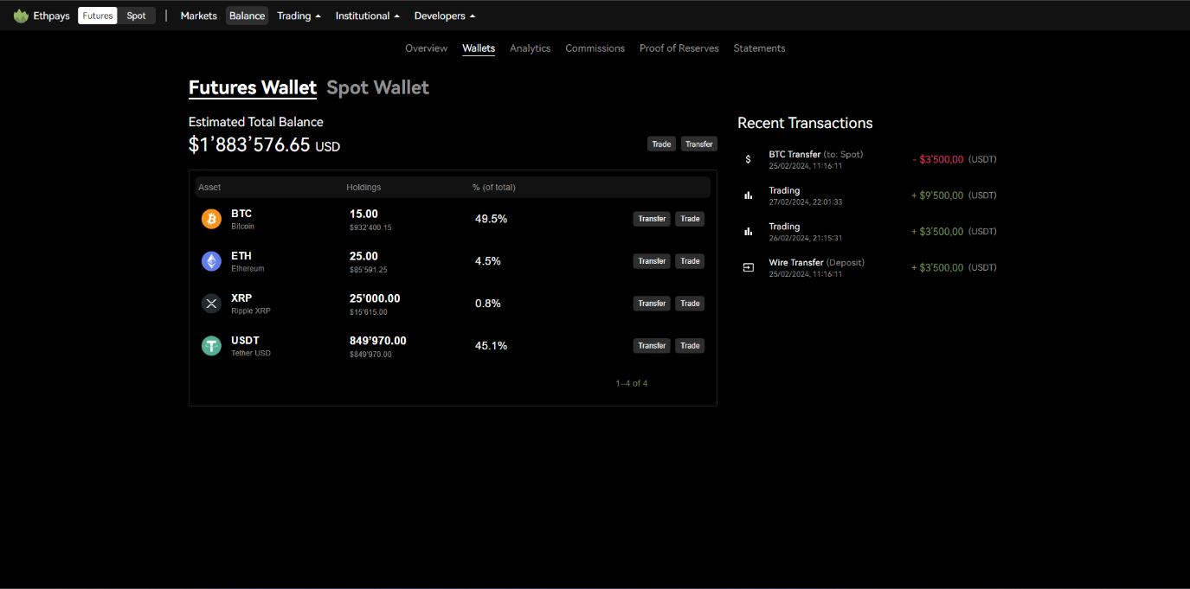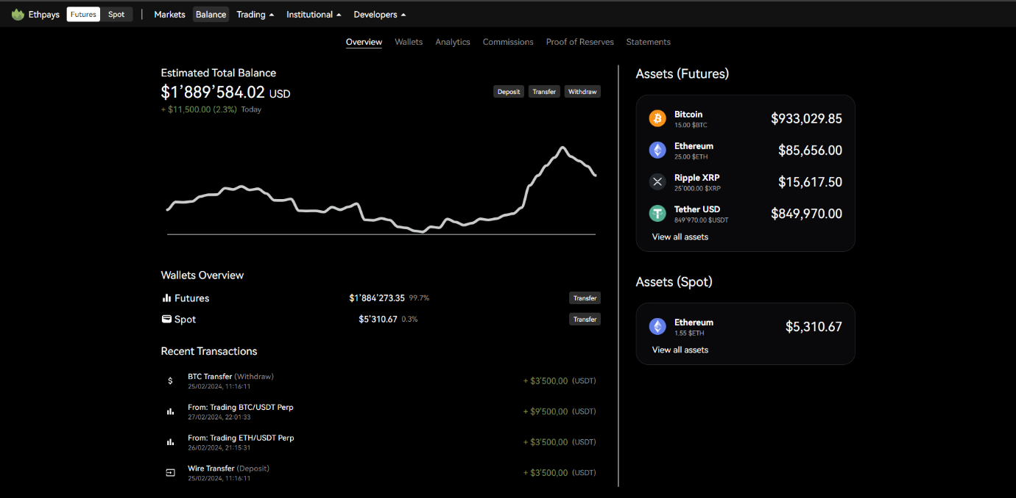

# Revenue

This are the expected source of revenue of **EthPays**

|  |  |
| --- | --- |
| **Source** | **Description** |
| Spot Fee | **Ethpays** will initially charge a 0.1% fixed fee per spot trade. More variations will be subsequently introduced, such as maker/taker, volumed based tiering and 0 fee promotions.  We will never charge above 0.1% for spot trades. |
| Margin Fee | Trading with margin may collect a small fee (or interest) on the borrowed amount. |
| Futures Fee | Trading futures contract will have max 0.01% fixed fee per futures trade. More variations will be subsequently introduced, such as maker/taker and volume based tiering. |
| Withdrawal Fee | **Ethpays** may charge a very small fee for fiat withdrawals |
| Listing Fee | If a coin or an asset will be listed on **Ethpays** a listing fee will be collected for the listing from the assset’s team. |
| Subscriptions Fee | We will create some subscriptions tiers (optionals) with some benefits for the subscribers, for a small monthly/yearly fee |
| Other Fees | There may be other fees on **Ethpays** we may collect from various services we offer to our users (eg. Copy trading, priority orders, etc) |

# Ethpays Coin ($ETP)

At **EthPays**, we believe in prioritizing substance over speculation. While we do not currently have plans to launch our own coin, we remain open to the possibility in the future as **EthPays** continues to evolve and expand its ecosystem. Our decision to refrain from an immediate coin launch stems from our commitment to ensuring that any cryptocurrency associated with **EthPays** carries tangible value and utility for its users.

We understand the importance of building a robust foundation and establishing a clear roadmap before introducing a native coin. Therefore, we are dedicated to focusing on the growth and development of **EthPays** as a platform first and foremost. Only when **EthPays** reaches a significant level of maturity and offers a diverse array of utilities and services that can be enhanced by the introduction of a native coin will we consider its launch.

Our approach is rooted in responsibility and pragmatism, prioritizing the creation of a sustainable and value-driven ecosystem over hasty coin offerings. Rest assured, any future plans regarding the introduction of the **EthPays** Coin ($ETP) will be meticulously evaluated and executed with the best interests of our users and the broader cryptocurrency community in mind. We remain committed to transparency and innovation as we navigate the exciting journey ahead.