**Lab 11 Template – Ethan Roepke**

**Part 1:**

1. **Screenshot of the genesis block**(5 points)

**Part 2:**

1. **Screenshot of bootnode identifier**(5 points)



1. **Individual node’s identifier with Ubuntu desktop’s IP address**(15 points)

enode://0281941bb68f002181d33f545fabdaba40372e3c2b1a3a3f1cd065d5492b19050d686ea0adfdbb006aa58da96c903272a1edcbc9298bf6ce59d2d706e0e31f04@81.59.123.1:30303

1. **Screenshot of peer node list**(10 points)

**Part 3:**

1. **Screenshot of balance**(5 points)

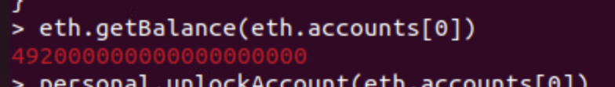

1. **Screenshot of balance two minutes later**(5 points)

**(This is a balance after I made transaction and mining for a few hours)**

**(Did not know we needed 2 balances)**

**Part 4:**

1. **Screenshot of transaction**(10 points)

1. **Screenshot of transaction block**(5 points)

1. **Screenshot of "final" balance after transactions**(10 points)

1. **How many US dollars would this translate to if using Ethereum PoS?**(5 points)

$ 170,838.86

1. **What is the US dollar value of EthereumPoW for one ETH?**(5 points)

$3.46

**Part 5:**

1. **Screenshot of latest block number**(10 points)

1. **Screenshot of minedBlocks output**(10 points)

