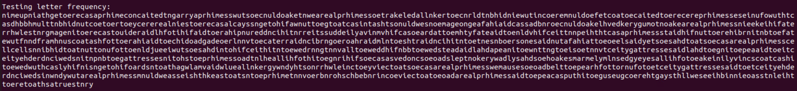

decryptTest = content.replace("I", "e").replace("C", "t").replace("R", "a").replace("Q", "o").replace("J", "i").replace("K", "n").replace("X", "s").replace("S", "h").replace("W", "r").replace("U", "d").replace("G", "l").replace("N", "c").replace("V", "u").replace("Y", "m").replace("T", "w").replace("P", "f").replace("H", "g").replace("Z", "y").replace("L", "p").replace("O", "b").replace("F", "v").replace("B", "k").replace("M", "j")

This is my first run, I see “to” and “toe” show up a bunch

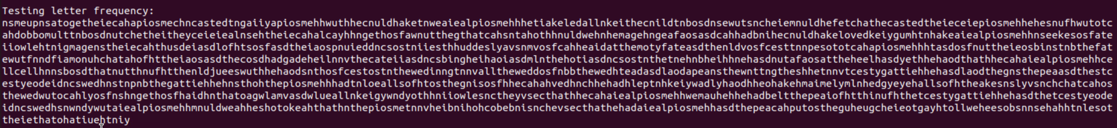

decryptTest = content.replace("I", "e").replace("C", "t").replace("R", "a").replace("Q", "h").replace("J", "s").replace("K", "n").replace("X", "h").replace("S", "o").replace("W", "i").replace("U", "d").replace("G", "l").replace("N", "c").replace("V", "u").replace("Y", "m").replace("T", "w").replace("P", "f").replace("H", "g").replace("Z", "y").replace("L", "p").replace("O", "b").replace("F", "v").replace("B", "k").replace("M", "j")

This is my second run, I believe I found the word “the”, also found words like “that”, “to”

Confident that “t, h, e, a, o” are correct

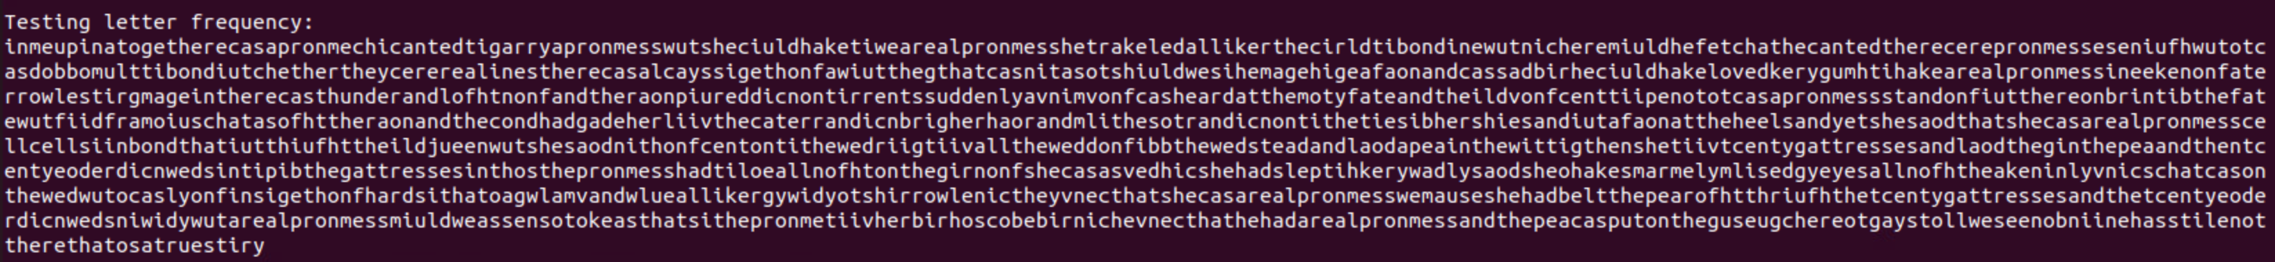

decryptTest = content.replace("I", "e").replace("C", "t").replace("R", "a").replace("Q", "h").replace("J", "n").replace("K", "i").replace("X", "s").replace("S", "o").replace("W", "r").replace("U", "d").replace("G", "l").replace("N", "c").replace("V", "u").replace("Y", "m").replace("T", "w").replace("P", "f").replace("H", "g").replace("Z", "y").replace("L", "p").replace("O", "b").replace("F", "v").replace("B", "k").replace("M", "j")

This is my third run, I am starting to see sentences starting to get together. For instance the first sentence is coming together with “in me up ina together” also “there, they”. I am confident in letters “t, h, e, a, o, n” y possibly correct.

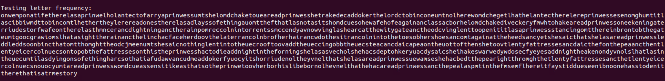

decryptTest = content.replace("I", "e").replace("C", "t").replace("R", "a").replace("Q", "h").replace("J", "n").replace("K", "o").replace("X", "s").replace("S", "i").replace("W", "r").replace("U", "c").replace("G", "d").replace("N", "l").replace("V", "m").replace("Y", "w").replace("T", "u").replace("P", "g").replace("H", "f").replace("Z", "y").replace("L", "p").replace("O", "b").replace("F", "v").replace("B", "k").replace("M", "j")

This is my fourth run, I am getting more words that I believe are right, this includes “story” “soon”. I am confident on the letters “s”. I believe I have the first 9 characters mapped right.

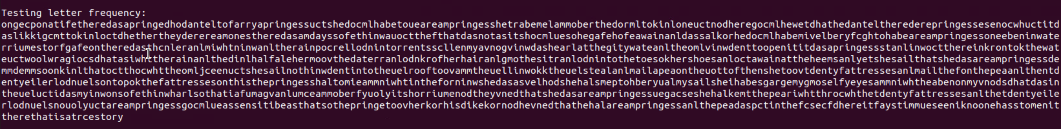

decryptTest = content.replace("I", "e").replace("C", "t").replace("R", "a").replace("Q", "h").replace("J", "n").replace("K", "o").replace("X", "s").replace("S", "i").replace("W", "r").replace("U", "l").replace("G", "m").replace("N", "d").replace("V", "c").replace("Y", "g").replace("T", "u").replace("P", "w").replace("H", "f").replace("Z", "y").replace("L", "p").replace("O", "k").replace("F", "v").replace("B", "b").replace("M", "j")

This is my fifth run, I am starting to see words coming together and can start guessing more words more confident as they become more obvious. For example, the ending right now says “thatisatrcestory”. I can see that this will translate to “thatisatruestory”. So next step ill change “c” to “u” and hopefully I get more words to show.

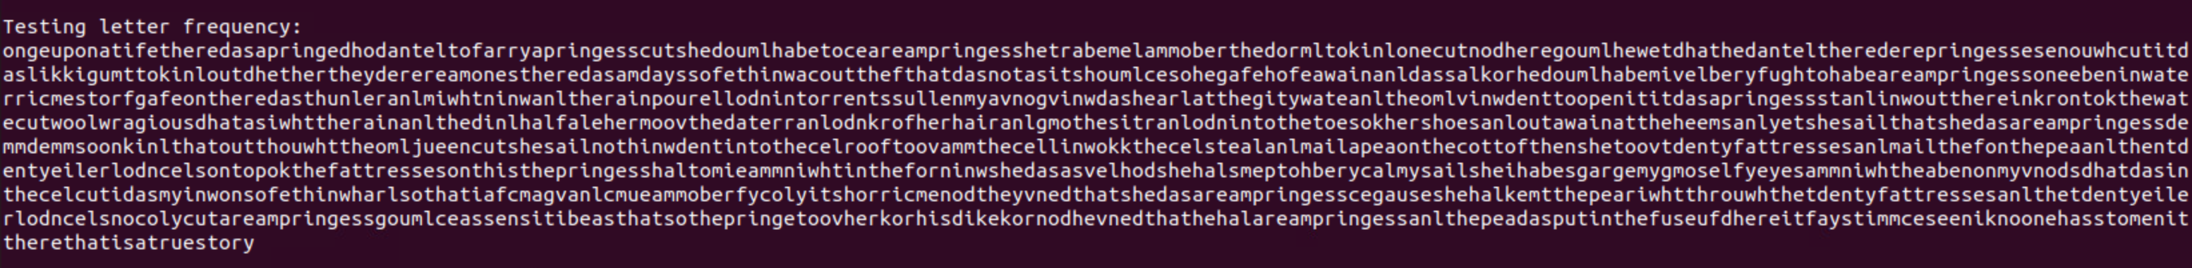

decryptTest = content.replace("I", "e").replace("C", "t").replace("R", "a").replace("Q", "h").replace("J", "n").replace("K", "o").replace("X", "s").replace("S", "i").replace("W", "r").replace("U", "l").replace("G", "m").replace("N", "d").replace("V", "u").replace("Y", "g").replace("T", "c").replace("P", "w").replace("H", "f").replace("Z", "y").replace("L", "p").replace("O", "k").replace("F", "v").replace("B", "b").replace("M", "j")

This is run number six, I was right on “V” mapping to “u”. I cracked words “true” “upon” possibly “out”

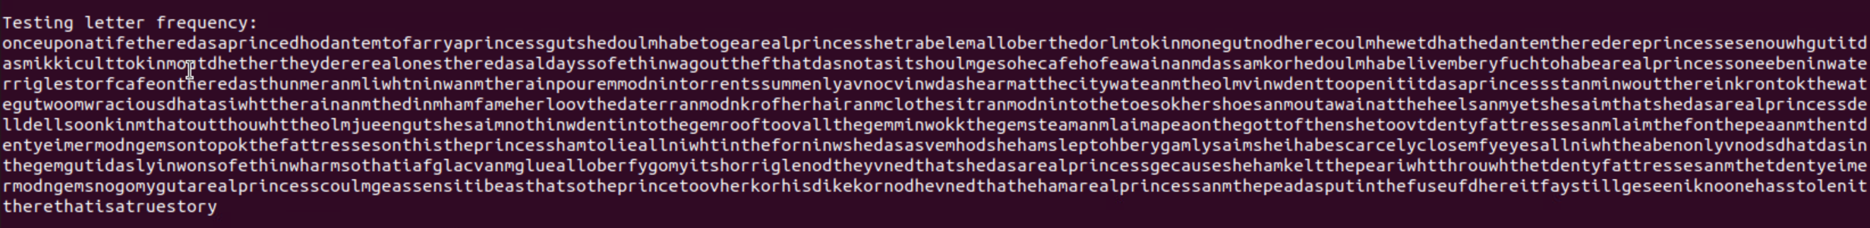

Run number seven, looks like I have “onceuponatifetheredasaprince” this helps me to correct the missing letters in this piece of sentence. Theoretically, this should say “onceuponatimetherewasaprince” I will change “f” to “m” and “d” to “w”

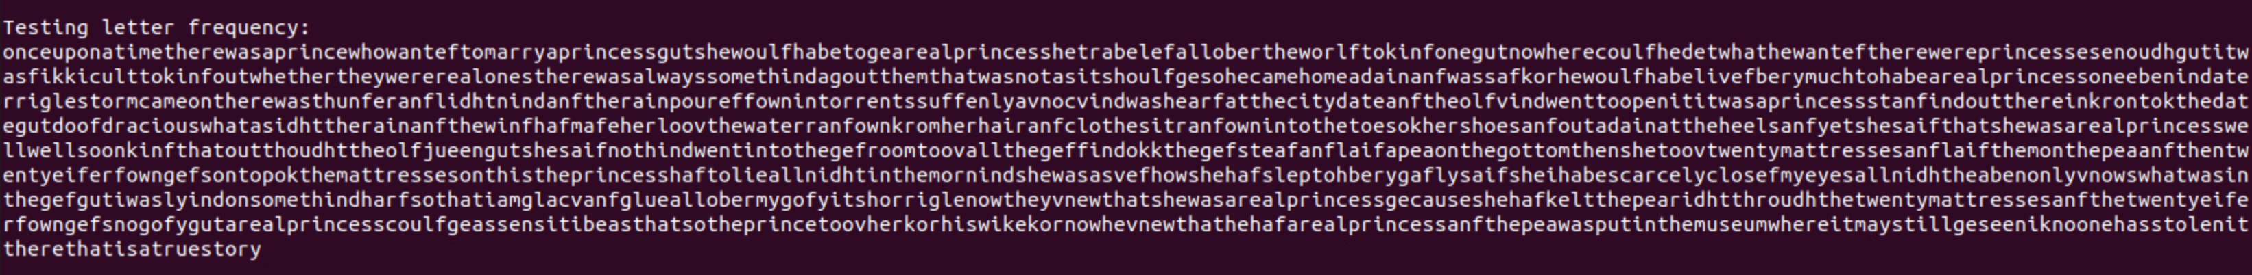

decryptTest = content.replace("I", "e").replace("C", "t").replace("R", "a").replace("Q", "h").replace("J", "n").replace("K", "o").replace("X", "s").replace("S", "i").replace("W", "r").replace("U", "f").replace("G", "l").replace("N", "w").replace("V", "u").replace("Y", "c").replace("T", "g").replace("P", "d").replace("H", "m").replace("Z", "y").replace("L", "p").replace("O", "k").replace("F", "v").replace("B", "b").replace("M", "j")

This is my run number eight, I was correct on the letter swaps from previous run. Now I can assume we flip “f” to “d”, as I can see this will make words “wanted” “would” “could”

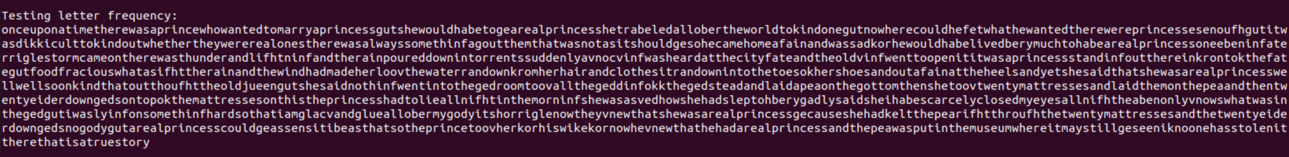

decryptTest = content.replace("I", "e").replace("C", "t").replace("R", "a").replace("Q", "h").replace("J", "n").replace("K", "o").replace("X", "s").replace("S", "i").replace("W", "r").replace("U", "d").replace("G", "l").replace("N", "w").replace("V", "u").replace("Y", "c").replace("T", "g").replace("P", "f").replace("H", "m").replace("Z", "y").replace("L", "p").replace("O", "k").replace("F", "v").replace("B", "b").replace("M", "j")

Run number nine, I was correct “U” maps to “d”. Going down the sentence “marryaprincessgutshewouldhabeto”. With common guess I would change “g” to “b” to get the word “but”

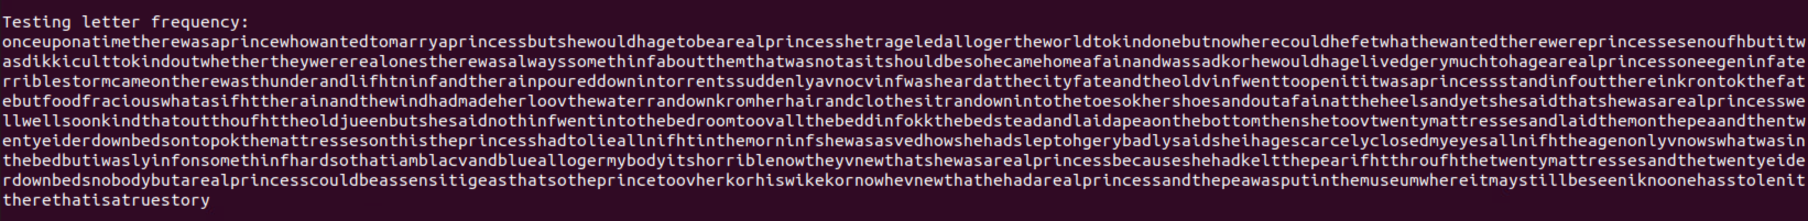

decryptTest = content.replace("I", "e").replace("C", "t").replace("R", "a").replace("Q", "h").replace("J", "n").replace("K", "o").replace("X", "s").replace("S", "i").replace("W", "r").replace("U", "d").replace("G", "l").replace("N", "w").replace("V", "u").replace("Y", "c").replace("T", "b").replace("P", "f").replace("H", "m").replace("Z", "y").replace("L", "p").replace("O", "k").replace("F", "v").replace("B", "g").replace("M", "j")

Run ten, we are so close to decrypting the cipher text. A section that pops out is “thebedbutiwaslyinfonsomethinf”. This shows me to change “f” to “g”. the sentence would be “thebedbutiwaslyingonsomething”

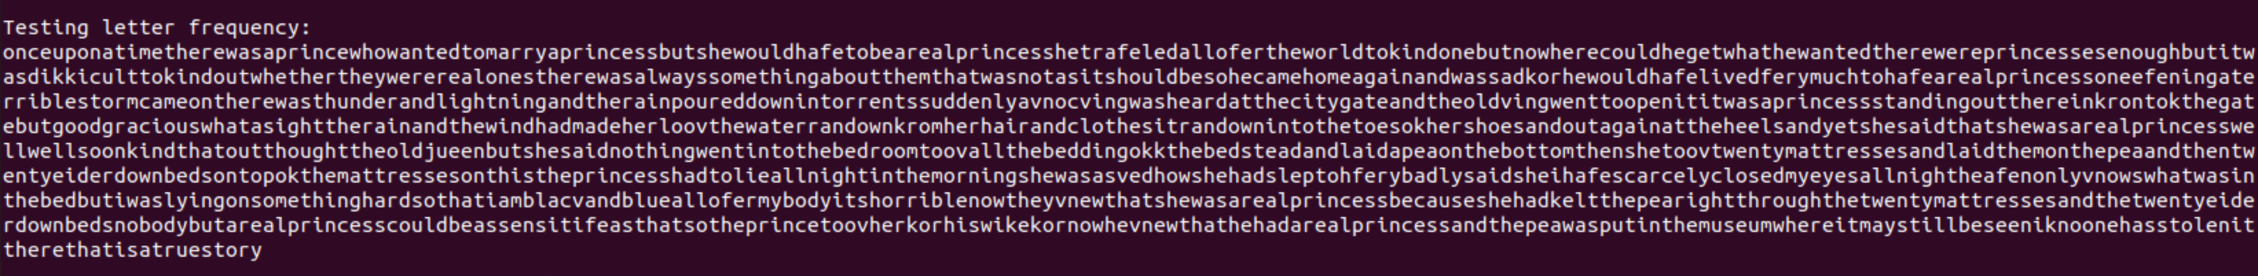

decryptTest = content.replace("I", "e").replace("C", "t").replace("R", "a").replace("Q", "h").replace("J", "n").replace("K", "o").replace("X", "s").replace("S", "i").replace ("W", "r").replace("U", "d").replace("G", "l").replace("N", "w").replace("V", "u").replace("Y", "c").replace("T", "b").replace("P", "g").replace("H", "m").replace("Z", "y").replace ("L", "p").replace("O", "k").replace("F", "v").replace("B", "f").replace("M", "j")

Run eleven, I should only have a few more test to finish up. I need to change “f” to “v”

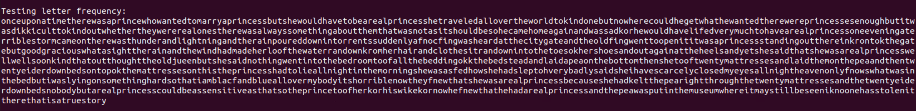

decryptTest = content.replace("I", "e").replace("C", "t").replace("R", "a").replace("Q", "h").replace("J", "n").replace("K", "o").replace("X", "s").replace("S", "i").replace ("W", "r").replace("U", "d").replace("G", "l").replace("N", "w").replace("V", "u").replace("Y", "c").replace("T", "b").replace("P", "g").replace("H", "m").replace("Z", "y").replace ("L", "p").replace("O", "k").replace("F", "f").replace("B", "v").replace("M", "j")

Run twelve, I will flip “k” to “f” to make words “find”

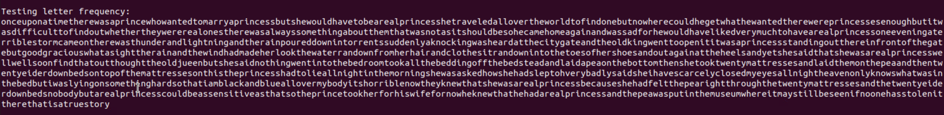

decryptTest = content.replace("I", "e").replace("C", "t").replace("R", "a").replace("Q", "h").replace("J", "n").replace("K", "o").replace("X", "s").replace("S", "i").replace ("W", "r").replace("U", "d").replace("G", "l").replace("N", "w").replace("V", "u").replace("Y", "c").replace("T", "b").replace("P", "g").replace("H", "m").replace("Z", "y").replace ("L", "p").replace("O", "f").replace("F", "k").replace("B", "v").replace("M", "j")

After 13 tries I have cracked the plaintext password!!