Guidance-centric user interface for IT systems: a proposal

Elliot Chandler (Wallace)
14 December 2017

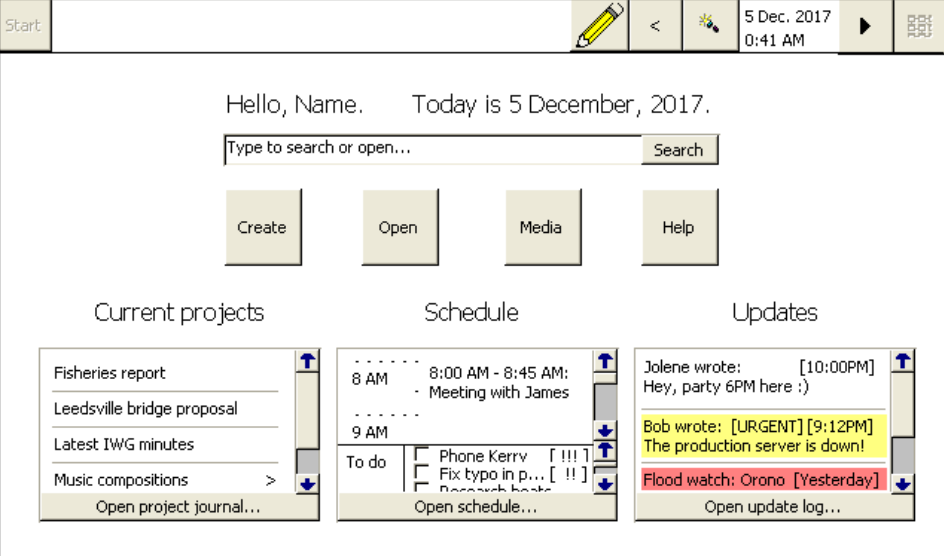

Problem Statement
Information technology systems are not connected to each other effectively. While standard protocols for some types of data interchange are available, a single integrated IT system for building documents that leverage the full array of diverse types of information that can be represented using IT does not yet exist. In addition, current IT systems do not effectively orient their users and give them a sense of groundedness in regard to what they are doing.

Proposed solution
To resolve these issues, this proposal suggests creating an IT system that uses standard data formats within itself to allow complete interoperability between all types of data, and allows single documents to hold any type of data that the system supports. This will prevent frustration of users when they are unable to combine disparate types of data into a single logical document, as would be their reasonable expectation. To make a system that is effective and useful, it should provide an interface, described here, to orient users and give them a guided workflow based on the information the IT system knows regarding them to help them get what they need to do done.

Research

Statistics and findings
A major goal of this proposal is to create an information technology system that will help guide people with dementia and other mental disabilities. The WHO estimates that 47 million people have dementia. [WHO 2017] Another group of people who would likely find such tools useful is those with autism-spectrum learning disabilities. Entire worldwide population statistics for autism-spectrum disorders are not accurately known [Miller-Wilson, n.d.], but according to the WHO [WHO 2017b], estimated 1 in 160 children worldwide have autism-spectrum disorders, and according to the NIH [NIH, n.d.], estimated 1 in 68 within the United States. Finally, ordinary computer users would likely be able to benefit somewhat from the same systems, simply because while optimally designed tools may provide the greatest amount of benefit to those with challenges that affect their ability to use current systems, such tools would likely help everyone to some extent.
The other side of this proposal is developing an information technology system that integrates diverse types of data. This is something that would improve efficiency and reduce frustration from unexpected, artificial limitations within computer systems for nearly any user of information technology systems. The number of personal computers was estimated to be “0.17 computers per person worldwide” in 2015 [Statista, n.d.]. 3.58 billion people are estimated to use the Internet [Statista, n.d. (b)]. This represents an enormous amount of people who use information technology systems, and it is likely that the majority of these would benefit from this proposal, especially those who work often with multimedia.
Because there are so many people affected by these challenges, and many others would likely benefit as well, there is a large group of people who would potentially find the proposed tools helpful. Consequently, working towards developing such a system is a valuable and important goal. The large potential benefit that could be gained from having such a system could, even if the individual increase in productivity were relatively small, have a substantial impact on the overall ability of humans to be productive and educated. In addition, a smaller group of people who are less able to use current information technology systems would probably see even larger gains in their productivity.

User Interviews
To learn about how viable and helpful this proposal would be, I interviewed two people to learn about their use of information technology systems and how they would be affected by the tools proposed here.

Interview questions
- What tasks do you frequently use information technology (IT) systems to complete? A few examples of information technology systems, for purposes of this question, are computers, telephones, portable music players, and fax machines.
- What aspects of yourself influence your use of, and experience of using, information technology systems? For example, if your job needs you to use IT systems, what is that job and what aspects of it relate to your use of IT systems? Or, if you find IT systems difficult to use because of difficulty processing complex visual stimuli, or because of physical mobility impairments.
- Also, when using information technology systems, are there any other challenges that you face?
- Imagine a computer or smart phone that, when you first start it, presents a list of recent projects you have worked on (such as documents you have had opened), and a list of upcoming projects you have told it about. Would you find a memory aid like that helpful in guiding you to the projects you are there to work on?
- For the next two questions, imagine an IT system that gives you information about current circumstances — your name, where you are, the date and year, and recent news and messages.
  - Would that help you feel grounded in the present and more easily able to complete the tasks you are there to work on?
  - If you or someone you know has trouble remembering that sort of state information, for instance due to Alzheimer’s disease or dementia, do you think this would be helpful in dealing with that?
- Current information technology systems are generally unable to facilitate combining information from various domains of use. For example, if you are writing a textual document, it is not really possible to include a musical composition within that document in such a way that it can still be edited when you send the document to someone else, and that it is a first-class, native feeling part of the document. For the next two questions, consider an IT system that uses a single way of storing and manipulating information for all the types of information it works with. For instance, you could work with a text document and a musical recording within a single document, using a single interface, or you could use a video as the subject of an email.
  - Would you find such a system helpful?
  - What are some specific situations in your use of IT systems that would benefit from that?
Thank you for participating in the interview!

Responses
Note that these responses have been lightly edited to make them clearer. The meaning of the responses is unchanged.
Interviewee 1
Interviewee 1 works as a church organist and piano teacher.
- Computer: Researching music repertoire and performance techniques for my work; learning repertoire; listening to music for work. Telephone: Business and personal contacts.
- No problems except for not always understanding the technology in a complete way and so not always being able to solve problems on my own.
- Financial restrictions in not having all the ideal components for a virtual pipe organ. Also, sometimes information not fitting on a screen correctly, or otherwise not working as it should.
- I don’t have so many projects going at once that I cant keep track of them.

  - Perhaps if I had a condition like Alzheimer's disease, but otherwise, no. Recent news would be a distraction unless that was my field of work.
  - Yes, it could be helpful. I believe.

  - Yes, that could be helpful. It would prevent the need to make two (or possibly more) separate communications, in some cases.
  - Trying to share a photo with commentary attached or a musical composition with my questions attached and also to get a critique.

Interviewee 2
- I use IT systems for many tasks:
- Music writing and recording
- Music listening
- Video watching
- Reading books
- Reading news
- Checking the weather
- Studying Spanish
- Looking up words in English and other languages
- Finding synonyms
- Making phone calls
- Texting
- Video chatting
- Keeping my appointments straight
- As an alarm clock
- As a timer
- As a stopwatch
- Tuning my guitar
- Finding information about people and businesses
- To guide my travels via GPS
- Emailing
- Research of products and subjects of interest
- Backing up information
- Storing photos
- Digitizing music and photographic slides
- Scanning books and other documents
- Finding, creating, and sharing recipes
- Journaling
- Making and publishing videos
- Publishing digital music
- Taking photos
- Opening the garage door
- Making shopping lists
- As a metronome
- To create editable documents using OCR
- To measure the level of sound
- To create animation
- To practice piano
- To recreate orchestras
- To alter photos
- My work is in music, and I use a computer and an iPhone extensively to support that work, as can be gleaned from the list above.
As long as images are relatively static, I can manage OK visually, although my eyes will get tired. When things are moving quickly, it is a challenge even when my eyes are fresh. Watching a movie with subtitles can be a challenge, for instance.
- Because I often interact with others via video chat, internet connection issues can often present challenges.
Because I use IT systems so extensively in my work, I am often challenged by the fact that my formative years did not include "thinking like a computer." In other words, using IT systems is not second nature to me.
- I think I would have to be shown how it would intersect with my workflow. I am used to using Calendar to keep my appointments straight, and I use Notes to make lists of projects when they become too numerous to hold in my "internal memory," so to speak. I am generally reluctant to learn new applications when what I am using is basically working for me, but when I am shown that it is in my best interest to do so, I overcome the reluctance.

  - I have such an IT system. I can ask Siri for any of that information.
  - I think it could be helpful, especially if someone was still in the work force, or if they still were striving to meet the challenges of living alone, or of helping to care for others.

  - I think it would be brilliant. Helpful? Absolutely.
  - Oh, goodness. I might send a recording to a client, and in the email mention specific passages about which I wanted them to comment; with such a holistic system, focusing their attention would be easy. Again, I sometimes send links to YouTube videos I have posted, and it would be great if it weren't necessary for the recipient to leave the email client in order to view and comment.
When creating text documents, I often want to incorporate photos or other materials; it is always a struggle because the applications that are best for the text aren't as nimble when managing other materials. I can absolutely see the value in being able to incorporate both video and sound files, for instance, in such documents.
Also, it would be wonderful to be able to add recorded verbal content (or even video) as a response to emails or other documents received from others. It is often easier and faster to speak impressions and complex responses to things than to write them.

Summary of findings
These interview responses show that various aspects of the proposed information technology system would be helpful. The interviews find some parts of the project helpful and others not necessarily so for their specific goals. Consequently, to make the proposed system ideal for all users, a method should be provided to allow users to choose which of its capabilities they would like to use. That way, the interface they have is the most relevant to them personally, and thus the most helpful in solving the particular problems they face.

Personas
While these personas are based on the interview respondents, they are somewhat fictionalized.
Persona 1
Lara is a 37-year-old professional church organist. They make extensive use of computers to manage business communications, and to simulate an organ for practice at home. Their work often requires communicating with their employer regarding music and business. To discuss music with their employer, it is often not practical to use a computer, and it is necessary to meet in person, due to the limitation of current information technology systems. If computers could provide tools for easily sharing and collaborating on scores and recorded performances of those scores, Lara’s job would be made easier by reducing travel time and the requirement of meeting in person to work on things that do not actually need an in-person meeting.
Persona 2
Joseph is a 40-year-old film teacher at a large public university. They use non-linear editing software in computers to edit films, and to demonstrate film editing in class to their students, as well as to work on separate projects for independent clients. Because the people they work for often have a hard time communicating what they want in a project, several iterations of work and feedback are needed before a finished product is delivered. Consequently, Joseph would be better able to communicate with students and clients if they could work with film in the way their non-linear editing software allows, but collaboratively online with the clients and students, like cloud-based collaborative word processors allow. If there were a single editing tool for text and films, the same collaboration abilities from one medium would be available in others, making Joseph’s job a lot easier and allowing more efficient communication between Joseph and their clients.

Storyboard
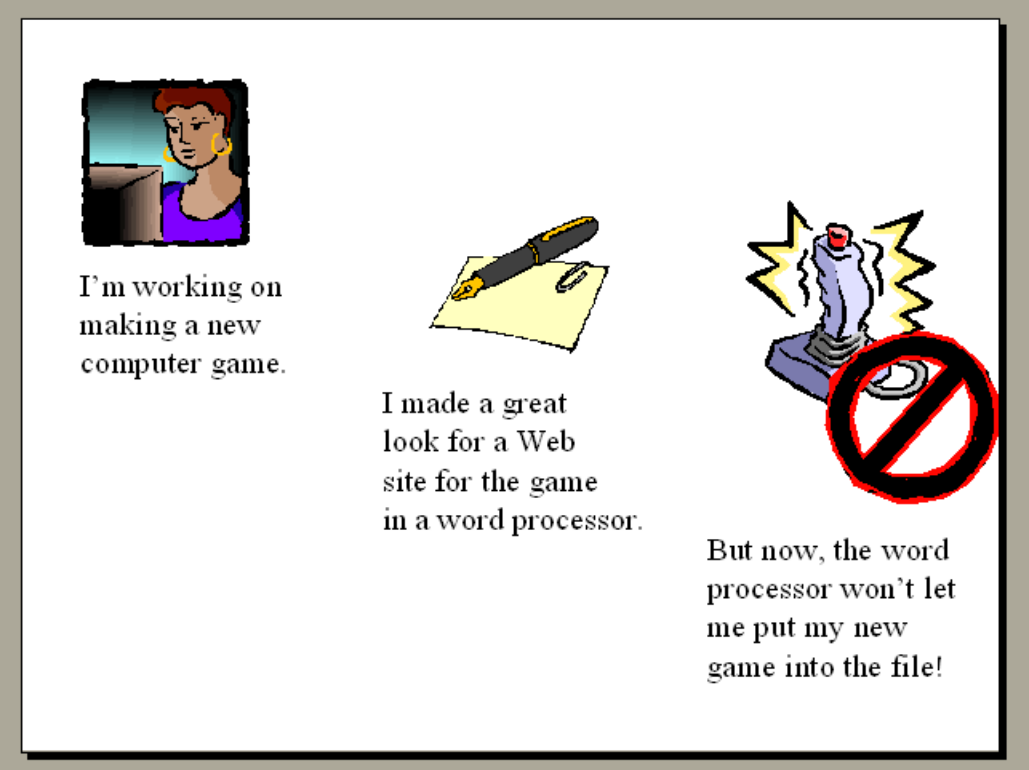
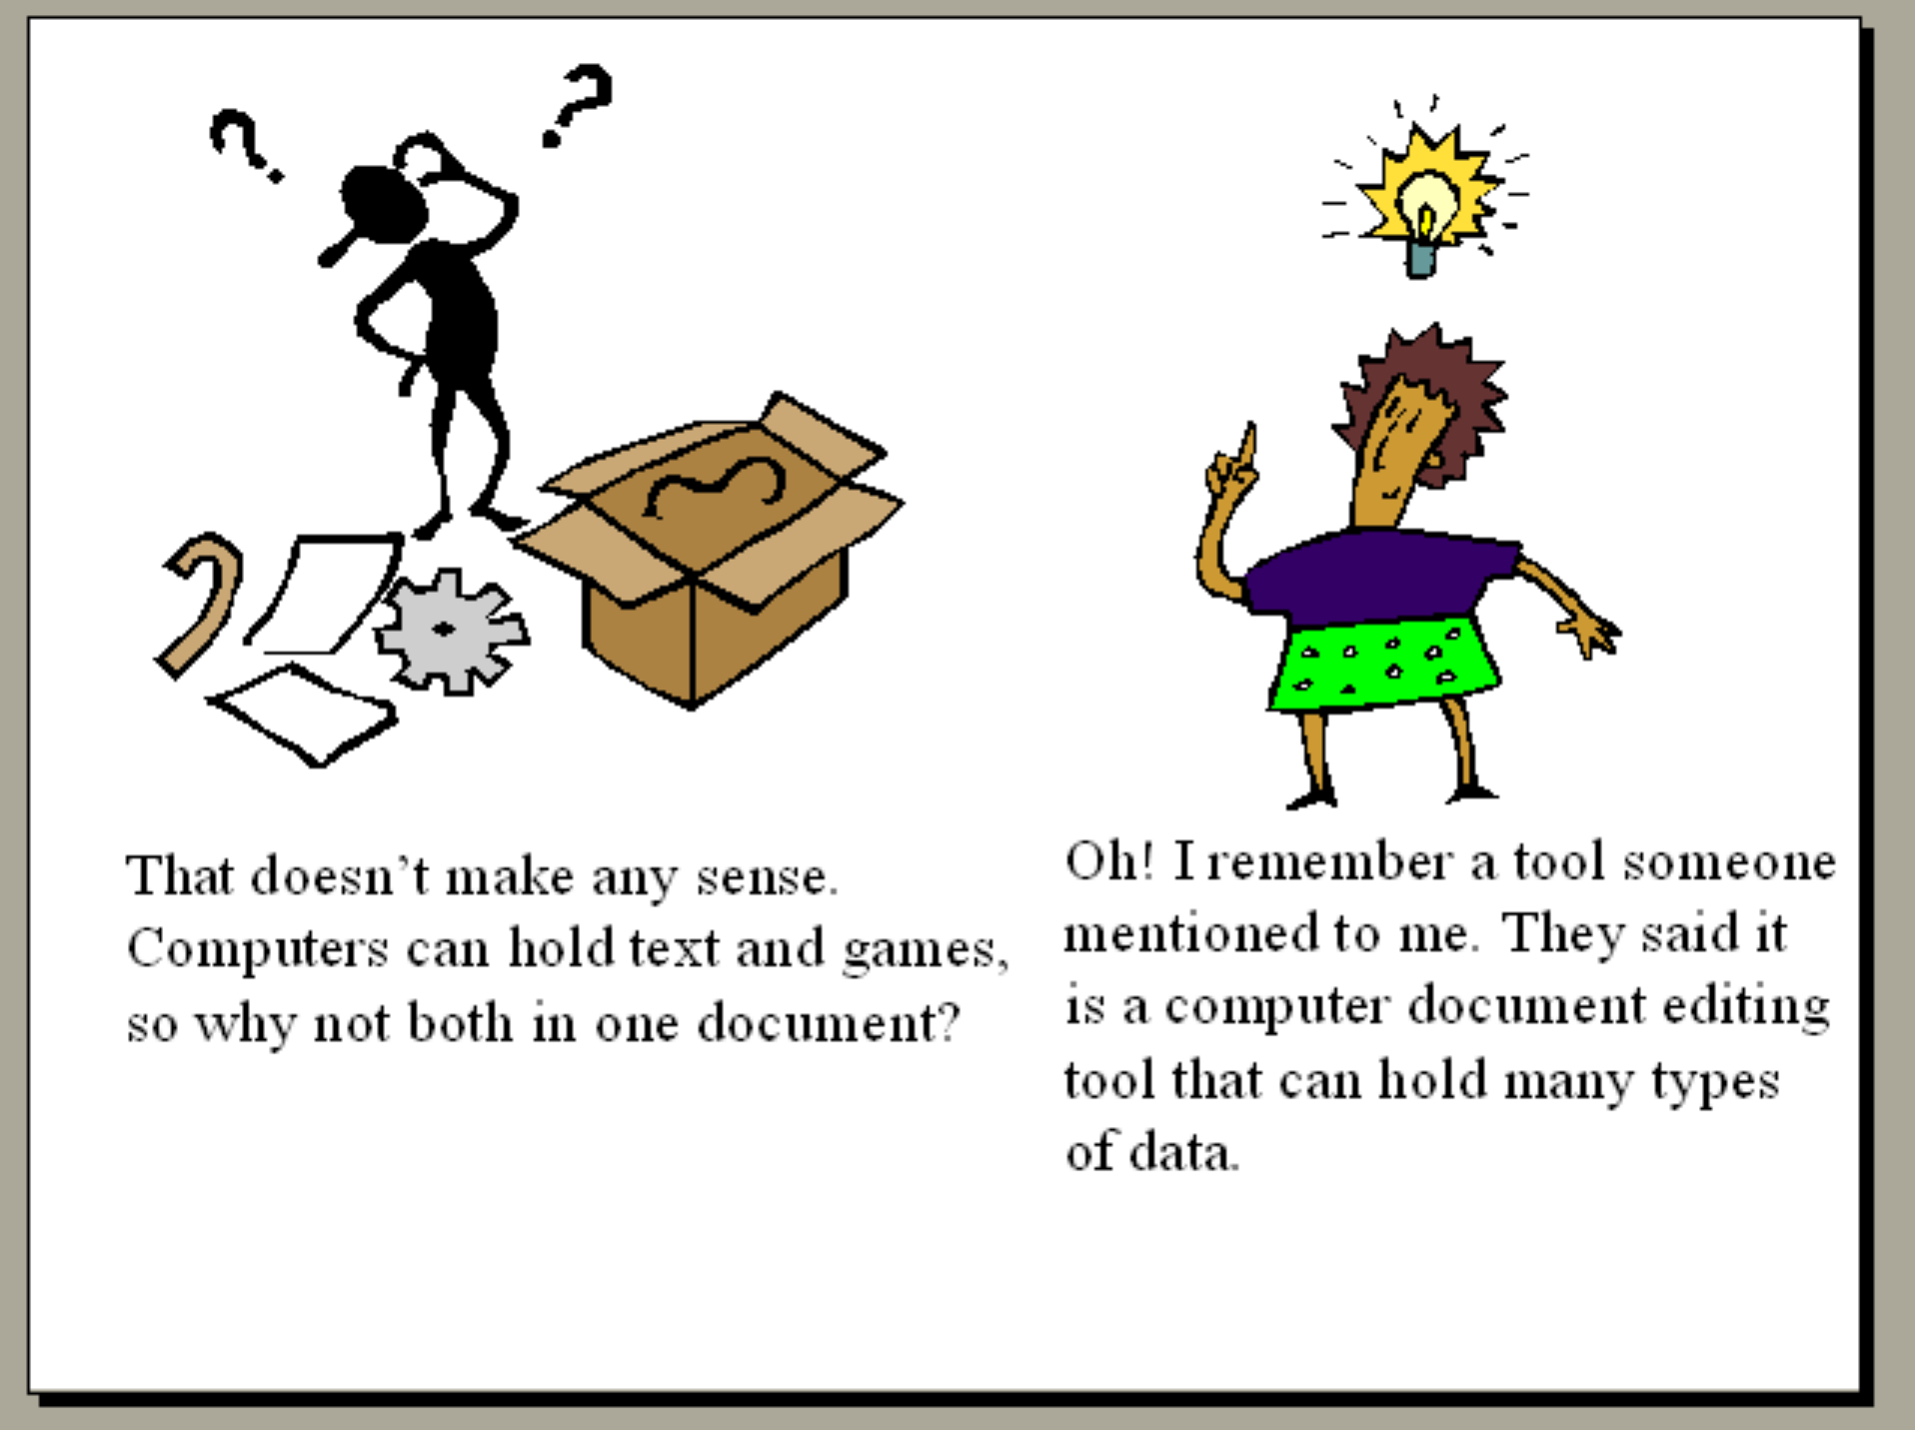
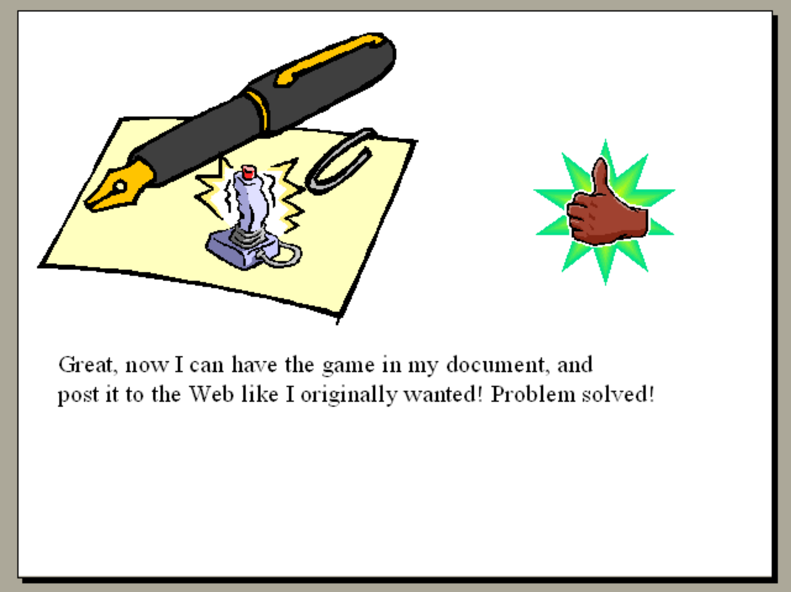

Prototype
An interactive prototype is available for this proposal, to allow you to explore the proposed tools as if you were using them.
The interactive prototype is available online: http://futuramerlin.com/people/elliot/writings/blogs/elliotchandlernmd442/2017/12/06/12799819e/

Proposed user acceptance testing strategy
To test the viability of this project, I would suggest developing a functional instance of it, and presenting it to a range of users who work with various challenges to using information technology systems. For testing the general viability of the project, it would not be necessary to fully implement all the features that would be needed to make it competitive with other information technology systems; rather, it would only be needed to implement a representative subset of capabilities that would allow the users to explore the general interface and the system’s basic interaction structure. To gather data on challenges that users might encounter in using the system, the testers should be presented with a task to complete using the system, and asked to give commentary on their experience of the tool, and any frustration they encounter during the process, while they work on completing the assigned task. An article from the Nielsen Norman Group states that “A scripted study of product usage is done in order to focus the insights on specific usage aspects, such as on a newly redesigned flow.” [Rohrer, 2014] Consequently, that seems like the correct user testing strategy for determining the viability of this proposal, and finding roadblocks in its usability.

Bibliography
- [WHO 2017] WHO. “10 facts on dementia”. April, 2017. http://www.who.int/features/factfiles/dementia/en/
- [NIH, n.d.] NIH. “How many people are affected by autism?”. https://www.nichd.nih.gov/health/topics/autism/conditioninfo/Pages/at-risk.aspx#f1
- [WHO 2017b] WHO. “Autism spectrum disorders”. April, 2017. http://www.who.int/mediacentre/factsheets/autism-spectrum-disorders/en/
- [Miller-Wilson, n.d.] Miller-Wilson, Kate. “How Many People Are Affected by Autism Worldwide?”. http://autism.lovetoknow.com/what-is-autism/how-many-people-are-affected-by-autism-worldwide
- [Statista, n.d.] Statista. “Global PC penetration per capita from 2000 to 2015 (in percent)”. https://www.statista.com/statistics/203677/global-pc-penetration-per-capita-since-2000/
- [Statista, n.d. (b)] Statista. “Number of internet users worldwide from 2005 to 2017 (in millions)”. https://www.statista.com/statistics/273018/number-of-internet-users-worldwide/
- [Rohrer, 2014] Rohrer, Christian. “When to Use Which User-Experience Research Methods”. https://www.nngroup.com/articles/which-ux-research-methods/

