NMD324: Elliot Chandler (Wallace) — Birdman favorite frame

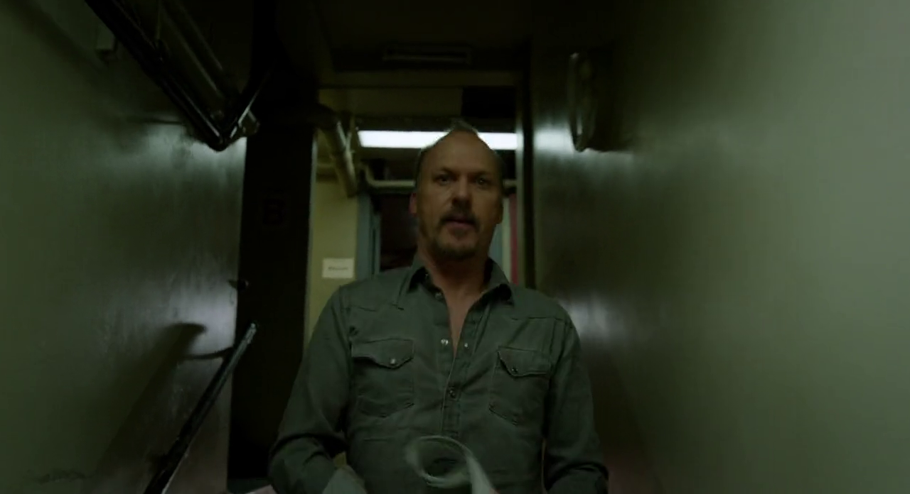

My favorite frame in Birdman is the one pictured above (55m29s), which is one of the shots used to transition between scenes. I find it very effective because it creates an evocative and intense environment. This has been a hard assignment for me to write. While choosing my favorite frame was very easy — I knew right away, instinctively, what my favorite was — figuring out how to describe what appeals to me about it is more difficult. Even now, I do not feel like I fully understand what draws me to this frame so strongly.

