Introduction
- Introduction should be deliberately brief as there is a lot to cover in methods and potentially results.

Methods

Approach
To perform scenario-based simulation of future LULCC in Switzerland between 2020 and 2060 we utilized a constrained cellular automata (CCA) modelling approach using the environment modelling software Dinamica EGO (citation). CCA models of LULCC (LULCC-CCAs) treat landscapes as a pixelated grid of cells of individual LULC states with cells changing state over time typically based on two processes. Firstly, the spatial distribution of potential LULCC is determined through calculation of cellular probabilities of change to alternate LULC states. The means by which this is achieved, differs between popular LULCC-CAs although it is commonly based on the quantification of correlative relationships with explanatory variables such as biophysical and socio-economic and neighbourhood (focal LULC) predictors. Secondly, the amount of cellular LULC changes that occur in a given time step is prescribed by values of transition rates extrapolated from historic LULC data, with an allocation algorithm selecting the required number of cells to change based upon their transition probabilities. The internal model process of LULCC-CCAs offers several opportunities to operationalize aspects of scenarios for the purpose of simulations.

These are represented visually in Figure X below.

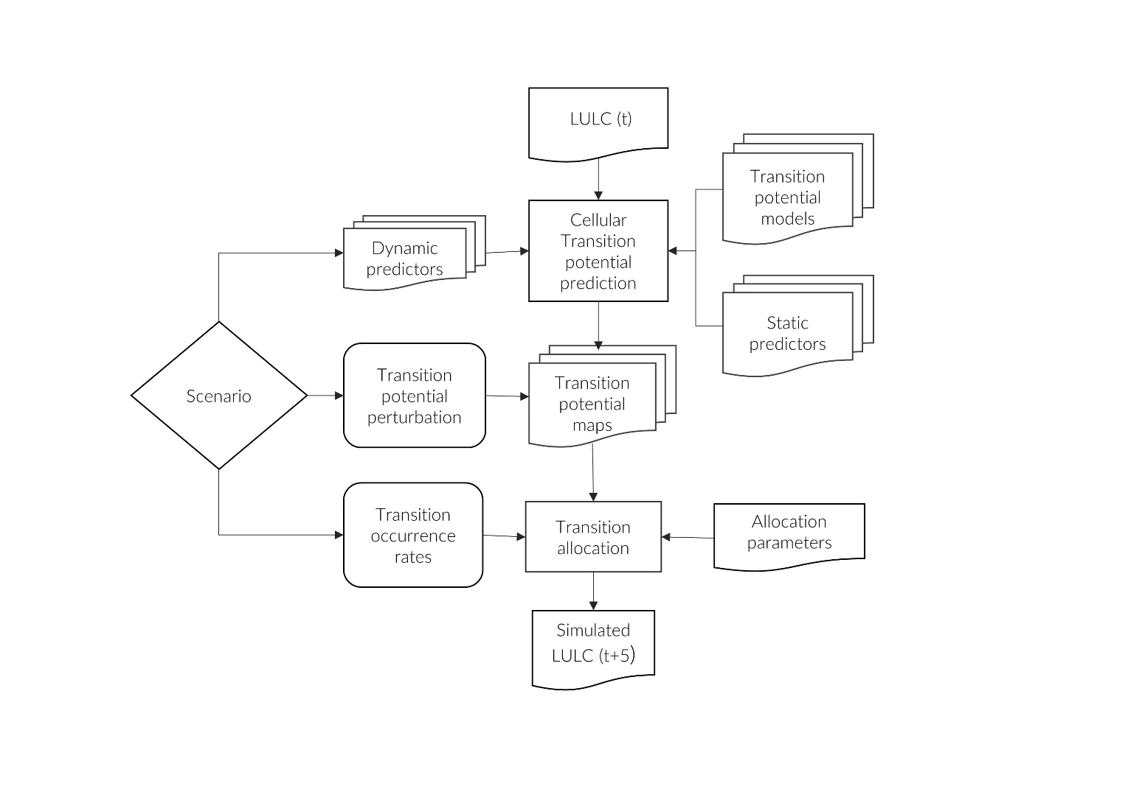

2.2 Land use land cover transition modelling
- Overview of method with reference to Black et al. 2022.
- For calibration models prepared for all historical time periods, for simulation models from the 2009-2018 period were used.

2.3 Scenario development
- Brief description of method with reference to paper or Paula/Sven-Erik
- Include scenario table

2.4 Scenario quantification
- Calculation of transition rates
- Perturbation of transition probabilities
- Dynamic variable preparation: Climate, population

2.5 Model validation

